**Git Tutorial:**

6/8/2018

<https://medium.freecodecamp.org/git-cheat-sheet-and-best-practices-c6ce5321f52>

<https://www.atlassian.com/git/tutorials/setting-up-a-repository> -- git bare Vs Cloned repository

7/8/2018 – in the evening at home

How to delete file using Git

1. <https://stackoverflow.com/questions/2047465/how-can-i-delete-a-file-from-git-repo/2047477>

**Warning:** git rm is the right answer, but remember that the file will still be there in history. If you want to remove a file because it had sensitive information, you'll need to do something more drastic. (Changing history, especially for content you've already pushed, is a drastic action, and should be avoided if possible.) – [Keith Thompson](https://stackoverflow.com/users/827263/keith-thompson)[May 16 '13 at 21:06](https://stackoverflow.com/questions/2047465/how-can-i-delete-a-file-from-git-repo/2047477#comment23856805_2047465)

2.<https://git-scm.com/docs/git-rm>

3.<https://www.google.com.au/search?source=hp&ei=M5dpW_WiJtP4hwOG3rzQDA&q=git+how+to+ignore+files+already+in+repository&oq=git+how+to+ignore+&gs_l=mobile-gws-wiz-hp.1.1.0l5.1191.14383..16832...9.0..0.317.5752.0j16j11j1......0....1.......0..5j46j0i131j46i131j0i10.0-4Az-hZTOc>

4.<https://gist.github.com/tsrivishnu/a2f3adbbca9fcad5f3597af301ad1abb>

8/8/2018

Popular git command

<https://orga.cat/posts/most-useful-git-commands>

what does git cat –file stand for

<https://stackoverflow.com/questions/38177026/what-does-cat-file-stand-for-in-git>

**Rename/move and remove files**

git rm removeme.txt tmp/crap.txt

git mv file_oldname.txt file_newname.txt

git commit -m "deleting 2 files, renaming 1"

show content of a file – very good

<https://stackoverflow.com/questions/5153199/git-show-content-of-file-as-it-will-look-like-after-committing/5153379>

cat myhdfile.txt

git show :myhdfile.txt

--

**Most commonly used git tips and tricks.**

<https://github.com/git-tips/tips>

can change to Chinese !

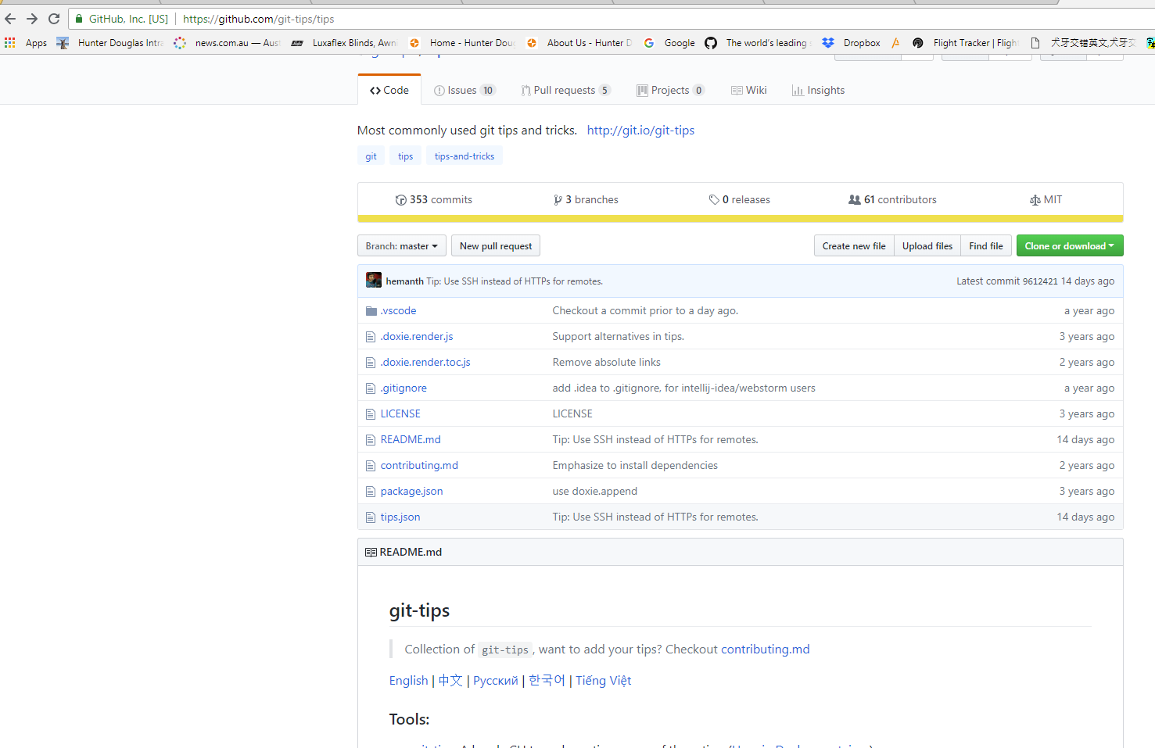

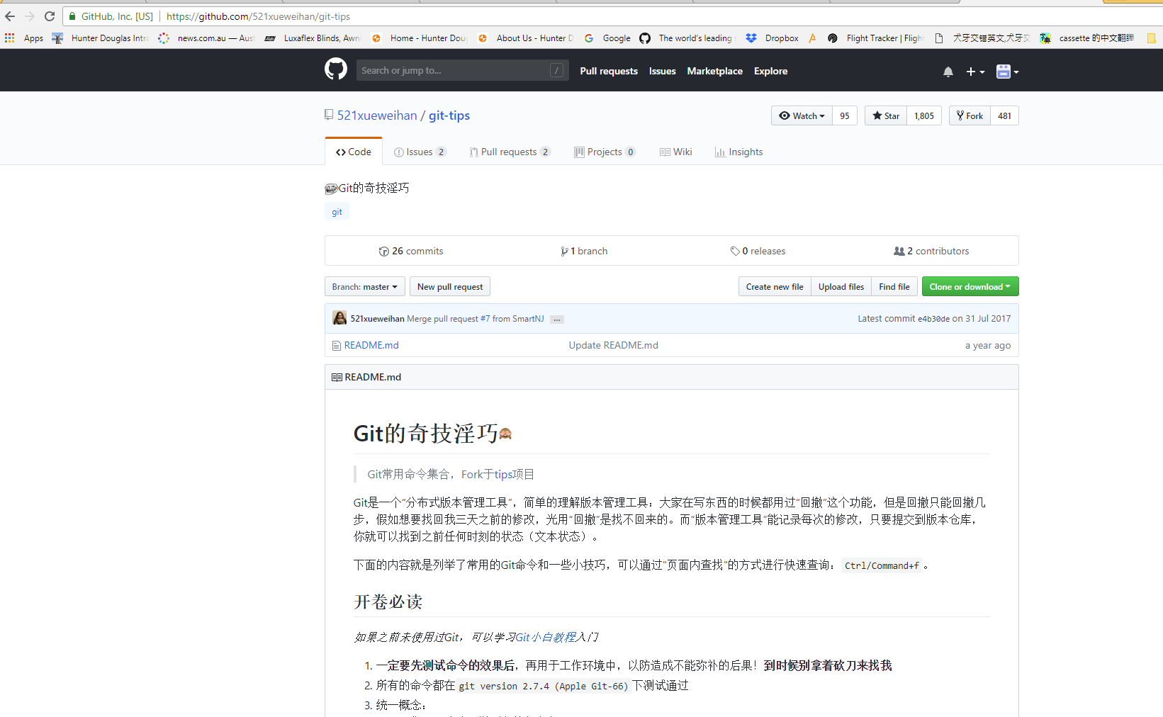

**Cmd command**

Pwd

Cd ..

Cd

Dir

Dir –all

Ls –la

Type

Echo “ ‘’ >> myfile.txt append more line

Echo “ ‘’ > myfile.txt overwrite all line

Type f2.txt -- Open & Display the file content

Or simple

C:\>F2.txt 🡪 then ‘Enter’ to Open & Display the text file

Del txt.file

Color

Cls ( to clear command history )

doskey /history ( cmd ) - show command history

<https://helpdeskgeek.com/how-to/redirect-output-from-command-line-to-text-file/> - save command

doskey /listsize=0

save command history to a file

doskey /history > C:\Users\name\Desktop\commands.txt

out put file:

ipconfig /all > c:\my_directory\network_info.txt

output file :

**NOTE:** If you saved the file to a different directory, be sure to put the full path to the file after “**notepad.exe**” on the command line as follows:

notepad.exe network_info.txt

notepad.exe C:\my_directory\network_info.txt

**NOTE:** If you use the same filename a second time, that file will be overwritten and any output it previously contained will be lost. To preserve your previous output, use a different filename or you can append the output to the end of an existing file. To append data to an existing file, use two redirection symbols as shown below:

dir c:\my_music >> network_info.txt

**NOTE:** Redirection is also useful for saving directory listings. The previous command saves a listing of the **c:\my_music** directory into the end of the **network_info.txt** file. Enjoy!

Cat f2.txt -- cmd command line to display file content. Cat stand for concatenate

<https://stackoverflow.com/questions/38177026/what-does-cat-file-stand-for-in-git>

While [cat](https://en.wikipedia.org/wiki/Cat_(Unix)) does stand for "concatenate", what it actually does is simply display one or multiple files, in order of their appearance in the command line arguments to cat. The common pattern to *view*the contents of a file on Linux or *nix systems is:

cat <file>

The main difference between cat and Git's [cat-file](https://git-scm.com/docs/git-cat-file) is that it only displays a single file (hence the -file part). Git's cat-file doesn't really stand for "concatenate"; it simply is a reference to the behavior of the cat command.

---

**Git command:**

Pwd

Git - - version

Git status

Git add . git –A

Touch .gitignore -- create .gitignore file

Git commit –m “”

Git push

Git pull

Git init

Git clone

Git log

Git diff

Git merge

Git diff - - staged

Git rm

Git rm –rf .git - remove .git so no longer track your project

Git init - put it back, start to track your project

Git mv -- change name /move

git mv old_filename new_filename

git status

git commit -m "Rename file"

git push origin your-branch

Git checkout

Git branch

Git reset - while file is in staging area, not commit yet

History ( git ) / doskey /history ( cmd ) -- show command history

clear

git show : f2.txt - show content of the file

cat f2.txt

--

Ls –la

Git config –global