Problem:

You are given a matrix that contains booleans. If an element is true, it means that it is colored black, otherwise it is colored white.

Your task is to find perimeter of the objects colored black.
Example
For
matrix = [[false, false, false, true, false],
[false, true, true, true, false],
[false, false, false, true, false],
[false, true, true, true, false],
[ true, true, false, false, false]]

the output should be
MatrixPerimeter(matrix) = 22.

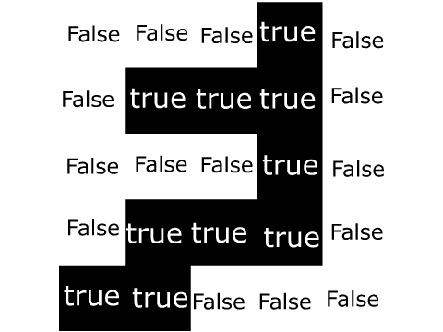

As you can see, perimeter of the area colored black is 22.

Input/Output
- [time limit] 3000ms (java)
- [input] array.array.boolean matrix
A rectangular matrix.
Constraints:
1 ≤ matrix.length ≤ 100,
1 ≤ matrix[i].length ≤ 100.
- [output] integer
Perimeter of the black figures.

Solution:

Check each element in the matrix.

If the element is true, then we have a block, and we assume that it initially provides a total of 4 to the total perimeter.

For each neighbor of the block ( a block to the left, right, above or below), decrease its parameter by one.

