Heading is in sentence case, bold, centred and fourteen point: maximum 100 characters including spaces

Anne N. Author,1* Charles Centred2* and James Twelve-Point2

**\*These authors contributed equally to this work.**

# Abstract (all major headings in bold 14 pt)

All normal text Times New Roman 12 point and justified. In the Abstract there should be no abbreviations/subtitles/references. Maximum of 400 words.

**Author affiliations:**

1 Author affiliations, are justified, 12 point

2 And need Department, Address including post code and Country

1 Hotchkiss Brain Institute

3330 Hospital Dr NW, Calgary, AB, Canada T2N 4N1

Correspondence to: justified, 12 point, address with E-mail. No telephone numbersor fax numbers

**Running title**: maximum 40 characters including spaces

**Keywords:** separate by semi-colon; 12 point; maximum of five

**Abbreviations:** alphabetical order, separated by semi-colons; 12 point (see Table 1 below for abbreviations that do not need defining); abbreviations should be in the format: UPDRS = Unified Parkinson’s disease Rating Scale

**Introduction**

Here are some guidelines (Reference, 2010) for different (Author and Writer, 2009) kinds of reference (Reference, 2008*a*, *b*), which you might include in your article (Reference, 2008*a*, *b*, 2010; Author and Writer, 2009; Andlastbutnotleast *et al*., 2011). All in ascending date order followed by alphabetical order; *et al.* is in italics and used if more than two authors are on the reference in the main text. Use last name followed by comma followed by year. Citations to be separated by semi-colons. If an author appears on two citations in one year add *a, b* in italics after the year.

Text is Times New Roman 12 point and justified.

Abbreviations are to be kept to a minimum. Any abbreviations used in the manuscript must be defined, except for those in Table 1 which do not need to be defined or listed. Tables should be uploaded as separate files and not embedded in the main text document.

**Table 1 Words that do not need to be defined in a Brain article**

|  |  |  |
| --- | --- | --- |
| AIDS | CT | HIV |
| ANOVA | DNA | MRI |
| ATP | ECG | PET |
| CNS | EEG | GABA |
| CSF | EMG | RNA |
| ELISA | PCR | PBS |
| cDNA | tRNA | mRNA |

Names of diseases should NOT be abbreviated e.g. multiple sclerosis, Parkinson's disease, Alzheimer's disease etc.

**Materials and methods**

If possible please use a maximum of two subheadings per section. Numbers below 10 to be written in full except when attached to a unit such as an SI unit or time unit including days, weeks and months. Equations should be labelled in numerical order, and provided in a MathType format:

$y =mx +c$ (1)

$β=2σ ± \left(στ × ∆\right)$ (2)

**Subheading 1 is bold and 13 pt**

**Subheading 2 is bold and 12 pt**

Some examples of this could be as follows:

**Imaging**

**Magnetic resonance**

Here the MRI protocol is discussed.

**Diffusion tensor imaging**

Here the DTI protocol is discussed.

**Results**

Similar subheading structure as previously.

All variables must be italicized e.g. *n* = 12 and *P* < 0.05.

$$Impact Density=\sum_{i=1}^{m}{\sum_{j=1}^{n}{\frac{Acceleration_{j}}{Time to ERP Measurement_{i}}}} (1)$$

Note: Acceleration can be linear (Units in g/sec) or rotational (Units in rad/s/s/s). m = Time point of the measurement (mid-season or end-of-season), n = Number of impacts

**Discussion**

Similar subheading structure as previously.

**Acknowledgements**

This section is not mandatory.

**Funding**

Details of any funding received towards the work in the article should be included here.

**Conflict of interest**

This section should be included only if applicable to the work carried out in the article.

**Supplementary material**

If your manuscript refers to extra material, please state here that ‘Supplementary material is available at *Brain* online’.

**Appendix 1**

This section is included if the article contains an appendix, for example, to list consortium collaborators who must be indexed online.

**References**

Bibliographic references should be listed in alphabetical order and not numbered. For multiple publications by the same author, those by the author alone are listed first, those with two authors listed after these. Author names are to be listed to a maximum of **six** and any more should be indicated by et al. If there is more than one paper for a given author in a given year, these should be listed a, b, c, etc. The references should be presented in the Vancouver style and journal titles given in their abbreviated forms.

**Examples of reference style**

Barkovich AJ. Disorders of neuronal migration and organization. In: Kuzniecky RI, Jackson GD, editors. Magnetic resonance in epilepsy. New York: Raven Press; 1994. p. 235-55.

Bushby KMD, Gardner-Medwin D. The clinical, genetic and dystrophin characteristics of Becker muscular dystrophy. I. Natural history. J Neurol 1993; 240: 98-104.

Costa DC, Morgan GF, Lassen NA, editors. New trends in neurology and psychiatry. London: John Libbey; 1993.

Handwerker HO, Kobal G. Psychophysiology of experimentally induced pain. [Review]. Physiol Rev 1993; 73: 639-71.

Shy ME, Frohman EM, So YT, Arezzo JC, Cornblath DR, Giuliani MJ, et al. Quantitative sensory testing: report of the Therapeutics and Technology Assessment Subcommittee of the American Academy of Neurology. Neurology 2003; 60: 898-904.

Stys PK, Ransom BR, Waxman SG. Tertiary and quaternary local anesthetics protect CNS white matter from anoxic injury at concentrations that do not block excitability. J Neurophysiol 1992a; 67: 236-40.

Stys PK, Sontheimer H, Ransom BR, Waxman SG. Noninactivating, tetrodotoxin-sensitive Na+ conductance in rat optic nerve axons. Proc Natl Acad Sci USA 1993; 90: 6976-80.

Stys PK, Waxman SG, Ransom BR. Ionic mechanisms of anoxic injury in mammalian CNS white matter: role of Na+ channels and Na(+)-Ca2+ exchanger. J Neurosci 1992b; 12: 430-9.

Figures and Tables

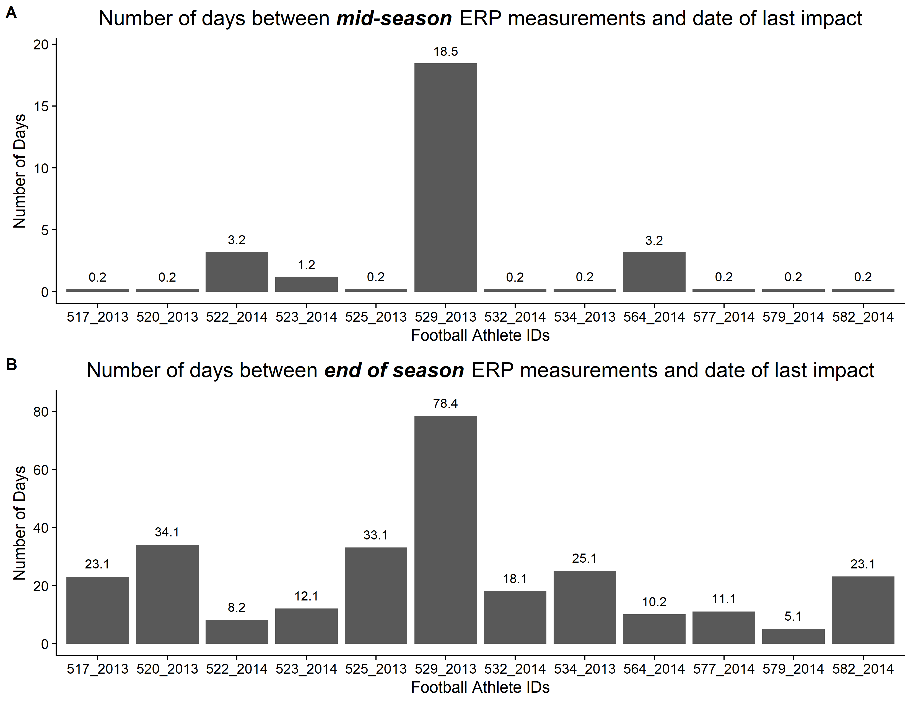

Figure 1

**Figure 1 All figures should have a short figure heading highlighted in bold font.** (**A**)Panel labels should be in bold font in the legend. (**B**) In the figure itself, panels should be arranged reading *left* to *right*, *top* to *bottom*. Please check figures for colourblind compatibility. Some helpful advice on choosing an appropriate palette and testing your images using Vischeck and ImageJ (both free) can be found at: <http://jfly.iam.u-tokyo.ac.jp/color/>.

**Table 2 Tables should have a short heading in bold font.**

|  |  |  |
| --- | --- | --- |
| **Column 1 heading** | **Column 2 heading** | **Column 3 heading** |
| Column headings should be in bold | Data A | Data B |
| **Subheadings can be merged across columns, in bolda** | | |
| Data | More data | More data* |
| Data | More data | More data |
| Data | More datab | More data* |

Tables should be in an editable format, with cells clearly marked. Tab separated tables should not be used.

aTable footnotes, if used, should be listed alphabetically.

bThis is another footnote.

\**P* < 0.05. Symbols may be used for statistical values.