

3Ds Team Assignment House Report

Submitted to the Department of Game and Mobile Contents

at Keimyung University, Korea

**Head of Department**: Dr. Joon-Jae Lee

**Project Supervisor**: Cathal McCosker

**Submitted By:** Ludovic – 7019767

Wladimir – 7019844

Olivier – 7020244

**Course ID**: 27895-02

**Date Submitted**: 5 November 2015

Table of Contents

Chapter 1 : Introduction 1

1.1 Background 1

1.2 The task 1

Chapter 2 : Timeplan 2

Chapter 3 : Organisation 4

3.1 Naming 4

3.2 Layer 4

Chapter 4 : Image planes 5

Chapter 5 : Modifiers 6

5.1 Bend 6

5.2 Cloth 6

5.3 Lathe 7

5.4 Mirror 7

5.5 Shell 8

5.6 UVW Map 8

Chapter 6 : Cloned element and instancing objects 9

Chapter 7 : Spline modeling 10

Chapter 8 : Selection sets 11

Chapter 9 : Conclusion 11

Chapter 10 : References 12

List of Figures

Figure 1: Image plane for walls 5

Figure 1: Water tap without bend modifier 6

Figure 2: Water tap with bend modifier 7

List of Tables

Table 1: The timeplan for house project 3

Table 2 : References for this project 12

# Introduction

This chapter will give a brief introduction to this report and what the house project concerns.

## Background

This paper serves as the documentation for the house team assignment in the course 3D Game Authoring Practice, fall semester, 2015. It is meant to be used in conjunction with the submitted 3D model created in 3Ds Max to explain our work.

## The task

The given task for the House team assignment was to create a 3D house model with a set of blueprints to use in order to build the walls and the roof. The house must contain furniture for each room.

The minimum requirements for the 3D models were:

* Named Objects, Materials, Layers, etc.
* Use of Selection Sets.
* Objects must be snapped to other Objects.
* The intelligent use of Referencing or Instancing.
* Spline modeling.
* Use of Image Planes.
* The use of six different Modifiers.
* No “World Space Modifiers”
* The use of Editable Poly.
* Real World Objects.

Furthermore the concepts of clean geometry and edge flow principles were required to be implemented into the model where it seemed reasonable.

# Timeplan

The following table is an overview of the timeplan followed to complete this project (Cf. Table 1).

|  |  |
| --- | --- |
| Date | TasK |
| 28/10 | All Members: Division of work and research for images models. Choice of the naming convention and unit setup.  Ludovic: Table. |
| 29/10 | All Members: Write Rough Document.  Ludovic: Creation of image plan and modeling material. Start of walls.  Wladimir: Start furniture of the kitchen (spoon, plate).  Olivier: Start of bathroom (toilet). |
| 31/10 | Ludovic: Finished wall and holes for windows and doors. Created pillars.  Olivier: Finished toilet and start shower.  Wladimir: |
| 01/11 | Ludovic: Created doors, cupboard door, ground and placed in the house.  Olivier: Finished shower, start bath and taps.  Wladimir: |
| 02/11 | All members: Update rough document.  Ludovic: Created windows, the door window and placed them in the scene.  Olivier: Finished bath, taps and created bathroom sink.  Wladimir: |
| 03/11 | Ludovic: Created bed, pillow, blanket and nightstand. Placed all of them in the house.  Olivier: Created roof and chimney.  Wladimir: |
| 04/11 | Ludovic: Created light and switch for the bedroom. Started wardrobe and hanger.  Olivier: Created TV, TV support and mirror.  Wladimir: |
| 05/11 | All member: Created first draft of report.  Ludovic: Finished wardrobe and created shoes wardrobe. Merge object in the scene.  Olivier: Created towel (+ support), toilet paper (+ support) and low table in living room. Merge objet in the scene.  Wladimir: |
| 06/11 | All member: Texturing  Ludovic: created lights, desks, books, shelf, desk chair.  Olivier: Created painting, carpet, counter, stool, cocktail glass, iron board.  Wladimir: |

Table 1: The timeplan for house project

# Organisation

This chapter covers the main convention used to name all objects and materials in this project.

## Naming

All objects, materials and maps have been named in this project, following the same main convention LocationInHouse_Object_Location.

An example will be used to explain the main convention. All kitchen’s objects used the prefix “Kitchen_”, after the name of the object. If the name of the part is not in one world, they will be separated by a “_”. The incremental naming can be used. Moreover, if a location is needed, the suffix “_Location” was used.

The objects which have the modifiers have the suffix “Modifier”.

The objects which used a spline have their model copy with the suffix “Spline” (and are placed in the closets).

All materials used in the project have the prefix “MAT_” applied and all textures have the prefix “MAP_”.

## Layer

We decided to use one layer for each type of object:

* + - Light: contains all light objects in the house.
    - Opening: contains all windows and doors.
    - Roof: contains the roof of the house, to allow to see the house without the roof.
    - Wall.
    - Electrical: contains all electrical objects, like television, domestics electrical, etc.
    - Furniture: contains all furniture objects in the house. For example, beds, tables, chairs, spoons, etc.
    - Plumbing: contains all plumbing stuff in the house as toilet, shower, sink, etc.

## Work organization

In order to be well organized, we created a git depot where we committed our objects every time we created one. Then, we merged this object in our house scene.

According to the research, we looked for few things on internet and on 3ds Max like the “Flat mirror Material”, the “Sub Objects Material”, some modifiers (UVW Map, Shell).

We would use the Material modifier but after research, we have seen we just have to create a sub-material, put materials needed in the sub material and choose id in the polygon material IDs roll out if editable poly.

# Image planes

Image planes are used for have a reference for the objects we have created, for example we have used image plan to create wall and roof with the good dimension and aspect. Or we have used for the hanger.

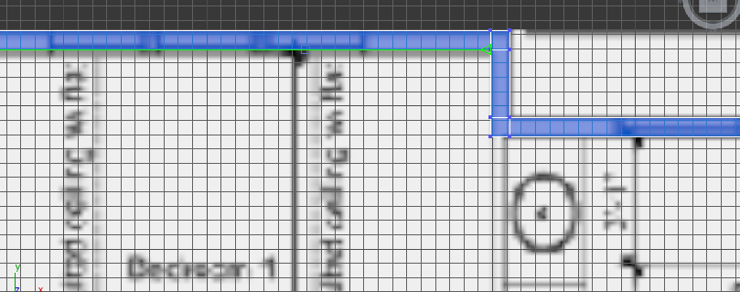

Figure 1: Image plane for walls

We have used image planes just as reference, we haven’t used image planes as a perfect reference for our models.

# Modifiers

## Bend

The bend modifier allows you to bend the object with two parameters, the direction (x, y and z axis) and the angle (in degree). It has been used on the different taps that we can find in our scene in the bathrooms and the kitchen (Bathroom_Sink, Kitchen_Sink, Garage_Sink_Modifier) in order to give to the tap a more realistic and modern effect. In the figure X, the tap is showed as a simple box with the bend modifier. In the figure X, the tap is showed after the bend modifier, in its final version.

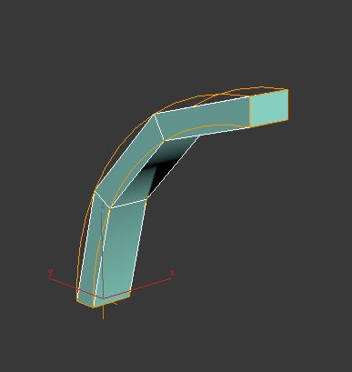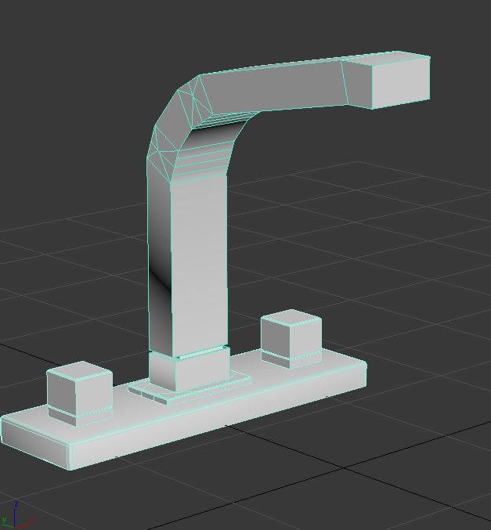

## Cloth

The cloth modifier allows you to give on a selected object a simulation of what it looks like when he collides with a selected object during a time lapse. It has been used on the “Bathroom_Towel” in order to give it a more realistic effect of what looks like a towel hanging on a support. In the figure X, the towel has not been modified and looks like an unfolded towel. In the figure X, the towel has been modified with the cloth modifier.

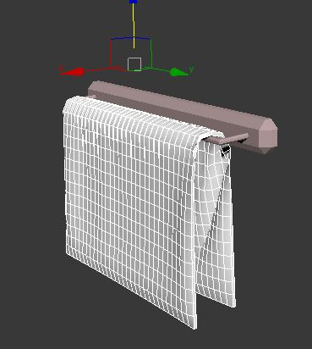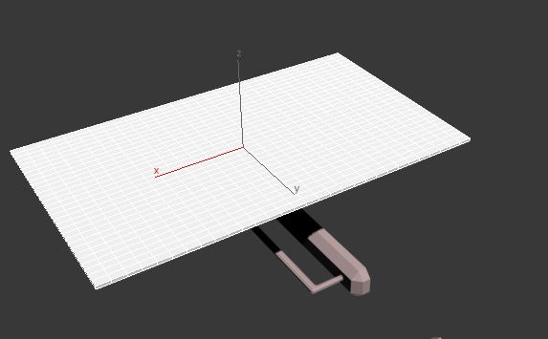

## Lathe

The lathe modifier allows you to create a 3D object by rotating a spline around an axis. It has been used to create on the “Kitchen_Plate” in order to make this object in a better a faster way than usual. In the figure X, the spline has not been modified. In the figure X, the spline has been modified and turned into a plate.

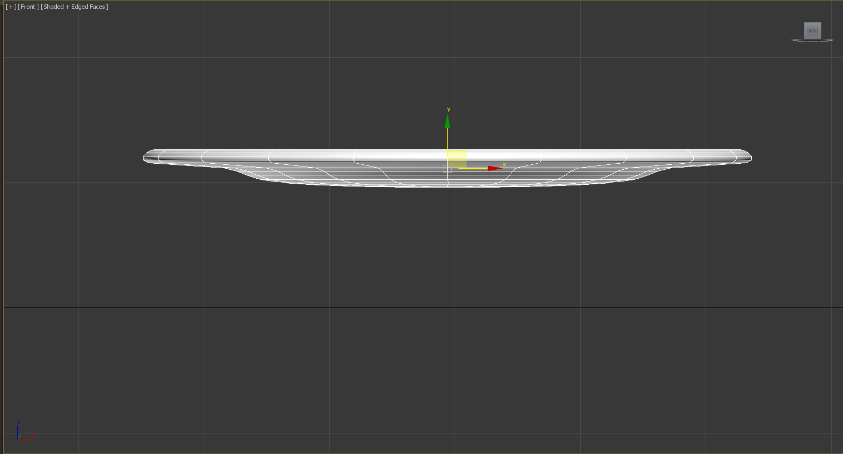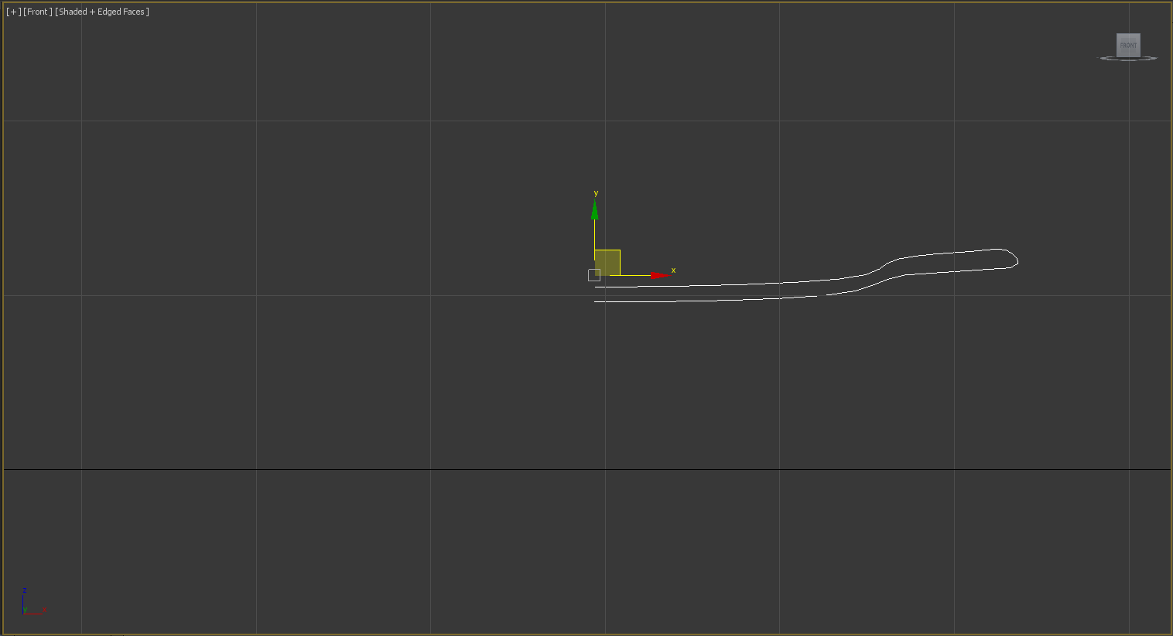

## Mirror

The mirror modifier creates an exact copy of the object on which you apply this modifier but looks like as reflected as in a mirror. It has been used to create the fridge because we decided to make an American style fridge with two doors and this modifier was helpful in order to create our fridge. In the figure X, the fridge has not been copied with the mirror modifier and has only one door. In the figure X, the fridge has been modified and has its second door.

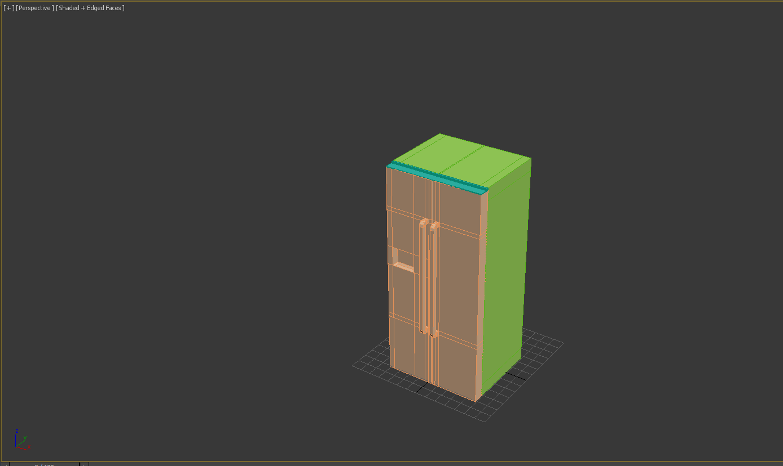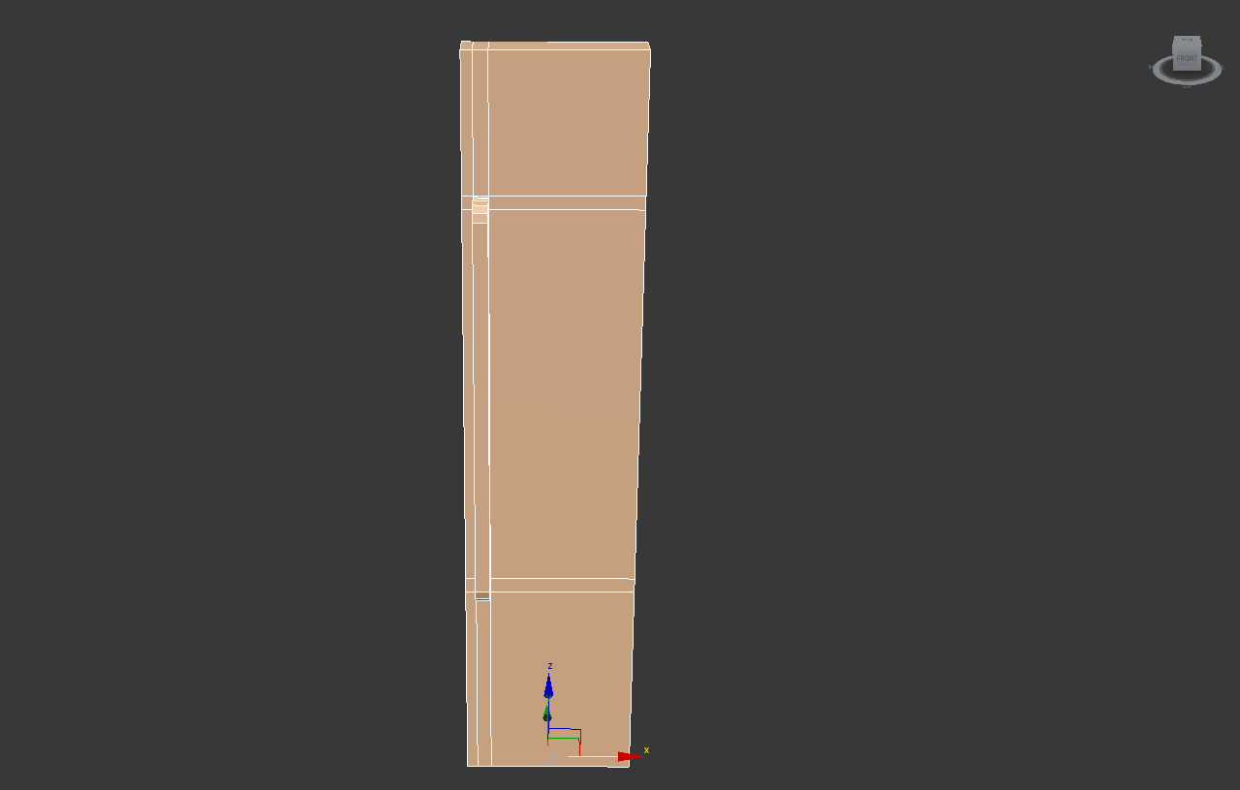

## Shell

The shell modifier allows you to close all the edges and add thickness to your object when it contains opened edges. It has been used on the pan in order to make the large central hole in an easier and faster way. In the figure X, the pan has not been modified with the shell modifier. In the figure X, the pan has been modified with the shell modifier and appears in his last final version.

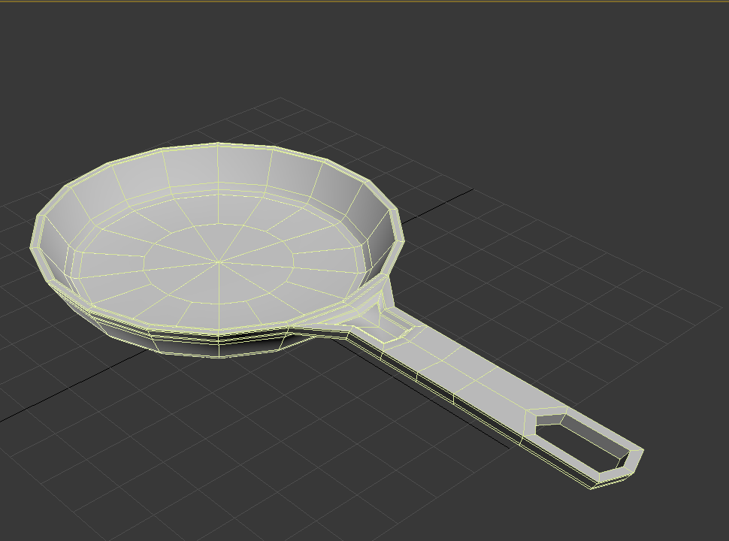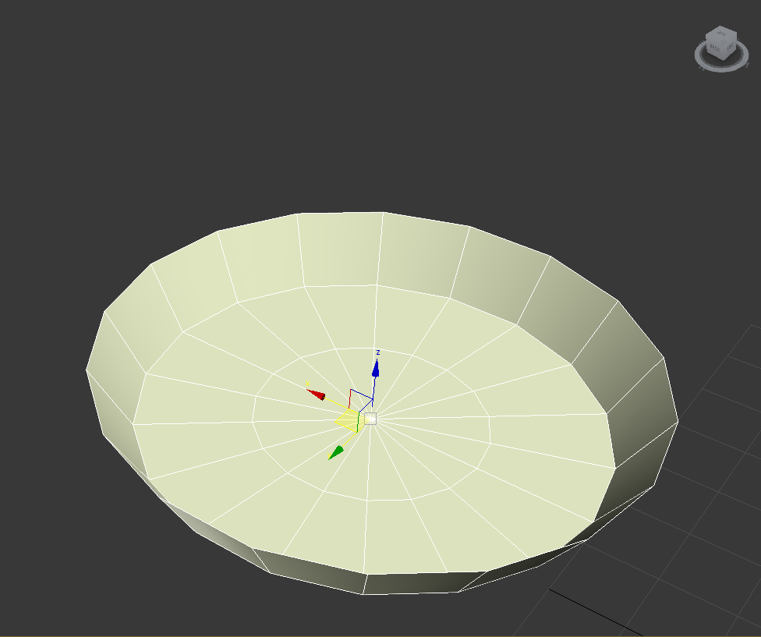

## UVW Map

The UVW Map modifier allows you to apply a texture correctly on a multiple surface without deforming the texture (by default) and in multiple ways. It has been used on the button of the “Washing_Machine” in order to make a better textured button than using the basic material way. In the figure X, the button has not been modified. In the figure X, the button has been modified and is well textured.

## 

## TurboSmooth

The TurboSmooth modifier allows to you to add details on the selected object and smoothing the object. It has been used on the button of the “Kitchen_Gas_Cooker” in order to give it a more realistic effect of what looks like a button. In the figure X, the button has not been modified. In the figure X, the button has been “TurboSmoothed”.

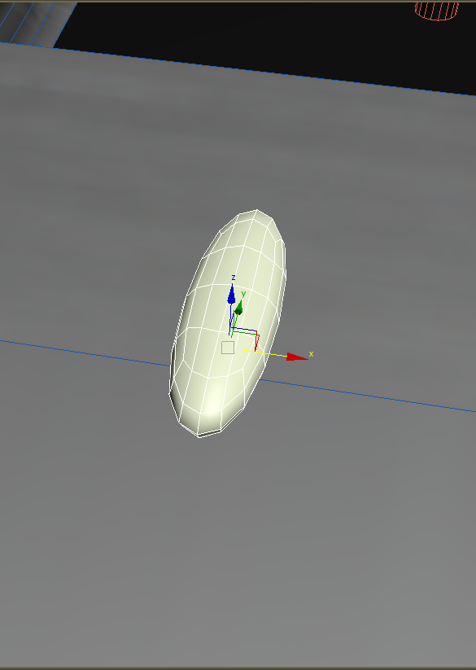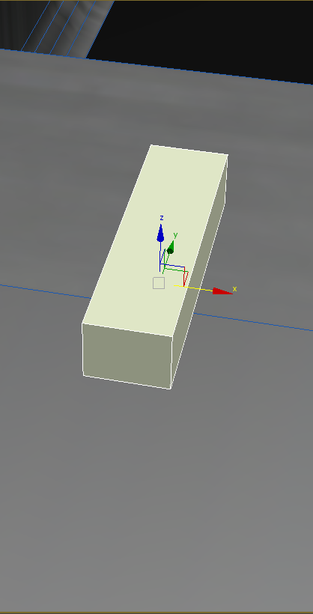

# Cloned element and instancing objects

**Instance**: duplicate the object with instance allows the modeller to modify the instance and the original object at the same time. Add modifier on the instance will also modify the original object.

For example, we have used instance on the “Bedroom_Bed” because if we wanted to modify all the beds by modifying just one.

**Reference**: duplicate the object with reference allows the modeller to modify the Reference and the original object at the same time. Add modifier on the Reference will also modify the original object if the modifier is place under the line in grey in the stack modifier. That is to say if the modifier is place above this line, only the reference will be affect by the modifier. Add a modifier on the original object will always modify the reference object.

For example, we have used reference on “Bathroom_Mirror_Modifier to give it a bend effect in order to make it different than the other mirrors and to allow us to still have the possibility to change all the mirrors if we want to.

# Spline modeling

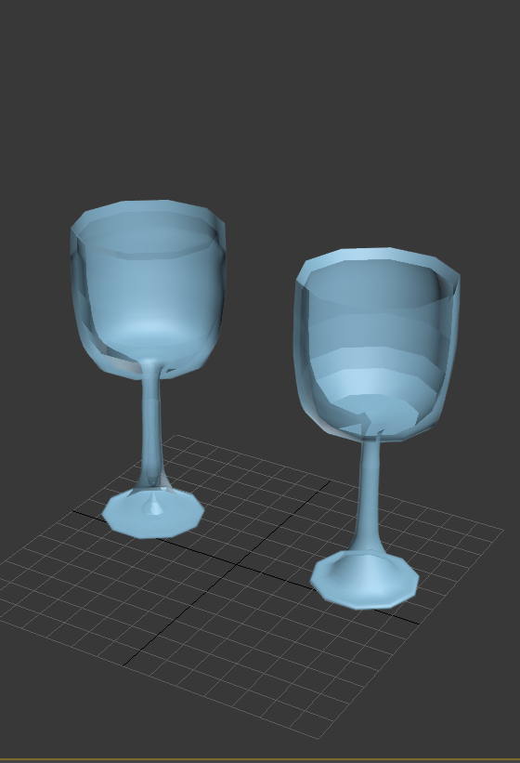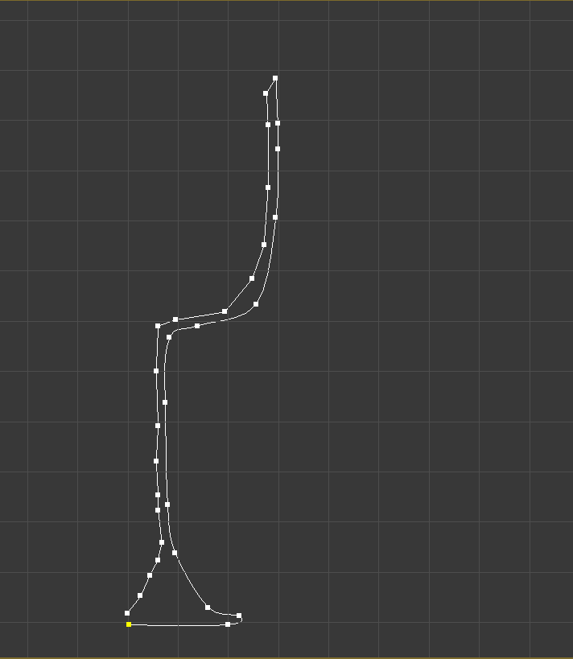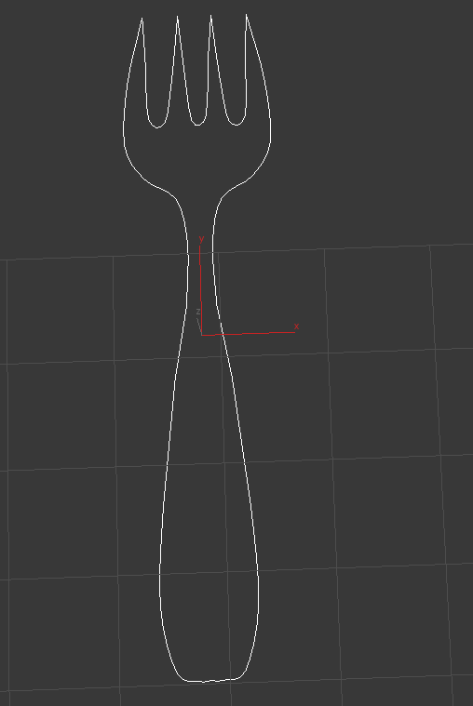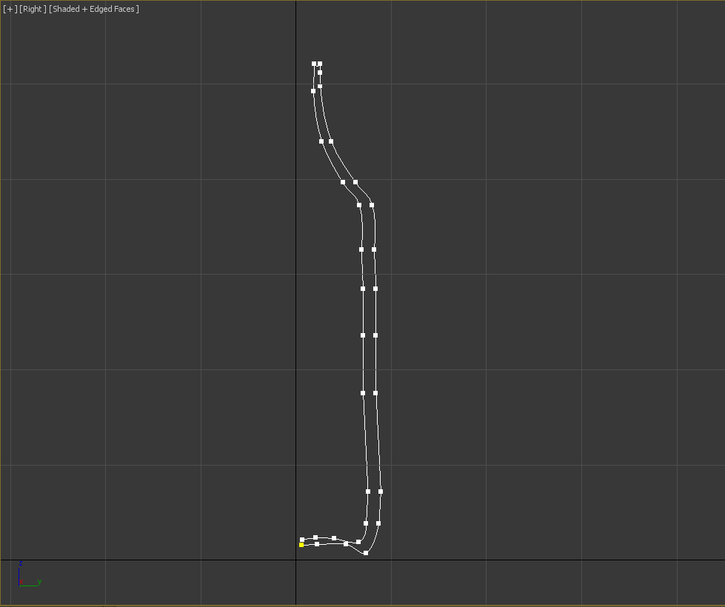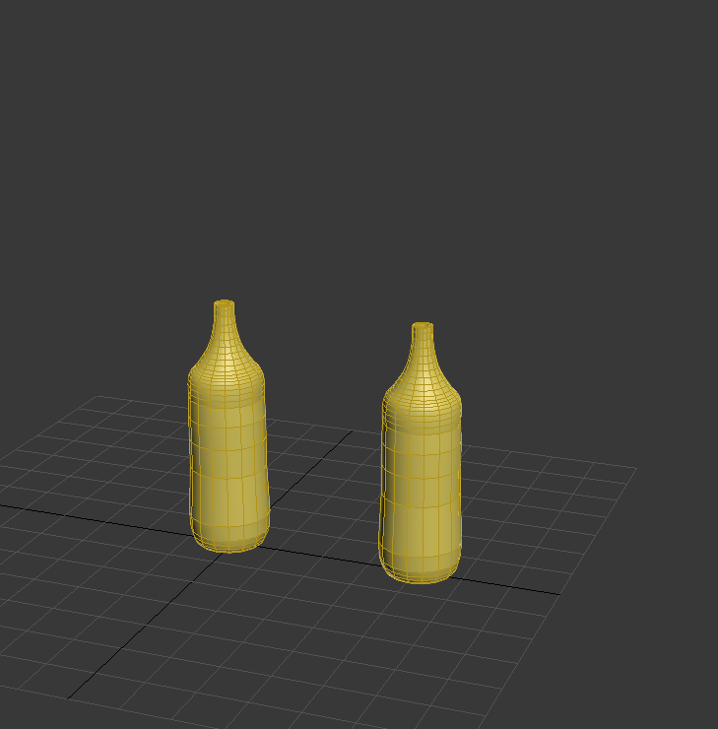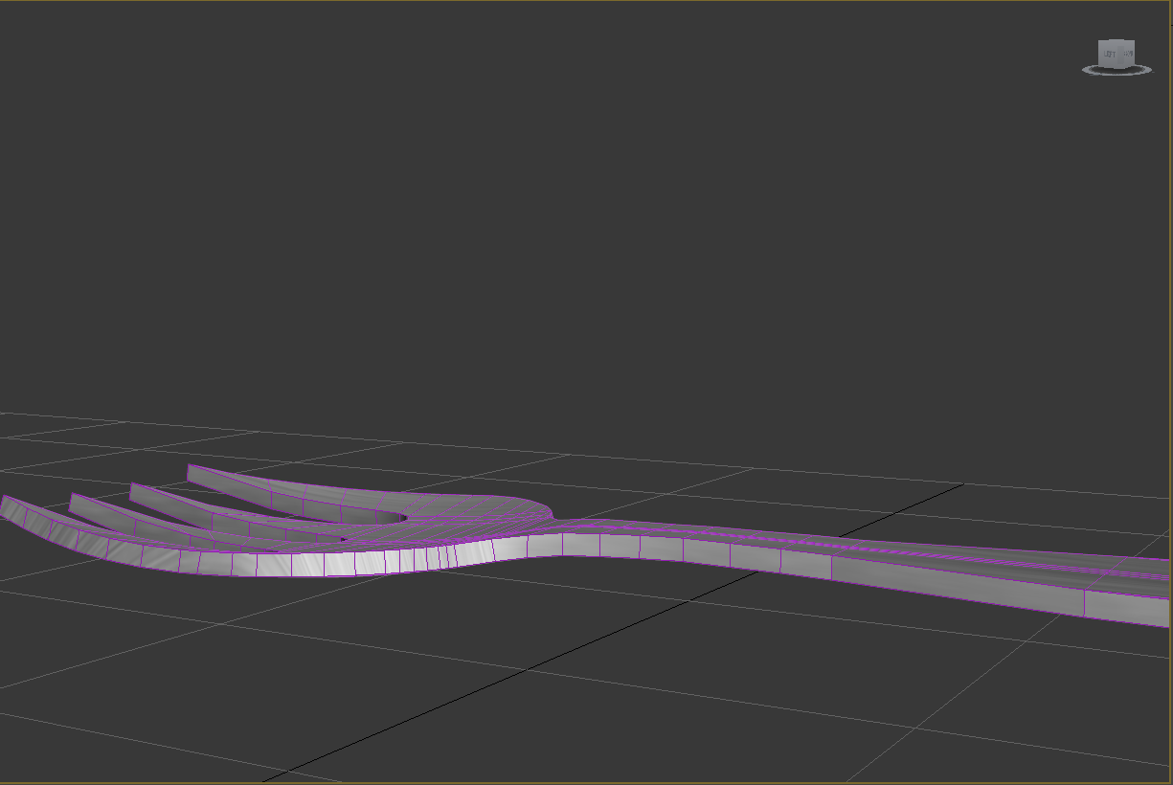Spline modeling allows you to draw 2D shape. We have used it forbottle, fork and glass. For particular models, it’s easier to draw before the shape and after make into a 3D object.

# Selection sets

Selection sets allows you to create personal selection. For example, with the table and the chairs, if you want move all the objects in the same time you can create a useful selection with all this objects.

# Conclusion

The final 3D model created can be seen in the following “” The model fulfils all the requirements stated in Section 1.2 on page 1.

# References

The following table is all the references we used to complete this project (Cf. Table 2).

|  |  |  |
| --- | --- | --- |
| Object | AUTHOR | url |
|  |  |  |
|  |  |  |
|  |  |  |
|  |  |  |
|  |  |  |
|  |  |  |
|  |  |  |
|  |  |  |
|  |  |  |

Table 2 : References for this project