**Figure S1.** Cladogram for Neognathae, which includes 129 of the 164 species used in this study. The branch calibration and the basal relationships up to the family level follow the classification of Hackett et al. (2008) based on nuclear DNA sequences of 19 independent loci. Scale bar indicates substitutions per site. For those families with more than two species, internal relationships were solved with specific references: Accipitridae (Lerner and Mindell 2005), Alcedinidae (Luczon et al. 2010), Alcidae (Pereira and Baker 2008), Anatidae (Donne-Goussé et al. 2002), Charadriidae (Ericson et al. 2003), Columbidae (Johnson and Clayton 2000), Cuculidae (Hughes 2000), Fringillidae (Barker et al. 2004), Hirundinidae (Sheldon et al. 2005), Laridae (Pons et al. 2005), Motacillidae (Voelker and Edwards 1998), Picidae (Benz et al. 2006), Procellaridae (Kennedy and Page 2002), Psittacidae (Wright et al. 2008), Rallidae (Livezey 1998), Scolopacidae (Thomas 2004), Strigidae (Wink et al. 2009), Turdidae (Sangster et al. 2010).

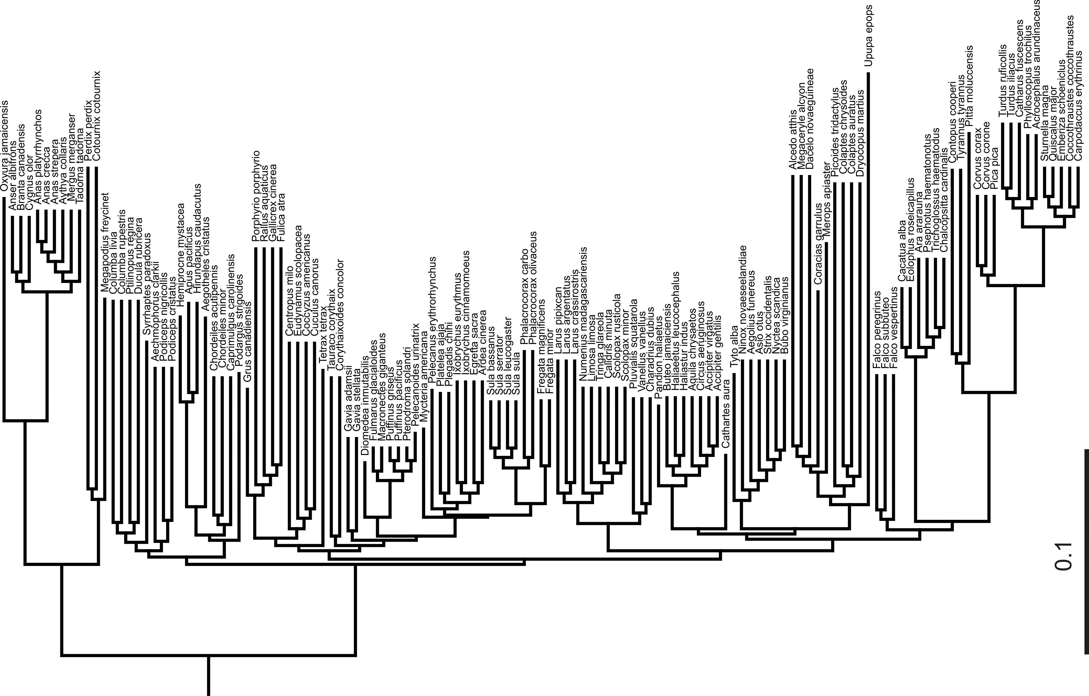

**References of Figure S1**

Barker, F. K., A. Cibois, P. Schikler, J. Feinstein, and J. Cracraft. 2004. Phylogeny and diversification of the largest avian radiation. Proc. Natl. Acad. Sci. USA 101(30):11040-11045.

Benz, B. W., M. B. Robbins, and A. T. Peterson. 2006. Evolutionary history of woodpeckers and allies (Aves: Picidae): Placing key taxa on the phylogenetic tree. Mol. Phylogenet. Evol. 40:389-399.

Donne-Goussé, C., V. Laudet, and C. Hanni. 2002. A molecular phylogeny of anseriformes based on mitochondrial DNA analysis. Mol. Phylogenet. Evol. 23:339-356.

Ericson, P. G., I. Envall1, M. Irestedt, and J. A. Norman. 2003.Inter-familial relationships of the shorebirds (Aves: Charadriiformes) based on nuclear DNA sequence data. BMC Evol. Biol. 3:16.

Hackett, S., R. Kimball, S. Reddy, R. Bowie, E. Braun, M. Braun, J. Chojnowski, W. Cox, K. Han, J. Harshman, C. Huddleston, B. Marks, K. Miglia, W. Moore, F. Sheldon, D. Steadman, C. Witt, and T. Yuri. 2008. A Phylogenomic study of birds reveals their evolutionary history. Science 320:1763-67.

Hughes, J. M. 2000. Monophyly and phylogeny of cuckoos (Aves, Cuculidae) inferred from osteological characters. Zool. J. Linn. Soc. 130:263-307.

Johnson, K. P., and D. H. Clayton. 2000. Nuclear and Mitochondrial Genes Contain Similar Phylogenetic Signal for Pigeons and Doves (Aves: Columbiformes). Mol. Phylogenet. Evol. 14(1):141-151.

Kennedy, M., and R. M. Page. 2002. Seabird supertrees: Combining partial estimates of Procellariiform phylogeny. The Auk 119(1):88-108.

Lerner, H. R. L., and D. P. Mindell. 2005. Phylogeny of eagles, Old World vultures, and other Accipitridae based on nuclear and mitochondrial DNA. Mol. Phylogenet. Evol. 37:327-346.

Livezey, B. C. 1998. A phylogenetic analysis of the Gruiformes (Aves) based on morphological characters, with an emphasis on the rails (Rallidae). Phil.Trans. R. Soc. Lond. B 353:2077-2151.

Luczon, A. U., A. H. Mohammad Isa, J. P. Quilang, P. S. Ong, I. K. Fontanilla. 2010. DNA barcoding of the White-Collared Kingfisher Todiramphus chloris (Boddaert1783) (Alcedinidae) using the mitochondrial cytochrome c oxidase subunit I gene. Philippine Science Letters 3(2):74-77.

Pereira, S. L., and A. J. Baker. 2008. DNA evidence for a Paleocene origin of the Alcidae (Aves: Charadriiformes) in the Pacific and multiple dispersals across northern oceans. Mol. Phylogenet. Evol. 46:430-445.

Pons, J. M., A. Hassanin, and P. A. Crochet. 2005. Phylogenetic relationships within the Laridae (Charadriiformes: Aves) inferred from mitochondrial markers. Mol. Phylogenet. Evol. 37:686–699.

Sangster, G., P. Alström, E. Forsmark, and U. Olsson. 2010. Multi-locus phylogenetic analysis of Old World chats and ﬂycatchers reveals extensive paraphyly at family, subfamily and genus level (Aves: Muscicapidae). Mol. Phylogenet. Evol. 57:380-392.

Sheldon, F. H., L. A. Whittingham, R. G. Moyle, B. Slikas, and D. W. Winkler. 2005. Phylogeny of swallows (Aves: Hirundinidae) estimated from nuclear and mitochondrial DNA sequences. Mol. Phylogenet. Evol. 35:254-270.

Thomas, G. H., M. A. Wills, and T. Székely. 2004. A supertree approach to shorebird phylogeny. BMC Evol. Biol. 4:28.

Voelker, G., and S. V. Edwards. 1998. Can Weighting Improve Bushy Trees? Models of Cytochrome b Evolution and the Molecular Systematics of Pipits and Wagtails (Aves: Motacillidae). Syst. Biol. 47(4):589-603.

Wink, M., and Seibold, I. 1996. Molecular phylogeny of mediterranean raptors (families Accipitridae and Falconidae). Biology and conservation of the Mediterranean raptors, 1994, 335-344.

Wink, M., A. El-Sayed, H. Sauer-Gürth, and J. Gonzalez. 2009. Molecular Phylogeny of Owls (Strigiformes) Inferred from DNA Sequences of the Mitochondrial Cytochrome b and the Nuclear RAG-1 gene. Ardea 97(4):581-591.

Wright, T. F., E. Schirtzinger, T. Matsumoto, J. Eberhard, G. Graves, J. Sanchez, S. Capelli, H. Müller, J. Scharpegge, G. Chambers, and R. C. Fleischer. 2008. A Multilocus Molecular Phylogeny of the Parrots (Psittaciformes): Support for a Gondwanan Origin during the Cretaceous. Mol. Biol. Evol. 25(10):2141–2156.