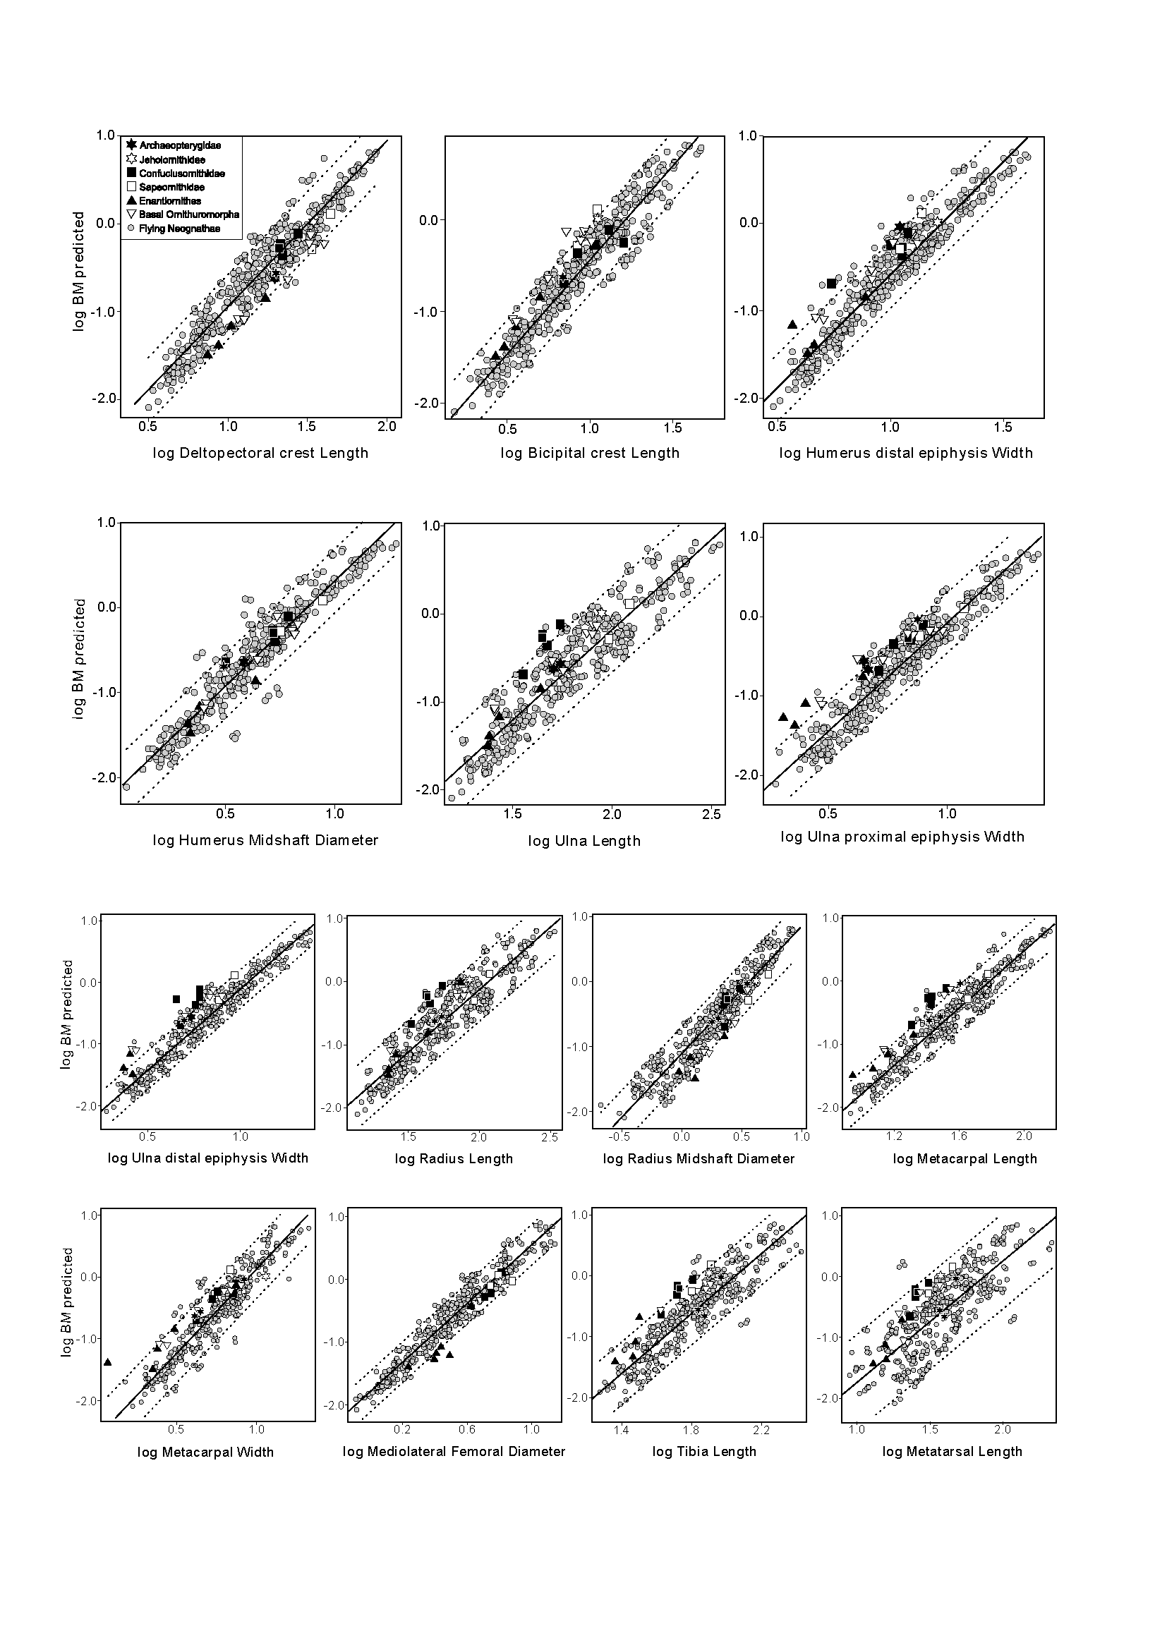**Figure S2.** Biplots used in the procedure for selection of different variables from those represented in Fig. 4. Each predictor variable was plotted against a combination of the remaining variables used for estimating BM (Table S3). Each biplot shows the regression line with the 95% intervals (dotted lines) fitted for extant birds (grey circles).