SUPPLEMENTAL MATERIALS

APPENDICES
Limb Bone Measurements

Institutional abbreviations: AMNH – American Museum of Natural History, New York City, NY, USA; BHM/ BHI – Black Hills Institute, Hill City, SD, USA; BM(NH) – The Natural History Museum, London, UK; BMRP – Burpee Museum Rockford Paleontology, Rockford, IL, USA; BP – Bernard Price Institute for Palaeontological Research, University of the Witwaaterstrand, Johannesburg, South Africa; BS – Bayerische Staatssammlung für Paläontologie und Geologie, Münich, Germany; BYU – Brigham Young University, Provo, UT, USA; CEU – College of Eastern Utah Prehistoric Museum, Price, UT, USA; CM – Cincinnati Museum, Cincinnati, OH, USA; CMNH – Cleveland Museum of Natural History, Cleveland, OH, USA; DMNH – Denver Museum of Nature & Science, Denver, CO, USA; DNM/ DINO – Dinosaur National Monument, Dinosaur, CO, USA; FMNH – Field Museum of Natural History, Chicago, IL, USA; GI – Geological Institute, Section of Palaeontology and Stratigraphy, Academy of Sciences of the Mongolian People’s Republic, Ulaan Bator, Mongolia; HMN – Humbolt Museum für Naturkunde, Berlin, Germany; IGM – Geological Institute, Mongolian Academy of Sciences, Ulaan Bator, Mongolia; IVPP – Institute of Vertebrate Paleontology & Paleoanthropology, Beijing, China; KUVP – University of Kansas Museum of Natural History, Lawrence, KS, USA; MACN – Museo Argentino de Ciencias Naturales, Coleccion Rio Negro, Argentina; MCZ – Harvard University Museum of Comparative Zoology, Cambridge, MA, USA; MLP – Museo de la Plata, Buenos Aires, Argentina; MOR – Museum of the Rockies, Bozeman, MT, USA; MWC – Museum of Western Colorado, Grand Junction, CO, USA; NMC – Canadian Museum of Nature, Ottawa, Canada; NMMNH – New Mexico Museum of Natural History, Albuquerque, NM, USA; OMNH – Oklahoma Museum of Natural History, Norman, OK, USA; PIN – Paleontological Institute, Moscow, Russia; PU – Princeton University Museum of Natural History, Princeton, NJ; PVL – Fondación Miguel Lillo, San Miguel de Tucamán, Argentina; PVSJ – Museo Provincial de San Juan, San Juan, Argentina; ROM – Royal Ontario Museum, Toronto, Canada ; RTMP/ TMP – Royal Tyrell Museum of Paleontology, Drumheller, Canada; SDSM – South Dakota School of Mines, Rapid City, SD, USA; SMNS - Palaontologische Abteilung, Staatliches Museum für Naturkund Stuttgart, Stuttgart, Germany; TCM – The Children’s Museum of Indianapolis, Indianapolis, IN, USA; TM – Transvaal Museum, Pretoria, South Africa; TMM – Texas Memorial Museum, Austin, TX, USA; UA – University of Alberta, Edmonton, Canada; UFMNH – University of Florida Museum of Natural History, Gainesville, FL, USA; UUVP – Utah Museum of Natural History, Salt Lake City, UT, USA; WDC – Wyoming Dinosaur Center, Thermopolis, WY, USA; YPM – Yale Peabody Museum, New Haven, CT, USA; Z.Pal – Zoological Institute of Paleobiology, Polish Academy of Sciences, Warsaw, Poland

Appendix A. Femoral measurements and their sources.
Taxon | Specimen | Length | Circumference | Source

Saurischia

Theropoda
Allosaurus fragilis | DNM | 910 | 335 | Madsen (1976)
Allosaurus fragilis | DNM No. D | 905 | 348 | Madsen (1976)
Allosaurus fragilis | UUVP 3694 | 905 | 307 | Madsen (1976)
Allosaurus fragilis | DNM No. C | 880 | 326 | Madsen (1976)
Allosaurus fragilis | UUVP 6000 | 865 | 325 | Madsen (1976)
Allosaurus fragilis | UUVP 1165 | 865 | 295 | Madsen (1976)
Allosaurus fragilis | UUVP 5993 | 800 | 290 | Madsen (1976)
Allosaurus fragilis | Cast | 730 | 276 | Madsen (1976)
Allosaurus fragilis | Cast | 700 | 255 | Madsen (1976)
Allosaurus fragilis | UUVP 5302 | 695 | 252 | Madsen (1976)
Allosaurus fragilis | UUVP 3385 | 660 | 217 | Madsen (1976)
Allosaurus fragilis | UUVP 3980 | 630 | 210 | Madsen (1976)
Allosaurus fragilis | UUVP 30-17 | 605 | 206 | Madsen (1976)
Allosaurus fragilis | UUVP 1364 | 575 | 210 | Madsen (1976)
Allosaurus fragilis | UUVP 5991 | 555 | 184 | Madsen (1976)
Allosaurus fragilis | UUVP 3192 | 545 | 194 | Madsen (1976)
Allosaurus fragilis | UUVP 40-268 | 535 | 174 | Madsen (1976)
Allosaurus fragilis | UUVP 718 | 535 | 179 | Madsen (1976)
Allosaurus fragilis | UUVP 30-743 | 535 | 175 | Madsen (1976)
Allosaurus fragilis | UUVP 30-16 | 535 | 179 | Madsen (1976)
Allosaurus fragilis | UUVP 30-724 | 525 | 165 | Madsen (1976)
Allosaurus fragilis | UUVP 2280 | 505 | 168 | Madsen (1976)
Allosaurus fragilis | UUVP 492 | 480 | 162 | Madsen (1976)
Allosaurus fragilis | UUVP 3164 | 475 | 147 | Madsen (1976)
Allosaurus fragilis | UUVP 30-752 | 465 | 155 | Madsen (1976)
Allosaurus fragilis | UUVP 30-35 | 465 | 147 | Madsen (1976)
Allosaurus fragilis | UUVP 847 | 450 | 142 | Madsen (1976)
Allosaurus fragilis | UUVP 2559 | 435 | 138 | Madsen (1976)
Allosaurus fragilis | UUVP 6023 | 245 | 74 | Madsen (1976)
Allosaurus fragilis | AMNH 257 | 927 | 360 | Chure (Pers. Comm.)
Allosaurus fragilis | AMNH 275 | 919 | 360 | Chure (Pers. Comm.)
Allosaurus fragilis | AMNH 324 | 891 | 332 | Chure (Pers. Comm.)
Allosaurus fragilis | AMNH 680 | 998 | 383.5 | Chure (Pers. Comm.)
Allosaurus fragilis | AMNH 5753 | 923 | 353 | Chure (Pers. Comm.)
Allosaurus fragilis | AMNH 6125 | 868 | 345 | Chure (Pers. Comm.)
Allosaurus fragilis | USNM 2323 | 650 | 230 | Chure (Pers. Comm.)
Allosaurus fragilis | USNM 8423 | 787.5 | 299 | Chure (Pers. Comm.)
Allosaurus fragilis | MCZ 3897 | 428 | 163 | Chure (Pers. Comm.)
Allosaurus fragilis | NMMNH P-26083 | 1030 | 460 | Chure (Pers. Comm.)
Allosaurus fragilis | PU?? | 535.5 | 185 | Chure (Pers. Comm.)
Allosaurus fragilis | DINO 2560 | 875.5 | 330 | Chure (Pers. Comm.)
Allosaurus fragilis | DINO 2963 | 860 | 330 | Chure (Pers. Comm.)
Allosaurus fragilis | DINO 2976 | 883 | 352 | Chure (Pers. Comm.)
Allosaurus fragilis | DINO2975 | 901 | 320 | Chure (Pers. Comm.)
Allosaurus fragilis | YPM 4944 | 526 | 188.5 | Carrano (1998)
Allosaurus fragilis | FMNH PR 25114 | 882 | 338 | Carrano (1998)
Allosaurus fragilis | MOR 693 | 742 | 2745 | Carrano (1998)
Allosaurus fragilis | CM 11844 | 842.5 | 352 | Carrano (1998)
Allosaurus fragilis | AMNH 630 | 1001 | 381 | Carrano (1998)
Daspletosaurus torosus | **AMNH 5438 | 1030 | 390 | Carrano (1998)
Daspletosaurus torosus | FMNH PR 308 | 960 | 382 | Erickson (Pers. Comm.)
Daspletosaurus torosus | UA 11 | 1000 | 415 | Carrano (1998)
Daspletosaurus torosus | FMHN 5336 | 1010 | 370 | Carrano (1998)
Daspletosaurus torosus | NMC 11315 | 665 | 226 | Carrano (1998)
Daspletosaurus torosus | MOR 553e | 912 | 339 | Carrano (1998)
Gallimimus bullatus | G.I. No. DPS 100/11 | 665 | 194.779 | Osmólska et al. (1972)
Gallimimus bullatus | Z. Pal. No. Mg. D-I/1 | 360 | 94.248 | Osmólska et al. (1972)
Gallimimus bullatus | Z. Pal. No. Mg. D-I/94 | 270 | 69.115 | Osmólska et al. (1972)
Gallimimus bullatus | IGM100/12 | 497.5 | 157 | Kobayashi (Pers. Comm.)
Gallimimus bullatus | ?? | 504 | 153 | Christiansen (1999)
Gorgosaurus libratus | RTMP 91.36.500 | 654 | 188 | Christiansen (1999)
Gorgosaurus libratus | RTMP 94.12.602 | 916 | 320 | Erickson (Pers. Comm).
Gorgosaurus libratus | FMNH PR 2211 | 445 | 133 | Current Study
Gorgosaurus libratus | ROM 672 | 795 | 283 | Carrano (1998)
Gorgosaurus libratus | AMNH 5423 | 605 | 195 | Carrano (1998)
Gorgosaurus libratus | AMNH 5458 | 1025 | 357 | Carrano (1998)
Gorgosaurus libratus | NMC 530 | 930 | 394 | Carrano (1998)
Gorgosaurus libratus | RTMP 81.10.01 | 893 | 287 | Christiansen (1999)
Gorgosaurus libratus | NMC 2120 | 1040 | 378 | Carrano (1998)
Gorgosaurus libratus | AMNH 5218 | 885 | 300 | Carrano (1998)
Gorgosaurus libratus | TCM 2001.89.1 | 825 | 270 | Larson (Pers. Comm.)
Gorgosaurus libratus | ROM 1247 | 804.15 | 267 | Carr et al. (2005)
Herrarasaurus ischigualastensis | PVL 2566 | 482 | 169.5 | Carrano (1998)
Herrarasaurus ischigualastensis | PVSJ 373 | 354 | 105.5 | Carrano (1998)
Herrarasaurus ischigualastensis | MACN 18.060 | 280.6 | 93 | Carrano (1998)
Herrarasaurus ischigualastensis | PVL 2054 | 370 | 146 | Carrano (1998)
Herrarasaurus ischigualastensis | MLP 61-VIII-2-3 | 336 | 120 | Carrano (1998)
Tarbosaurus bataar | PIN 551-2 | 970 | 390 | Maleev (1974)
Tarbosaurus bataar |  | 854 | 312 | Christiansen (1999)
Tarbosaurus bataar |  | 771 | 281 | Christiansen (1999)
Tarbosaurus bataar | PIN 552-2 | 560 | 200 | Maleev (1974)
Tarbosaurus bataar | IVPP V4878 | 279 | 82 | Currie (2001)
Troodon formosus | MOR 553s | 302 | 109 | Carrano (1998)
Troodon formosus | MOR 721 | 156.9 | 50.5 | Carrano (1998)
Troodon formosus | MOR 748 | 317 | 89.5 | Carrano (1998)
Troodon formosus | MOR 553s | 233 | 63 | Carrano (1998)
Troodon formosus | MOR 553s | 238 | 59 | Carrano (1998)
Troodon formosus | MOR 553s | 273 | 86 | Carrano (1998)
Troodon formosus | MOR 553s | 218 | 63 | Carrano (1998)
Tyrannosaurus rex | RTMP 81.12.1 | 1289 | 497 | Christiansen (1999)
Tyrannosaurus rex | CM 9780 (AMNH 5027) | 1273 | 540 | Christiansen (1999)
Tyrannosaurus rex | MOR 555 | 1280 | 514 | Farlow et al. (1995)
Tyrannosaurus rex | FMNH PR 2081 | 1345 | 5802 | Erickson (Pers. Comm.)
Tyrannosaurus rex | BHM 3033 | 1321 | 527 | Erickson (Pers. Comm.)
Tyrannosaurus rex | RTMP 81.6.1 | 1200 | 495 | Erickson (Pers. Comm.)
Tyrannosaurus rex | MOR 009 | 1195 | 473 | Carrano (1998)
Tyrannosaurus rex | CM 9380 | 1269 | 555 | Carrano (1998)
Tyrannosaurus rex | MOR 1125 | 1150 | 510 | Larson (Pers. Comm.)
Tyrannosaurus rex | MOR 1128 | 1260 | 580 | Larson (Pers. Comm.)
Tyrannosaurus rex | MOR 980 | 1232 | 483 | Larson (Pers. Comm.)
Tyrannosaurus rex | BHI 6232 | 1180 | 527 | Larson (Pers. Comm.)
Tyrannosaurus rex | BHI 6233 | 1110 | 515 | Larson (Pers. Comm.)
Tyrannosaurus rex | BHI 6230 | 1190 | 494 | Larson (Pers. Comm.)
Tyrannosaurus rex | HK | 1180 | 512 | Larson (Pers. Comm.)
Tyrannosaurus rex | USNM V6183 | 990 | 425 | Larson (Pers. Comm.)
Tyrannosaurus rex | LL.12823 | 1200 | 467 | Larson (Pers. Comm.)
Tyrannosaurus rex | "Sampson" | 1295 | 560 | Larson (Pers. Comm.)
Tyrannosaurus rex | BCT | 1055 | 320 | Larson (Pers. Comm.)
Tyrannosaurus rex | BMRP 2002.4.1 | 720 | 188 | Current Study
Tyrannosaurus rex | AMNH 7755 | 1127 | 499 | Current Study

Sauropodomorpha
Apatosaurus sp. | CM 566 | 330 | 148 | Wilhite (2003)
Apatosaurus sp. | CM 33976 | 725 | 288 | Wilhite (2003)
Apatosaurus sp. | P25112 | 1810 | 805 | Wilhite (2003)
Apatosaurus sp. | OMNH 1667 | 1730 | 766 | Wilhite (2003)
Apatosaurus sp. | KUVP 1351 | 1777 | 795 | Wilhite (2003)
Apatosaurus sp. | BS 157 | 1387 | 600 | Wilhite (2003)
Apatosaurus sp. | CMNH 10039 | 1071 | 513 | Wilhite (2003)
Apatosaurus sp. | USNM 4797 | 1803 | 810 | Wilhite (2003)
Apatosaurus sp. | BYU 601-17103 | 819 | 349 | Wilhite (2003)
Apatosaurus sp. | YPM 5862 | 759 | 310 | Wilhite (2003)
Apatosaurus sp. | BYU 601 | 1665 | 725 | Wilhite (2003)
Apatosaurus sp. | WDC Bsaptocast | 1490 | 666 | Wilhite (2003)
Camarasaurus sp. | KUVP 1407 | 1430 | 700 | Wilhite (2003)
Camarasaurus sp. | YPM 5851 | 730 | 336 | Wilhite (2003)
Camarasaurus sp. | CM 5723 (cast) | 1167 | 524 | Wilhite (2003)
Camarasaurus sp. | USNM 13786 | 974 | 492 | Wilhite (2003)
Camarasaurus sp. | "Hump" | 1491 | 679 | Wilhite (2003)
Camarasaurus sp. | CM 2772 | 550 | 226 | Wilhite (2003)
Camarasaurus sp. | YPM 1910 | 747 | 360 | Wilhite (2003)
Camarasaurus sp. | CM 11338 | 591 | 298 | Wilhite (2003)
Camarasaurus sp. | CM 11393 | 1566 | 682 | Wilhite (2003)
Camarasaurus sp. | DNM 2941 | 324 | 157 | Wilhite (2003)
Camarasaurus sp. | UUVP No. # | 1190 | 624 | Wilhite (2003)
Camarasaurus sp. | AMNH 911 | 557 | 224 | Wilhite (2003)
Camarasaurus sp. | AMNH 461 | 1007 | 445 | Wilhite (2003)
Camarasaurus sp. | AMNH 895 | 948 | 377 | Wilhite (2003)
Camarasaurus sp. | AMNH 918 | 953 | 405 | Wilhite (2003)
Camarasaurus sp. | AMNH 945 | 700 | 328 | Wilhite (2003)
Camarasaurus sp. | OMNH 1794 | 600 | 278 | Wilhite (2003)
Camarasaurus sp. | BYU 725 12600 | 1177 | 480 | Wilhite (2003)
Camarasaurus sp. | BYU 725 12173 | 1200 | 543 | Wilhite (2003)
Camarasaurus sp. | MWC 623 | 1410 | 617 | Wilhite (2003)
Camarasaurus sp. | BS 13 | 1490 | 659 | Wilhite (2003)
Camarasaurus sp. | Thermopolis no # | 1370 | 667 | Wilhite (2003)
Camarasaurus sp. | BYU 725-12164 | 1423 | 584 | Wilhite (2003)
Camarasaurus sp. | BYU 725-17104 | 1490 | 631 | Wilhite (2003)
Camarasaurus sp. | BYU 725-13689 | 540 | 239 | Wilhite (2003)
Camarasaurus sp. | WDC BS157 | 1402 | 628 | Wilhite (2003)
Camarasaurus sp. | BYU 610-12006 | 1165 | 550 | Wilhite (2003)
Diplodocus sp. | USNM 10865 | 1545 | 564 | Wilhite (2003)
Diplodocus sp. | AMNH 5855 | 1125 | 405 | Wilhite (2003)
Diplodocus sp. | TMM993-1 | 1485 | 551 | Wilhite (2003)
Diplodocus sp. | BB 761 | 1255 | 451 | Wilhite (2003)
Diplodocus sp. | OMNH 1793 | 610 | 254 | Wilhite (2003)
Diplodocus sp. | BYU 725-4889 | 1121 | 354 | Wilhite (2003)
Diplodocus sp. | BYU 725-11421 | 975 | 354 | Wilhite (2003)
Diplodocus sp. | DNM 3781 | 665 | 243 | Wilhite (2003)
Diplodocus sp. | BB 463 | 950 | 361 | Wilhite (2003)
Diplodocus sp. | AMNH 7539 | 1170 | 455 | Wilhite (2003)
Diplodocus sp. | BYU 725-16610 | 875 | 325 | Wilhite (2003)
Diplodocus sp. | BYU 725-13670 | 1105 | 365 | Wilhite (2003)
Diplodocus sp. | BYU 725-16569 | 467 | 162 | Wilhite (2003)
Diplodocus sp. | BYU Fe-4-DM/97 | 1320 | 490 | Wilhite (2003)
Diplodocus sp. | BYU 725-13643 | 1136 | 385 | Wilhite (2003)
Diplodocus sp. | BYU 725-16937 | 1253 | 456 | Wilhite (2003)
Diplodocus sp. | BYU 725-9026 | 1246 | 377 | Wilhite (2003)
Diplodocus sp. | BYU 725field#fe-5-dm/72 | 1355 | 435 | Wilhite (2003)
Diplodocus sp. | BYU 725-13369 | 1365 | 513 | Wilhite (2003)
Diplodocus sp. | AMNH 435 | 1058 | 458 | Wilhite (2003)
Diplodocus sp. | AMNH 7539 | 1178 | 458 | Wilhite (2003)
Diplodocus sp. | BYU 725-12155 | 1345 | 455 | Wilhite (2003)
Diplodocus sp. | MOR 592-35 | 1243 | 405 | Wilhite (2003)
Massospondylus carintaus | BP/1/4751 | 252.3 | 30 | Chinsamy-Turan (Pers. Comm.)
Massospondylus carintaus | BP/1/4777 | 274.2 | 29.4 | Chinsamy-Turan (Pers. Comm.)
Massospondylus carintaus | BP/1/4693 | 284.8 | 39.5 | Chinsamy-Turan (Pers. Comm.)
Massospondylus carintaus | BP/1/4747a | 279.2 | 33.2 | Chinsamy-Turan (Pers. Comm.)
Massospondylus carintaus | BP/1/5241 | 359.7 | 46 | Chinsamy-Turan (Pers. Comm.)
Massospondylus carintaus | BP/1/4747b | 220.2 | 24.2 | Chinsamy-Turan (Pers. Comm.)
Massospondylus carintaus | BP/1/5143 | 259.5 | 27.4 | Chinsamy-Turan (Pers. Comm.)
Massospondylus carintaus | BP/1/5007 | 164.4 | 19.4 | Chinsamy-Turan (Pers. Comm.)
Massospondylus carintaus | BP/1/4267 | 240.4 | 21.3 | Chinsamy-Turan (Pers. Comm.)
Massospondylus carintaus | A.C. 25 | 146.2 | 18.3 | Chinsamy-Turan (Pers. Comm.)
Massospondylus carintaus | BP/1/5253 | 127.5 | 14.3 | Chinsamy-Turan (Pers. Comm.)
Massospondylus carintaus | BP/1/4861 | 409.2 | 53 | Chinsamy-Turan (Pers. Comm.)
Massospondylus carintaus | R1012 | 258.4 | 31.4 | Chinsamy-Turan (Pers. Comm.)
Massospondylus carintaus | BP/1/5108 | 332.2 | 49 | Chinsamy-Turan (Pers. Comm.)
Massospondylus carintaus | BP/1/5133 | 279.2 | 43.5 | Chinsamy-Turan (Pers. Comm.)
Massospondylus carintaus | QR3054 | 443.6 | 63.4 | Chinsamy-Turan (Pers. Comm.)
Riojasaurus incertus | PVL 3808 | 608 | 285 | Carrano (1998)
Riojasaurus incertus | PVL 3805 | 416 | 225.5 | Carrano (1998)
Riojasaurus incertus | PVL 3669 | 589 | 248 | Carrano (1998)
Riojasaurus incertus | UPRL 27 | 495 | 202 | Carrano (1998)
Riojasaurus incertus | UPRL 56 | 427 | 172 | Carrano (1998)
Riojasaurus incertus | PVL 3526 | 461 | 250 | Carrano (1998)
Riojasaurus incertus | PVL 3663 | 337.5 | 124.8 | Carrano (1998)
Riojasaurus incertus | PVL 3662 | 302 | 117 | Carrano (1998)

Ornithischia

Ornithopoda
Dryosaurus lettowvorbecki | BMNH R. 12278 | 330 | 131.5 | Carrano (1998)
Dryosaurus lettowvorbecki | SMNS | 195.2 | 72 | Carrano (1998)
Dryosaurus lettowvorbecki | HMN Wy y18 | 182.1 | 70 | Carrano (1998)
Dryosaurus lettowvorbecki | SMNS | 266 | 99 | Carrano (1998)
Dryosaurus lettowvorbecki | SMNS | 270 | 100 | Carrano (1998)
Dryosaurus lettowvorbecki | SMNS | 280 | 112 | Carrano (1998)
Dryosaurus lettowvorbecki | SMNS | 251 | 88 | Carrano (1998)
Dryosaurus lettowvorbecki | SMNS | 295 | 108 | Carrano (1998)
Dryosaurus lettowvorbecki | SMNS | 294 | 120 | Carrano (1998)
Dryosaurus lettowvorbecki | SMNS | 225 | 86 | Carrano (1998)
Dryosaurus lettowvorbecki | HMN IG | 120 | 46 | Carrano (1998)
Dryosaurus lettowvorbecki | HMN IG | 276 | 108 | Carrano (1998)
Dryosaurus lettowvorbecki | HMN IG | 143 | 55 | Carrano (1998)
Dryosaurus lettowvorbecki | HMN IG (UT 1495/14)* | 204 | 79 | Carrano (1998)
Dryosaurus lettowvorbecki | HMN Jg 962 | 326 | 114.5 | Carrano (1998)
Dryosaurus lettowvorbecki | BMNH R 12777 | 343 | 134 | Carrano (1998)
Dryosaurus lettowvorbecki | BMNH R 12280 | 225 | 84 | Carrano (1998)
Dryosaurus lettowvorbecki | HMN ?Wy 9024 | 177.8 | 70.5 | Carrano (1998)
Dryosaurus lettowvorbecki | HMN | 309 | 124.5 | Carrano (1998)
Dryosaurus lettowvorbecki | HMN Jg 993 | 301 | 110 | Carrano (1998)
Dryosaurus lettowvorbecki | HMN Jg 998 | 294 | 115 | Carrano (1998)
Dryosaurus lettowvorbecki | HMN Jg 986 | 326 | 125 | Carrano (1998)
Dryosaurus lettowvorbecki | HMN Jg 986 | 294 | 114 | Carrano (1998)
Dryosaurus lettowvorbecki | HMN Jg 977 | 308 | 120.5 | Carrano (1998)
Dryosaurus lettowvorbecki | HMN Jg 976 | 227 | 90 | Carrano (1998)
Dryosaurus lettowvorbecki | HMN Jg 979 | 322 | 125 | Carrano (1998)
Dryosaurus lettowvorbecki | HMN Jg 982 (#2?) | 217 | 87.5 | Carrano (1998)
Hypacrosaurus stebingeri | RTMP 87.79.219 | 84 | 40 | Horner & Currie (1994)
Hypacrosaurus stebingeri | RTMP 87.79.265 | 62.5 | 31 | Horner & Currie (1994)
Hypacrosaurus stebingeri | RTMP 87.79.52 | 68 | 34 | Horner & Currie (1994)
Hypacrosaurus stebingeri | MOR 548 F3 | 235 | 100 | Horner & Currie (1994)
Hypacrosaurus stebingeri | MOR 548 F2 | 195 | 84 | Horner & Currie (1994)
Hypacrosaurus stebingeri | MOR 35 | 600 | 250 | Horner & Currie (1994)
Hypacrosaurus stebingeri | MOR 548 F1 | 168 | 75 | Horner & Currie (1994)
Hypacrosaurus stebingeri | MOR 773 | 1190 | 448 | Horner & Currie (1994)
Hypacrosaurus stebingeri | MOR 562 | 80 | 40 | Horner & Currie (1994)
Hypacrosaurus stebingeri | MOR 549 | 1050 | 400 | Horner & Currie (1994)
Hypacrosaurus stebingeri | MOR 559 | 72 | 32 | Horner & Currie (1994)
Hypacrosaurus stebingeri | MOR 553 | 870 | 334 | Horner & Currie (1994)
Maiasaura peeblesorum | YPM PU 22400 | 11.555 | 4.38 | Dilkes (1993)
Maiasaura peeblesorum | YPM PU 22400 | 12.125 | 4.75 | Dilkes (1993)
Maiasaura peeblesorum | YPM PU 22400 | 12.42 | 4.65 | Dilkes (1993)
Maiasaura peeblesorum | YPM PU 22400 | 12.47 | 4.3 | Dilkes (1993)
Maiasaura peeblesorum | YPM PU 22400 | 12.75 | 4.58 | Dilkes (1993)
Maiasaura peeblesorum | YPM PU 22400 | 12.82 | 4.63 | Dilkes (1993)
Maiasaura peeblesorum | YPM PU 22400 | 13.02 | 4.73 | Dilkes (1993)
Maiasaura peeblesorum | YPM PU 22400 | 13.035 | 4.9 | Dilkes (1993)
Maiasaura peeblesorum | YPM PU 22400 | 13.47 | 5.15 | Dilkes (1993)
Maiasaura peeblesorum | MOR 005 | 45.92 | 15.75 | Dilkes (1993)
Maiasaura peeblesorum | MOR 005 | 46.6 | 16 | Dilkes (1993)
Maiasaura peeblesorum | MOR 005 | 47.28 | 16.48 | Dilkes (1993)
Maiasaura peeblesorum | MOR 005 | 47.93 | 16.1 | Dilkes (1993)
Maiasaura peeblesorum | MOR 005 | 48.08 | 15.94 | Dilkes (1993)
Maiasaura peeblesorum | MOR 005 | 49.15 | 17.25 | Dilkes (1993)
Maiasaura peeblesorum | MOR 005 | 49.38 | 16.33 | Dilkes (1993)
Maiasaura peeblesorum | MOR 005 | 51.16 | 18 | Dilkes (1993)
Maiasaura peeblesorum | MOR 005 | 51.594 | 16.51 | Dilkes (1993)
Maiasaura peeblesorum | MOR 005 | 52.46 | 16.14 | Dilkes (1993)
Maiasaura peeblesorum | MOR 005 | 67.628 | 25.9 | Dilkes (1993)
Maiasaura peeblesorum | MOR 005 | 82.08 | 28 | Dilkes (1993)
Maiasaura peeblesorum | MOR 005 | 84 | 28.5 | Dilkes (1993)
Maiasaura peeblesorum | MOR 005 | 93.54 | 31.55 | Dilkes (1993)
Tenontosaurus tilletti | AMNH 3022 | 20.12 | 8.6 | Carrano (1998)
Tenontosaurus tilletti | MCZ 4205 | 38.85 | 15.25 | Carrano (1998)
Tenontosaurus tilletti | AMNH 3031 | 37.2 | 16.8 | Carrano (1998)
Tenontosaurus tilletti | AMNH 3014 | 30.45 | 13.2 | Carrano (1998)
Tenontosaurus tilletti | MOR 682 | 40 | 17 | Carrano (1998)
Tenontosaurus tilletti | AMNH 3012 | 20.7 | 9.1

Stegosauria
Kentrosaurus aethiopicus | HMN St | 622 | 219 | Hennig (1924)
Kentrosaurus aethiopicus | HMN St | 625 | 214 | Hennig (1924)
Kentrosaurus aethiopicus | HMN St | 610 | 230 | Hennig (1924)
Kentrosaurus aethiopicus | HMN St 930 | 465 | 161.5 | Hennig (1924)
Kentrosaurus aethiopicus | HMN St 669 | 618 | 215.5 | Hennig (1924)
Kentrosaurus aethiopicus | HMN St 774 | 632 | 211 | Hennig (1924)
Kentrosaurus aethiopicus | HMN St 812 | 593 | 231 | Hennig (1924)
Kentrosaurus aethiopicus | HMN St | 611 | 261 | Hennig (1924)
Kentrosaurus aethiopicus | SMNS 15693 | 593 | 233 | Hennig (1924)
Kentrosaurus aethiopicus | HMN St 592 | 660 | 234 | Hennig (1924)
Kentrosaurus aethiopicus | HMN St 131 | 532 | 190.5 | Hennig (1924)
Kentrosaurus aethiopicus | HMN (large mount) | 636.5 | 254 | Hennig (1924)
Kentrosaurus aethiopicus | HMN St 471 | 512 | 167 | Hennig (1924)
Kentrosaurus aethiopicus | HMN St 510 | 603 | 244 | Hennig (1924)
Kentrosaurus aethiopicus | HMN St 434 | 539 | 186 | Hennig (1924)
Kentrosaurus aethiopicus | HMN St 2 | 583 | 200 | Hennig (1924)
Kentrosaurus aethiopicus | HMN St 220 | 625 | 225 | Hennig (1924)
Stegosaurus stenops | USNM 4934 | 825 | 313 | Carrano (1998)
Stegosaurus stenops | YPM 1856 | 1090 | 445 | Carrano (1998)
Stegosaurus stenops | AMNH 552 | 840 | 295 | Carrano (1998)
Stegosaurus stenops | YPM 1387 | 1157 | 366 | Carrano (1998)
Stegosaurus stenops | AMNH 956 | 905 | 320 | Carrano (1998)
Stegosaurus stenops | AMNH 21804 | 271 | 104 | Current Study

Ceratopsia
Chasmosaurus mariscalensis | WPA-1 Individual Group 1 | 770 | 325 | Lehman (2007)
Chasmosaurus mariscalensis | WPA-1 Individual Group 2 | 713 | 282 | Lehman (2007)
Chasmosaurus mariscalensis | WPA-1 Individual Group 3 | 700 | 292 | Lehman (2007)
Chasmosaurus mariscalensis | WPA-1 Individual Group 4 | 680 | 275 | Lehman (2007)
Chasmosaurus mariscalensis | WPA-1 Individual Group 5 | 625 | 230 | Lehman (2007)
Chasmosaurus mariscalensis | WPA-1 Individual Group 6 | 595 | 243 | Lehman (2007)
Chasmosaurus mariscalensis | WPA-1 Individual Group 7 | 577 | 205 | Lehman (2007)
Chasmosaurus mariscalensis | WPA-1 Individual Group 8 | 577 | 205 | Lehman (2007)
Chasmosaurus mariscalensis | WPA-1 Individual Group 9 | 561 | 235 | Lehman (2007)
Chasmosaurus mariscalensis | WPA-1 Individual Group 10 | 540 | 235 | Lehman (2007)
Chasmosaurus mariscalensis | WPA-1 Individual Group 11 | 520 | 190 | Lehman (2007)
Chasmosaurus mariscalensis | WPA-1 Individual Group 12 | 490 | 192 | Lehman (2007)
Chasmosaurus mariscalensis | WPA-1 Individual Group 13 | 463 | 164 | Lehman (2007)
Chasmosaurus mariscalensis | WPA-1 Individual Group 14 | 452 | 156 | Lehman (2007)
Chasmosaurus mariscalensis | WPA-1 Individual Group 15 | 424 | 157 | Lehman (2007)
Chasmosaurus mariscalensis | WPA-1 Individual Group 16 | 374 | 145 | Lehman (2007)
Chasmosaurus mariscalensis | WPA-1 Individual Group 17 | 355 | 132 | Lehman (2007)
Chasmosaurus mariscalensis | WPA-1 Individual Group 18 | 285 | 101 | Lehman (2007)
Chasmosaurus mariscalensis | WPA-1 Individual Group 19 | 263 | 92 | Lehman (2007)
Chasmosaurus mariscalensis | WPA-1 Individual Group 20 | 248 | 87 | Lehman (2007)
Chasmosaurus mariscalensis | OMNH 10081 | 770 | 325 | Lehman (2007)
Centrosaurus apertus | TMP 82.18.68 | 450 | 188 | Carrano (1998)
Centrosaurus apertus | TMP 67.20.226 | 285 | 117 | Carrano (1998)
Centrosaurus apertus | TMP PC.79.11.52 | 720 | 3065 | Carrano (1998)
Centrosaurus apertus | YPM 2015 | 787 | 320 | Carrano (1998)
Pachyrhinosaurus sp. | TMP 89.55.362 | 242 | 95 | Carrano (1998)
Pachyrhinosaurus sp. | TMP 89.55.39 | 385 | 156 | Carrano (1998)
Pachyrhinosaurus sp. | TMP 88.55.17 | 362 | 138 | Carrano (1998)
Pachyrhinosaurus sp. | TMP 87.55.5 | 282 | 105 | Carrano (1998)
Pachyrhinosaurus sp. | TMP 87.55.57 | 676 | 264 | Carrano (1998)
Pachyrhinosaurus sp. | TMP 88.55.71 | 463 | 177 | Carrano (1998)
Pachyrhinosaurus sp. | TMP 87.55.225 | 256 | 103 | Carrano (1998)
Pachyrhinosaurus sp. | TMP 87.55.307 | 409 | 137 | Carrano (1998)
Psittacosaurus lujiatunensis | midsize purple | 13.5 | 1.65 | Current Study
Psittacosaurus lujiatunensis | midsize purple&white skull | 15 | 1.6 | Current Study
Psittacosaurus lujiatunensis | midsize white skull | 16.5 | 1.9 | Current Study
Psittacosaurus lujiatunensis | second largest skull (ZMNH XX) | 19 | 2 | Current Study
Psittacosaurus lujiatunensis | largest skull ZMNH spec. | 20 | 2.15 | Current Study

Appendix B. Tibial measurements and their sources.
Taxon | Specimen | Length | Circumference | Source

Saurischia

Theropoda
Allosaurus fragilis | UUVP 6000 | 737.5 | 284 | Madsen (1976)
Allosaurus fragilis | Cast | 711 | 262 | Madsen (1976)
Allosaurus fragilis | Cast | 705 | 241 | Madsen (1976)
Allosaurus fragilis | Cast | 702 | 275 | Madsen (1976)
Allosaurus fragilis | UUVP 10248 | 695 | 267 | Madsen (1976)
Allosaurus fragilis | UUVP 1473 | 637 | 230 | Madsen (1976)
Allosaurus fragilis | UUVP 5300 | 622 | 219 | Madsen (1976)
Allosaurus fragilis | UUVP 40-297 | 612 | 231 | Madsen (1976)
Allosaurus fragilis | UUVP 5361 | 596 | 202 | Madsen (1976)
Allosaurus fragilis | UUVP 5988 | 577 | 195 | Madsen (1976)
Allosaurus fragilis | UUVP 5301 | 567 | 177 | Madsen (1976)
Allosaurus fragilis | Cast | 560 | 226 | Madsen (1976)
Allosaurus fragilis | UUVP 3833 | 553 | 195 | Madsen (1976)
Allosaurus fragilis | UUVP 40-304 | 552 | 183 | Madsen (1976)
Allosaurus fragilis | UUVP 40-301 | 552 | 181 | Madsen (1976)
Allosaurus fragilis | UUVP 5990 | 546 | 191 | Madsen (1976)
Allosaurus fragilis | UUVP 3249 | 543 | 194 | Madsen (1976)
Allosaurus fragilis | UUVP 249 | 542 | 197 | Madsen (1976)
Allosaurus fragilis | UUVP 40-308 | 540 | 205 | Madsen (1976)
Allosaurus fragilis | UUVP 3835 | 540 | 197 | Madsen (1976)
Allosaurus fragilis | UUVP 40-298 | 525 | 182 | Madsen (1976)
Allosaurus fragilis | UUVP 40-306 | 525 | 180 | Madsen (1976)
Allosaurus fragilis | UUVP 30-714 | 500 | 170 | Madsen (1976)
Allosaurus fragilis | Cast | 480 | 149 | Madsen (1976)
Allosaurus fragilis | UUVP 40-768 | 475 | 152 | Madsen (1976)
Allosaurus fragilis | Cast | 468 | 147 | Madsen (1976)
Allosaurus fragilis | UUVP 154 | 410 | 147 | Madsen (1976)
Allosaurus fragilis | UUVP 30-55 | 343 | 97 | Madsen (1976)
Allosaurus fragilis | AMNH 290 | 874 | 325 | Chure (Pers. Comm).
Allosaurus fragilis | AMNH 324 | 714 | 282 | Chure (Pers. Comm).
Allosaurus fragilis | AMNH 408 | 722 | 263 | Chure (Pers. Comm).
Allosaurus fragilis | AMNH 496 | 497 | 202 | Chure (Pers. Comm).
Allosaurus fragilis | AMNH 608 | 856 | 322 | Chure (Pers. Comm).
Allosaurus fragilis | AMNH 5750 | 677 | 245 | Chure (Pers. Comm).
Allosaurus fragilis | AMNH 5753 | 849 | 345 | Chure (Pers. Comm).
Allosaurus fragilis | AMNH 6125 | 785 | 289 | Chure (Pers. Comm).
Allosaurus fragilis | DMNH 2149 | 775 | 290 | Chure (Pers. Comm).
Allosaurus fragilis | MCZ 3897 | 371 | 138 | Chure (Pers. Comm).
Allosaurus fragilis | NMMNH | 903 | 391 | Chure (Pers. Comm).
Allosaurus fragilis | DINO 2560 | 761.5 | 290.5 | Chure (Pers. Comm).
Allosaurus fragilis | DINO 11541 | 651 | 247 | Chure (Pers. Comm).
Allosaurus fragilis | YPM 4944 | 450 | 154 | Carrano (1998)
Allosaurus fragilis | MOR 693 | 706.5 | 238.5 | Carrano (1998)
Allosaurus fragilis | MOR 637 | 734 | 259 | Carrano (1998)
Gallimimus bullatus | G.I. No. DPS 100/11 | 740 | 135 | Osmólska et al. (1972)
Gallimimus bullatus | Z. Pal. No. Mg. D-I/1 | 390 | 78.53 | Osmólska et al. (1972)
Gallimimus bullatus | Z. Pal. No. Mg. D-I/94 | 306 | 56.54 | Osmólska et al. (1972)
Gallimimus bullatus | ?? | 537 | 146 | Christiansen (1999)
Gallimimus bullatus | IGM100/11 | 670 | 200 | Kobayashi (Pers. Comm.)
Gallimimus bullatus | IGM100/11 | 655 | 195 | Kobayashi (Pers. Comm.)
Gallimimus bullatus | IGM100/12 | 490 | 152 | Kobayashi (Pers. Comm.)
Gorgosaurus libratus | ROM 672 | 813 | 231.5 | Carrano (1998)
Gorgosaurus libratus | AMNH 5218 | 785 | 280 | Carrano (1998)
Gorgosaurus libratus | AMNH 5432 | 960 | 304 | Carrano (1998)
Gorgosaurus libratus | FMNH PR 2211 | 505.5 | 127.5 | Current Study
Gorgosaurus libratus | RTMP 91.36.500 | 689 | 191 | Christiansen (1999)
Gorgosaurus libratus | RTMP 81.10.01 | 957 | 251 | Christiansen (1999)
Gorgosaurus libratus | RTMP ? | 987 | 268 | Christiansen (1999)
Gorgosaurus libratus | RTMP ? | 821 | 222 | Christiansen (1999)
Gorgosaurus libratus | FMNH PR 308 | 984 | 264 | Christiansen (1999)
Gorgosaurus libratus | ROM 1247 | 792.2 | 229 | Carr et al. (2005)
Herrerasaurus ischigualastensis | PVL 2566 | 415 | 136 | Carrano (1998)
Herrerasaurus ischigualastensis | PVSI 104 | 373 | 107 | Carrano (1998)
Herrerasaurus ischigualastensis | PVSJ 373 | 318 | 87 | Carrano (1998)
Herrerasaurus ischigualastensis | MACN 18.060 | 259 | 85 | Carrano (1998)
Herrerasaurus ischigualastensis | PVL 2054 | 335 | 107 | Carrano (1998)
Herrerasaurus ischigualastensis | MLP 61-VIII-2-3 | 287 | 93 | Carrano (1998)
Tarbosaurus bataar |  | 799 | 281 | Christiansen (1999)
Tarbosaurus bataar |  | 767 | 261 | Christiansen (1999)
Tarbosaurus bataar | PIN 552-2 | 585 | 120 | Maalev (1974)
Tarbosaurus bataar | PIN 551-2 | 870 | 314.2 | Maalev (1974)
Troodon formosus | MOR 553s | 382 | 85 | Carrano (1998)
Troodon formosus | MOR 553s | 431 | 88 | Carrano (1998)
Troodon formosus | MOR 721 | 224 | 47.5 | Carrano (1998)
Troodon formosus | MOR 748 | 361 | 81.5 | Carrano (1998)
Troodon formosus | MOR 553s | 283 | 59 | Carrano (1998)
Troodon formosus | MOR 553s | 317 | 67 | Carrano (1998)
Troodon formosus | MOR 553s | 361 | 82 | Carrano (1998)
Troodon formosus | MOR 553s | 323 | 68.5 | Carrano (1998)
Tyrannosaurus rex | FMNH PR 2081 | 1255 | 490
Tyrannosaurus rex | RTMP 81.12.1 | 1173 | 435 | Christiansen (1999)
Tyrannosaurus rex | CM 9780 | 1199 | 468 | Christiansen (1999)
Tyrannosaurus rex | MOR 555 | 1180 | 497 | Carrano (1998)
Tyrannosaurus rex | MOR 009 | 1105 | 405 | Carrano (1998)
Tyrannosaurus rex | BHI 3033 | 1075 | 491 | Carrano (1998)
Tyrannosaurus rex | BMRP 2002.4.1 | 840 | 208.28 | Current Study

Sauropodomorpha
Apatosaurus sp. | OMNH 1285 | 206 | 116 | Wilhite (2003)
Apatosaurus sp. | OMNH 1286 | 224 | 114 | Wilhite (2003)
Apatosaurus sp. | YPM 1907 | 205 | 103 | Wilhite (2003)
Apatosaurus sp. | YPM 1980 | 1100 | 475 | Wilhite (2003)
Apatosaurus sp. | CM556 | 845 | 377 | Wilhite (2003)
Apatosaurus sp. | CM 21729 | 767 | 323 | Wilhite (2003)
Apatosaurus sp. | AMNH 271 | 912 | 400 | Wilhite (2003)
Apatosaurus sp. | BYU 681-13326 | 859 | 365 | Wilhite (2003)
Apatosaurus sp. | CMNH 10038 | 930 | 495 | Wilhite (2003)
Apatosaurus sp. | AMNH 514 | 411 | 216 | Wilhite (2003)
Apatosaurus sp. | OMNH 52396 | 189 | 108 | Wilhite (2003)
Apatosaurus sp. | TM 001 | 1068 | 460 | Wilhite (2003)
Apatosaurus sp. | OMNH 1291 | 230 | 114 | Wilhite (2003)
Apatosaurus sp. | OMNH 1668 | 1344 | 561 | Wilhite (2003)
Camarasaurus sp. | YPM 5861 | 523 | 254 | Wilhite (2003)
Camarasaurus sp. | YPM 1905 | 732 | 339 | Wilhite (2003)
Camarasaurus sp. | P25109 | 736 | 343 | Wilhite (2003)
Camarasaurus sp. | CM 11338 | 335 | 180 | Wilhite (2003)
Camarasaurus sp. | CM 21777 | 623 | 270 | Wilhite (2003)
Camarasaurus sp. | CM 21783 | 770 | 376 | Wilhite (2003)
Camarasaurus sp. | YPM 1910 | 438 | 249.5 | Wilhite (2003)
Camarasaurus sp. | DNM 2959 | 627 | 271 | Wilhite (2003)
Camarasaurus sp. | AMNH 925 | 297 | 150 | Wilhite (2003)
Camarasaurus sp. | AMNH 461 | 607 | 289 | Wilhite (2003)
Camarasaurus sp. | YPM 40865 | 799 | 350 | Wilhite (2003)
Camarasaurus sp. | KUVP 129716 | 930 | 436 | Wilhite (2003)
Camarasaurus sp. | BB 94 | 757 | 308 | Wilhite (2003)
Camarasaurus sp. | SDSM 35952 | 694 | 317 | Wilhite (2003)
Camarasaurus sp. | USNM 4920 | 920 | 450 | Wilhite (2003)
Diplodocus sp. | CM 33951 | 1113 | 485 | Wilhite (2003)
Diplodocus sp. | CM 33967 | 612 | 225 | Wilhite (2003)
Diplodocus sp. | AMNH 478 | 1138 | 360 | Wilhite (2003)
Diplodocus sp. | USNM 10865 | 988 | 416 | Wilhite (2003)
Diplodocus sp. | DNM 2561 | 335 | 155 | Wilhite (2003)
Diplodocus sp. | DNM 2921 | 575 | 214 | Wilhite (2003)
Diplodocus sp. | BB 369 | 840 | 325 | Wilhite (2003)
Diplodocus sp. | AMNH 5855 | 795 | 277 | Wilhite (2003)
Diplodocus sp. | AMNH 559 | 920 | 366 | Wilhite (2003)
Diplodocus sp. | AMNH 585 | 1247 | 418 | Wilhite (2003)
Diplodocus sp. | AMNH 251 | 1065 | 385 | Wilhite (2003)
Diplodocus sp. | YPM 18710(AMNH 698) | 1147 | 371 | Wilhite (2003)
Diplodocus sp. | USNM 337844 | 618 | 227 | Wilhite (2003)
Diplodocus sp. | USNM 4730 | 728 | 274 | Wilhite (2003)
Diplodocus sp. | USNM 4727 | 550 | 210 | Wilhite (2003)
Diplodocus sp. | BYU 681-4718 | 713 | 264 | Wilhite (2003)
Diplodocus sp. | MOR 790 7-12-96-12 | 763 | 267 | Wilhite (2003)
Diplodocus sp. | MOR 714 8-17-93-197 | 741 | 267 | Wilhite (2003)
Diplodocus sp. | MOR 714 7-25-92-180 | 553 | 243 | Wilhite (2003)
Diplodocus sp. | BYU-725-9027 | 360 | 155 | Wilhite (2003)
Riojasaurus incertus | PVL 3808 | 520 | 236 | Carrano (1998)
Riojasaurus incertus | UPRL 27 | 415 | 156 | Carrano (1998)
Riojasaurus incertus | UPLR 56 | 315 | 148 | Carrano (1998)
Riojasaurus incertus | PVL 3815 | 321 | 134 | Carrano (1998)
Riojasaurus incertus | PVL 3393 | 321 | 149.5 | Carrano (1998)
Riojasaurus incertus | PVL 3526 | 377.5 | 195 | Carrano (1998)
Riojasaurus incertus | PVL 3663 | 320 | 99 | Carrano (1998)

Ornithischia

Ornithopoda
Dryosaurus lettowvorbecki | SMNS | 14.75 | 4 | Carrano (1998)
Dryosaurus lettowvorbecki | SMNS | 14.59 | 4 | Carrano (1998)
Dryosaurus lettowvorbecki | SMNS | 11.96 | 2.85 | Carrano (1998)
Dryosaurus lettowvorbecki | SMNS | 24 | 6.2 | Carrano (1998)
Dryosaurus lettowvorbecki | HMN M B.R - 1709(Jg 779) | 11.43 | 3 | Carrano (1998)
Dryosaurus lettowvorbecki | HMN Wy 9051 | 11.81 | 3.8 | Carrano (1998)
Dryosaurus lettowvorbecki | HMN Wy 9027 | 16.26 | 4.5 | Carrano (1998)
Dryosaurus lettowvorbecki | SMNS | 20.2 | 5.4 | Carrano (1998)
Dryosaurus lettowvorbecki | SMNS ("#8705?") | 29.8 | 7.8 | Carrano (1998)
Dryosaurus lettowvorbecki | SMNS | 15.96 | 4.8 | Carrano (1998)
Dryosaurus lettowvorbecki | HMN Jg 787 | 26 | 7.7 | Carrano (1998)
Dryosaurus lettowvorbecki | HMN Jg 766 | 31.9 | 8.85 | Carrano (1998)
Dryosaurus lettowvorbecki | BMNH R .12779 | 37 | 10.9 | Carrano (1998)
Dryosaurus lettowvorbecki | HMN?Wy9024 | 17.05 | 4.85 | Carrano (1998)
Dryosaurus lettowvorbecki | HMN Jg 971 | 29.5 | 8 | Carrano (1998)
Dryosaurus lettowvorbecki | HMN Jg 982 (#3?) | 34 | 9.2 | Carrano (1998)
Dryosaurus lettowvorbecki | HMN Jg 982 | 19.08 | 5.8 | Carrano (1998)
Hypacrosaurus stebingeri | RTMP 87.79.115 | 81 | 36 | Horner & Currie (1994)
Hypacrosaurus stebingeri | MOR 548-T2 | 180 | 70 | Horner & Currie (1994)
Hypacrosaurus stebingeri | MOR 546 T1 | 140 | 60 | Horner & Currie (1994)
Hypacrosaurus stebingeri | MOR 355 8-25-2-4 | 1060 | 320 | Horner & Currie (1994)
Hypacrosaurus stebingeri | MOR 335 8 25 5 4 | 600 | 188 | Horner & Currie (1994)
Hypacrosaurus stebingeri | MOR 548 T3 | 220 | 79 | Horner & Currie (1994)
Hypacrosaurus stebingeri | MOR 562 | 80 | 35 | Horner & Currie (1994)
Hypacrosaurus stebingeri | RTMP 87.79.114 | 79 | 34 | Horner & Currie (1994)
Hypacrosaurus stebingeri | RTMP 87.79.1134 | 66 | 24 | Horner & Currie (1994)
Hypacrosaurus stebingeri | MOR 549 | 990 | 342 | Horner & Currie (1994)
Maiasaura peeblesorum | YPM PU 22400 | 11.3 | 3.79 | Dilkes (1993)
Maiasaura peeblesorum | YPM PU 22400 | 11.5 | 3.65 | Dilkes (1993)
Maiasaura peeblesorum | YPM PU 22400 | 11.53 | 3.54 | Dilkes (1993)
Maiasaura peeblesorum | YPM PU 22400 | 11.6 | 3.9 | Dilkes (1993)
Maiasaura peeblesorum | YPM PU 22400 | 11.83 | 3.68 | Dilkes (1993)
Maiasaura peeblesorum | YPM PU 22400 | 11.875 | 3.98 | Dilkes (1993)
Maiasaura peeblesorum | YPM PU 22400 | 11.95 | 3.72 | Dilkes (1993)
Maiasaura peeblesorum | YPM PU 22400 | 12 | 4.08 | Dilkes (1993)
Maiasaura peeblesorum | YPM PU 22400 | 12.3 | 3.97 | Dilkes (1993)
Maiasaura peeblesorum | YPM PU 22400 | 12.4 | 4.02 | Dilkes (1993)
Maiasaura peeblesorum | YPM PU 22400 | 12.9 | 3.95 | Dilkes (1993)
Maiasaura peeblesorum | MOR 005 | 38.748 | 12.63 | Dilkes (1993)
Maiasaura peeblesorum | MOR 005 | 39.55 | 13.4 | Dilkes (1993)
Maiasaura peeblesorum | MOR 005 | 40.92 | 12.64 | Dilkes (1993)
Maiasaura peeblesorum | MOR 005 | 43.475 | 14.5 | Dilkes (1993)
Maiasaura peeblesorum | MOR 005 | 44.18 | 14 | Dilkes (1993)
Maiasaura peeblesorum | MOR 005 | 44.62 | 13.5 | Dilkes (1993)
Maiasaura peeblesorum | MOR 005 | 44.86 | 14 | Dilkes (1993)
Maiasaura peeblesorum | MOR 005 | 45.148 | 13.911 | Dilkes (1993)
Maiasaura peeblesorum | MOR 005 | 45.24 | 13.75 | Dilkes (1993)
Maiasaura peeblesorum | MOR 005 | 45.4 | 14.68 | Dilkes (1993)
Maiasaura peeblesorum | MOR 005 | 45.674 | 13.34 | Dilkes (1993)
Maiasaura peeblesorum | MOR 005 | 45.71 | 14.5 | Dilkes (1993)
Maiasaura peeblesorum | MOR 005 | 45.82 | 14 | Dilkes (1993)
Maiasaura peeblesorum | MOR 005 | 45.83 | 14.22 | Dilkes (1993)
Maiasaura peeblesorum | MOR 005 | 46.43 | 14 | Dilkes (1993)
Maiasaura peeblesorum | MOR 005 | 46.44 | 15.55 | Dilkes (1993)
Maiasaura peeblesorum | MOR 005 | 46.6 | 15.5 | Dilkes (1993)
Maiasaura peeblesorum | MOR 005 | 46.69 | 14.58 | Dilkes (1993)
Maiasaura peeblesorum | MOR 005 | 47.052 | 13.652 | Dilkes (1993)
Maiasaura peeblesorum | MOR 005 | 47.15 | 14.6 | Dilkes (1993)
Maiasaura peeblesorum | MOR 005 | 47.64 | 14.04 | Dilkes (1993)
Maiasaura peeblesorum | MOR 005 | 49.08 | 16.472 | Dilkes (1993)
Maiasaura peeblesorum | MOR 005 | 49.4 | 14.087 | Dilkes (1993)
Maiasaura peeblesorum | MOR 005 | 49.874 | 15.95 | Dilkes (1993)
Maiasaura peeblesorum | MOR 005 | 50.21 | 14.84 | Dilkes (1993)
Maiasaura peeblesorum | MOR 005 | 51.75 | 15.78 | Dilkes (1993)
Maiasaura peeblesorum | MOR 005 | 52.634 | 16.354 | Dilkes (1993)
Maiasaura peeblesorum | MOR 005 | 73.14 | 21.32 | Dilkes (1993)
Maiasaura peeblesorum | MOR 005 | 74.25 | 21.8 | Dilkes (1993)
Maiasaura peeblesorum | MOR 005 | 75.128 | 21.144 | Dilkes (1993)
Maiasaura peeblesorum | MOR 005 | 77.91 | 21.78 | Dilkes (1993)
Maiasaura peeblesorum | MOR 005 | 82.92 | 24 | Dilkes (1993)
Maiasaura peeblesorum | MOR 005 | 89.535 | 29.21 | Dilkes (1993)
Maiasaura peeblesorum | MOR 005 | 93.45 | 31.22 | Dilkes (1993)
Maiasaura peeblesorum | MOR 005 | 98.92 | 30.65 | Dilkes (1993)
Maiasaura peeblesorum | MOR 005 | 101.6 | 31.115 | Dilkes (1993)
Maiasaura peeblesorum | MOR 005 | 104.6 | 30.08 | Dilkes (1993)
Tenontosaurus tilletti | AMNH 3022 | 217 | 71 | Carrano (1998)
Tenontosaurus tilletti | MCZ 4205 | 370.5 | 129 | Carrano (1998)
Tenontosaurus tilletti | AMNH 3031 | 339 | 141 | Carrano (1998)
Tenontosaurus tilletti | AMNH 3014 | 300 | 112.5 | Carrano (1998)
Tenontosaurus tilletti | YPM BB#1 | 373 | 129 | Carrano (1998)
Tenontosaurus tilletti | YPM 5462 | 481 | 203 | Carrano (1998)
Tenontosaurus tilletti | YPM 5459 | 375 | 148 | Carrano (1998)

Stegosauria
Stegosaurus stenops | YPM 1856 | 488 | 253 | Carrano (1998)
Stegosaurus stenops | AMNH 650 | 605 | 279 | Carrano (1998)
Stegosaurus stenops | YPM 1388 | 845 | 294 | Carrano (1998)
Stegosaurus stenops | AMNH 21804 | 162 | 84 | Current Study

Ceratopsia
Centrosaurus apertus | TMP 79.11.33 | 332 | 167 | Carrano (1998)
Centrosaurus apertus | TMP 79.11.56 | 372 | 183 | Carrano (1998)
Centrosaurus apertus | TMP 81.18.199 | 246 | 105 | Carrano (1998)
Centrosaurus apertus | TMP | 360 | 158 | Carrano (1998)
Centrosaurus apertus | TMP 80.18.82 | 285 | 133 | Carrano (1998)
Centrosaurus apertus | TMP 89.18.41 | 250 | 120 | Carrano (1998)
Centrosaurus apertus | YPM 2015 | 540 | 272 | Carrano (1998)

Appendix C. Humeral measurements and their sources.
Taxon | Specimen | Length | Circumference | Source

Sauropodomorpha
Apatosaurus sp. | OMNH 1275 | 257 | 128 | Wilhite (2003)
Apatosaurus sp. | OMNH 1276 | 233 | 141 | Wilhite (2003)
Apatosaurus sp. | OMNH 1277 | 233 | 114 | Wilhite (2003)
Apatosaurus sp. | OMNH 1278 | 254 | 142 | Wilhite (2003)
Apatosaurus sp. | OMNH 2115 | 227 | 116 | Wilhite (2003)
Apatosaurus sp. | CM 21715 | 792 | 460 | Wilhite (2003)
Apatosaurus sp. | CM 566 | 222.5 | 120 | Wilhite (2003)
Apatosaurus sp. | YPM 1981 | 1139 | 580 | Wilhite (2003)
Apatosaurus sp. | CEU 252 | 1080 | 633 | Wilhite (2003)
Apatosaurus sp. | MWC-No # | 608 | 340 | Wilhite (2003)
Apatosaurus sp. | MNH 1278 | 258 | 144 | Wilhite (2003)
Apatosaurus sp. | DSM 25413 | 535 | 312 | Wilhite (2003)
Apatosaurus sp. | FMNH PR | 1106.5 | 394 | Wilhite (2003)
Apatosaurus sp. | AMNH 6114 | 1037 | 578 | Wilhite (2003)
Apatosaurus sp. | USNM 337827 | 275 | 129 | Wilhite (2003)
Apatosaurus sp. | AMNH 711 | 1177 | 488 | Wilhite (2003)
Apatosaurus sp. | "Bertha" | 1055 | 555 | Wilhite (2003)
Apatosaurus sp. | MWC 2548 | 1165 | 578 | Wilhite (2003)
Camarasaurus sp. | YPM 5858 | 525 | 241 | Wilhite (2003)
Camarasaurus sp. | YPM 5859 | 616 | 294 | Wilhite (2003)
Camarasaurus sp. | YPM 1901 | 892 | 398 | Wilhite (2003)
Camarasaurus sp. | YPM 1905 | 865 | 405 | Wilhite (2003)
Camarasaurus sp. | P25182 | 922 | 404 | Wilhite (2003)
Camarasaurus sp. | CM 11338 | 420 | 254 | Wilhite (2003)
Camarasaurus sp. | CM 11393 | 1195 | 500 | Wilhite (2003)
Camarasaurus sp. | USNM 13786 | 804 | 380 | Wilhite (2003)
Camarasaurus sp. | CM 33963 | 508 | 224 | Wilhite (2003)
Camarasaurus sp. | CM 38320 | 1040 | 484 | Wilhite (2003)
Camarasaurus sp. | CM 21781 | 792 | 404 | Wilhite (2003)
Camarasaurus sp. | YPM 1910 | 516.5 | 271 | Wilhite (2003)
Camarasaurus sp. | CM 21772 | 550 | 226 | Wilhite (2003)
Camarasaurus sp. | AMNH 664 | 773 | 350 | Wilhite (2003)
Camarasaurus sp. | AMNH 913 | 348 | 172 | Wilhite (2003)
Camarasaurus sp. | AMNH 823 | 765 | 350 | Wilhite (2003)
Camarasaurus sp. | AMNH 332 | 786 | 368 | Wilhite (2003)
Camarasaurus sp. | YPM 6221 | 739 | 335 | Wilhite (2003)
Camarasaurus sp. | YPM (acc# 1111) | 930 | 448 | Wilhite (2003)
Camarasaurus sp. | OMNH 1277 | 238 | 114 | Wilhite (2003)
Camarasaurus sp. | OMNH 2115 | 227 | 117 | Wilhite (2003)
Camarasaurus sp. | OMNH 2113 | 1204 | 557 | Wilhite (2003)
Camarasaurus sp. | UUVP 3927 | 990 | 500 | Wilhite (2003)
Camarasaurus sp. | MWC 2842 | 1183 | 517 | Wilhite (2003)
Camarasaurus sp. | KUVP 129716 | 1119 | 535 | Wilhite (2003)
Camarasaurus sp. | BB rt. Hum. Cast | 592 | 290 | Wilhite (2003)
Camarasaurus sp. | BS 1561 | 1037 | 509 | Wilhite (2003)
Camarasaurus sp. | Jensen/ Jensen | 1296 | 620 | Wilhite (2003)
Camarasaurus sp. | USNM 481085 | 910 | 367 | Wilhite (2003)
Camarasaurus sp. | CFLCM 171 (cast) | 1015 | 479 | Wilhite (2003)
Camarasaurus sp. | UUVP 5109 (rest) | 990 | 426 | Wilhite (2003)
Camarasaurus sp. | UFMNH - Red | 1062 | 560 | Wilhite (2003)
Riojasaurus incertus | PVL 3808 | 482 | 229 | Carrano (1998)
Riojasaurus incertus | UPLR 56 | 290 | 110 | Carrano (1998)
Riojasaurus incertus | PVL 3815 | 278.5 | 100 | Carrano (1998)
Riojasaurus incertus | PVL 3393 | 292 | 135 | Carrano (1998)
Riojasaurus incertus | PVL 3663 | 257 | 95 | Carrano (1998)
Riojasaurus incertus | PVL 3662 | 252 | 84.5 | Carrano (1998)
Riojasaurus incertus | PVL 3533 | 365 | 173 | Carrano (1998)

Ornithischia

Ornithopoda
Maiasaura peeblesorum | YPM-PU 22400 | 7.01 | 2.88 | Dilkes (1993)
Maiasaura peeblesorum | YPM-PU 22400 | 7.17 | 2.77 | Dilkes (1993)
Maiasaura peeblesorum | YPM-PU 22400 | 7.19 | 2.67 | Dilkes (1993)
Maiasaura peeblesorum | YPM-PU 22400 | 7.41 | 2.69 | Dilkes (1993)
Maiasaura peeblesorum | YPM-PU 22400 | 7.47 | 2.68 | Dilkes (1993)
Maiasaura peeblesorum | YPM-PU 22400 | 7.56 | 2.88 | Dilkes (1993)
Maiasaura peeblesorum | YPM-PU 22400 | 7.6 | 2.83 | Dilkes (1993)
Maiasaura peeblesorum | YPM-PU 22400 | 8.08 | 2.8 | Dilkes (1993)
Maiasaura peeblesorum | YPM-PU 22400 | 8.1 | 2.89 | Dilkes (1993)
Maiasaura peeblesorum | YPM-PU 22400 | 8.28 | 3.03 | Dilkes (1993)
Maiasaura peeblesorum | MOR 005 | 22.7 | 8.64 | Dilkes (1993)
Maiasaura peeblesorum | MOR 005 | 23 | 8.53 | Dilkes (1993)
Maiasaura peeblesorum | MOR 005 | 23.42 | 8.15 | Dilkes (1993)
Maiasaura peeblesorum | MOR 005 | 23.9 | 8.47 | Dilkes (1993)
Maiasaura peeblesorum | MOR 005 | 24.9 | 8.4 | Dilkes (1993)
Maiasaura peeblesorum | MOR 005 | 24.93 | 8.7 | Dilkes (1993)
Maiasaura peeblesorum | MOR 005 | 25 | 8.7 | Dilkes (1993)
Maiasaura peeblesorum | MOR 005 | 25.05 | 9.1 | Dilkes (1993)
Maiasaura peeblesorum | MOR 005 | 25.1 | 8.892 | Dilkes (1993)
Maiasaura peeblesorum | MOR 005 | 26.45 | 9.85 | Dilkes (1993)
Maiasaura peeblesorum | MOR 005 | 26.87 | 9.21 | Dilkes (1993)
Maiasaura peeblesorum | MOR 005 | 27 | 10 | Dilkes (1993)
Maiasaura peeblesorum | MOR 005 | 33.47 | 11.5 | Dilkes (1993)
Maiasaura peeblesorum | MOR 005 | 34.93 | 12.6 | Dilkes (1993)
Maiasaura peeblesorum | MOR 005 | 35.3 | 12.88 | Dilkes (1993)
Maiasaura peeblesorum | MOR 005 | 35.62 | 12.84 | Dilkes (1993)
Maiasaura peeblesorum | MOR 005 | 36 | 14 | Dilkes (1993)
Maiasaura peeblesorum | MOR 005 | 36.37 | 12.17 | Dilkes (1993)
Maiasaura peeblesorum | MOR 005 | 36.47 | 12.55 | Dilkes (1993)
Maiasaura peeblesorum | MOR 005 | 36.53 | 13.1 | Dilkes (1993)
Maiasaura peeblesorum | MOR 005 | 36.6 | 12.78 | Dilkes (1993)
Maiasaura peeblesorum | MOR 005 | 39.58 | 13.75 | Dilkes (1993)
Maiasaura peeblesorum | MOR 005 | 42.71 | 14.769 | Dilkes (1993)
Maiasaura peeblesorum | MOR 005 | 43.11 | 15.03 | Dilkes (1993)
Maiasaura peeblesorum | MOR 005 | 48.5 | 17.2 | Dilkes (1993)
Maiasaura peeblesorum | MOR 005 | 50.2 | 18.75 | Dilkes (1993)
Maiasaura peeblesorum | MOR 005 | 51.4 | 16.05 | Dilkes (1993)
Maiasaura peeblesorum | MOR 005 | 54.66 | 12.03 | Dilkes (1993)
Maiasaura peeblesorum | MOR 005 | 56.42 | 20.1 | Dilkes (1993)
Maiasaura peeblesorum | MOR 005 | 57.7 | 19.5 | Dilkes (1993)
Maiasaura peeblesorum | MOR 005 | 74.12 | 27.5 | Dilkes (1993)
Tenontosaurus tilletti | AMNH 3022 | 158 | 66 | Carrano (1998)
Tenontosaurus tilletti | MCZ 4205 | 296 | 120.5 | Carrano (1998)
Tenontosaurus tilletti | MOR 682 | 309.5 | 117.5 | Carrano (1998)
Tenontosaurus tilletti | YPM BB#1 | 235 | 116 | Carrano (1998)
Tenontosaurus tilletti | YPM 5456 | 448 | 182 | Carrano (1998)
Tenontosaurus tilletti | AMNH 3043 | 251 | 113 | Current Study

Stegosauria
Kentrosaurus aethiopicus | HMN Ng 4 | 298 | 53 | Hennig (1924)
Kentrosaurus aethiopicus | HMN St 735 | 369 | 61 | Hennig (1924)
Kentrosaurus aethiopicus | HMN St 229 | 355 | 65 | Hennig (1924)
Kentrosaurus aethiopicus | HMN St 307 | 335 | 65 | Hennig (1924)
Kentrosaurus aethiopicus | HMN St 228 | 325 | 65 | Hennig (1924)
Kentrosaurus aethiopicus | HMN St 649 | 305 | 56 | Hennig (1924)
Kentrosaurus aethiopicus | HMN St 668 | 297 | 55 | Hennig (1924)
Kentrosaurus aethiopicus | HMN St 129 | 295 | 53 | Hennig (1924)
Kentrosaurus aethiopicus | HMN St 5 | 235 | 48 | Hennig (1924)
Kentrosaurus aethiopicus | HMN Ng 5 | 295 | 54 | Hennig (1924)
Kentrosaurus aethiopicus | HMN r 19 | 375 | 62 | Hennig (1924)
Kentrosaurus aethiopicus | HMN St 105 | 365 | 68 | Hennig (1924)
Kentrosaurus aethiopicus | HMN St 740 | 346 | 64 | Hennig (1924)
Kentrosaurus aethiopicus | HMN Y V 7 | 365 | 65 | Hennig (1924)

Ceratopsia
Centrosaurus apertus | TMP 80.24.4A | 364 | 138 | Carrano (1998)
Centrosaurus apertus | TMP 64.5.195 | 598 | 275 | Carrano (1998)
Centrosaurus apertus | TMP 86.18.75 | 235 | 97.5 | Carrano (1998)
Centrosaurus apertus | TMP 82.18.273 | 251 | 108 | Carrano (1998)
Centrosaurus apertus | TMP | 273 | 111 | Carrano (1998)
Centrosaurus apertus | TMP 78.14.854 | 372 | 139 | Carrano (1998)

Supplemental Figures

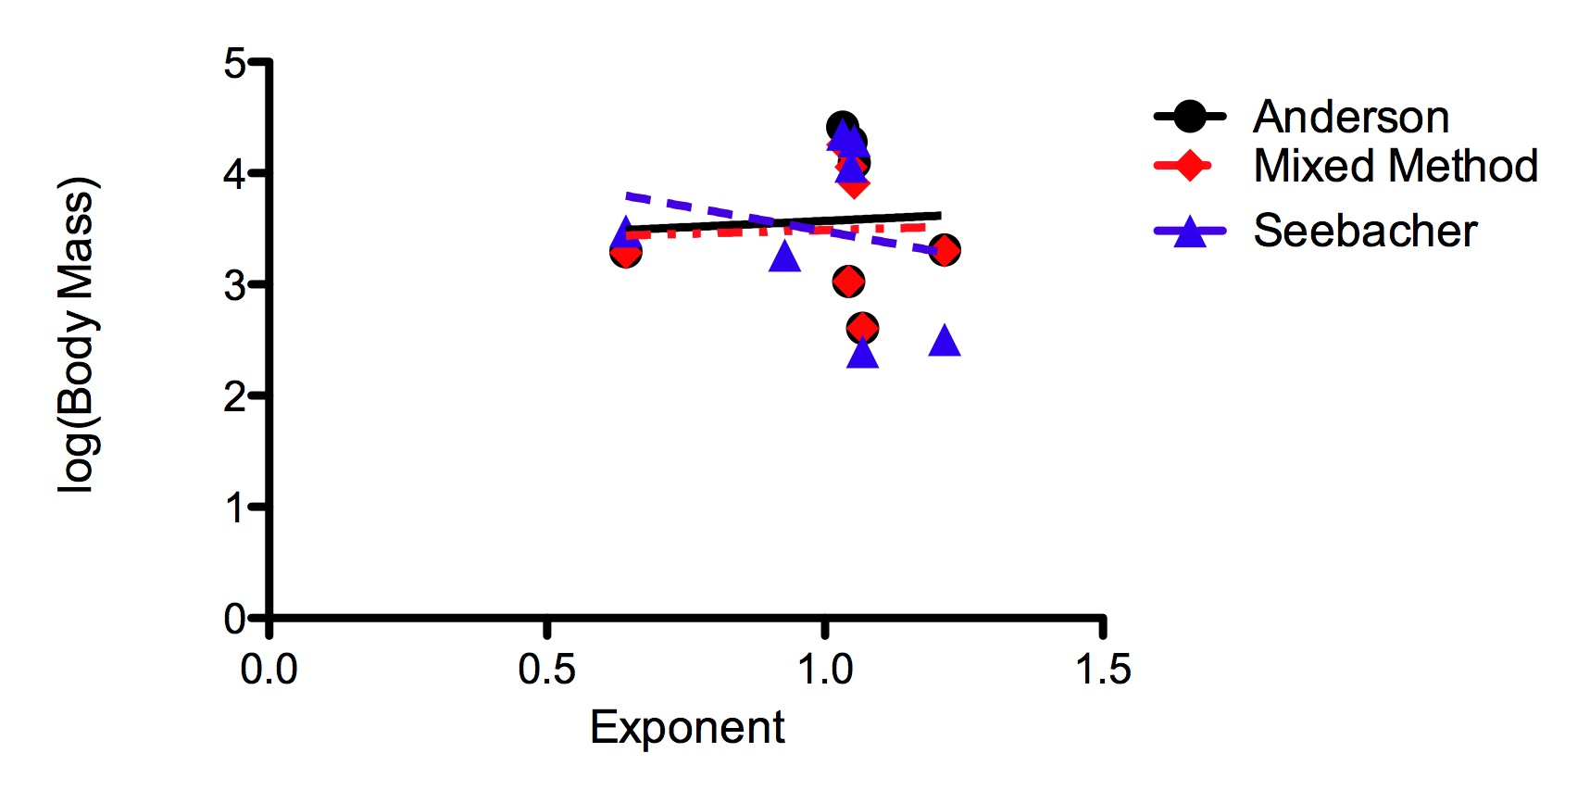
Figure S1. Humeral allometry vs. body mass in Dinosauria. Regardless of mass estimate used, the correlation between body mass and humeral growth is not significant (Anderson et al: R² = 0.0033, P = 0.9022; Mixed Model: R² = 0.0016, P = 0.9327; Seebacher: R² = 0.0386, P = 0.6730).

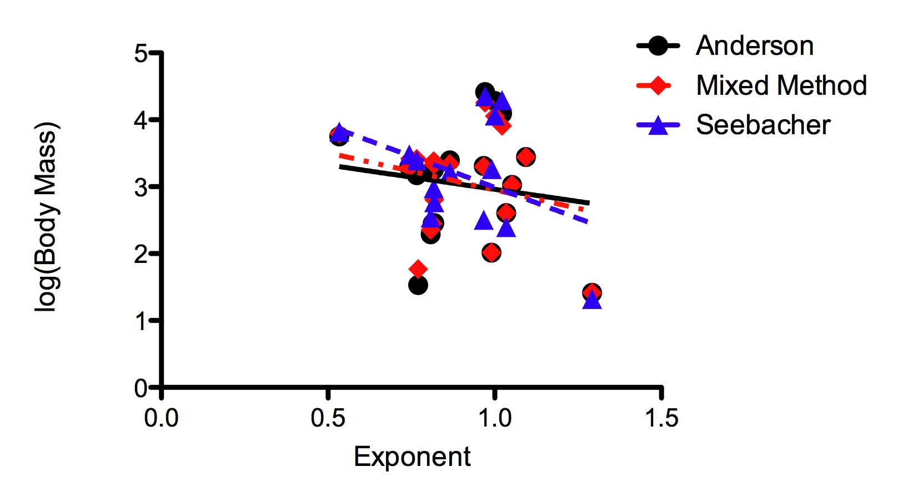
Figure S2. Femoral allometry vs. body mass in Dinosauria. Regressions between femoral growth and body mass are not significant (Anderson et al: R² = 0.0214, P = 0.5384; Mixed Model: R² = 0.0587, P = 0.3033; Seebacher: R² = 0.1564, P = 0.1616).

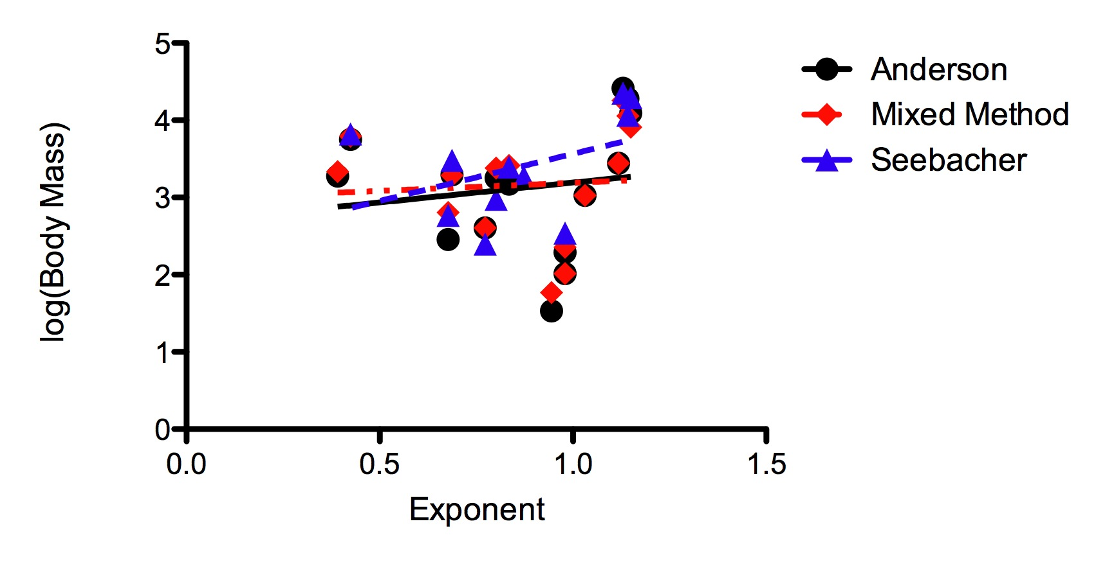
Figure S3. Tibial allometry vs. body mass in Dinosauria. Tibial allometry is independent of body mass (Anderson et al: R² = 0.0232, P = 0.5881; Mixed Model: R² = 0.0049, P = 0.8036; Seebacher: R² = 0.1640, P = 0.2166).

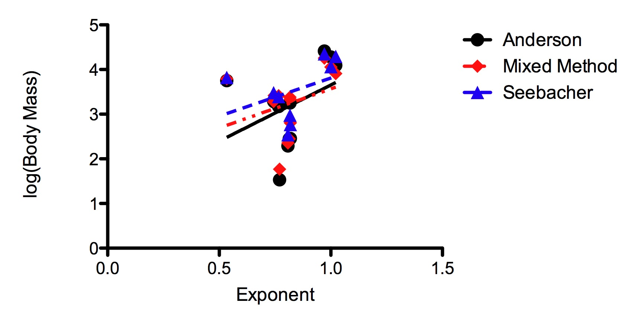
Figure S4. Femoral allometry vs. body mass in Saurischia. In spite of the positive relationships, none of the regressions are significant (Anderson et al: R² = 0.1445, P = 0.2002; Mixed Model: R² = 0.0947, P = 0.3063; Seebacher: R² = 0.1541, P = 0.2960

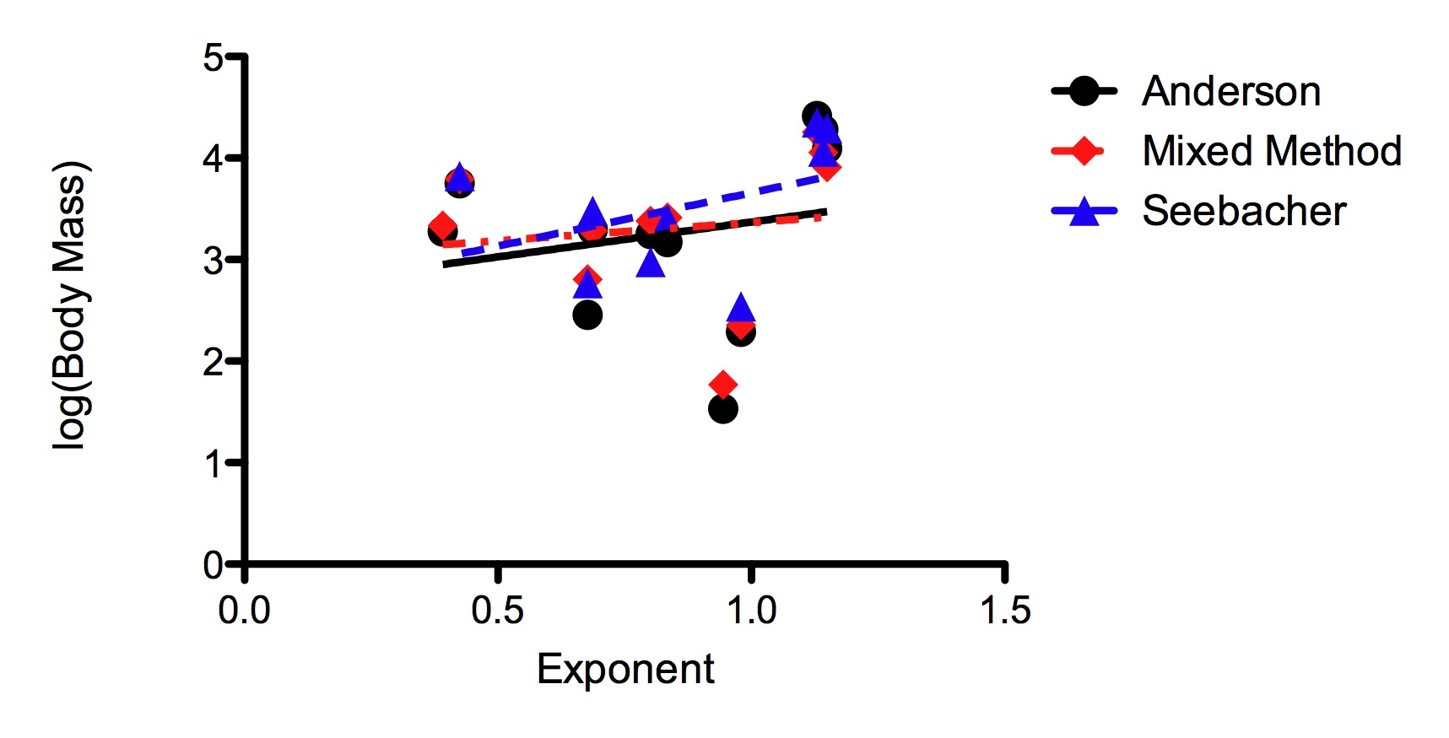
Figure S5. Tibial allometry vs. body mass in Saurischia. The relationship between tibial growth and body mass is positive, but not significant (Anderson et al: R² = 0.0434, P = 0.5389; Mixed Model: R² = 0.0167, P = 0.7051; Seebacher: R² = 0.1592, P = 0.2874

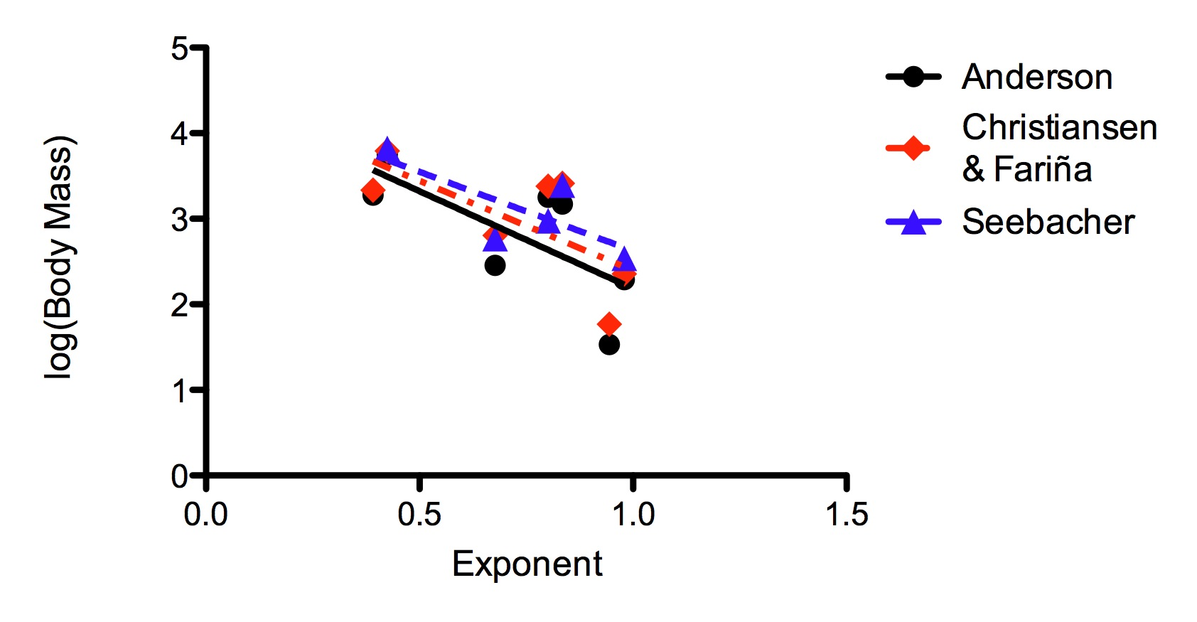
Figure S6. Tibial allometry vs. body mass in non-avian theropods. A negative relationship between these two variables is present, but is not significant (Anderson et al: R² = 0.5013, P = 0.750; Mixed Model: R² = 0.4873, P = 0.0811; Seebacher: R² = 0.5674, P = 0.1415).

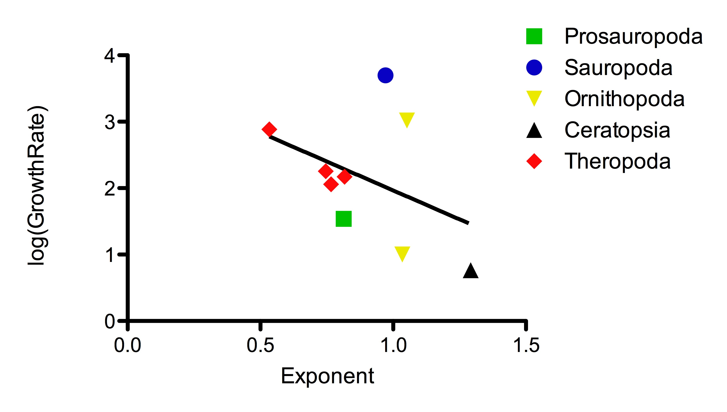
Figure S7. The relationship between maximum growth rate and femoral allometry, R² = 0.1611 and P = 0.2843. Included in the plot are Allosaurus, Daspletosaurus, Gorgosaurus, Tyrannosaurus, Massospondylus, Apatosaurus, Psittacosaurus, Tenontosaurus and Maiasaura. Growth rate estimates taken from Erickson et al. (2001, 2004), Lee & Werning (2008), and Lehman & Woodward (2008).
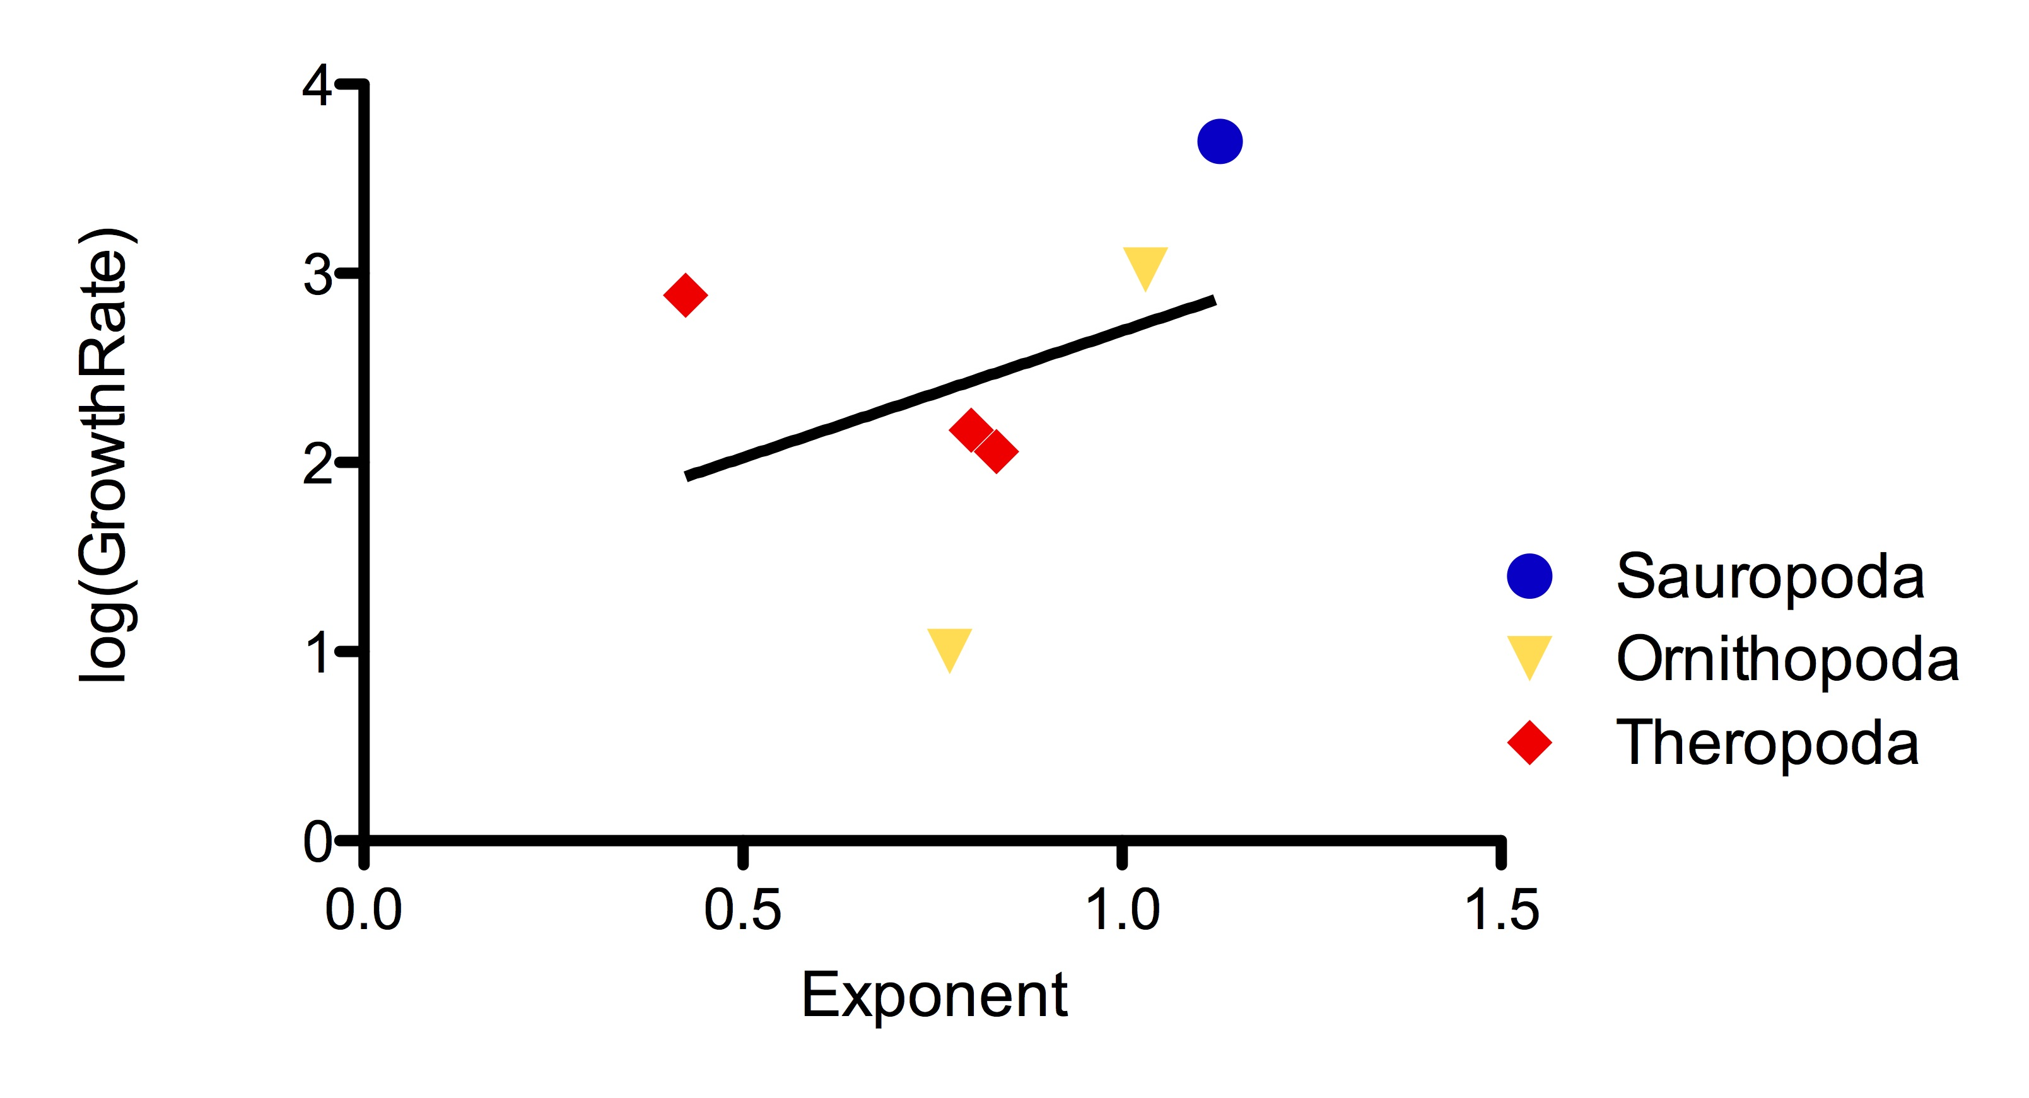
Figure S8. Maximum growth rate versus tibial allometry. Taxa included are Tyrannosaurus, Gorgosaurus, Allosaurus, Apatosaurus, Maiasaura, and Tenontosaurus, and R² = 0.1219 and P = 0.4975.

