Utegration’s Back Office Assist Tool – Utilization Writeback Tool

The utilization writeback tool is available at https://util-writeback-dot-ute-bo-dev.appspot.com/#/
which can only be authorized by one user – admin.
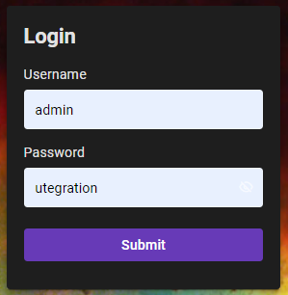

The application allows users to view, modify, delete, and insert records into below tables.
T_CONTRACTOR_INDIA_LKP
T_DOMAIN_LEAD_LKP
T_REDUCED_UTILIZATION_LKP
The tables can be accessed via three different tabs as shown in the below figure.
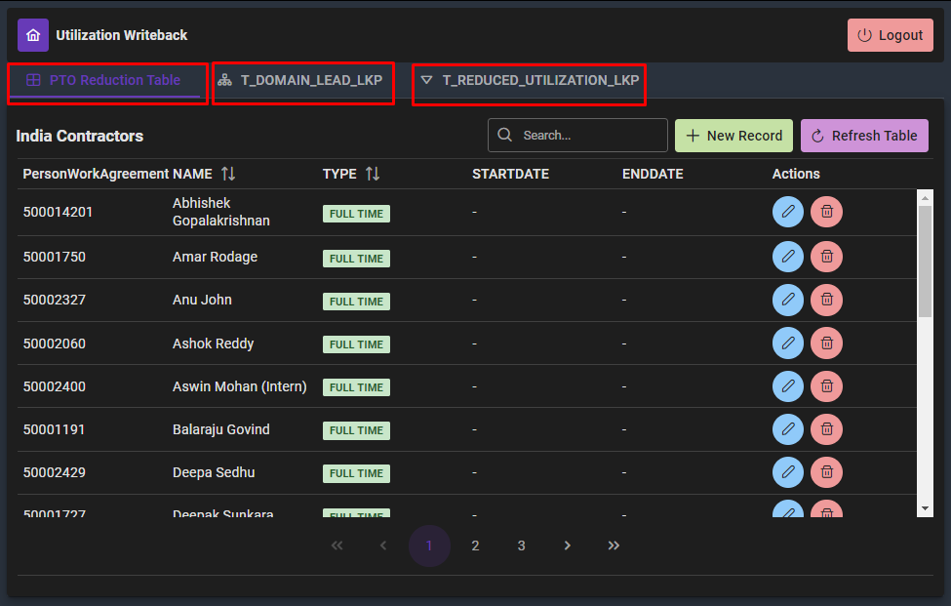
Functionality of the application
Inserting new records | 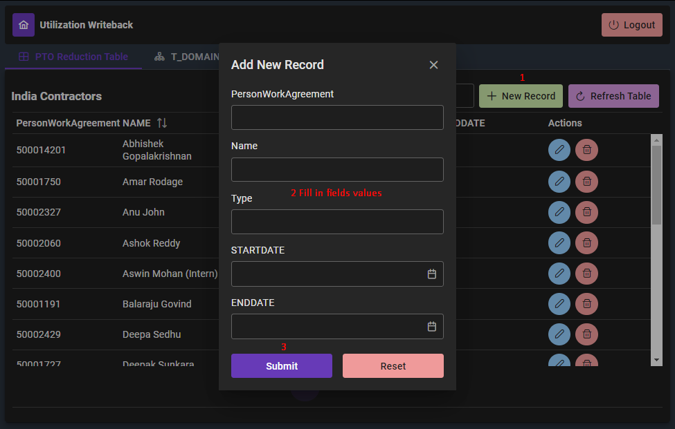
Modify records | 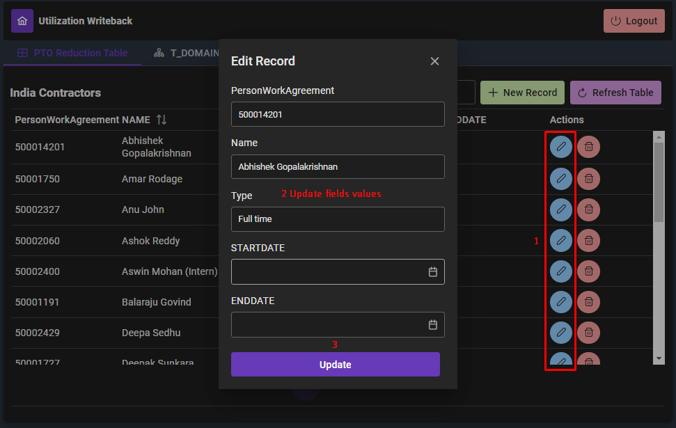
Delete records | 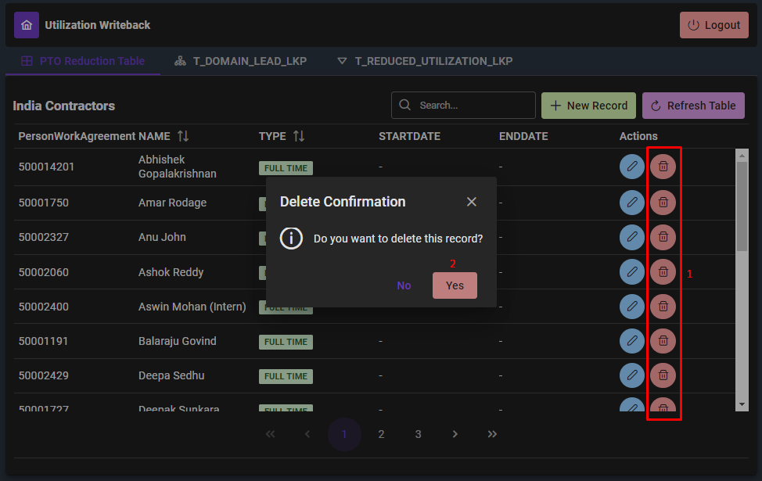
Refresh table – Lets users check the updated records / deleted records updated in tables after performing insert / delete / modify operations. | 