# Docker Hello world

## Installing Docker

Visit the web [page](https://docs.docker.com/desktop/) and click on the correct link based on your OS. Next, to the section matching your environment.

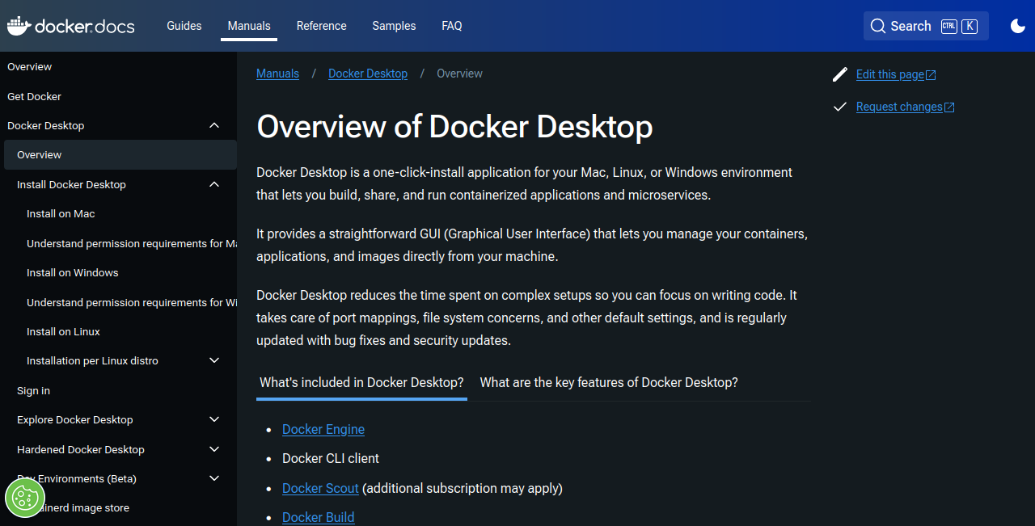

Docker desktop homepage

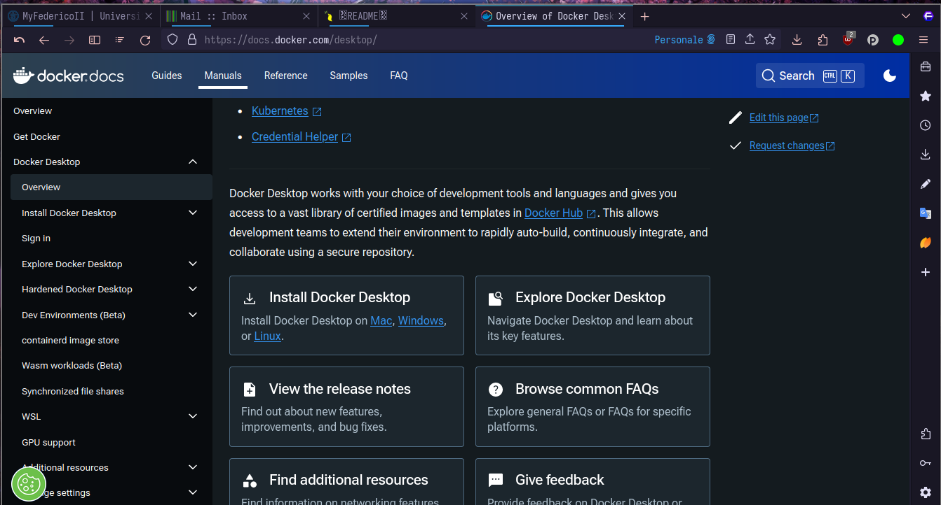

Docker desktop install

### POV: you are on Windows

To run Docker on Windows, you need some extra step.

You need to install WSL2 (Windows subsystem for linux). Other requirements listed in the page should be automatically satisfied if you have successfully installed a Linux virtual machine.

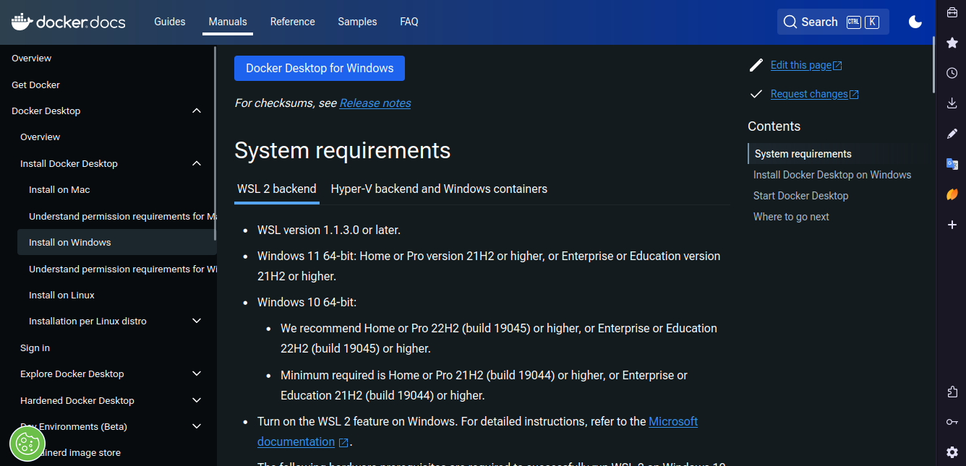

Windows docker desktop

#### Installing WSL

To install WSL, visit the [docs](https://learn.microsoft.com/en-us/windows/wsl/install?source=docs).

Open a Powershell (Administrator prompt) and run the command wsl --install. 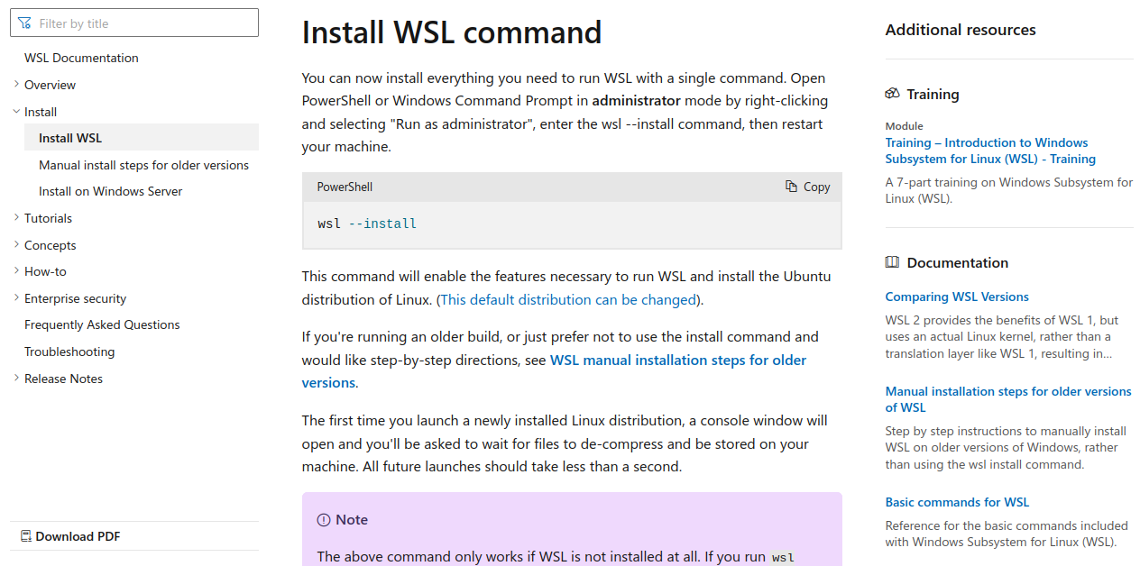

Now you should have an Ubuntu CLI integrated in Windows!

#### Installing Windows Terminal

Windows terminal is an utility used to create and manage terminal like in Linux. You can install it from the [official documentation](https://learn.microsoft.com/en-us/windows/terminal/install).



Windows docker desktop

### POV: you are on MAC (intel/arm chip)

You should be fine: Docker is supported on recent version of macOS.

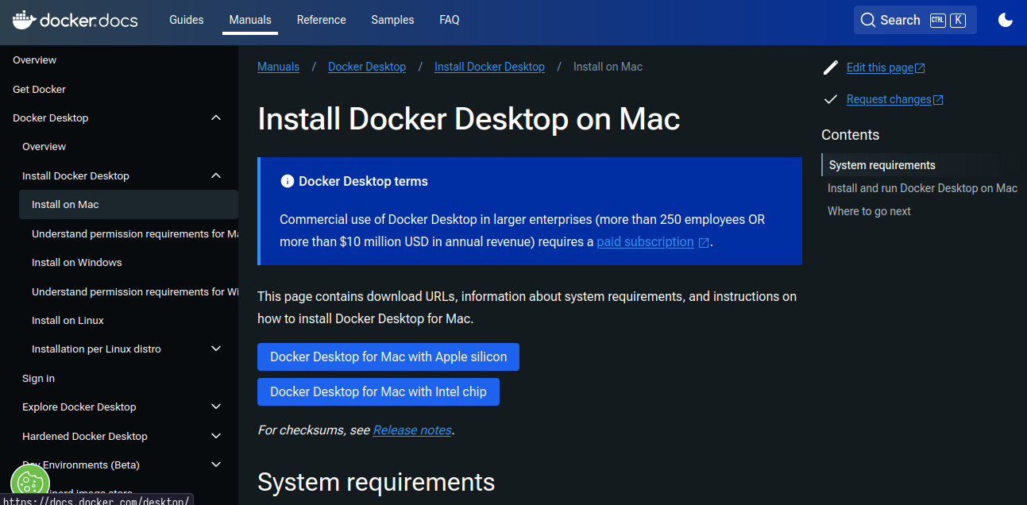

Mac docker desktop

Just follow the instruction and you should have a working Docker installation.

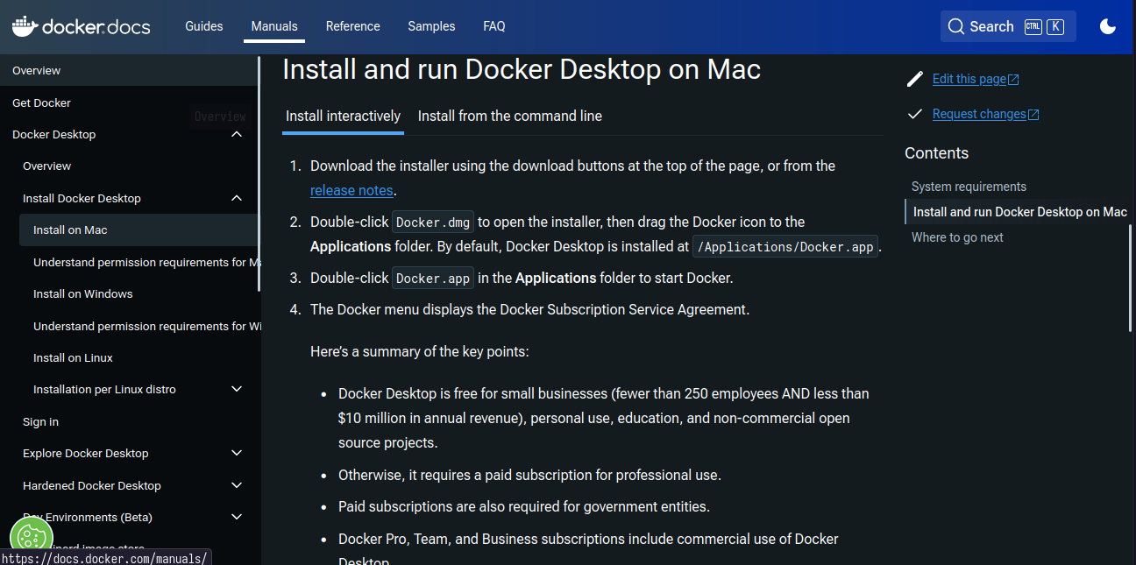

Mac docker desktop installation

### POV: you are on Linux

Docker is natively supported by Linux. Before installing Docker desktop we need to install the Docker engine. For example, if you are on a Debian based distro, you can find the [docs](https://docs.docker.com/engine/install/ubuntu/#install-using-the-repository)

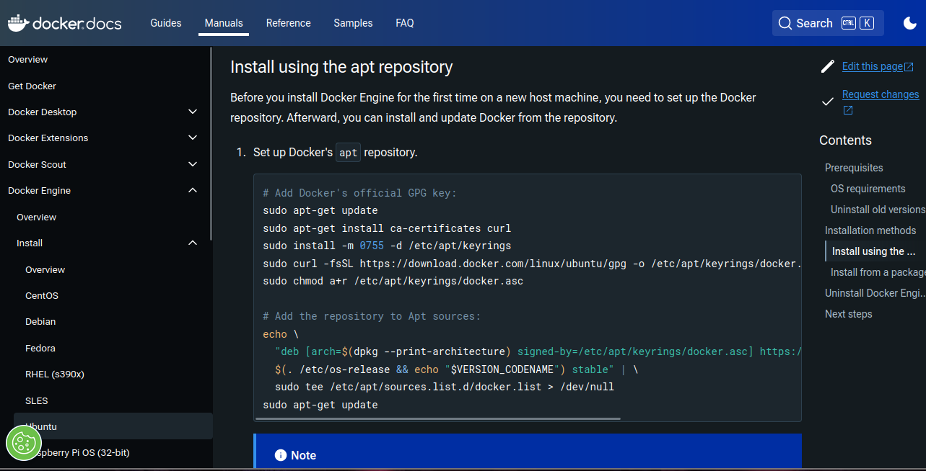

Linux docker engine install

This script sets up your repository, now you can install by running the command:

sudo apt-get install docker-ce docker-ce-cli containerd.io docker-buildx-plugin docker-compose-plugin

Now, if you want you can install Docker Desktop but it is not necessary for this lab.

#### Permission issues

If you are on Linux, you can run containers with sudo. If you want to execute docker as a normal user you can put yourself in the docker group running the command:

sudo usermod -aG docker <your username>

Restart your machine and now you are ready to test the installation.

## Testing your docker installation

Every one should have Docker installation. To check if everything worked open a terminal (Windows terminal for Windows users) and run the command:

docker run hello-world

You should get an output like this:

Unable to find image 'hello-world:latest' locally  
latest: Pulling from library/hello-world  
c1ec31eb5944: Pull complete  
Digest: sha256:91bc16c380fe750bcab6a4fd29c55940a7967379663693ec9f4749d3878cd939  
Status: Downloaded newer image for hello-world:latest  
  
Hello from Docker!  
This message shows that your installation appears to be working correctly.  
  
To generate this message, Docker took the following steps:  
 1. The Docker client contacted the Docker daemon.  
 2. The Docker daemon pulled the "hello-world" image from the Docker Hub.  
 (amd64)  
 3. The Docker daemon created a new container from that image which runs the  
 executable that produces the output you are currently reading.  
 4. The Docker daemon streamed that output to the Docker client, which sent it  
 to your terminal.  
  
To try something more ambitious, you can run an Ubuntu container with:  
 $ docker run -it ubuntu bash  
  
Share images, automate workflows, and more with a free Docker ID:  
 https://hub.docker.com/  
  
For more examples and ideas, visit:  
 https://docs.docker.com/get-started/

## Your first Docker application

To test things out, we can deploy a simple python application.

The application will print out information about the operating system and will ask for a username. The code should look like this.

import platform  
import sys  
  
print("Hello, you are executing me from", platform.machine(), "processor")  
print("Platform information:", platform.platform())  
print("OS:", platform.system())  
print("Python:", sys.version)  
name = input("Give me your name: \n")  
  
print("Hello,", name)

Now we need a Dockerfile. For example we decide to use this one:

FROM python:3.10.14-bookworm  
  
WORKDIR /app  
COPY main.py .  
  
CMD [ "python", "/app/main.py" ]

Now we can build the image with the command:

docker build -t dtlab-docker .

And we execute it

docker run -i dtlab-docker

**STOP and THINK**: what does the -i flag do?