# A Python web-server with Docker

## Goal

We want to deploy a web server application using Docker.

### Integrated web-server

Did you know? Python already has an integrated web server. We can run a web server by running the command:

python -m http.server 3000

Let’s put it in a Docker container. So we need a Dockerfile

FROM python:3.10.14-bookworm  
  
WORKDIR /  
  
CMD [ "python", "-m", "http.server", "3000" ]

Build the image

docker build -t dtlab-simple-webserver .

Run the container

docker run -p 3000:3000 dtlab-simple-webserver:latest

**STOP and THINK**: what does -p flag do?

## Now it’s your turn

### Scenario

You are working as a DevOps engineer and you need to deploy an website. The developer used Python and sends you a Github link. Code can be found at this [link](https://github.com/alarmfox/dtlab-website).

Click on the code button and dowload the directory as a ZIP. 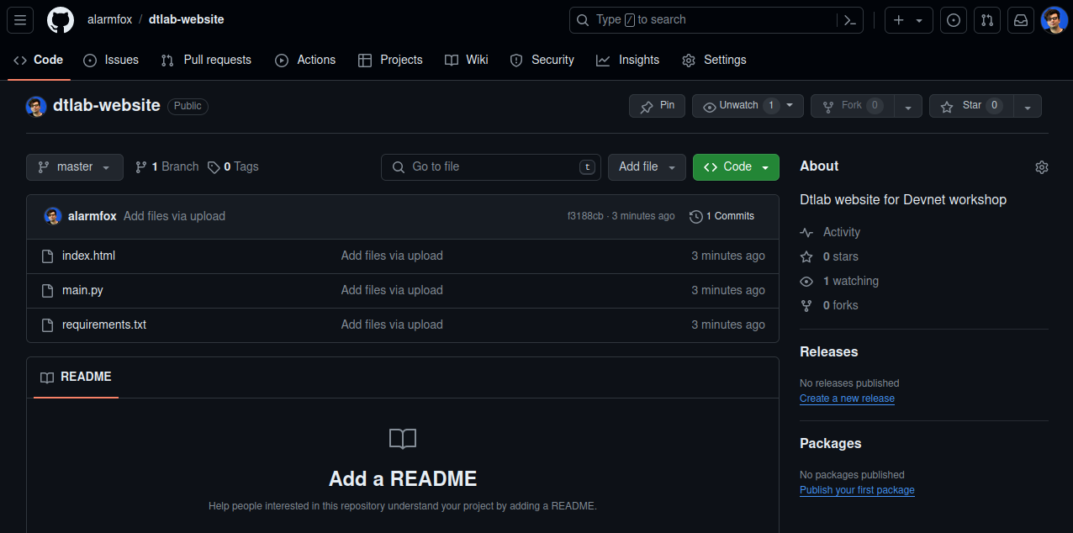

You need to: * Download the source code from Github; * Create a Dockerfile; * Running the application as a Docker container on your PC;

#### Downloading code from Github

You can simply donwload someone’s code from Github, by downloading a ZIP. The code has 3 files: 1. main.py: a python script acting as a webserver; 2. index.html: the entrypoint for every website; 3. requirements.txt: a list of libraries the developer used;

#### Creating the Dockerfile

The Dockerfile is similar to the previous one, but we need to **COPY** also the files index.html and requirements.txt. Also we need to and a **RUN** command to install the libraries from the requirements.txt file.

#### Running the application

Like the previous example you can the application by using the docker run command.

**DOES IT WORK?** If not, why? Try to inspect the python script and see if you see an error! You can fix it and re-build the image!