# Lab 3 - Configure a ZPF

We will work in pair tables. Each table will have a LAN and will have to forward only the correct traffic class to the other one.

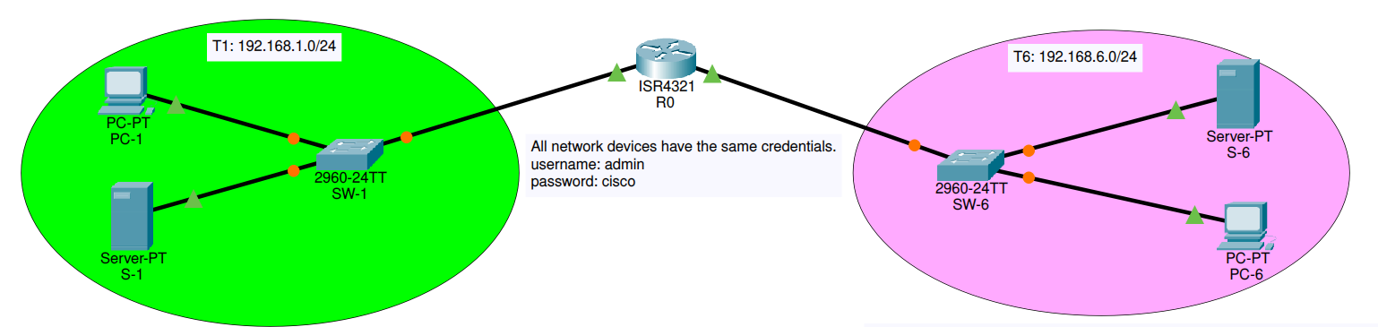

Topology

Even tables (2, 4, 6) will have to forward **FTP** traffic while odd tables (1, 3, 5) will have to allow **HTTP** traffic.

### Running test services

You can use Docker to run test servers. For example, to run a web server you can use:

docker run -p 80:80 nginx

Open your browser on localhost. You should see the following:

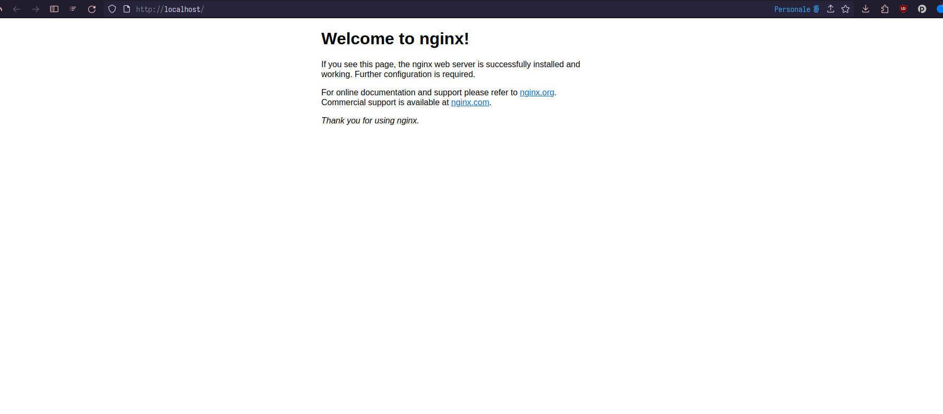

Web server

While for an ftp server, the command will be (substitute the with a real directory you want to share):

docker run --env FTP_PASS=123 --env FTP_USER=user --publish 20-21:20-21/tcp --publish 40000-40009:40000-40009/tcp --volume <path-to-dir>:/home/user garethflowers/ftp-server

You can check the configuration by running an ftp client. Open your file explorer and put the following in your bar

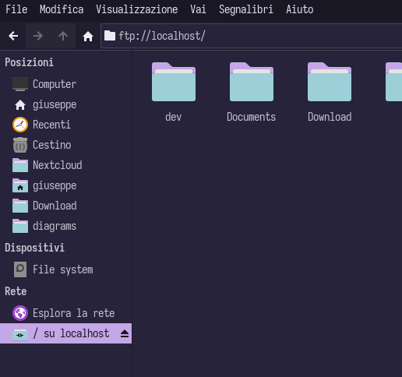

Ftp

## Configuration steps

***Assumptions***: the topology does not need routing as the networks are directly attached. In the initial state, all devices can be reached through ping and hosts in T1 network can configure switch in T6 network. Assume that the server has a static IP address configured.

Some part of the Lab will require the two tables to interact and agree on policies

### Zone configuration

The two tables will interact to decide zone names. These names will be used to create the zone-pair and to assign the interface with the zone-member securitu <zone-name> command.

Configure the zones in the router with the zone security <zone-name>.

### Traffic type identification

Now each group will create a **class map** to identify the traffic to forward.

***Remember***: a default class action exists and drops every packet by default.

The traffic type should have two elements: 1. identify source and destination IP addresses: for this purpose you should create an **extended** ACL allowing for IP protocol specifying as source the LAN source and as destination the static server IP address; 2. allow HTTP (or FTP traffic): use multiple **match** statements when configuring the class map;

For example:

r0(config)#access-list 100 permit ip 192.168.1.0 0.0.0.255 host 192.168.6.50  
r0(config)#class-map type inspect match-all t1-traffic  
r0(config-cmap)#match access-group 100  
r0(config-cmap)#match protocol http  
r0(config-cmap)#exit  
r0(config)#

### Create a policy

Now you should create a policy and attach the created class map to it.

R0(config)#policy-map type inspect t1-policy  
R0(config-pmap)#class type inspect t1-traffic  
R0(config-pmap-c)#inspect  
R0(config-pmap-c)#

### Create a zone-pair

Now you can create a pair and assign the policy to it. For example, we will configure the policy from t1 to t6.

R0(config)#zone-pair security t1-2-t6 source <t1-zone> destination <t6-zone>  
R0(config-sec-zone-pair)#service-policy type inspect t1-policy  
R0(config-sec-zone-pair)#exit

### Assign the zones to the interfaces

Finally you can assign the interfaces according to zones. For example, if <t1-zone> is attached to interface g/0/0/0, command should be:

R0(config)#interface g/0/0/0  
R0(config)#zone-memeber security <t1-zone>

### Verify

Now you should be able to visit the web server on **192.168.6.50**, but you cannot access any devices with ICMP messages. Same should be for FTP server for **192.168.1.50**.