# Multi VM setup

## Description

In this activity, you will learn how to make two different virtual machines communicate.

You will create a dedicated virtual network on your hypervisor and attach both virtual machines to it.

## Virtual Box

If you have Virtual Box as your hypervisor, you will need to go into Files -> Tools -> Network tools and create a new host network by clicking on the New button.

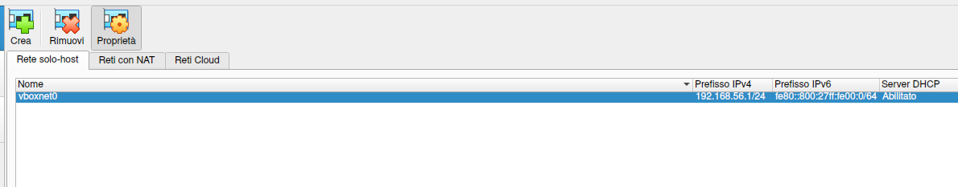

Network Settings

Once you click on New, a new network will be created with a dedicated IP LAN and a DHCP. Now you can use this network to make all your virtual machines to communicate.

## Attaching Host to the created VM

#### Metasploitable

For Metasploitable2 is simple: just go into settings and choose from the current NIC (it’s not needed to enable a new one).

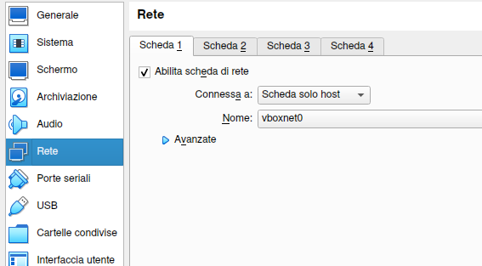

IPv4 settings

Reboot the virtual machine and now it should have an IP from the virtual network you created.

### Kali Linux

For example, if you want to attach Kali Linux to the new Network, go into VM settings, enable an extra adapter and choose the vboxnet0.

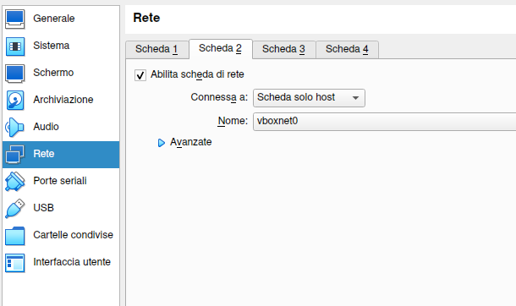

Kali Network Settings

When you enable an extra NIC, you will likely have to configure it (by default Kali configures only the first NIC). Start the virtual machine and enable the connection like in the pictures below.

First, go to Advanced Network Settings and create a new Profile.

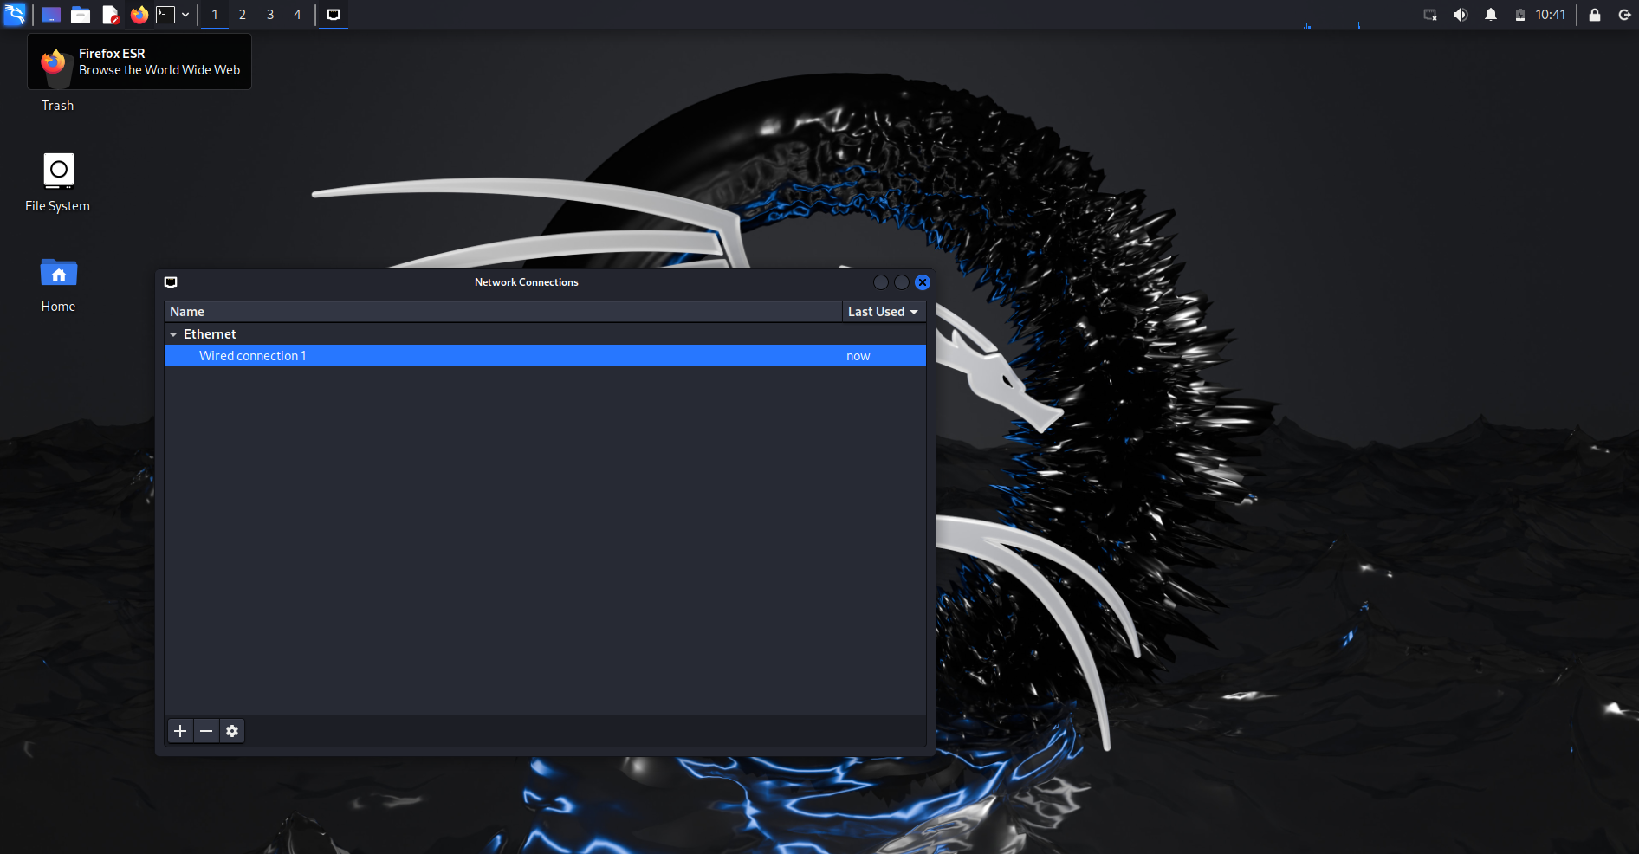

Advanced Network Settings

Choose Ethernet when asked. 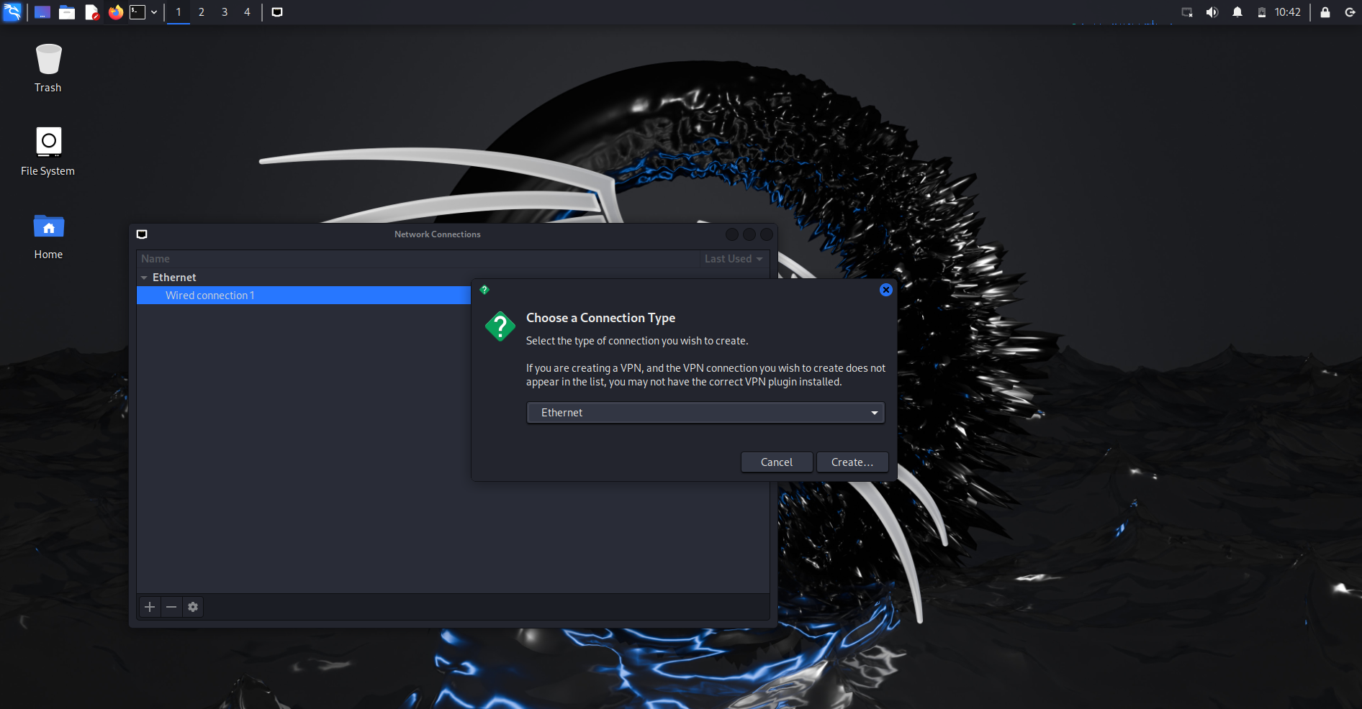

Select eth1 for the device. 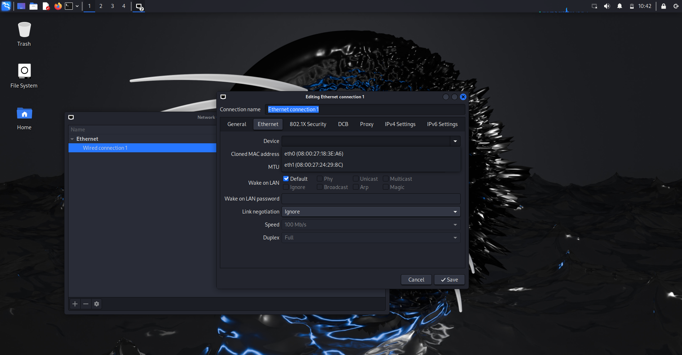

Make sure, DHCP is enabled. 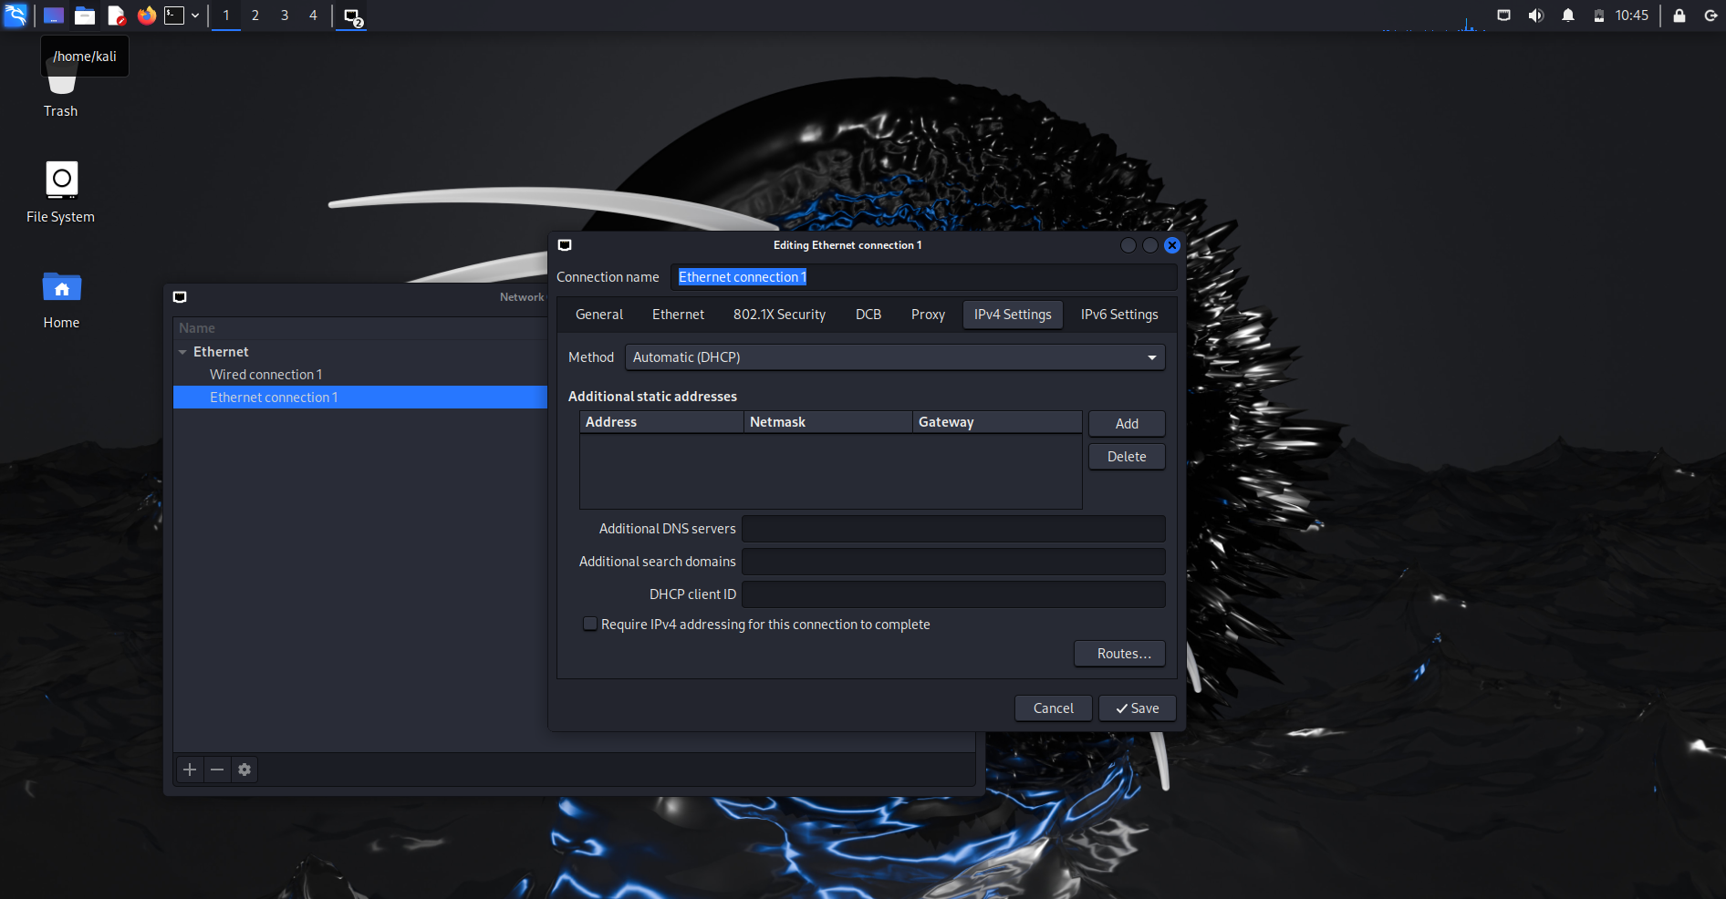

## Result

Now you have two virtual machines in the same virtual network and you can make practice on your own!

Here it is the result of nmap from Kali Linux in the virtual network created.

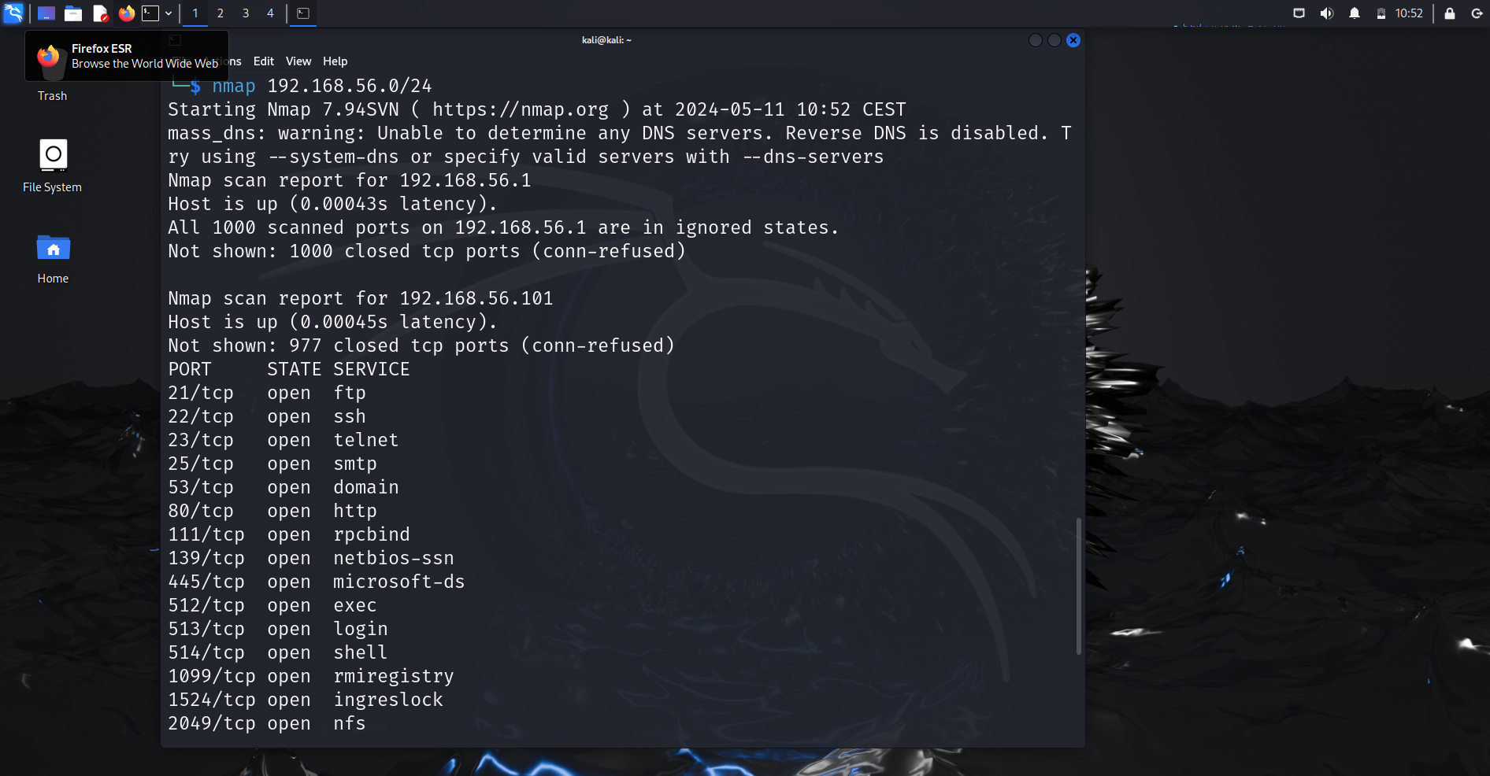

Nmap result