# Setup a linux virtual machine

We will be using [Kali Linux](https://www.kali.org/) for the cybersecurity class. Any other linux environment will be fine (feel free to reach out if you encounter any issues with software we use during practical labs).

If you have already a linux machine skip the installation phase.

## Download ISO

Get your Kali Linux ISO [here](https://www.kali.org/get-kali/#kali-installer-images).

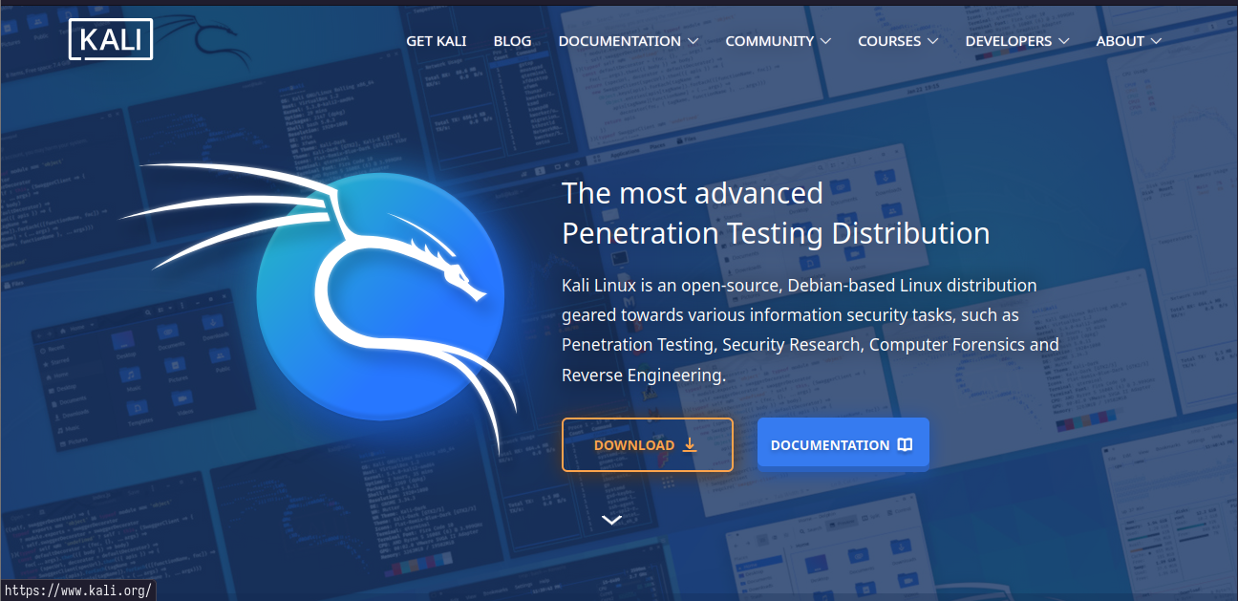

Kali

### Hypervisor setup

Now you need an hypervisor (something that runs virtual machines). We will use Virtual Box which can be download from the [official site](https://www.virtualbox.org/wiki/Downloads) (most likely you will have to download the Windows Hosts version.) 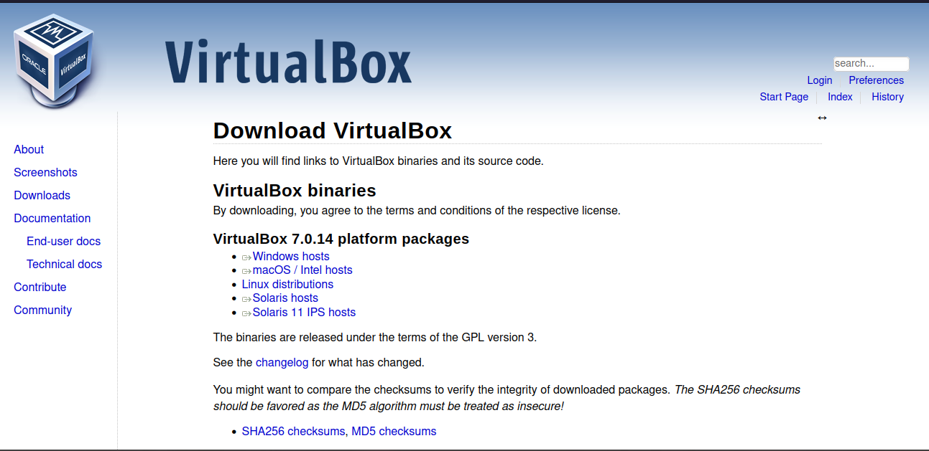

Create a new virtual machine, as in pictures. 

Give it a name and select the ISO you just downloaded. 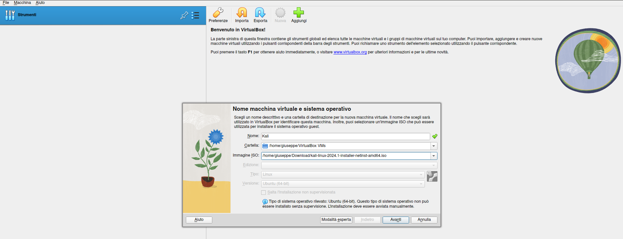

Finally, give it at least 2GB ram and 2CPUs and start the installation!

### Installation guide

Installation is very simple. Just follow the instructions!

First, you will see a screen like this:

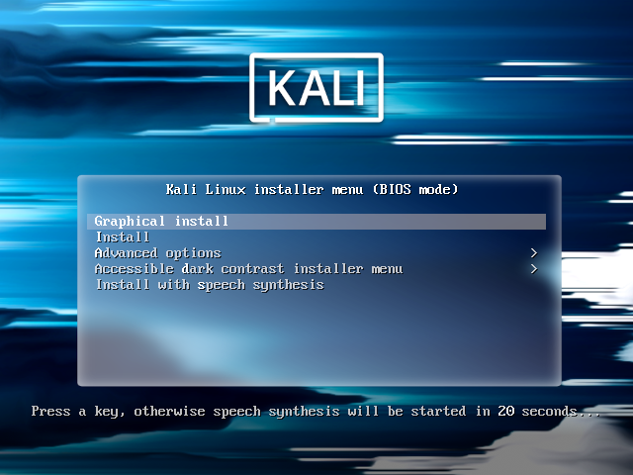

Create VM

Choose graphical install and go on, you will be asked for general informations about languages and to create a user (provide username and password).

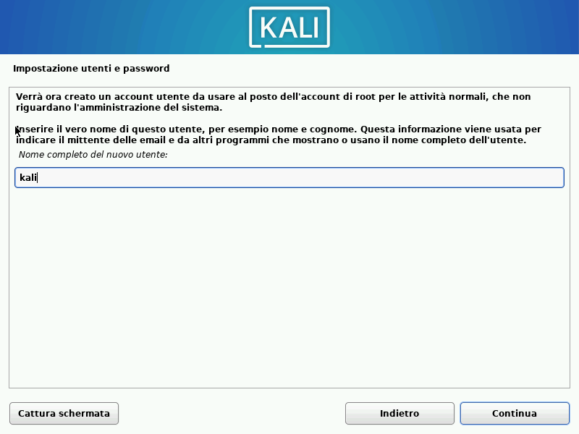

Create VM

Create a simple partition scheme and confirm choices (select yes):

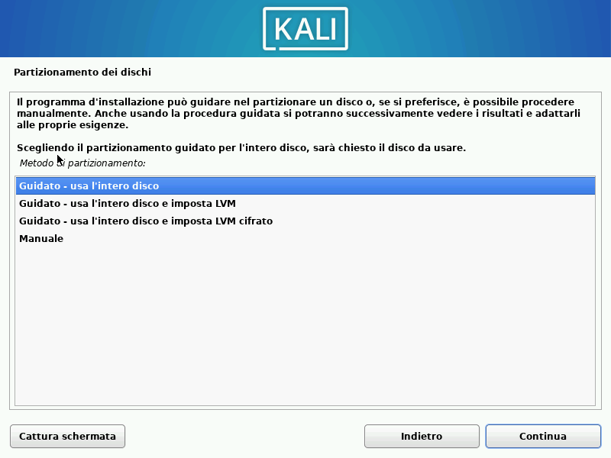 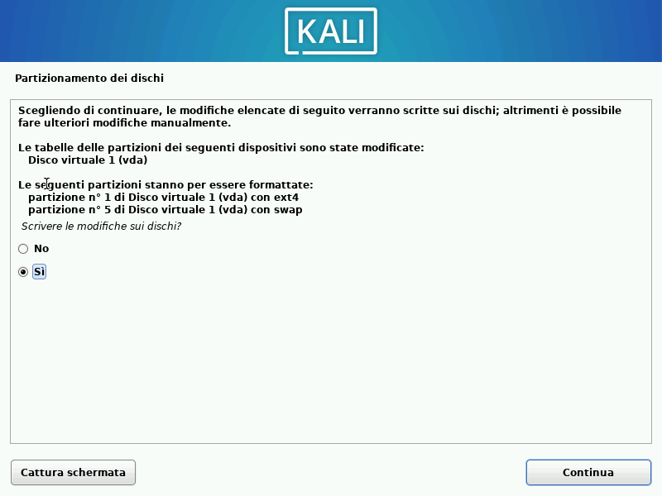

Leave blank here and click Continue: 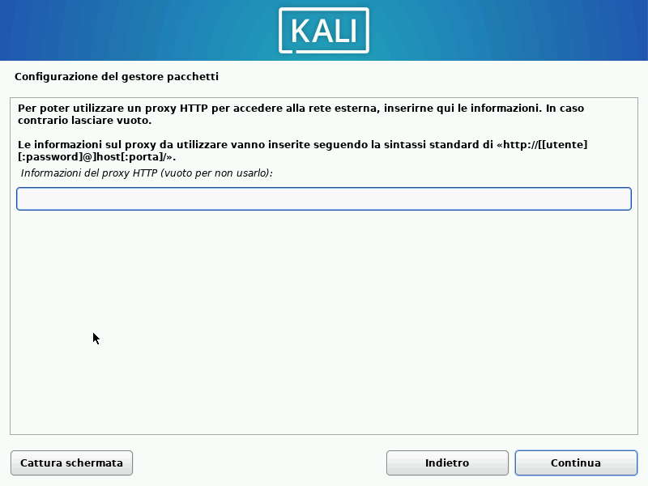

Select default option for installation:

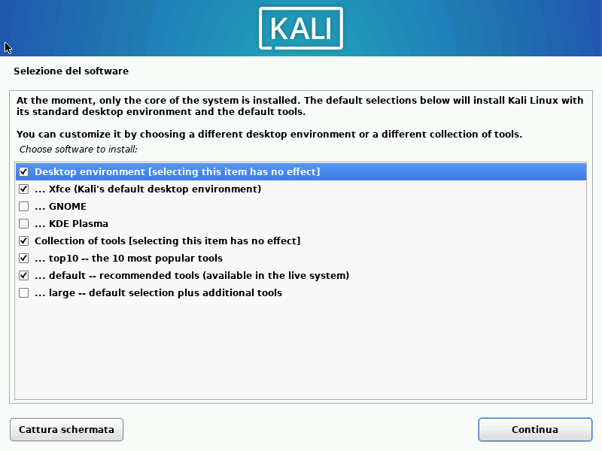

Create VM

When the installation end, you should reboot in your new virtual machine.