**Flocking WebGL simulation throw OpenEarth**

Arce A.*, Blazquez L.F.**

*University of León (Spain) infaar01@estudiantes.unileon.es

** Department of Electrical Engineering, Systems and Automation, University of León (Spain) lfblaq@unileon.es

Abstract: This paper aims to obtain a better knowledge of the mechanism of

As a conclusion, this simulation program results an appropriate tool considering that

Keywords: /Simulation/Modelling/

1. INTRODUCTION

1.1

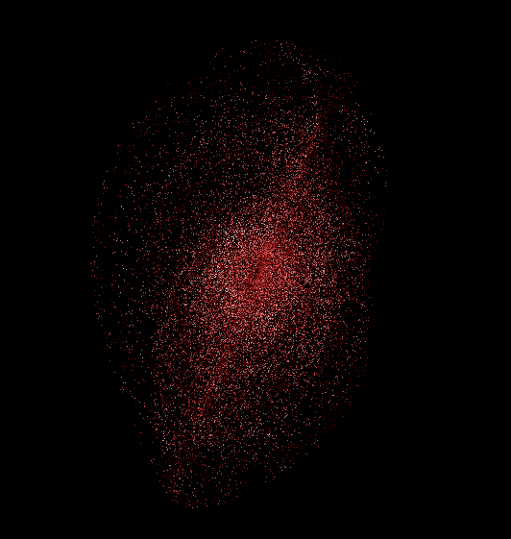

Fig. 1.

1.2

2. METHODOLOGY

2.1

3. CONCLUSIONS

REFERENCES