|  |
| --- |
| Serious Games |
| Our Planet Report |
| COMP10010 |

|  |
| --- |
| Alasdair Hendry  21/09/2019 |

Contents

2 Introduction 1

2.1 Introduction to the Problem Area 1

2.2 Solution to the Problem Area 1

2.3 Previous Use of Serious Games 1

2.3.1 Plastic Heroes 2

2.3.2 World Without Oil 2

2.3.3 Ways2Sort 2

2.3.4 Eco Designer 2

2.4 Learning Outcomes 3

2.5 Ethical Considerations 3

3 Design Document 5

3.1 Overview 5

3.2 Mechanics and Features 5

3.2.1 Driving System 5

3.2.2 Trash System 5

3.2.3 Task System 6

3.2.4 Multiplier System 6

3.2.5 Citizen System 6

3.3 Assessment Integration 6

3.4 Content Integration 7

3.5 Development Approach 8

3.5.1 Agile 8

3.5.2 Waterfall 8

3.5.3 RAD 8

3.5.4 Chosen Approach 8

3.6 Risk Analysis 9

3.6.1 Data Loss 9

3.6.2 Project Scope 9

3.6.3 Team Performance 9

4 Implementation 11

4.1 Instructions 11

4.2 Truck Behaviour 11

4.3 Trash System 13

4.4 Multiplier System 14

4.5 Citizen System 15

5 Evaluation Plan 17

5.1 Overview 17

5.2 Design 17

5.3 Analysis 18

5.4 Research Methodology 19

5.4.1 Qualitative Approach 19

5.4.2 Quantitative Approach 19

5.4.3 Mixed Methods Approach 19

5.4.4 Chosen Approach 19

6 References 21

# Introduction

## Introduction to the Problem Area

It seems that climate change is a subject spoken about, now more than ever. Protestors and activists are taking to the streets, governments are declaring climate emergencies, and most recently, 11,000 scientists banded together to voice their concerns that the planet is now past the tipping point. Current methods promoted to reduce the average persons’ carbon footprint include eating less meat, using public or green transport, and recycling one-time use products such as food packaging and plastic carrier bags.

However, in the UK, only 45.7% of household waste was recycled in 2017. Although this figure has risen steadily from 40.4% in 2010, it can be argued that it is still not good enough. The UK has a target to recycle 50% of waste by 2020, whilst other countries, such as Germany, Australia and South Korea already recycle an average of 60-70% of waste (Dept. for Environment Food & Rural Affairs, 2019).

Use of public transport in the UK is increasing, especially in populated areas such as London, with 4.85 billion passengers using public transport in 2018. However, as 83% of passengers still travel by car or van, a rate which is increasing yearly, and a record 808 billion passenger kilometres were travelled in 2018, it is easy to see how the benefits of public transport are negated (Dept. for Transport, 2018).

It is argued that urban transport solutions, specifically optimising costs to the average consumer, could aid in the effort to half transportation emissions by 50% by 2050. Reduced parking costs can lower distance that is travelled, whilst congestion charges, such as the one implemented in London, can reduce distance travelled in the affected zone (Cruetzig et al., 2016).

The main problem seems to be a lack of awareness in the subject area. Increasing the average person’s knowledge in recycling, pollution, and reducing their carbon footprint may be a definitive path to preserving the climate of the planet.

## Solution to the Problem Area

As the issue seems to be that the average person may simply be misinformed, or doubtful, of the effects their actions have on the environment, the solution may be to raise general awareness. This project will test if a serious game can be implemented to solve this issue by increasing informed knowledge on the subject and displaying the effects that a single action can have.

The game will allow the participant to play through a game environment directly related to recycling and pollution. Information will be displayed to the participant passively at relevant times during the gameplay, with the intention that they will accumulate knowledge they did not already have or that they actively think more about issues they wouldn’t normally think of. Some of the information display will be tied directly to gameplay, for example, players may be informed of the benefits of recycling aluminium cans as they successfully recycle them in-game.

During gameplay, participants will also be able to increase the remaining time in the minigame by correctly answering questions relating to the subject area. It is not expected that participants will naturally know the answer to these questions, therefore, the game will be completable even if each answer is incorrect. The correct answer will be displayed to the participant, alongside additional information related to the question. In doing this, participants will be able to accumulate knowledge whilst engaging with an interactive environment.

## Previous Use of Serious Games

Serious games are an excellent choice, and the go-to solution when looking to combine interactivity and pedagogical content to improve a consumer’s knowledge in a particular area. However, when researching the subject matter of this project, it is easy to see that there are not many examples of serious games which target pollution, recycling or waste management. Most implementations of combining interactivity and teaching these aspects come in the form of board games, such as P.I.P.E.S, Game of Floods and many more.

The few examples of when a serious game has been created to increase knowledge in this subject have been documented below.

### Plastic Heroes

Plastic Heroes is an android game, developed by the company PlasticTwist. It aims to increase awareness and create behavioural changes in relation to single-use plastics. Additionally, it looks to increase knowledge surrounding the environmental impact of the average person’s actions.

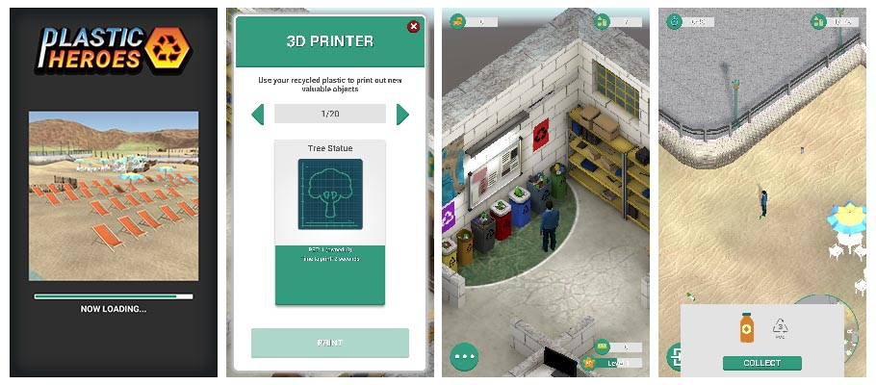

Figure A preview displaying multiple sections of the game [https://www.ptwist.eu/plastic-heroes]

### World Without Oil

An alternate reality and serious game combined, World Without Oil was released in 2007 which attempted to increase awareness, open dialogue and bring attention to the global oil shortage. The game ran for 32 days after its initial release and, after showing users possible scenarios that could happen in the future, asked them to document how they would deal with these issues as oil production grinded to a halt.

Players could post their stories to the project website, by uploading images, videos and blog entries. “In-game” characters stories would also be posted on the website, and these characters would comment on the stories of real players. The project was also made available on instant messaging platforms, and social media platforms, such as Twitter.

### Ways2Sort

Ways2Sort is a mobile game aimed towards primary and secondary school pupils. The game aims to educate children on the importance of waste sorting and how to sort waste correctly. It directly incorporates factual data from the user’s municipality, which allows it to be highly customisable in relation to the user’s location.

Users are required to correctly identify specific waste items, then place them in the correct sorting bin. This is performed by the user via drag and drop on the touchscreen and they are provided with feedback with voiceover, sound, and visual effects.

### Eco Designer

Eco Designer is a game that is targeted towards university students and companies alike, with a primary goal of raising aware about eco-friendly product design whilst learning about design principles and methods. Players are required to roll dice in order to determine the current play state, then make decisions based off of that.

Eco Designer blends a print-it-yourself style of game with technology, as users are required to print and cut out cards which are compatible with their mobile app. The game features one playable scenario and, when used with the app, allows the player to explore multiple different avenues to analyse their effects.

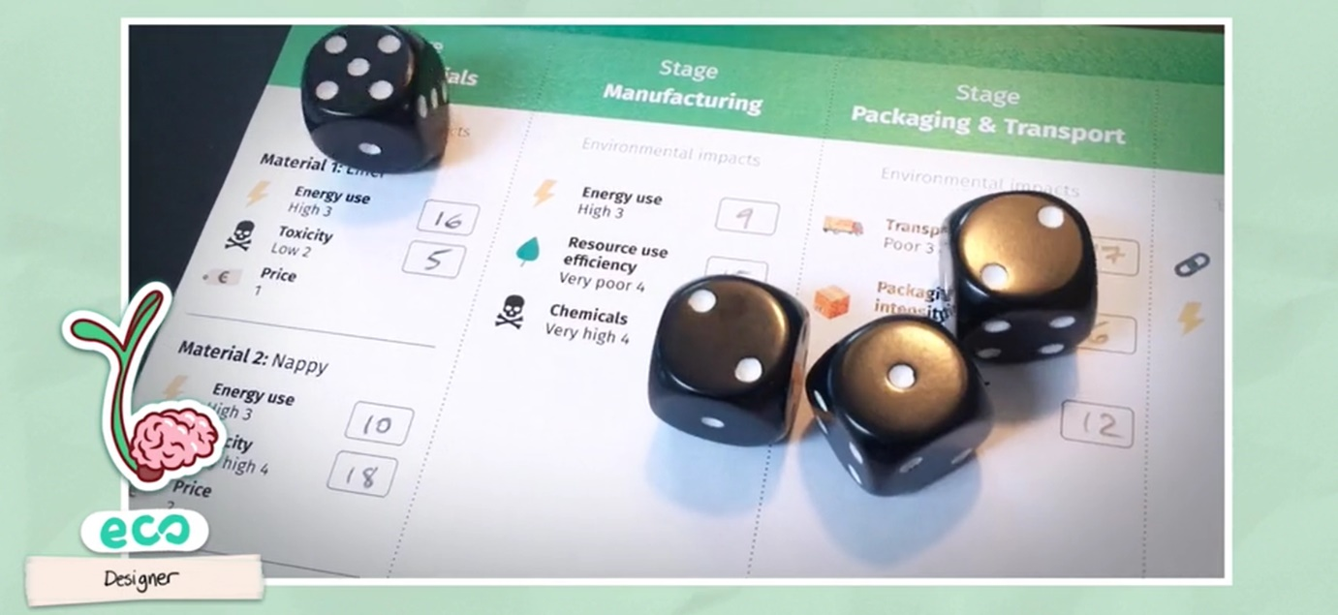

Figure A preview of the game being played with dice [<https://w4t.seriousgames.net/ecodesign/>]

## Learning Outcomes

This project aims to analyse and investigate the effects that a serious game can have when used to increase knowledge in the subject of recycling and pollution. The following learning outcomes should be achieved as a result of this project.

* The project should deliver a bug-free, informative, and unique serious game
* The serious game developed should provide correct information on the subject chosen
* Data collected from participants should be anonymous and adhere to data protection regulations
* Participants should display a clear increase in knowledge in the subject area after the game is played
* Participants should leave the study with an increased appreciation for the subject area
* Data collected should display whether the serious game provided better growth than traditional pedagogical methods

## Ethical Considerations

Projects that involve any form of public participation, such as questionnaires and playtesting, should consider the ethical implications and consequences that they may run into. This project will include one occurrence of public participation, near end of the project, in which participants will be asked to answer quiz questions and play a serious game.

Many considerations should be taken when collecting data from a user. First and foremost, participants should be made aware that they can withdraw from the process at any time and that their anonymity will be retained when they are submitting data. Further to this, it should be considered if a participant is somehow unable to provide free and informed consent in regard to the Mental Capacity Act 2005.

Participants should be made aware that they will have access to all research results upon request and may request all data they have provided be deleted at any time. Regardless of participant requests, all data that has been collected from participants should be deleted after a set period of time.

The questionnaire should be reviewed before it is published to evaluate if any of the questions or statements could cause distress or may be considered insensitive towards participants. Likewise, each part of the questionnaire should be analysed to determine whether it is pertinent to the topic at hand. If not, this data should not be requested from the participant.

Requesting personal data such as age, gender, and location should generally be avoided unless it is required to formulate data in the final research report. it is also important to consider the manner in which questions are asked. For example, rather than asking directly what a participants age is, asking which age bracket they fall under (20-30 years old) may be more polite. Finally, the project should also be reviewed as a whole to determine whether it poses any risks to participants or the researcher. Such risks may include researching personal fears in a virtual reality setting.

# Design Document

## Overview

Our Planet is a 3D arcade game designed to increase a player’s knowledge about recycling and pollution. Players control a garbage truck in the game world and are tasked with collecting as much recyclable materials as possible. These materials spawn randomly in different areas of the world.

Players are assigned tasks throughout the game. These tasks are timed and require the player to complete various actions such as collect specific materials or drift the truck for a certain distance. If the player does not complete the task within the allocated time, they are required to answer a question relating to the research topic in order to gain more time. Regardless of whether the player answers correctly or not, they will receive more time to complete their task. Additionally, once the question has been answered, background information will be displayed to the player to provide a better understanding.

At the end of a session, players are shown how much of each recyclable material they collected and provided with information on how to recycle it.

## Mechanics and Features

### Driving System

Driving will be the main form of gameplay for the player as this is how they will navigate the game world. The driving mechanics will implement Unity’s physics system combined with a custom wheel physics system.

Driving physics will be crafted to mimic an arcade style and the truck should feel light and bouncy. This will also give the players the ability to drift around corners at high speeds. Finally, driving the truck should be easy enough for the average person to do, whilst rewarding higher skilled players who can accurately control the drifting mechanics.

### Trash System

The game world will be broken into different areas, such as “Downtown” and “The Suburbs”. This allows the gameplay to be partitioned and can provide extra dynamics when combined with the task system.

The trash system will monitor the amount of trash that exists in each area and if that number drops below a certain threshold then more trash will be spawned. Trash can be spawned in multiple different variations and provides a different set of materials based on what variation it is. For example, a trash bag is an uncategorised item and can provide the player with multiple different materials when collected, whereas collecting a plastic bottle will only provide the player with plastic materials.

A collection of the different types of trash are displayed below.

|  |  |  |
| --- | --- | --- |
| Trash Type | Provides | Amount |
| Trash Bag | Plastic, Glass, Aluminium, Paper and Food | 25 items split randomly |
| Plastic Bottle | Plastic | 25 items |
| Glass Bottle | Glass | 25 items |
| Aluminium Can | Aluminium | 25 items |
| Paper Cup | Paper | 25 items |
| Food Waste | Food waste | 25 items |
| Blue Bin | Paper | 100 items |
| Green Bin | Glass | 100 items |
| Red Bin | Plastic | 100 items |
| Grey Bin | Aluminium | 100 items |
| Yellow Bin | Food waste | 100 items |

### Task System

The task system will be implemented into the game to improve user immersion and provide an extra layer of gameplay for the player to focus on. This may help overcome the challenge of making a serious game not feel like a serious game.

The task system is loaded with pre-defined tasks that can be assigned to the player. The first task assigned will always be “Collect 5 Trash” as this will introduce the player to the game without overwhelming them. After they have completed this task, the remaining tasks are shuffled and assigned at random. This shuffle and assign pattern will loop throughout the entire game so that the player always has a task.

Each task is given a time frame in which the player should complete it. In the event that it is not completed in time, the player will be asked to answer a question relating to recycling and pollution. Upon answering, the player will be given extra time, equal to half of the original time, to complete the task. If the player does not complete the task within the new timeframe then they will fail the task, and they will be assigned a new one. Failing a task will remove the players current multiplier. The player will not be asked a question if they complete the task within the initial allocated time.

### Multiplier System

A multiplier system will be integrated into the game to give the player an additional goal to work towards. Multiplier score will be awarded to the player when they perform certain actions. Any trash collected will be multiplied by the current multiplier.

The system is broken into 4 stages. In the first stage the player has no multiplier and will collect default quantities of trash. The subsequent stages provide a 2x, 3x, and 5x multiplier. During the first 3 stages, players will have 10 seconds to gain enough multiplier score to advance to the next stage. If they don’t gain enough score, their multiplier will decrease by one stage. In the fourth stage, the multiplier is applied for 15 seconds and will reset to stage one when the time has elapsed.

### Citizen System

AI characters will be spawned into the world to add some life to the game and will travel around the environment using Unity’s navigation system. Citizens will be split into two different categories, city and town, and will have multiple different meshes available in both categories. With a pre-defined set of values for each category, citizens will be spawned into the world at run-time through the citizen system.

Citizens will hook into the citizen system to request a destination to travel to. Once they have reached their destination, they will idle for a random amount of time, before requesting another destination. Each citizen will be assigned a random walk speed, scale and material to provide some variation in the world. Citizens will aim to stick to their category location within the world and will try to walk on the pavement as much as possible.

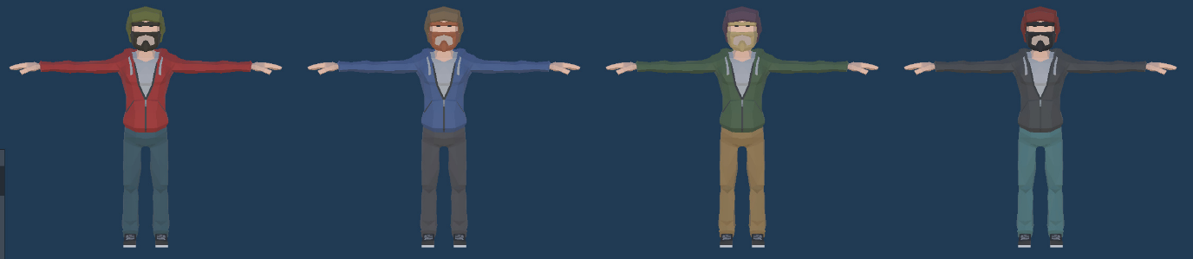

Figure Character variation using the same mesh

## Assessment Integration

This project will integrate assessment in an embedded and external manner. As such, the assessment will be performed before, during, and after gameplay. Approaching assessment integration in this manner will allow the learning outcomes of the project to be effectively analysed.

The external assessment will be completed before and after the participant has played the game and will consist of the same questions each time. This assessment will ask participants to rank certain issues from important to not important. Such an issue may be, “How important do you believe recycling metal cans to be?”. Performing this assessment, whilst retaining the same questions throughout, will identify whether the participant has successfully met the proposed learning outcomes.

The embedded assessment is directly integrated into and will run inside the gameplay cycle as the participant progresses through the game. Although an unusual statement, this assessment can be considered formative and summative concurrently. The assessment will follow a quiz-based model and will ask the participant to answer multiple-choice questions at relevant points in the game.

It can be considered a formative assessment due to the fact that participants will be informed whether they answered correctly and will be provided with further background information to the question, thus, directly affecting and adjusting the growth of knowledge. However, the data provided from this assessment can be collated and the participant will answer each question multiple times throughout the game cycle. Due to this, it seems unnecessary to perform a separate summative assessment, when the information provided during participation can easily be analysed and displayed in such a way that it measures the growth of the participant over a set period of time.

## Content Integration

Integrating content into the game, whilst maintaining a relationship with the pedagogical theme, presents multiple challenges. To ensure learning outcomes are achieved, content must be thoroughly planned to meet specific criteria. As this project aims to increase knowledge in recycling and pollution, a high percentage of content will cycle back to these topics.

Quiz-style content will be integrated to meet the learning outcome that a participant’s knowledge should undergo a measurable increase during the study. Further to this, dialogue relating to the quiz content will be integrated. This will provide background information to the question resulting in the participant understanding the underlying conditions, which should meet the outcome that a participant should leave the study with an increased appreciation for the subject.

This style of content will be cyclical, which is to say that it will consist of small, repetitive activities. The questions presented will be limited to a small number, increasing the likelihood they are encountered multiple times during gameplay. This will allow the content to strengthen specific knowledge and reinforce that this content should be focused on.

Pedagogical content is tied directly into the task system, which triggers every 45 seconds on average. This ensures a consistent separation of gameplay and learning by only requiring the player to engage in learning activities in brief periods, allowing the player to stay motivated and engaged. Feedback relating to this content is directly integrated too, as players receive the result of their answers in real-time. This allows the player to analyse the value of their learning and identify their successes and failures.

Participants don’t move forward and back in a linear fashion depending on the outcome of their answers. However, reinforcement is provided by rewarding a participant’s correct answer with additional score multiplier points. Furthermore, participants are informed in real-time how many, and the percentage, of answers they have currently answered correctly. In doing this, players can gauge the quality of their performance and see the impact their actions have on the gameplay.

Learning content is integrated directly with the framework of the game and learning occurs at the same time as gaming. This is simply due to the fact that participants are quizzed in a repetitive fashion throughout gameplay. However, it can also be said that the learning content is completely separated from the game content, as quizzes are optional, and participants can progress through the game naturally without engaging with learning content. Content such as this should be considered exogeneous, whilst it can also be intrinsic and extrinsic simultaneously.

## Development Approach

### Agile

The Agile methodology is a type of iterative development used in different variations to develop software. When following Agile, a project will continuously loop through planning, implementing, testing and evaluating allowing iterations of the software to be released in small increments.

This methodology can be extremely useful in flexible projects as it can minimise risks when implementing new features, detect bugs more frequently, and allows the design of the project to be changed more easily. However, Agile can negatively impact a project as a lot of time may be spent continuously testing and evaluating a project, when features could be getting worked on.

### Waterfall

Considered to be the most “traditional” approach to software development, Waterfall is a linear methodology which consists of consecutive phases which are thoroughly planned out. Each phase must be completely before the next one can be started.

Projects that have stable requirements, defined objectives and dynamic team compositions will benefit most from using a Waterfall approach. However, Waterfall does not allow much room for error and there’s no process to change the direction of the project.

### RAD

Rapid Application Development (RAD) is a development methodology based on Agile. This approach contains four distinct phases; planning, design, construction, cutover. The planning and design phases are repeated until the product meets all requirements. In some variations of RAD, the planning phase is replaced by making a proof of concept prototype.

RAD is useful to projects that are time-sensitive and are small in size. However, projects using RAD require a stable team with in-depth knowledge of the entire project as not much is documented.

### Chosen Approach

Comparing three of the most common development methodologies clearly shows that there is not a “one size fits all” approach to software development. As such, elements from each approach that align with the requirements of this project have been combined into a hybrid methodology.

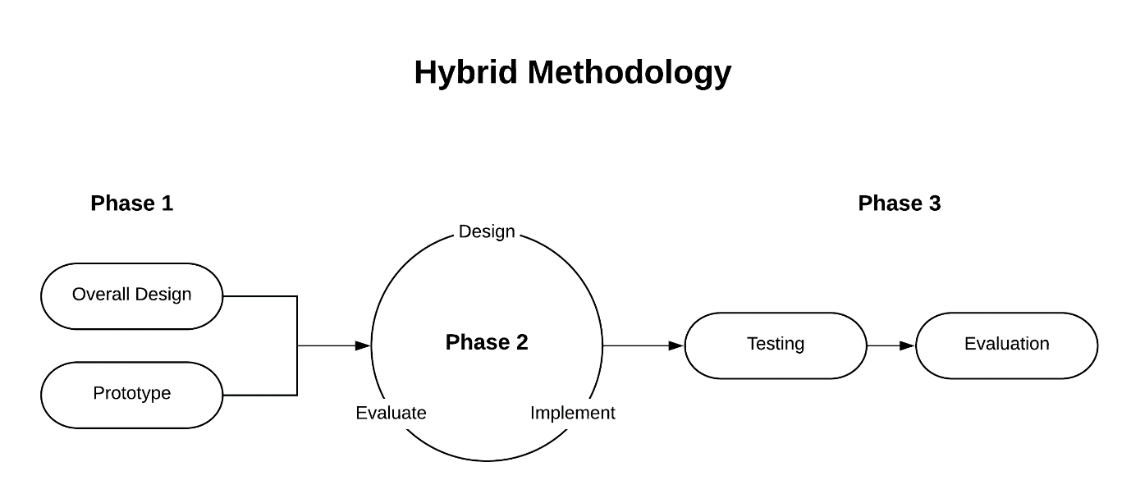

Figure Chart displaying flow of the Hybrid Methodology

As seen from Figure 1, the approach created will begin with phase 1 which has 2 sub-phases that run simultaneously. This phase allows an overall design and plan to be created, along with a prototype that proves the proposed design is feasible.

The approach then moves to phase 2, which has three sub-phases, design, implement, and evaluate. The three sub-phases run consecutively until the game meets the project requirements outlined in phase 1.

Phase 3 requires the entire game be tested and evaluated. At this time, any major bugs documented will be rectified. In the final stage, the evaluation will commence. This will involve sourcing candidates to participate in a randomised control trial.

## Risk Analysis

Analysing and preparing for the risk factors of a project can go a long way in avoiding trouble throughout the lifecycle of the project. Three main factors, usually the most notorious, have been evaluated below and preparations that have been taken to counteract them have been discussed.

### Data Loss

Data loss is the most prominent threat for any software development project. It can happen at any time for a myriad of reasons, such as data corruption, hardware faults, power failures, and hacking. Data loss occurring will be more impactful at the end of a project than at the start, as the amount of data lost can be much more substantial. However, as this project has such a short timescale, any sort of data loss will have a major effect on the outcome of the project.

To combat the possibility of data loss occurring, many precautions will be taken throughout the entire project. As discussed previously, GitHub and CrashPlan will be used during each phase of the project. GitHub will provide a backup at defined stages, where the project can be picked up from the backup point. These backups have to be performed manually and are usually completed after any iteration of the project is implemented.

CrashPlan will be used to back up the entire development system. This is essentially an added layer of security and shouldn’t be used as a primary method of data protection. CrashPlan automatically backs up the entire system at pre-defined intervals. This method has the added benefit of also protecting every piece of software on the development system and is most useful in the event of a major hardware failure.

### Project Scope

Scope defines how in-depth, technically advanced and detailed a project may be during development. Defining an achievable scope at the start of the project is an important factor in ensuring the project is completed in the given time frame. It can be easy, especially for novice designers, to overestimate how much workload they can take on or underestimate how much time they have to complete the project.

To ensure the scope of this project is achievable, thorough planning has been taken during the initial phases. A prototype of the game has been developed, implementing simplified versions of many of the major features in the game. Furthermore, specific features have been allocated time slots in which they must be completed.

During development of the game, implemented features will be compared to the planned features on a frequent basis, allowing a comparison to be made and ensuring the project is not heading in the wrong direction. On top of this, additional features that have not been planned beforehand should not be implemented until all planned features are fully implemented.

In the event that the original plan becomes unattainable during the project, features will need to be removed from the plan and documented correctly. Each feature which is not currently implemented will be prioritised based on a number of factors, such as relevance to the game and overall project. Features with the lowest priority will be removed from the plan, and the scope will be re-evaluated. This process should be repeated until the scope of the project is achievable again.

### Team Performance

Regardless of the fact that this is not a team project, performance can still become a risk and as such, it shall be prepared for. Performance can affect a project in many different ways, ranging from effort to illness. Some of these risks are harder to predict than others, however, the affect they have can still be avoided with proper planning and preparation.

Effort is a risk that’s much easier to prepare for in a solo project, as you can’t control another members’ input in a team project. To ensure effort does not become an issue, the original plan will be referenced through the life of the project to verify that the project is on track. Further to this, frequent communication with module lecturers will provide insight into how much effort is required to keep the project on track.

Illness is another factor that much be considered when evaluating the risks of team performance. Of course, illness is mostly unpredictable in terms of when it may happen, how long it may happen for, and how serious the illness is. However, there are measures that can be taken to minimise the effect illnesses can have on a project.

Firstly, having the “flu” or “cold” should not be considered an illness that is serious enough to affect the outcome of the project. Much like in a workplace environment, taking sick days to nurse a flu is not considered to be professional or acceptable. Members of the project should be expected to work through a flu, even if the same rate of production is not reached. Moreover, each planned feature should have a priority assigned to them before implementation begins, to ensure a quick process of removing planned features in the event of a serious illness.

# Implementation

## Instructions

Players will use the WASD control scheme to control the movement and direction of the truck. The truck should be used as an interaction trigger for objects in the world. Spawned trash should be collided with to collect it.

Players should aim to complete their assigned task as quickly as possible and can utilise the mini-map and location text to guide them. When questions are required, players can choose to answer or skip. Answering a question correctly will provide the player with more time and multiplier score. Answering incorrectly will provide the player with more time and no multiplier score. Skipping will not affect the game in any way, however, players will not be given extra to time to complete their task.

Multipliers can be gained by completing the following actions.

* Collecting trash
* Collecting specific trash
* Colliding with environment props
* Driving at high speeds
* Drifting for extended distances
* Lifting the truck off the ground
* Completing tasks
* Answering questions correctly

## Truck Behaviour

The player’s truck was implemented using Unity’s physics engine to improve controls, feel and interactivity with the world. The built-in Wheel Collider component was considered, and prototyped, to determine whether the physics matched the playstyle of the game. This component was quickly ruled out, however, as it was extremely temperamental (changing physical variable altered the entire physics interaction) and didn’t provide the cartoon-style physics that were desired.

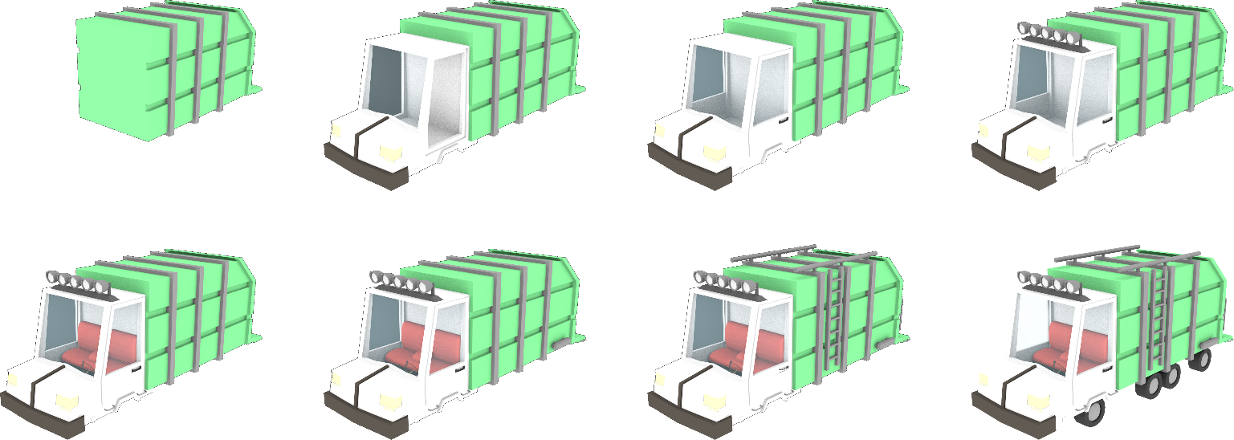

Figure Modelling progression of the garbage truck

To solve this issue, a custom wheel collider solution was implemented. This solution, a much simpler version of the Wheel Collider, used ray cast physics to determine the physical qualities of the wheel. The component allows a designer to specific the suspension, spring, spring damping, and radius of the wheel. These values are then used to work out a compression, ranging from 0 to 1, which is then used to work out the target position of the wheel. The wheel then implements physics to move towards this position using the spring and spring damping values.

A code snippet of this component is displayed below.

|  |  |
| --- | --- |
| **WheelCollider.cs** | **CalculateCompression()** |
|  | |

The custom wheel collider component is applied to each wheel, and directly affects the parent component, the truck controller. This parent component is attached to the root gameobject and hooks into each of the wheel colliders. Among other things, it directly controls the speed, direction and grip forces of the truck. Calculating these forces requires an average, normalised output from each of the wheel colliders, which is multiplied by player input and the trucks physical qualities.

A code snippet of this component is displayed below.

|  |  |
| --- | --- |
| **GarbageTruck.cs** | **CalculatePhysics()** |
|  | |

## Trash System

This system splits the world into multiple areas, which is used to evenly distribute the amount of trash in the game. It used to spawn new trash, keep track of current trash, and provide call-back methods when trash objects are spawned or collected.

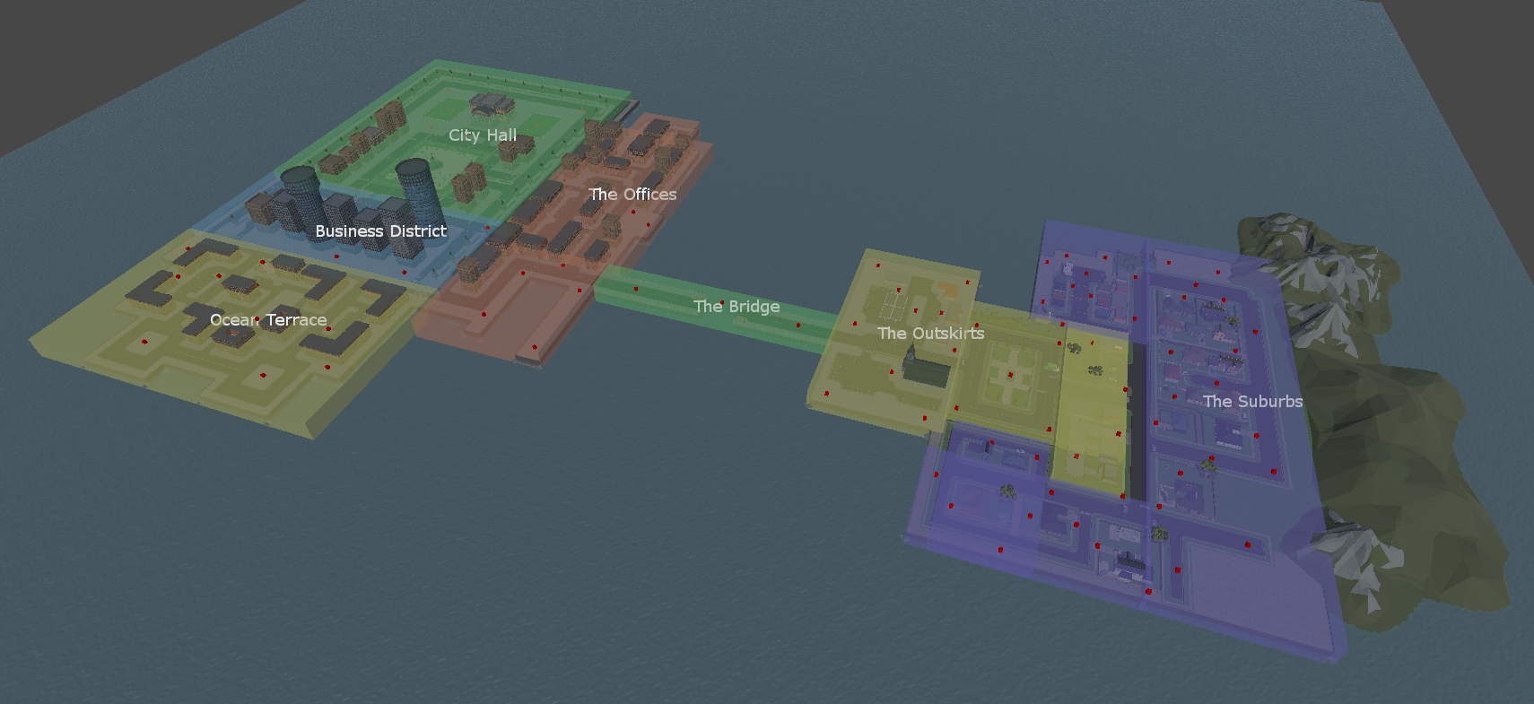

Figure Screenshot showing the game world split into areas

The system works on a series of delegates, so that it doesn’t have to evaluate the state of the world each frame. Instead, it can wait until it has been informed that something has happened (i.e. the player just collected some trash) then can decide what actions to take. This saves a tremendous amount of processing power and creates a manageable, extensible workflow.

The following code snippet shows what event is triggered when the player collects some trash in a specific area. It uses a weighting technique to allow 5 trash to be spawned for every 1 piece of unique trash.

|  |  |
| --- | --- |
| **TrashSystem.cs** | **SpawnTrash()** |
|  | |

## Multiplier System

The multiplier class is global, allowing any component to easily access it. It is set-up in a simple way, as over-complicating it may unnecessarily decrease the player’s ability to understand it.

When an object adds score multiplier, the system checks the current score progress against the current multiplier. If the progress is greater than the required progress of the next multiplier, then the multiplier increases. This check is also performed when the current time left decreases. The update loop monitors the time that the current multiplier has been active and decreases it if a certain time period has passed.

The system uses a delegate system to provide a call-back whenever a multiplier level has increased or decreased. This allows several other components to hook into this action and perform different behaviours based on their state.

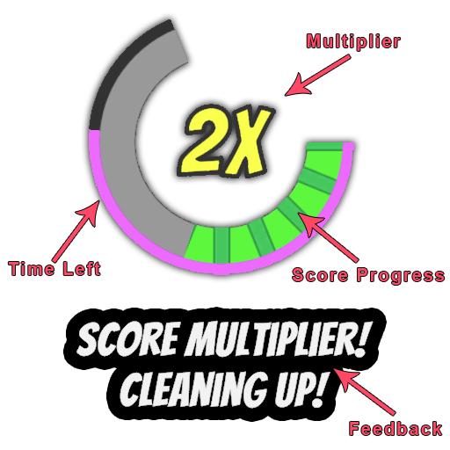

Figure The multiplier UI hooks into the multiplier system call-backs

A code snippet displaying how score progress is monitored is shown below.

|  |  |
| --- | --- |
| **MultiplierSystem.cs** | **CheckCurrentProgress()** |
|  | |

## Citizen System

The citizen system implements Unity’s experimental high-level navigation API. This allows any object in the scene to be tagged as navigation static and the surface can be categorised as walkable, non-walkable and more. Each ground tile in the world is categorised as walkable, and sub-divided further into road, pavement and crossing. This allows the navigation system to compute different paths for vehicles and citizens.

Hundreds of citizens are spawned at run-time and are distributed over each area. As each citizen has to update their state, a master-slave-like design pattern was implemented to ensure a steady framerate regardless of how many citizens are spawned. When a citizen requires a new path to be computed, instead of performing the action locally and forcing the current stack to wait, it sends a request to the citizen system.

The citizen system stores these requests in a queue and performs a small number of the requests each frame. The result of the request is then returned to the citizen when it is calculated. The citizen then uses their own artificial intelligence to navigate along the path. The slight delay in movement incurred with this method is acceptable in these circumstances as it can add variety to the movement of the citizens. To further improve performance, citizens that are far away from the camera receive less frequent updates or may not be updated at all. This check is also performed in a queue-like fashion by the citizen system.

A code snippet of the citizen system computing queue requests is shown below.

|  |  |
| --- | --- |
| **CitizenSystem.cs** | **MonitorGetPathQueue() & PerformGetPathQueue()** |
|  | |

## Destruction System

The player can interact with, and destroy, most props within the world. The only items that are not destructible are buildings and stone walls, as these provide environmental barriers for the player to navigate around. Each prop in the world has a specific component attached, DestructableEnvironmentProp. This component allows the designer to specify custom attributes for the prop, such as destruction mechanics, particles, and collision attributes.

When the garbage truck collides with a prop, it invokes the component and the prop reacts in the designed manner. Props can be destroyed or fall over when a collision is detected, and the collision attribute can be deactivated for bigger props, so they are not intrusive to the gameplay. To increase efficiency, colliders are restricted to being triggers so there is less stress on the physics system. Furthermore, physics for the prop is not activated until a collision is detected. This allows for thousands of props to be placed in the world without bringing framerate to a halt.

The code snippet below displays the functionality of the prop when a collision is detected.

|  |  |
| --- | --- |
| **DestructableEnvironmentProp.cs** | **OnCollisionDetected()** |
|  | |

# Evaluation Plan

## Overview

It is important to evaluate data that has been collected through a study. It allows researchers to determine whether the learning outcomes of a project have been met and can provide insight into enhancing them. The data can be used to improve user acceptance and create a better player experience for a serious game. Furthermore, it can assist in the development of the game, depending at which point of the project cycle that evaluation has taken place, as it can provide user insights and opinions.

This evaluation aims to accurately assess if a participant’s knowledge increases through the use of the serious game. Furthermore, it aims to assess behavioural changes in attitude towards the subject matter. Data will be collected through the use of quiz-like content that is integrated into the game and available in physical form.

An experimental design will be implemented to conduct this evaluation. Approaching in this way allows the evaluation to take place in a controlled environment, and therefore provide accurate data. This is opposed to a quasi-experimental design, in which multiple variables would be assigned randomly, which is much more difficult to statistically control. The experimental design dictates that participants be assigned at random and gives a greater likelihood that the candidate pool will consist of wider categoric variation.

## Design

In an ideal situation, the evaluation would use an experimental design in which subjects would participate in a pre-test study followed by an intervention. The intervention would consist of a control group and experimental group and be followed by a post-test study. In the final stage, a long-term follow-up post-test would be completed. This design would provide the most extensive and accurate data. However, it also requires an adequate quantity of time and resources and is much better suited to larger projects that require more in-depth research.

As previously mentioned, this evaluation will follow an experimental design which will implement a randomised control trial, using a quiz-based instrument. Two groups will be sourced for the study; the control group and the experimental group, with each group consisting of 15 people. Therefore, 30 people in total will participate in the study, which does present some issues. For example, such a small candidate pool may not provide enough variety to come to an informed conclusion. However, due to the time and resources restrictions of the project, this number of candidates seem achievable and should provide enough variety to come to a conclusion on a project of this scale.

Each participant will be randomly assigned to either the control group or the experimental group. The control group will be offered a traditional teaching method and the experimental group will be asked to play the serious game. All data encountered in the serious game will match the data in the paper-based quizzes.

The order of events of each group is displayed below.

|  |  |
| --- | --- |
| **Control Group** | **Experimental Group** |
| **Stage One** | |
| Complete a paper-based quiz related to recycling and pollution | Complete a paper-based quiz related to recycling and pollution |
| **Stage Two** | |
| Receive marked feedback and background information on the quiz questions | Play the serious game |
| **Stage Three** | |
| Wait a set period of time | Wait a set period of time |
| **Stage Four** | |
| Complete the same quiz from stage one | Complete the same quiz from stage one |

Upon the intervention stage being completed, each group will be asked to complete the quiz that was initially provided to the control group.

It would be beneficial to perform a long-term follow-up post-test as it would provide data points that could measure not only the long-term benefit of the study, but also how a participant’s attitude has been affected. However, this is not possible to perform due to the nature of the study, and the increased risk of losing contact with participants can skew or bias potential data.

## Analysis

Analysis of Variance, or ANOVA, is an analysis model commonly used in field studies, experiments and quasi-experiments. Running an Analysis of Variance is most commonly performed when a collection of groups is greater than two or there are multiple different variables within a study. However, this technique can be run on a group of two and will, depending on the variables, return the same result as an Independent Sample t-Test. This model requires a dependent variable that is continuous (interval or ratio data) and an independent categorical variable (two or more groups). Analytical results are not reliable when the assumption of homogeneity of variances is violated. Homogeneity of variances simply means that there is an assumption that variances are approximately equal among samples.

Dependent Sample t-Test, commonly known as Paired Sample t-Test, is a model of analysis in which the same individual or group is compared on a common dependent variable. This model requires that each sample be made up of the same individuals and that there are no outliers in the sample. For example, a study may be conducted on 10 people to determine whether alcohol increases happiness. The group would provide data before and after consuming the alcohol, and the result would be the comparison of the two datasets.

Independent Sample t-Test, commonly known as Unpaired t-Test, is a parametric analysis model that will be used for this study. Using this model, answers from the control group (µ1) and experimental group (µ2) will be compared, using both the pre-test and post-test data. The mean difference between these two samples will explicitly display whether are increase in pedagogical learning has occurred. Further to this, each answer that is recorded by the game can be categorised by question and displayed in a manner that shows whether knowledge increased over rate of play. Finally, qualitative pre-test and post-test data can be compared to determine whether participants of the study acknowledged an increase in awareness and attitude towards the subject area.

The Independent Sample t-Test is similar to the Analysis of Variance model, as it shares many of the same requirements. The differences between these two models are detailed below.

|  |  |  |
| --- | --- | --- |
|  | Independent Sample t-Test | Analysis of Variance |
| Case 1 | The model requires that the study consists of precisely two groups | The model can be run on two or more groups |
| Case 2 | Output includes the Welch t-Test statistic which can be used when equal sample sizes cannot be assumed | Test results are not reliable when the assumption of homogeneity of variances if violated |

The assumption that sample sizes will remain equal throughout this study cannot be guaranteed, as participants of the experimental group may choose to simply ignore the quiz content when it is displayed. Due to this, ANOVA is not an applicable analysis method for this study. Furthermore, as the study consists of two groups, Dependent Sample t-Test is not applicable either.

The alternative hypothesis in this study dictates that pedagogical growth is greater when the medium is a serious game, whereas the null hypothesis states that growth is the same, or greater, when using traditional teaching methods. The null hypothesis will be rejected if the result indicates that the control group mean does not equal the experimental group mean. The equations for these hypotheses are shown below.

|  |  |  |
| --- | --- | --- |
| Null hypothesis | Alternative hypothesis | Legend |
| H0: µ2 = µ2 | H1: µ1 ≠ µ2 | H0: Null hypothesis  H1: Alternative hypothesis  µ1: Group One Mean  µ2: Group One Mean |

## Research Methodology

A research methodology is a framework around which a piece of research is based. The specific type of research, along with some other factors, should dictate what type of methodology is used. Regardless of the methodology used or the goals of the study, research should follow the same overall structure of enquiry and investigation. This should lead to an increase in knowledge in the target area and result in data which can be formulated into an opinion or statement.

### Qualitative Approach

Qualitative research can result in detailed responses, in-depth opinions and may offer a personalised form of data. Researches that prefer using a qualitative approach often claim that the context gained from this type of research is important when forming a conclusion as it can aid in providing an underlying theme in responses from participants. This form of research can be collected through various methods, most popularly “one to one” style interviews, focus groups, and open questions in a survey.

### Quantitative Approach

Quantitative research is considered a more statistical approach, using pure numbers to conclude the opinions of participants. Researchers who use this method claim that it can eliminate observer bias and counter-act the emotional response that a participant may have. This approach ensures that data collected is objective, much like that of a scientific experiment. Conducting quantitative research can be performed by asking closed questions in a survey and monitoring a participants’ progress through data collection.

### Mixed Methods Approach

A mixed methods approach involves using both Qualitative and Quantitative research to conduct a study. This doesn’t necessarily mean that the weaknesses of each approach are negated. Qualitative data will still take time to analyse whilst providing a greater insight and Quantitative research will still be easy to collate whilst missing the “human aspect” of the data. However, collecting data in this way can be performed at any ratio and may provide the benefits of each approach, providing an overall improvement on the research conducted.

### Chosen Approach

Research will be conducted using a mixed methods approach, which seems to be an appropriate choice for a project of this style. Quantitative data, such as location and recycling habits, is required as it can be used to categorise participants’ responses and there isn’t a need for this data to be opinionated. Further data of this nature will be collected, such as rating each aspect of the game.

Qualitative research is also a benefit to this research, as the participants can provide specific insight into the game, such as underlying bugs, glitches, and opinions on specific features in the game. Additionally, participants can state opinions they have on the research, and whether or not they feel it has had an effect on them. This should allow the research to develop a deeper understanding of participants’ views, identifying themes and opinions that can improve the game in the future. Further to this, requesting qualitative data from participants may help reduce data saturation as similar answers can be combined.

# References

Dept. for Environment Food & Rural Affairs (2019). UK Statistics on Waste. [online] Available at: https://assets.publishing.service.gov.uk/government/uploads/system/uploads/attachment_data/file/784263/UK_Statistics_on_Waste_statistical_notice_March_2019_rev_FINAL.pdf [Accessed 7 Nov. 2019].

Dept. for Transport (2018). Transport Statistics Great Britain 2018. [online] Available at: https://assets.publishing.service.gov.uk/government/uploads/system/uploads/attachment_data/file/787488/tsgb-2018-report-summaries.pdf [Accessed 7 Nov. 2019].

Cruetzig, F., Fernandez, B., Haberl, H., Khosla, R., Mulugetta, Y. and Seto, K. (2016). Demand-Side Solutions for Climate Change Mitigation. Beyond Technology. [online] pp.174-191. Available at: https://www.annualreviews.org/doi/pdf/10.1146/annurev-environ-110615-085428 [Accessed 7 Nov. 2019].