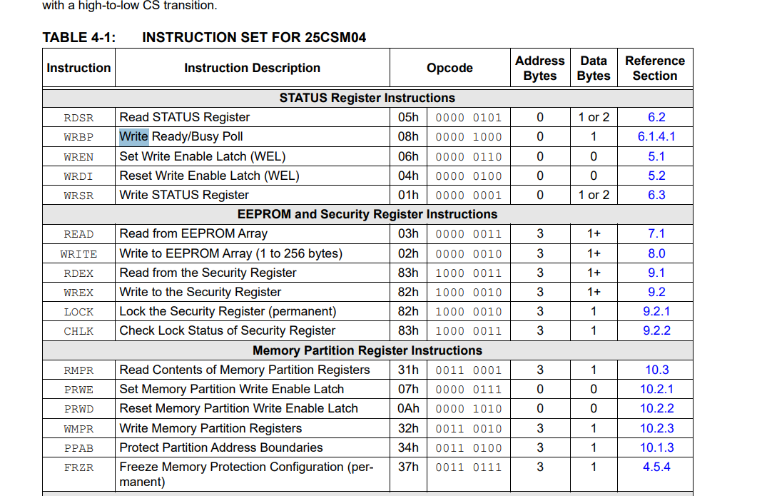

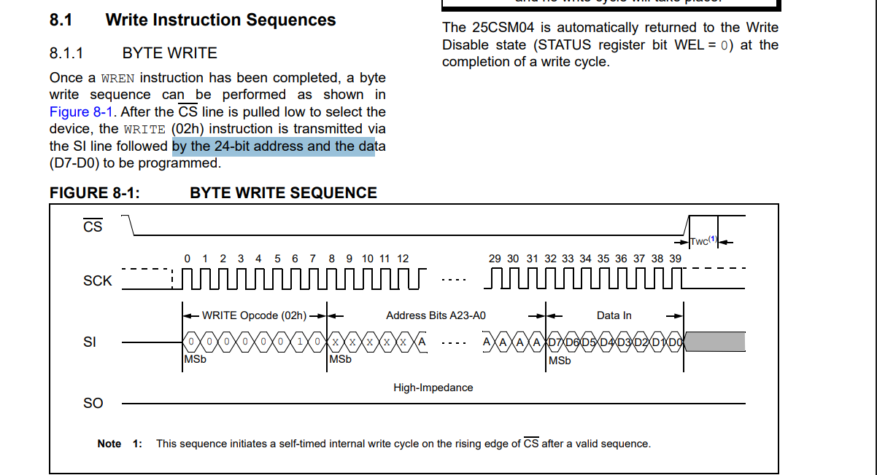

cmd[0] = 0x02; // WRITE opcode

cmd[1] = (addr >> 16) & 0xFF; // A23–A16

cmd[2] = (addr >> 8) & 0xFF; // A15–A8

cmd[3] = addr & 0xFF; // A7–A0