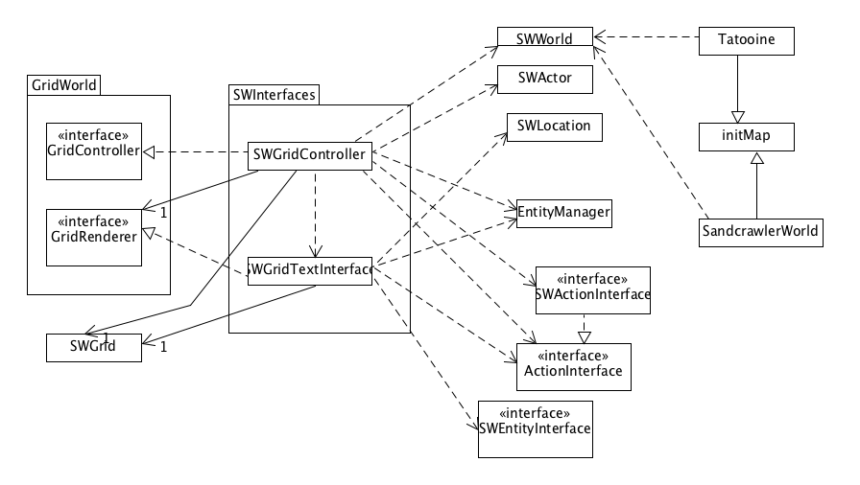

Grid initializing class:

We decided to create an abstract class called initMap that can be used to initialize any new grid. This class is extended by two classes:

* Tatooine : which is the main grid in the game
* SandcrawlerWorld: the grid for sandcrawler

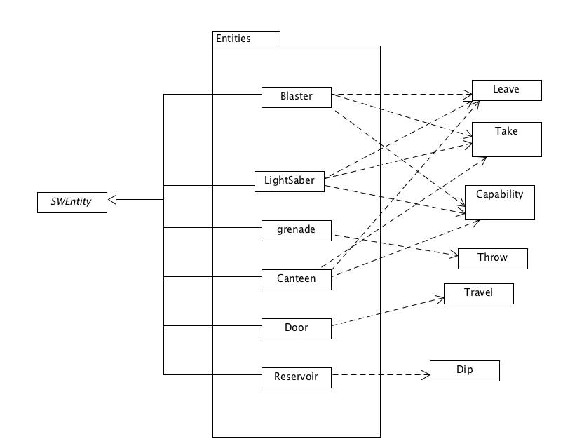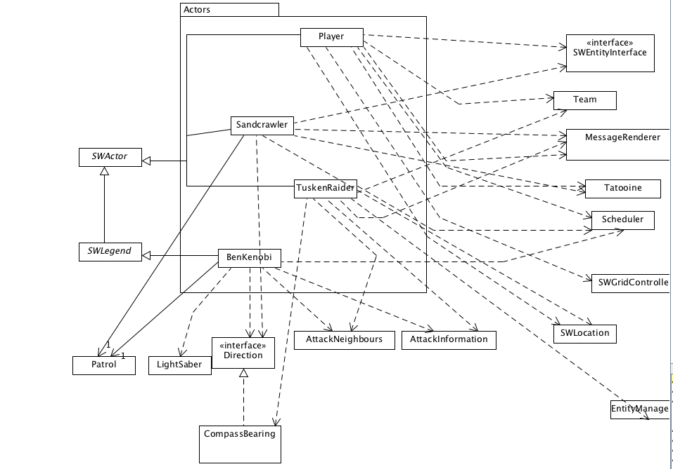

New Affordance Throw:

* This affordance allows the SWActor to throw entities
* It has only been used by grenade
* It cases damages to all entities and actors according to their distance from the location it is thrown at.

New Affordance Travel:

* Allows the SWActor to travel between different grids
* Used by exit and sandcrawler classes.

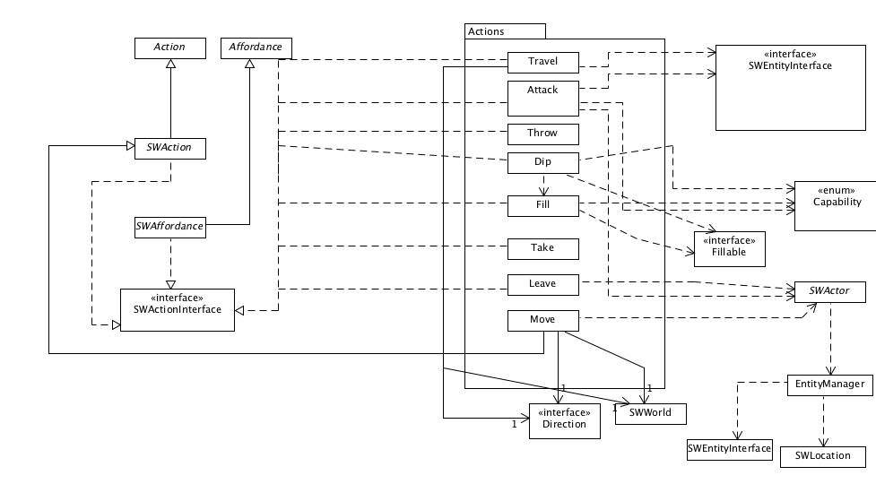

New SWActor Sandcrawler:

* This entity represent the Jawa Sandcrawler and it moves every second turn
* It take any droid in it is same location.