①
So, as we have established: an umbrella software that will handle 6 different modules - the user sees a single interface, but the back-end handles 6 different types of scripts - all based on excel spreadsheets.
The user sees different courses on the offer - behind each course there is a spreadsheet tier 1 (listing the Units and referencing them by folder and filename).
Each unit spreadsheet (tier 2) then is in a folder dedicated to that course. A Unit tier spreadsheet lists the activities (aka exercises) included in that unit. They will be "played" one by one (=line by line in the excel file). Each line will be referencing a specific tier 3 filename. Those tier 3 files will be of one of 6 types.
THAT is where we need those six different ways to handle the spreadsheets (and different formatting of their contents).
I have provided you with 4 of those modules so far: Znawca, Anvil, Sokole Oko, and Ekspert. To make the difference and purpose clearer:
Znawca - is a database of information associated with an itemized list that can be cross-referenced in multiple ways.
Anvil - in a bank of elaborate question/answer sets in multiple formats.
Ekspert - utilizes a more complex matrix of interconnected information (for example not just matching an historical time period to a type of an archeological artifact but also to a geograhic area - at the same time. The learner can be partly right.
Sokole Oko - is a visual patter-recognition trainer based on image-mask pairing. Clicking on a certain area of the image is the answer. For example: can you find a brown frog sitting on a bunch of brown, fallen leaves? Or find the Big Dipper in the image of the night sky?
The remaining two modules that I have not provided yet will be Companion and Direct. I will send the specifications soon.
In the meantime, I will also have to explain the details of this. Talk to you tomorrow. [Grin] The overall total project I have been calling "Augenblick" for about 12 years now, so it's going to be "Augenblick" - with its two foci: "Polyglot" for languages and "Savant" for knowledge. The former one we have been calling "至言". We don't have the name for the other one yet. Any suggestions?

②
And this is the most complex of the 6 engines. So what remains is the "Savant" - which I hope to complete tonight, and the "Augenblick"/"至言" superstructure - either tonight or tomorrow.
Within the "Companion" proposal you will find the technical solutions to the problem of speech recognition and its visual representation. I think this should beautifully solve that problem. [Fist]

③
I think that once you see the main coordinating tool, you will get a clearer picture. I could say that Companion is the speaking teacher (or even a group of teachers) talking to you and explaining things as well as provinding opportunities for practice. The other 5 engines are different types of activities that you may be engaged in: drills, pattern recognition, facts, tests.

Once you have the clear idea about how the engines are unified you will see them as one. There will be one engine missing ("Direct") which I need to give some more thought to. But you can develop everything else leaving the opening for one more engine, no problem.

④
I suggest the following folder structure: course folder — inside six folders (A, C, D, E, S, and Z - for the 6 types of content divided by engine) — specific dataset folders (for example “Lesson 1” under the Companion folder). This will be conveniently uniform and the access path will be kept to a minimum length.
Kaixin, Eureka! I have solved the problem with Znawca. Remember that we did not know how to flexibly formulate the questions to be asked based on different columns? The solution is to let Augenblick handle it in the second-tier excel file. This part here:
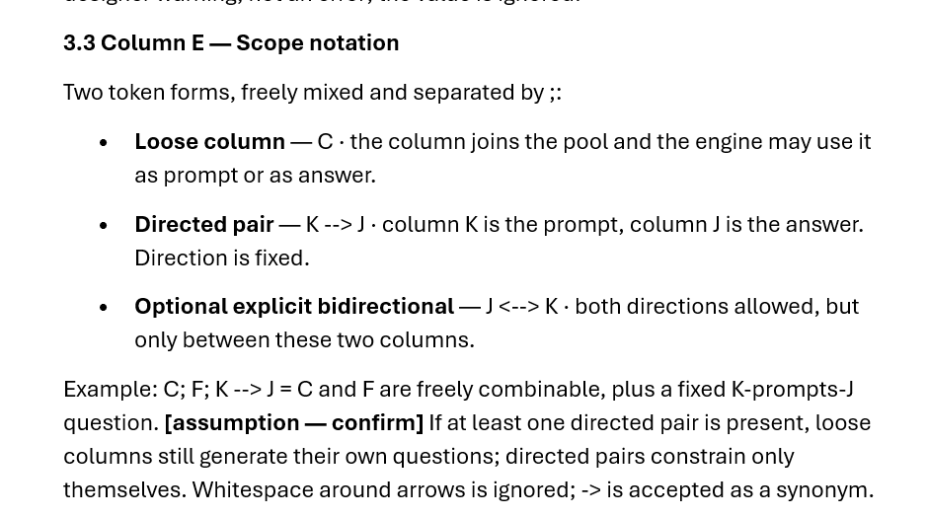
Instead of that, we do this: A: image "What do you see here?"; A: audio "Which species makes this noise?"; A-->B: "What is the latin name of this species?"; B-->A: "This is the latin name of...";

See the beauty of it? Even better: these questions can be different from course to course while still using the same images, audios and dataset! [Fist]

