①
Two additional points here, which are not in the word file: 1) both online and offline versions; 2) the software should also be able to play mp3 and wav files, not just show images.

②
Hello Kaixin,
I am extremely busy these days, having only about 20 minutes to spare, but I use them to slowly explore the software and although I don't know everyhting yet - but I can tell you this:
1) I like your work - it's quite transparent. One of my favorite features is that it informs me very specifically about where there is a problem with the excel or the file naming. Very convenient.
2) I like the feature that mixes different types of questions in terms of both content and style - I think it will be a very helpful thing for a beginner learner.
3) The cost/Your fee - OK.
4) And the look is fine too. :-)
5) I'm having a problem providing answers when the course requires a chemical molecule (for example in H2O the 2 is actually a small 2 at the bottom of the line, and if I type a normal 2 the software does not accept it, so I fail the test even though I know the answer. Can you provide the option of typing those lowered small numbers OR increase the tolerance so it accepts the normal 2?
Now about the feedback thusfar and proposed alterations:
1) I would like to add a neutral column to each excel file (as column A). The content would be a direct reference to audio/image/video file names refered to. Then column B would be the present column A. This means that I could use a single folder with one set of images for all language versions without having to build the same dataset under different names.
2) Then the excel file name would have to have a suffix with a language indication, for example Birds_Eng.xlsx and Birds_Ru.elsx etc. The name of the excel file would mnatch the name of the folder. The name of the course that the user would see would be in the spreadsheet in column A row 1 - in each file that could be a different language.
3) Layout: the colors are great. Let's get rid of the scrolling though. Let's place 4 images (or audios) clustered together as
[1] [2]
[3] [4]
This will be more convenient.
4) I would like to add a feature for naming of columns in excel files - some kind of a rare symbol in row 1 that would indicate that the column can be only used as a question, or only as an answer. Maybe $ or * or something like that.
My concern is that - for example - if the information about the feeding habits of a bird says, "eats seeds" and the software asks: "What kind of bird eats seeds?" - there could be a 100 posssible birds that do that. So "seeds" should be an answer to an image, or bird's name, or the sound of its voice.
But if the question is "seeds" then the olny reasonable situation would be a choice question in which the software makes sure that all the other options are wrong answers.
Or maybe you have already done that and I haven't found out yet.
In any case, the function might be useful in some future projects anyway.
5) Also, I'm thinking of adding a little "loudspeaker" icon to each answer button and all the question lines. This way the learner gets a chance to hear how everything sounds when it's spoken.
The relevant audio files would be in the same folder with the images/videos/audios, but they would be named differently: simply the name of the cell in the excel spreadsheet - individual names like C4.mp3 etc.

OK. That's it for now about "Znawca".

③
Hello Kaixin, a few more words on "Znawca": yesterday I mentioned the loudspeaker icon and the audios with the content matching each cell - one thing I forgot to say is:
I would like to indicate correct and incorrect answer with a short jingle (I can create that as a universal audio response (correct.mp3 and incorrect. mp3),
but regardless of whether the learner gives a correct answer or not - after that audio indicator the software should automatically ALSO play the audio content of the correct answer (reference to the relevant cell in the excel chart).

④
for "Znawca: as a new question shows up, let the software play the audio associated with the cell of the question (unless it's already an image, an audio or a video). So - for thext-based questions.

⑤
Two other things for "Znawca": 1) the progress bar at the top (questions asked, etc.) is not very useful. It would be more practical if we counted questions total vs. questions mastered vs. questions remaining. 2) If we have a question like: "What does this species eat" and the answer box has: "insects; worms; small mammals" - the software should allow for a changed order (like: "small mammals, insects, worms" - accepting also a comma, because this is not critical knowledge so we don't have to be iron-strict in this case).

⑥
Hello Professor, I just wanted to check in about lunch this weekend. I’m still available at noon on both Saturday and Sunday, so please feel free to choose whichever day and time are most convenient for you.I’m also looking forward to meeting you and your wife. If you already have a place in mind, just let me know.
I am currently reviewing the requirements for Znawca and Anvil in greater depth. Because they share several learning, testing, and multimedia features, I previously considered whether they could be combined into a single product. I now understand more clearly why you proposed two separate products: Znawca turns existing learning materials into exercises, mainly for personal and family use, while Anvil allows you to design complete courses for publication and sale to other learners. Their use cases and content-creation processes are different, so developing them separately makes more sense. I am continuing to refine the requirements and implementation plans for both projects based on this understanding.
During the initial development, I had already considered the answer ambiguity issue you mentioned. The current system checks whether a reverse relationship is unique. If several birds are associated with “eats seeds,” the system skips that reverse question, avoiding an incorrect result in which only one of those birds is accepted.

However, it cannot currently generate a multiple-answer question such as “Select all birds that eat seeds.”

In addition, the current question-generation logic is centered on item names. It supports two-way questions such as “country ↔ flag” and “country ↔ national anthem,” but it cannot directly test relationships between attributes or media, such as “flag ↔ national anthem.”

Since reverse multiple-answer questions and direct questions between attributes were not included in the original requirements, I kept the initial version within the agreed scope to avoid expanding the project without prior confirmation. If you need either of these capabilities, I can design an appropriate solution and include it in a future version.
I therefore think the special column-header markers may not be necessary.
Hi Kaixin! How about meeting on Saturday at about noon then? I'll let you know where a little later.
of course
During the initial development, I considered the compatibility of correct answers. The system already supports multi-part answers in any order, case-insensitive matching, and tolerance for leading, trailing, and repeated spaces. However, I had not considered the issue of subscripts in chemical formulas that you mentioned, and I will include it in the improvements.

Regarding answer separators, the initial requirements specified the use of the standard semicolon (`;`), while in your later feedback you also asked for commas to be accepted when answering. Supporting common separators is not technically difficult, but I suggest defining a clear boundary to balance convenience with consistent rules: Excel files should always use the standard semicolon (`;`) to separate multiple answers, while learners may use either standard or full-width semicolons and commas when answering: `;`, `；`, `,`, or `，`. Symbols with potentially ambiguous meanings, such as slashes, would not be treated as separators. Would you agree with this rule?
Yes, that sounds reasonable.
No problem. Let's not expand it, as it's not necessary. But I would like to discuss another issue:
I should also mention that the system cannot automatically recognize synonyms or alternative names as equivalent—for example, “China” and “PRC”—unless both are explicitly included as accepted answers in the Excel file.
Let's say we have 4 kinds of frogs (to make it easy I will use colors here). Each one of them lays a different number of eggs. The software may ask: "Frog Blue" + "How many eggs does it lay" by combining a specific cell from column A and the content from cell 1 of column O. But if it shows all four frogs as "a) Frog Blue; b) Frog Yellow; c) Frog Red; d) Frog Green" - then the questions should be "Which one lays this many eggs?"... Can we get this by splitting cell O1 with a slash? like: "How many eggs does it lay? / "Which one lays this many eggs?"
Yes... I think that ties to my question: can we make alternatives? Soe species have two different names in use, so perhaps we could split the cell with a slash too?
In that case the learner does not provide BOTH options as an answer (like in case of different foods) but ONE of the answers.
Doable?
Yes, this is doable. We can define semicolons as separating required answer parts, while slashes separate accepted alternatives within the same part. For example:

`China/PRC; Asia`

The learner must provide `Asia` and may provide `China`, `PRC`, or both. All three forms—`China; Asia`, `PRC; Asia`, and `China; PRC; Asia`—would be accepted as fully correct.
Super.
At present, the question wording is taken directly from the Excel column heading. For example, the software may display “Population” with the answer “100 million.” When the heading is only a short label rather than a complete question, the learner may need a moment to understand what is being asked.
I am going to give you some feedback on the language of the interface later. There are some minor issues there. For example, I understand why it's translated the way it is (there is some logic to it) but some of the translations have unintended funny meanings, so I'll have to make a list of those and get back to you. Also, instead of "Identify the object" we could include that question directly in the first row: "What species is it?"
Right. Hence my question.
This problem is very difficult to solve purely through programming, unless we introduce a large language model API — but that would require an internet connection and long-term expenses.
OK，I get it
Umm... I don't think it's that complicated. We could solve it by dedicating the first TWO rows to it instead of one: one for the situation where the column is the question, and one for when the column is the answer.
Or by splitting it with a slash.
I misunderstand your requirement.No need for an API[捂脸]
A slash is enough.
For example: Which country does this flag belong to? / Which flag belongs to this country?
Yes!
How about detecting files correct 00.mp3 correct 01.mp3 etc. & incorrect 00.mp3 etc. in the course folder? They would be played at random after the answer is given by the learner.
This is easy to implement
I would like to confirm one point about how multimedia files should be associated with the Excel data.

In the current version, multimedia files are associated with the object represented by an entire row, rather than with a specific property cell. For example, several pictures of the French flag, the Eiffel Tower and a French national flower could all be associated with “France.” The software would know that they all belong to France, but it would not know which picture represents the flag, the landmark or the flower. In other words, the original model uses multimedia to identify an object and then asks about that object’s properties; the multimedia itself does not represent a specific property.

Would you now prefer multimedia to be associated with individual cells instead? For example, the “Flag” cell could refer to one or more pictures of the French flag, while the “Landmark” cell could refer to pictures of the Eiffel Tower. When the software detects a media reference in a cell, it would display or play the file instead of showing its filename as text, and it could use it to generate the corresponding multimedia question. Different image formats, such as JPG, PNG and WEBP, could appear together as options.

It may also be useful to allow one cell to refer to several files of the same type. For example, a bird-name cell could refer to photographs of an adult bird, a juvenile bird, the bird in flight and the bird at rest. Each photograph would represent the same correct answer, and the software could randomly select one for each question. Likewise, a flag cell could contain several views of the same flag; these would be alternative representations of one answer and should not be used as distractors against one another.

Could you please confirm:

①Should multimedia be associated with specific cells rather than only with the object represented by the whole row?

②May one cell refer to several files of the same media type, with one selected randomly for each question?

③Could one cell ever refer to different media types at the same time, such as both an image and a video?

⑦
Let's change "Inteligentna partia" to "Inteligentnie dobrany zestaw pytań"; "Całość od razu" --> "Suma obecnych projeków"; "Trudne elementy" --> "Napotkane trudności";

Let's change "Ścisły" to "Wymagający" (with the finer print below: "Odpowiedzi nieprawidłowe podobne do prawidłowych") and let's keep "Łagodny" but change its fine print to "Silniejszy kontrast między odpowiedziami prawidłowymi i nieprawidłowymi". Let's chage "Styl nauki" to "Styl nauczania".



Instead of "Identify the object" we can use the first cell from the column with the name of the species, let's say: "What species is it?" (which in other courses would be "Which country does this flag represent?" or "Who is the author of this painting?")

This "Pominięte"... let's change it to: "Twoja błędna odpowiedź:"

I am not convinced this is right. How about: "The entire set"

Let's change the fine print below to: "Incorrect answers similar to correct answers" & "Incorrect answers clearly different from correct answers"


Let's get rid of "missed" in all language versions. And change "extra" to: "Your incorrect answer was:"
I will have to consult the Arabic and Russian versions with experts, as I'm not competent enough myself.

①Should multimedia be associated with specific cells rather than only with the object represented by the whole row?

②May one cell refer to several files of the same media type, with one selected randomly for each question?

③Could one cell ever refer to different media types at the same time, such as both an image and a video?

Those are great questions. Also, what really made me think is what you said here: "I previously considered whether they could be combined into a single product. I now understand more clearly why you proposed two separate products" - I think there is a way to do that, and I even have a rough concept. Let's talk about this at the table. [Grin]

⑧
Kaixin, a few more words of feedback about "Znawca". When the software gives me the name of the species and 4 images to match - and I mismatch, I get useless feedback that is just a mess.

How about showing a tiny picture (of the correct answer) there instead.
Also, I don't understand why the software is rejecting this course:
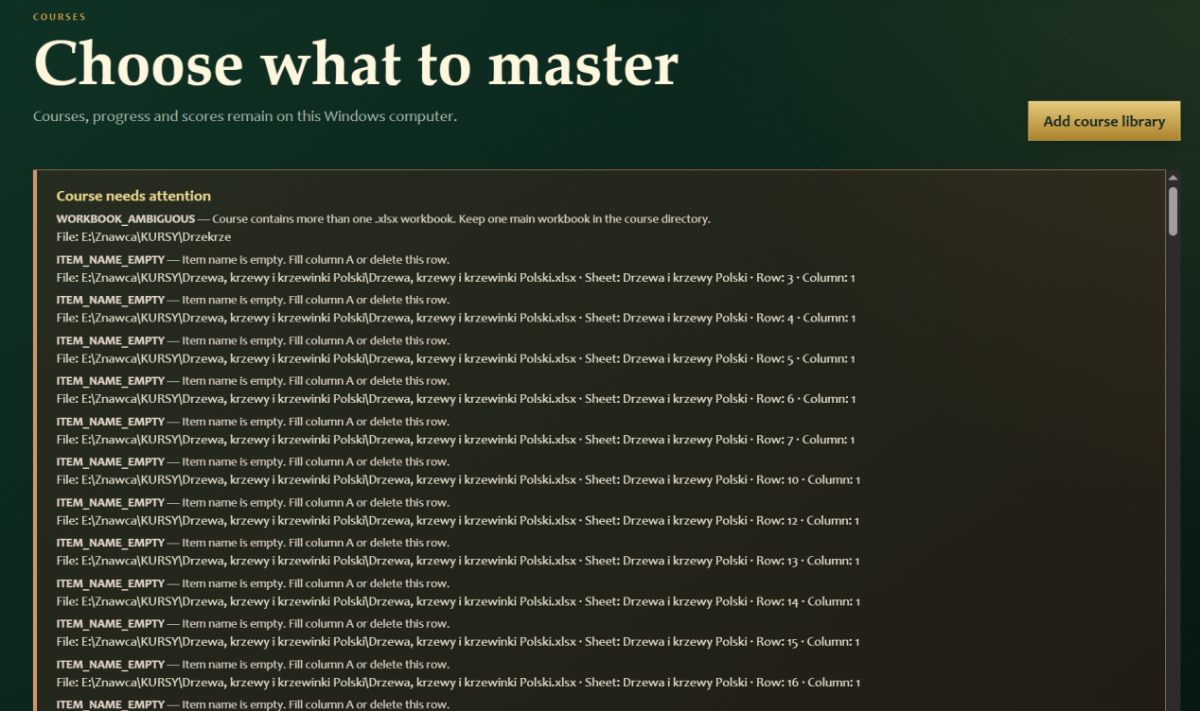
It says: "WORKBOOK_AMBIGUOUS — Course contains more than one .xlsx workbook. Keep one main workbook in the course directory." - but there is only one workbook. I even went to the trash bin and deleted all the older versions. ??? It also says that the "ITEM_NAME_EMPTY — Item name is empty. Fill column A or delete this row." - it's not empty. I am sending you the folder.
I am puzzled...
I have tested another thing though - the program is tolerant of longer numbers in the filename, which is great because some items will have a lot more pictures than 99. [ThumbsUp]

