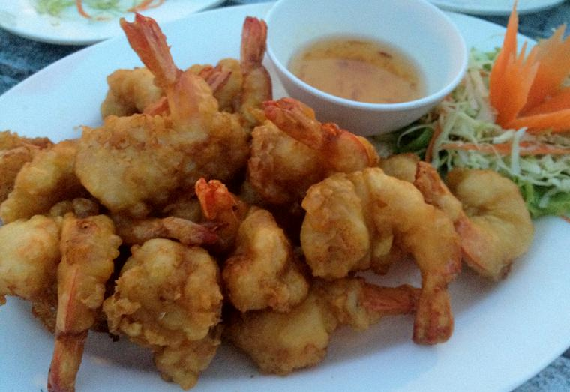 |  |  | 
Gung chup bang tawt 89บ. | Gung pow 180บ. | Bpaa chup bang tawt 69,129บ. | Bpuu pow nung(steam) 180,320บ.
 |  | 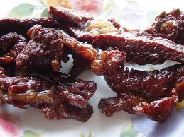 | 
Hoi kang pow 80บ. | Khao paat bpuu 49,89บ. | Nua daet dio 100บ. | Hoi waan pow 89,160บ.
 |  |  | 
Yaam khai kem 50บ. | Yam bpuu gerd 60บ. | Dom yam gung yai 60, 120,169บ. | Dom yam la chon 80บ.
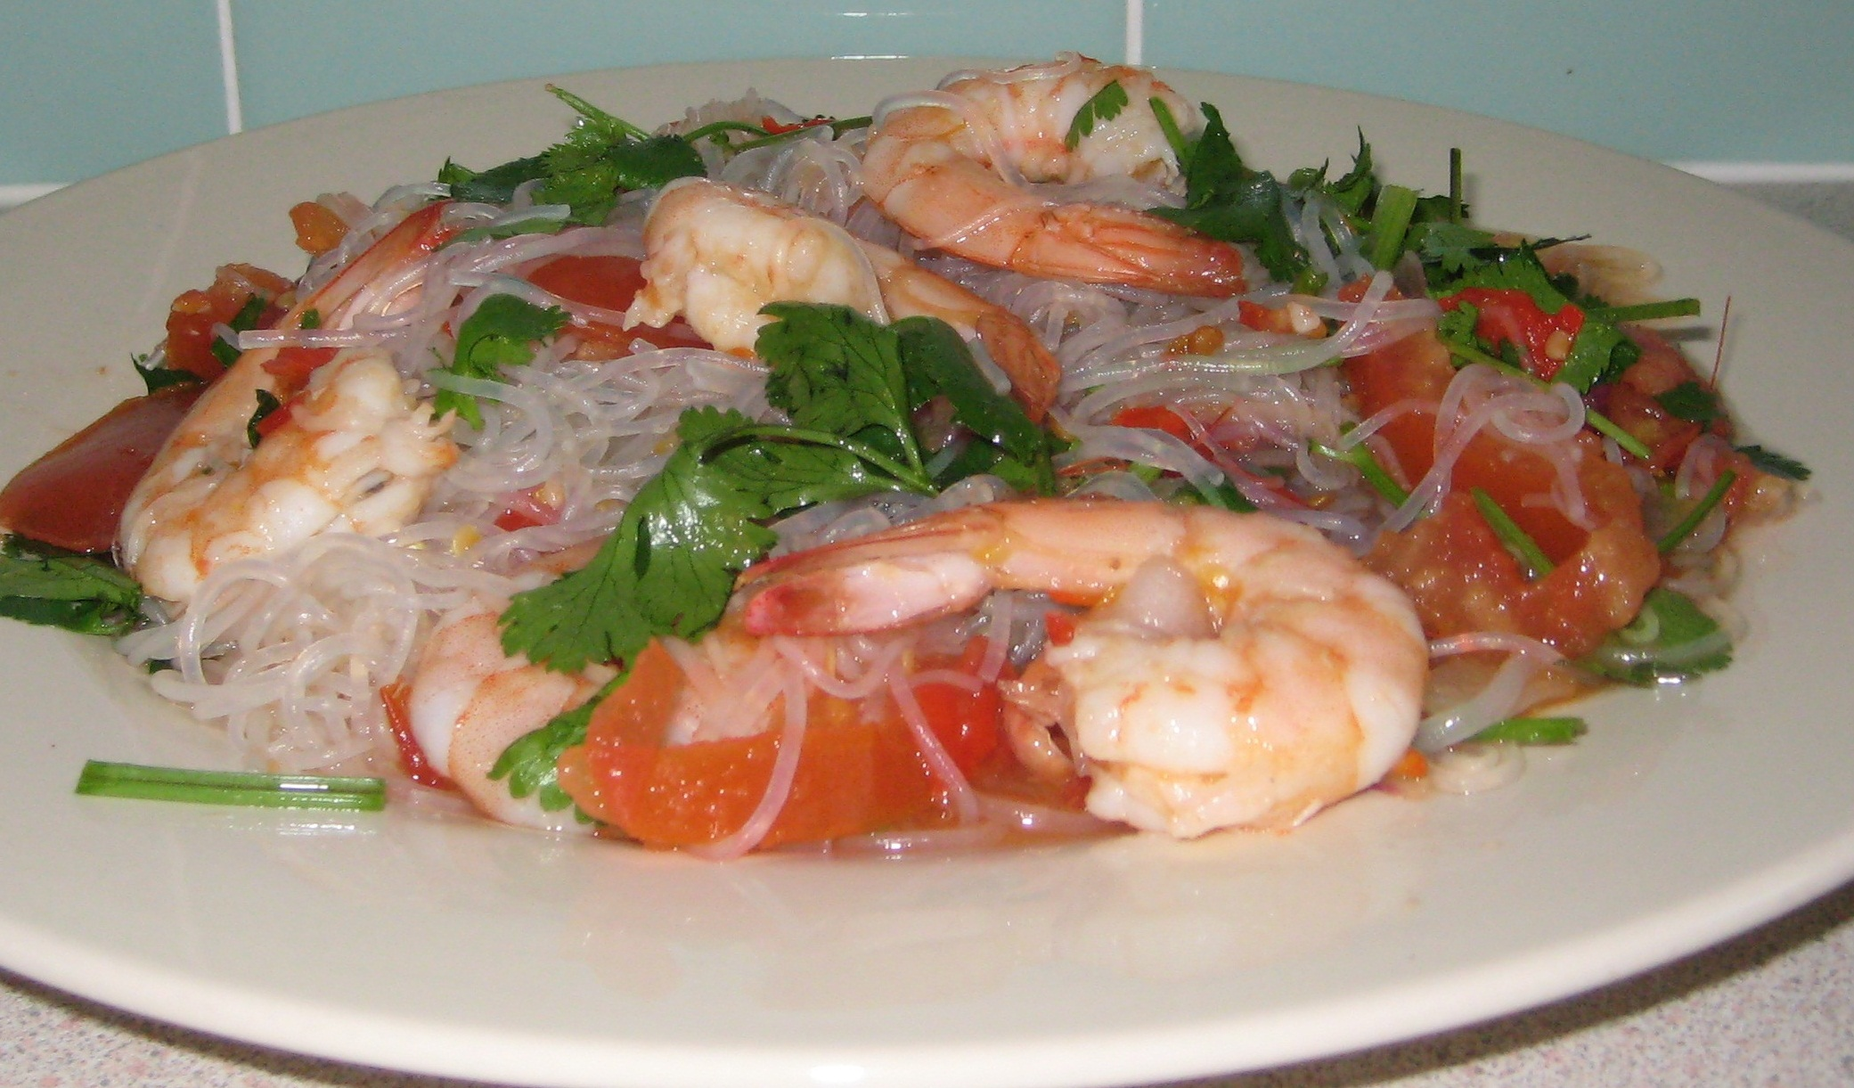 |  |  | 
Yaam woon sen 80บ. | Hoi nang rom 120บ. | Gai bawp 50บ. | Yaam kai yeo maa 50บ.

