This code and manual are modified from: <https://github.com/Eurybiadan/Confide>

Contents

This code and manual are modified from: 1

Prepare 1

Inputs 1

Scaling file 1

Images 1

Running the Program 2

File Interpretation 2

Confide-master_montage_mode_density_info.csv 2

coordinate_analysis_coordstats_xxxum_box.csv 3

Prepare:

Inputs:

1. A scaling file (LUT.csv).
2. Images (.tif format)

Scaling file:

The scaling file can be made with .csv, which can be created from EXCEL and export as .csv format, and should consists of three columns:

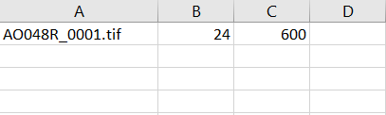

* ID column (example: Column A: AO048R_0001.tif)
* Axial length column (in mm, example: Column B: 24)
* Pixels per degree (example: Column C: 600)

Images:

The images should end in .tif format only (Not .tiff format) with the same naming as in the LUT.csv A column. All should be saved inside etc folder.

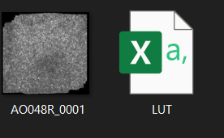

If doing montage mode, instead of saving in etc folder, save it in montage_crop folder. For every montage image, LUT table will automatically update the first-time selected reference point as future reference. If wish to reselect the reference point, you can go to the LUT.csv and delete the fourth and fifth column.

# Running the Program

Open cone_counting.m within MATLAB and run it.

If doing montage mode



Set montage_crop to 1, otherwise, set montage_crop to 00

The images within the etc folder will be displayed in a random order.

For each image:

* Left click on the image to mark a cell.
* Right click on the image to remove a cell.
* Move the red slider bars on the histogram window to adjust the brightness and contrast of the image.
* Press 'L' to switch the image between log and linear contrast.
* Use the (+/-) keys to zoom in and out.
* Press Tilde ( ~ ) to remove ALL found cones

There is a progress bar provided that will show how many images remain.

# File Interpretation

## Confide-master_montage_mode_density_info.csv



Most of the column name is self-explanatory. The density is in the unity of mm^2.

## coordinate_analysis_coordstats_xxxum_box.csv

The digit before the um is determined by the micron box size. And the Micron box size is calculated by image size x microns per pixels.



Mean N-N:

The mean distance between cell to cell.

Mean Voronoi Cell Area:

In Mathematics, a Voronoi diagram is a partition of a plane into regions close to each of a given set of objects. In this case, it is the averaged Voronoi diagram area of any given cell being found in the retina image.

Bounded Cells:

Bounded cells are the cells are surrounded by the other visible cells in the image. We are using this to exclude the extreme of the Voronoi Cell Area calculation.

DRP spacing:

DRP stands for density recovery profile, which is a plot of the spatial density of a set of points as a function of the distance of each of those points from all the others. In general, this indicates a cell spacing measurement.