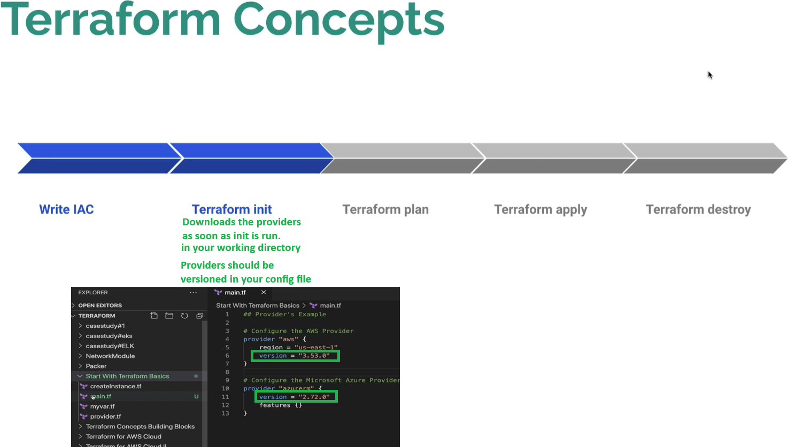

Centralised File for Providers and Credentials

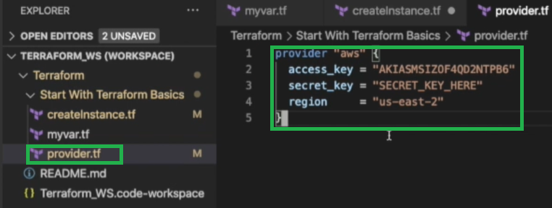
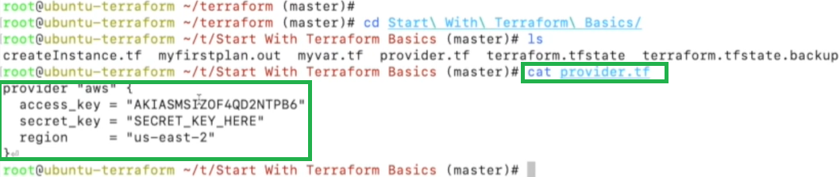

Because Terraform reads all the files within the folder, it picks up the “provider.tf” file information when you run “terraform init” so you do not need to provide that information each time in the code file.

Need to make sure you don’t have the credentials in any other documents
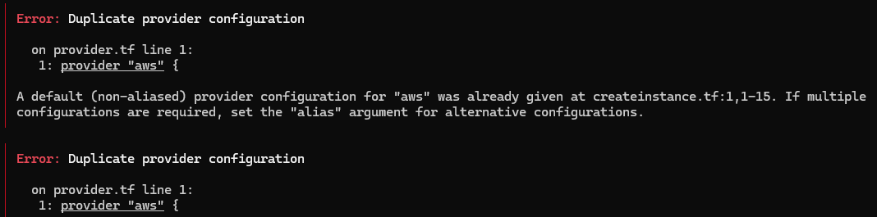

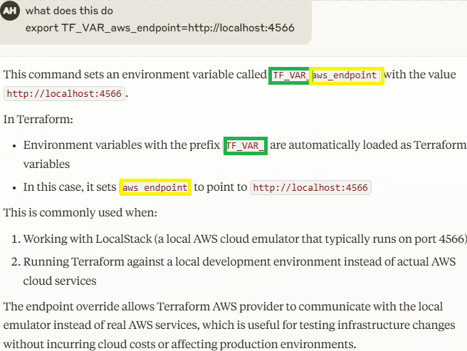
Environment Variables

AWS Config

export AWS_ACCESS_KEY_ID="test"
export AWS_SECRET_ACCESS_KEY="test"
export AWS_DEFAULT_REGION="us-east-1"

AWS CLI

export AWS_ENDPOINT_URL=http://localhost:4566

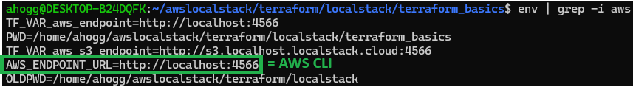

aws ec2 describe-instances \
--query 'Reservations[*].Instances[*].[InstanceId,Tags[?Key==`Name`].Value|[0]]' \
--output table \
--endpoint-url=http://localhost:4566
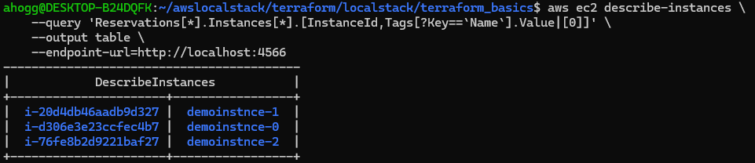
Providing Credentials with environment variables so that they are independent from the directory structure.
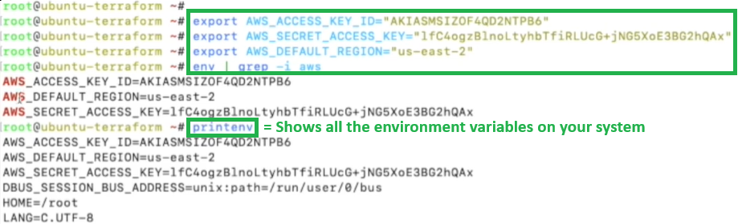

Now that environment variables are set you can remove the “provider.tf” and do not need to create a “provider.tf” file in each directory.
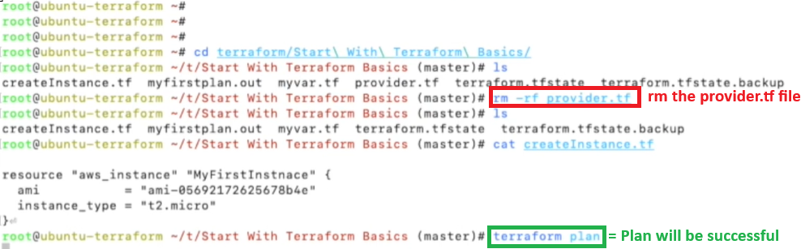

For localstacks – setting environment variables

export TF_VAR_aws_endpoint=http://localhost:4566
export TF_VAR_aws_s3_endpoint=http://s3.localhost.localstack.cloud:4566

env | grep -I aws
printenv
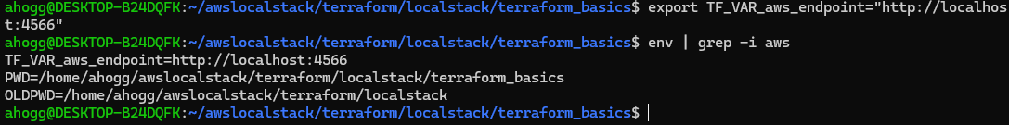
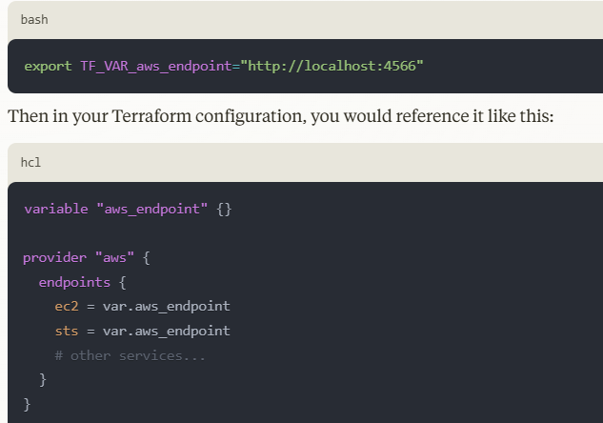
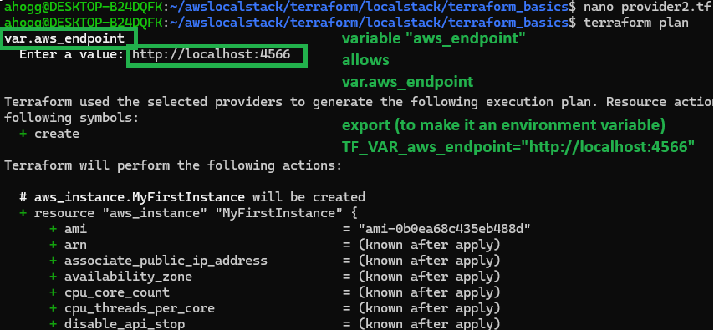
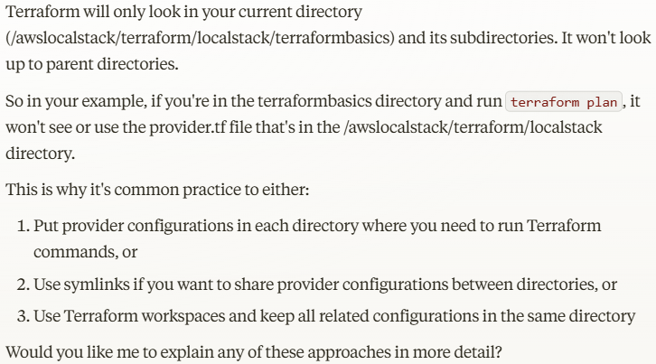

Linux Environment Variable Example

Test 1 = Works Ok
Provider2.tf terraform plan (fails)
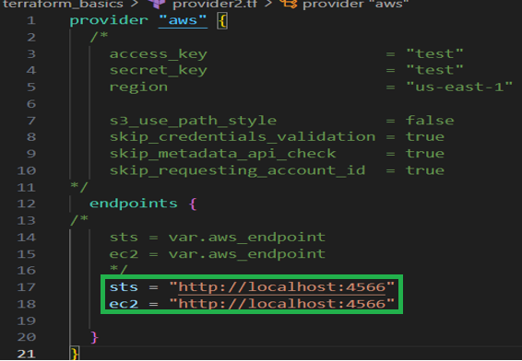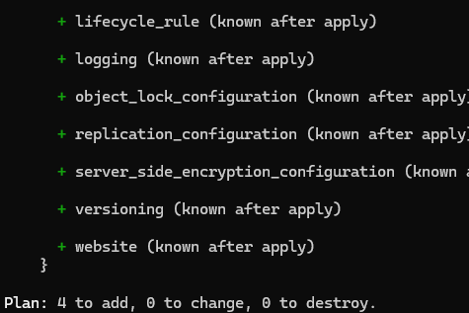

Test 2 (Failed) – because we have not environment variables for "http://localhost:4566”
Provider2.tf
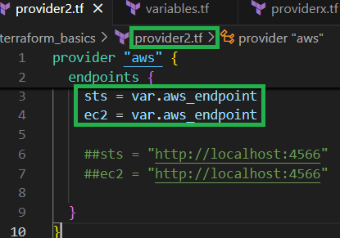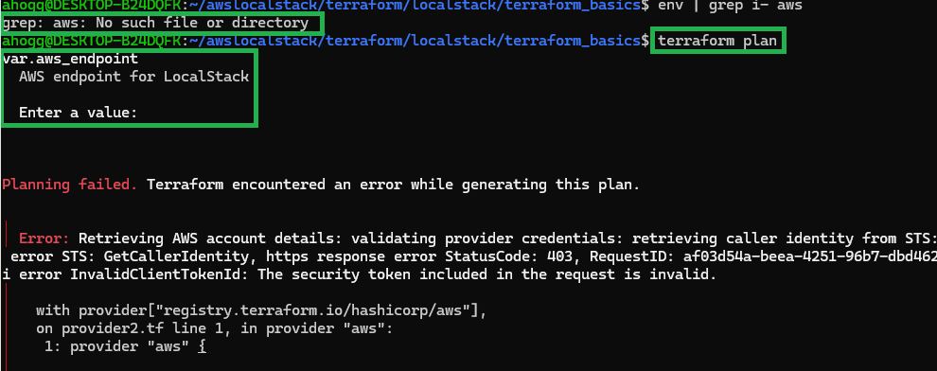

Test 3 (Successfull) – because we added the following environment variables – “http://localhost:4566” with” export TF_VAR_aws_endpoint=http://localhost:4566
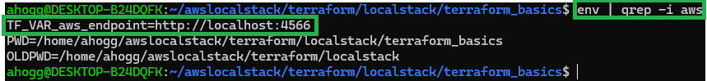
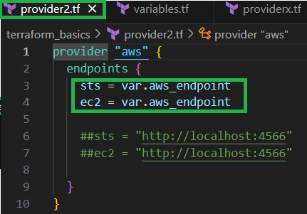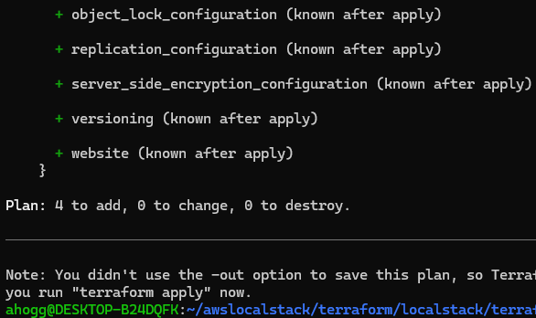
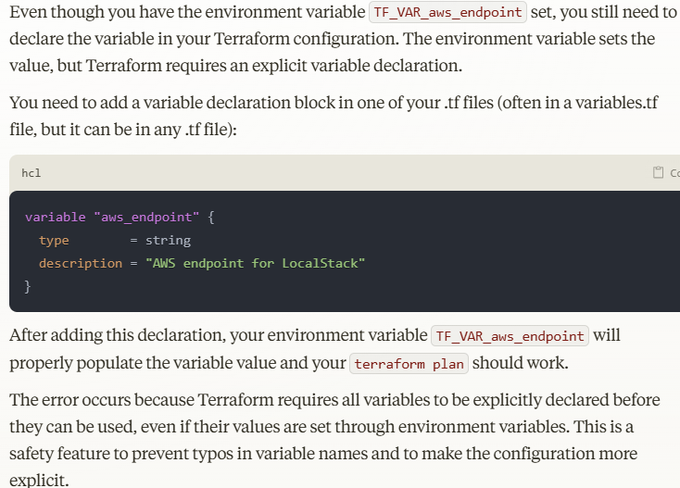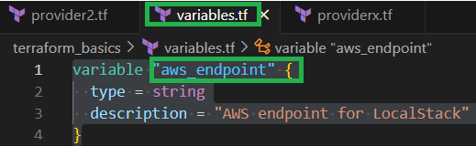

Note on LocalStacks

Looks like you don’t need to privide the access_key stuff for localstacks
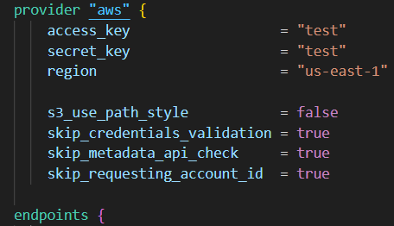
The following error is because this was missing - s3 = "http://s3.localhost.localstack.cloud:4566"
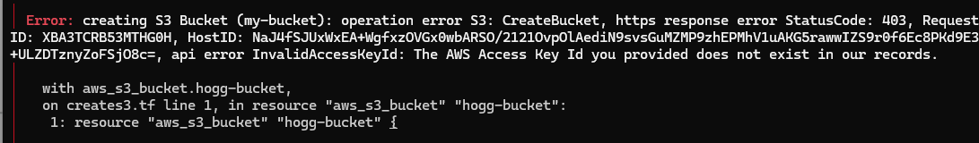

export TF_VAR_aws_s3_endpoint=http://s3.localhost.localstack.cloud:4566
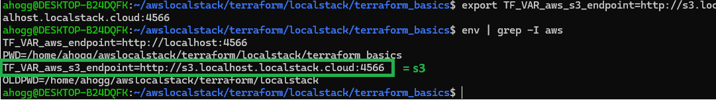

Don’t forget to declare it in the variables.tf file
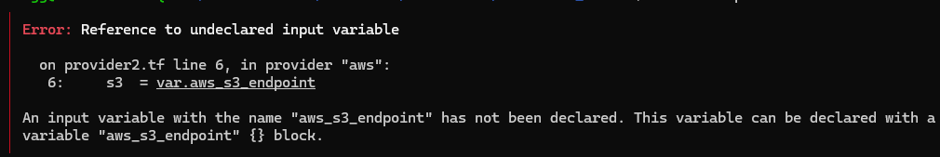

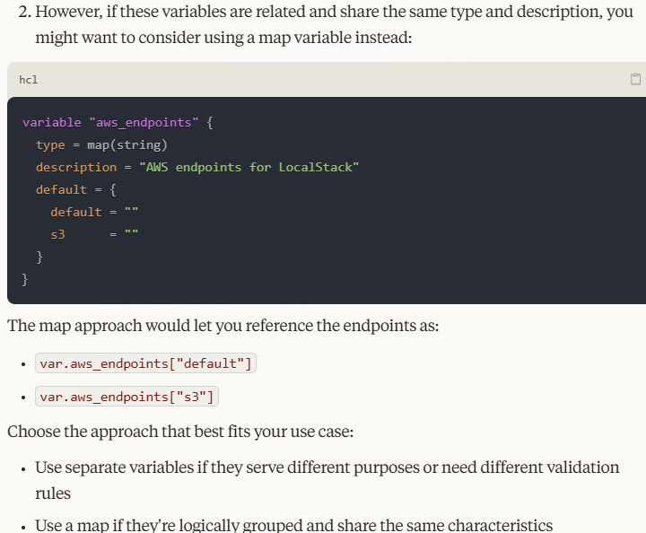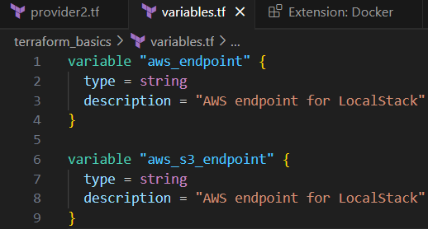
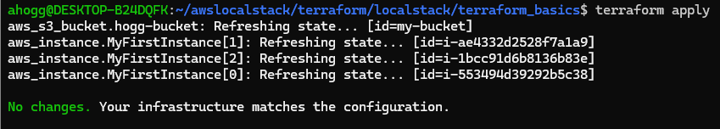

Create Resource s3

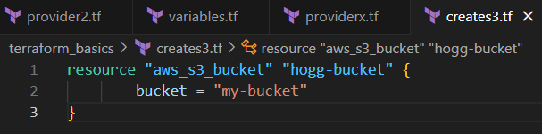

Create multiple EC2 Instances

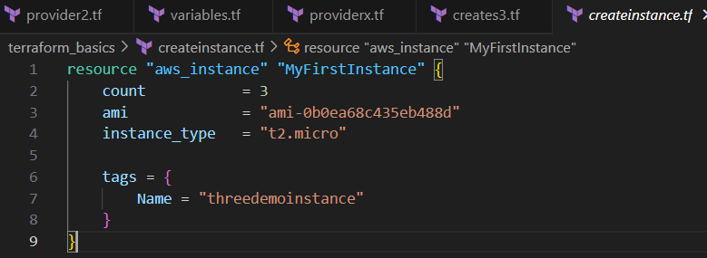
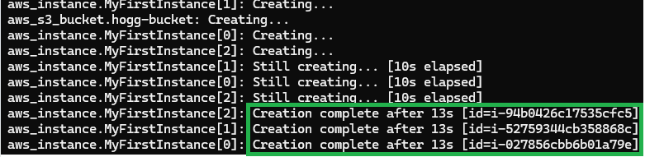
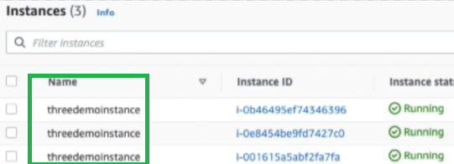

$ = Dynamic Value

To differentiate the name of the three instances so that it dynamically creates names related to the instance count.

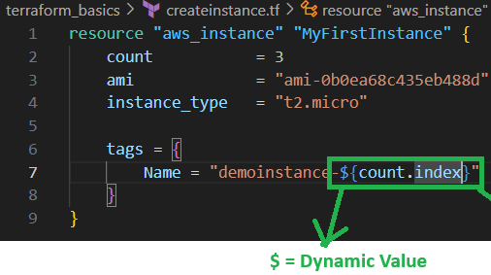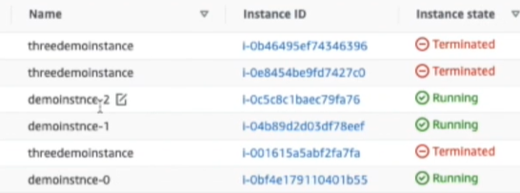

aws --endpoint-url=http://localhost:4566 ec2 describe-instances --no-cli-pager
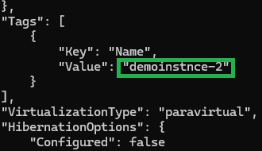
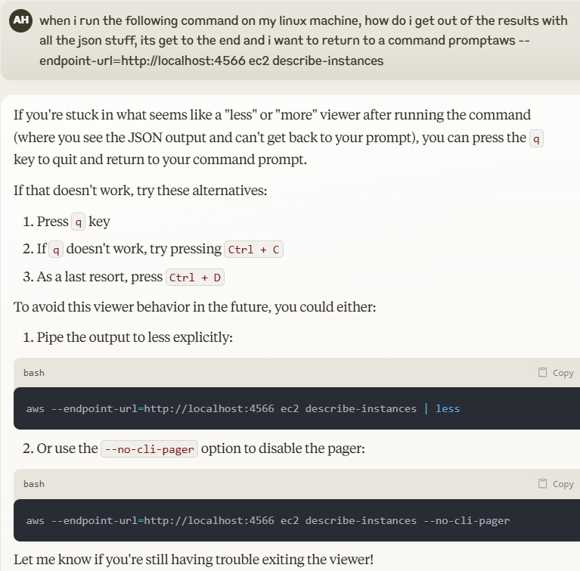

Or

aws ec2 describe-instances \
--query 'Reservations[*].Instances[*].[InstanceId,Tags[?Key==`Name`].Value|[0]]' \
--output table \
--endpoint-url=http://localhost:4566



Terraform State File – Like a database of resources

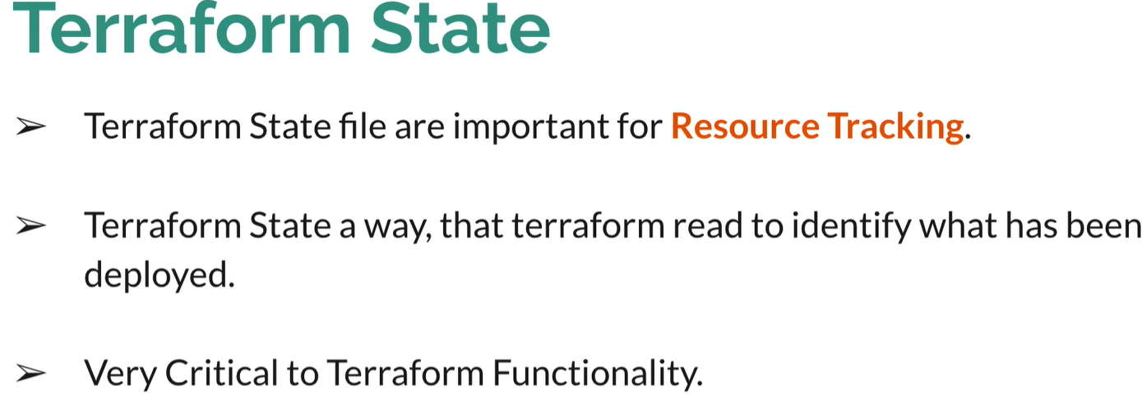
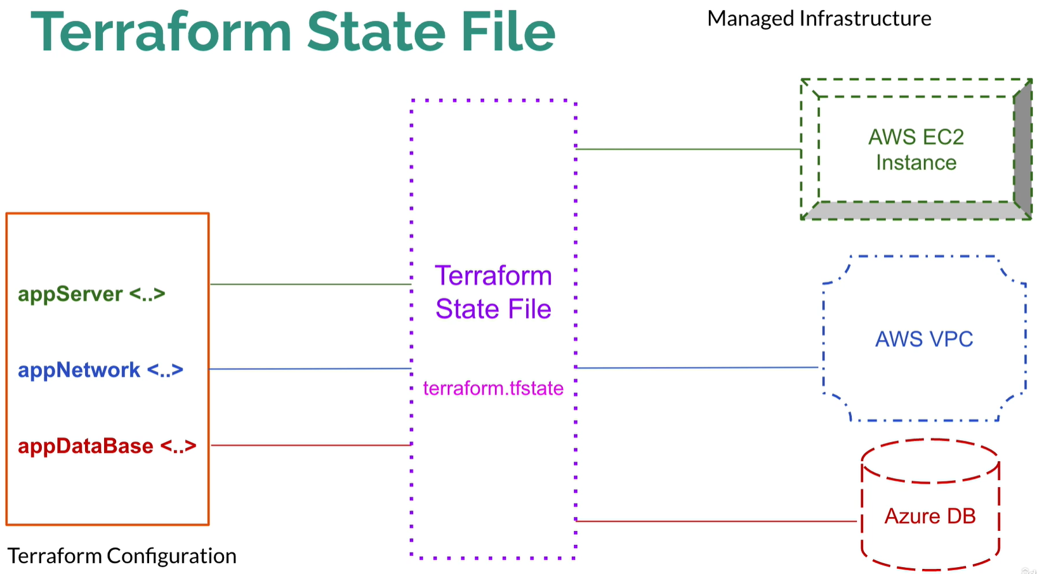
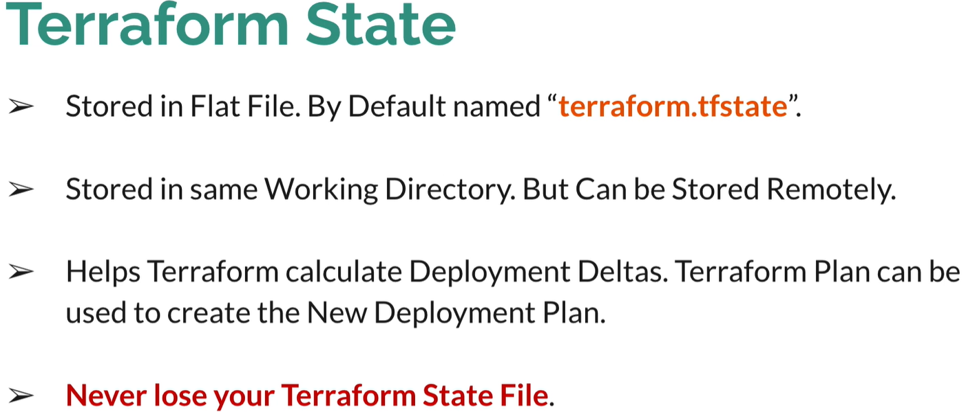
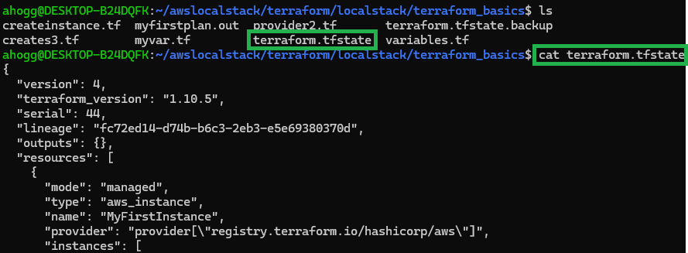
After Terraform destroy
