Variables in Terraform

All values need to be configurable so users can pass in the variables outside of the configuration file.
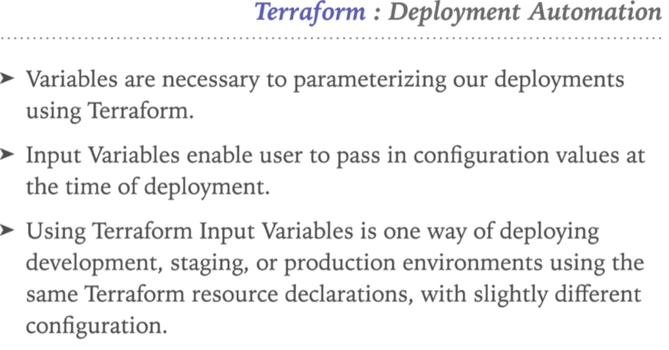
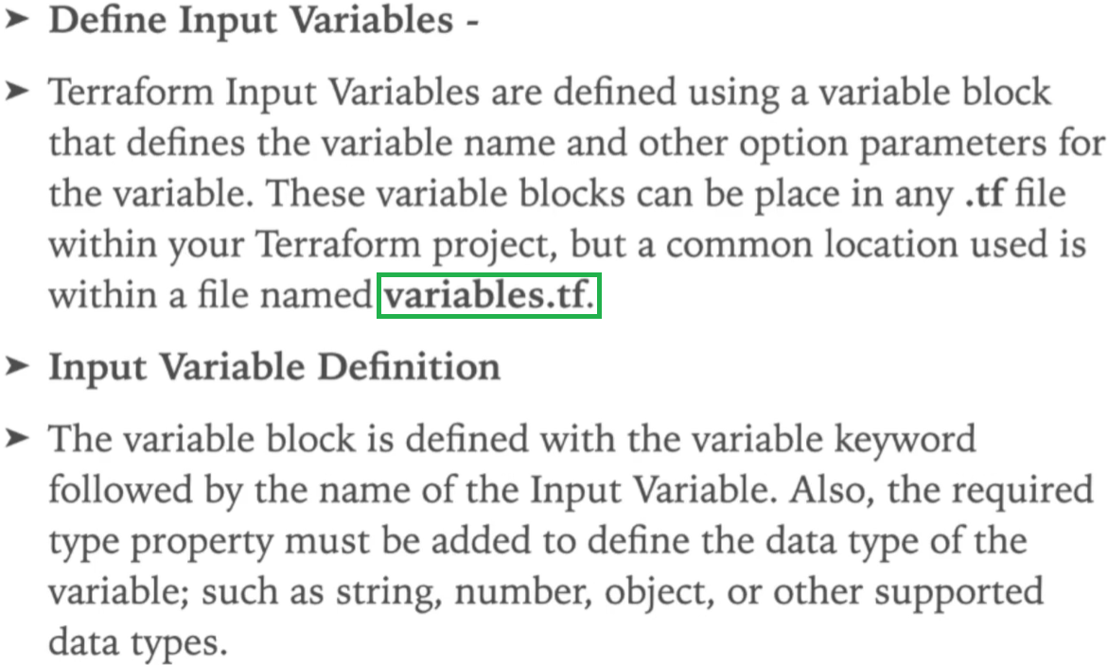
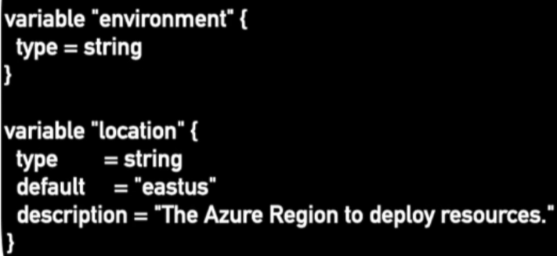
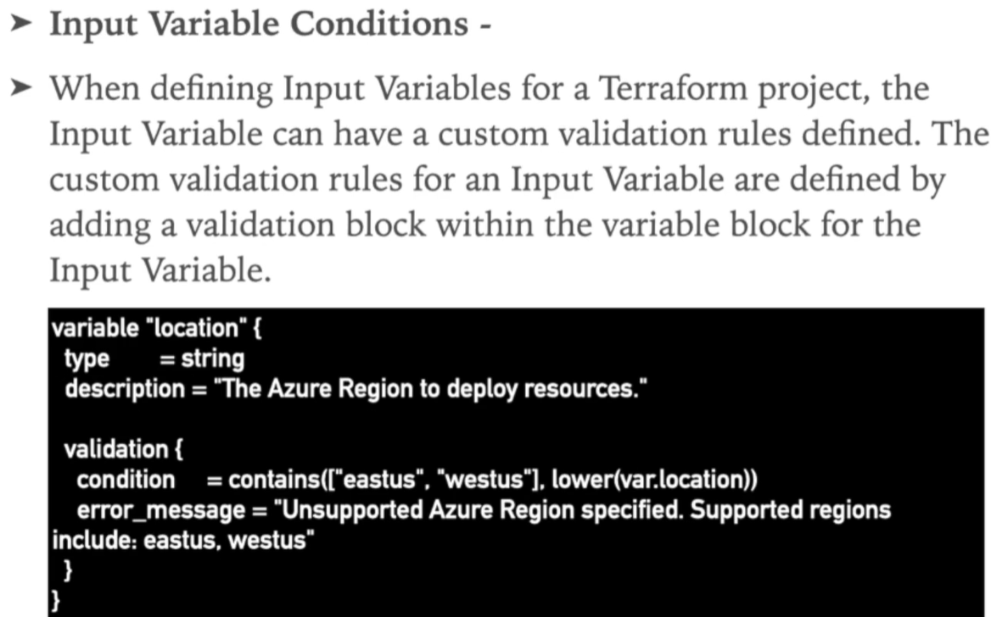
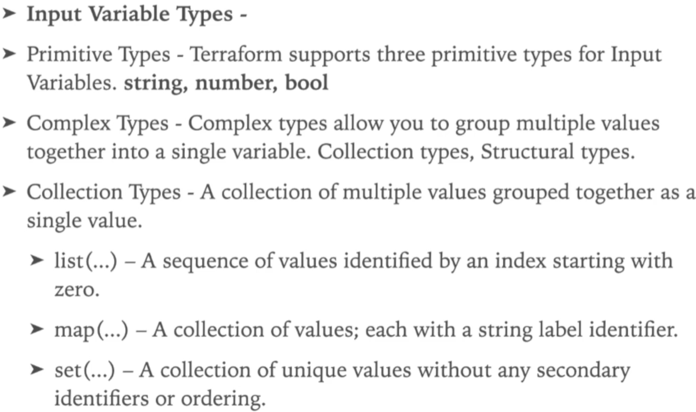
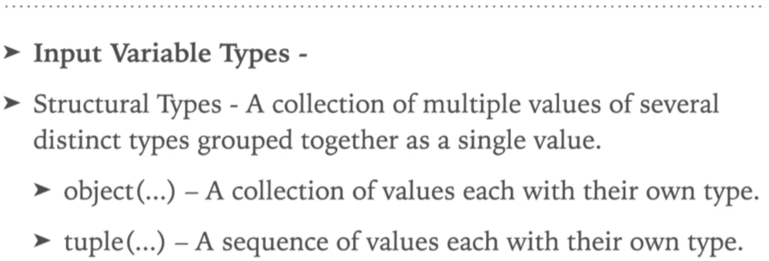

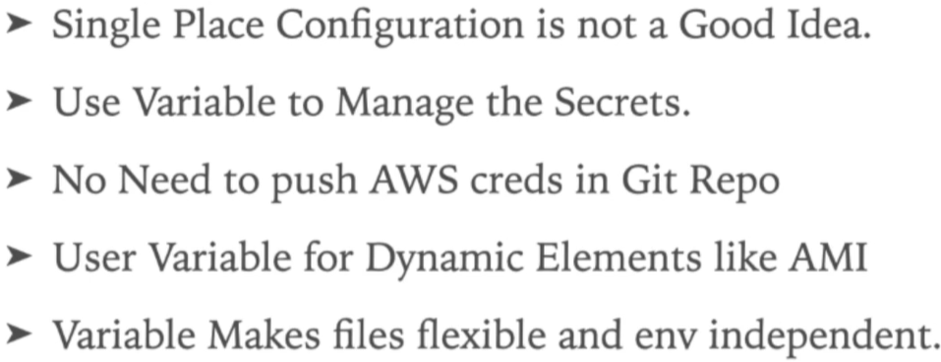

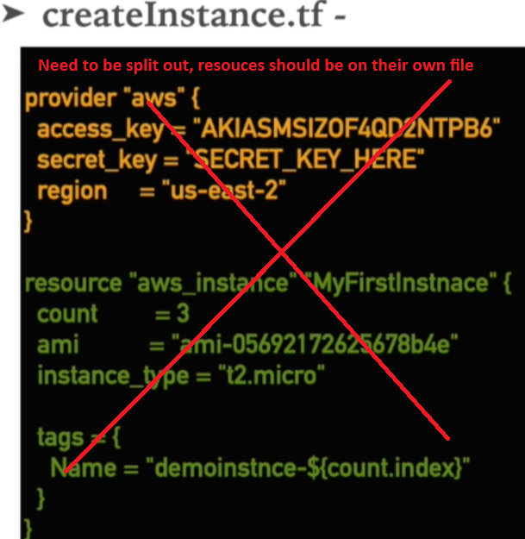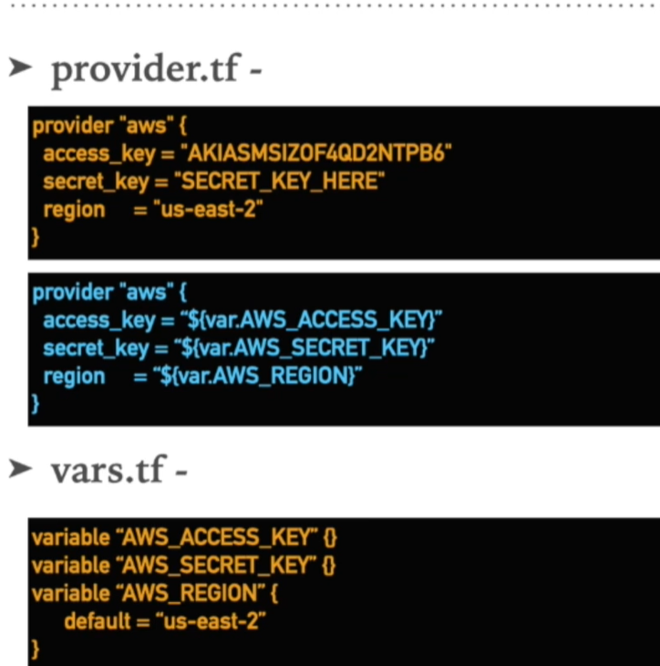
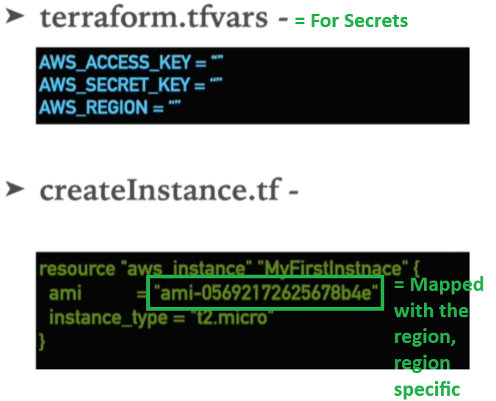
Three Ways to Supply Variables

Way 1 = Prompted

If you do not define the variable in any file it will prompt you for the variables when “terraform plan” is run

Create the Resource file “createinstance.tf”
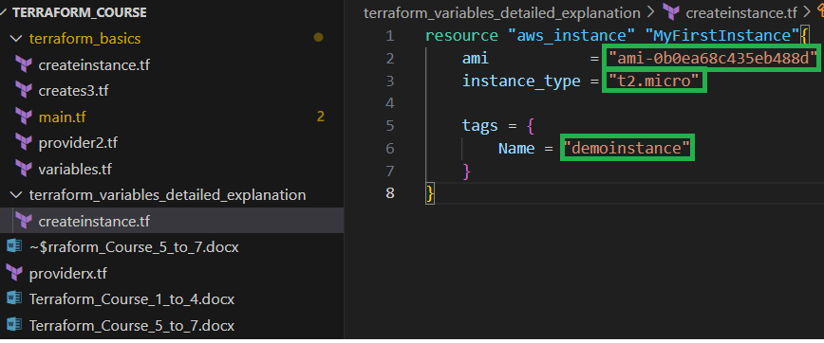

Create the “provider.tf” file that has dynamic values to use with a “variables.tf” file
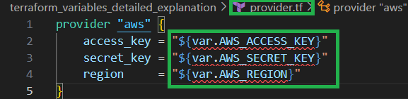

Create the “variables.tf” file; this is where you define the variables.
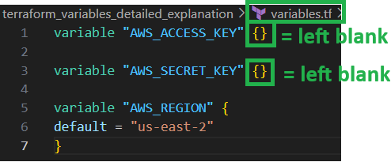

If you don’t define the variable in any file it will prompt you for the variables when “terraform plan” is run
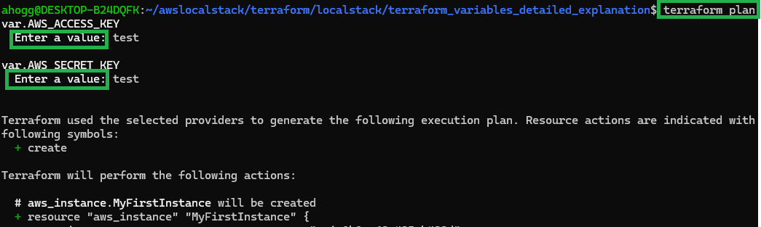

Way 2 “–var” switch = enter them on the command line after “terraform plan” using the “–var” switch
e.g “terraform plan –var AWS-ACCESS_KEY=”test” –var AWS_SECRET_KEY=”test””
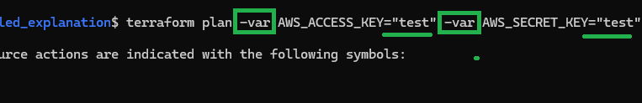

Way 3 create a “terraform.tfvars” file that the system will look at
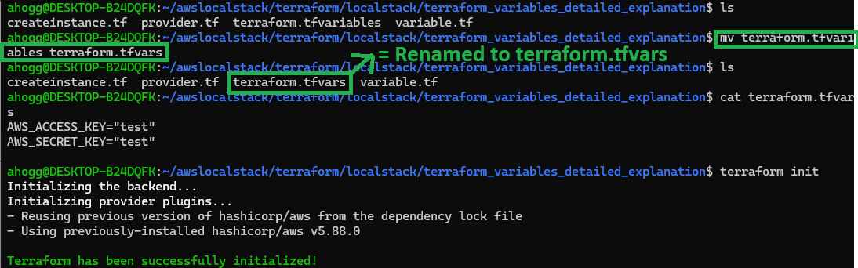
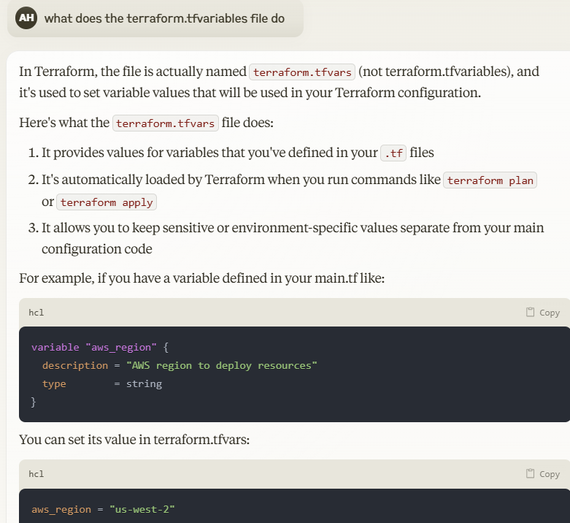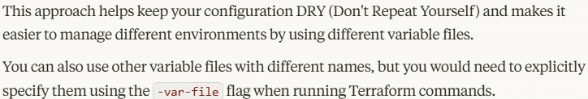

Way 4 = Specifically supplying a variables file using the “–var-file”
e.g “terraform plan –var-file=”terraform.tfsausages”

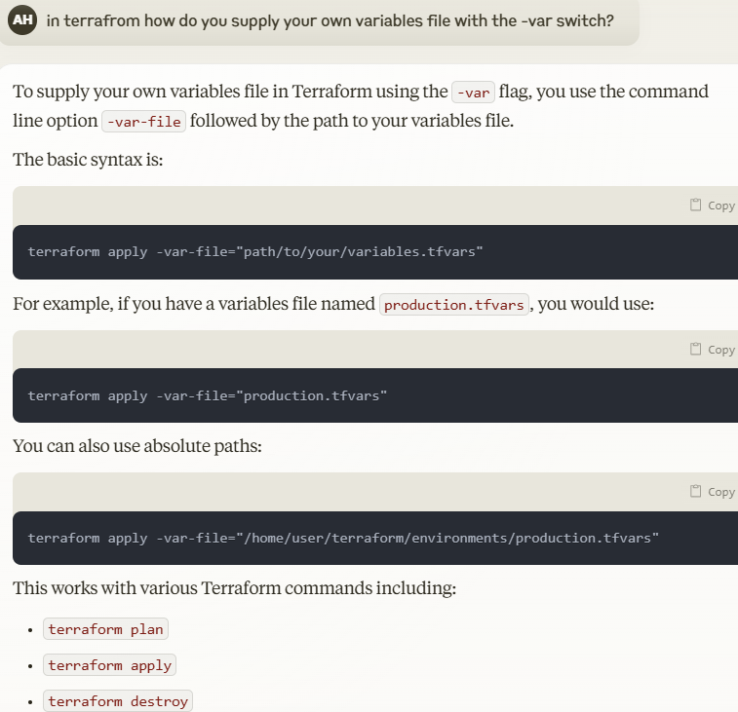

Lab – List & Map Variables

Define a default list in the “variables.tf” file
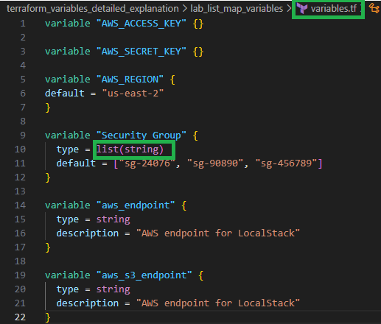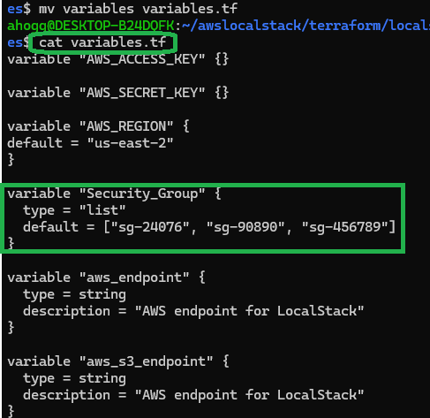

Inside the “createinstance.tf” I will define one more variable for the security groups
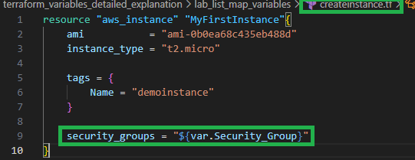

After running “terraform plan” you can see that the “variables.tf” variables have been used by the “createinstance.tf” file where “security_groups = “${var.Security_Group}”” dynamic variable has been assigned (as opposed to static or hard coded)

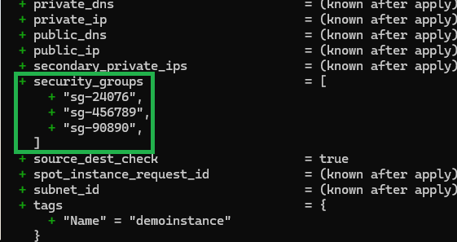
MAP

Hardcoded “AMI” variable

The reason we are using the “AMI” as a hardcoded value is because the AMI image is dependant on the region you are using.

Using type = map, you can define multiple regions and multiple “ami”

Define the following “map” variable for the AMIS in the “variable.tf” file
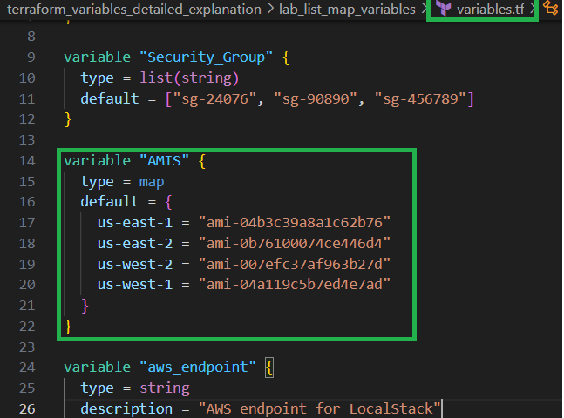

Using the “lookup” function will search the value of the “var.AWS_Region” inside the “variable.tf” file where “AMIS” is mentioned

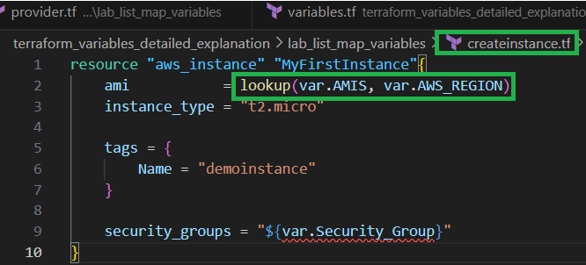

If the value is “us-west-2” it will will pickup


Basically whenever you define a AWS_REGION manually it will dynamically choose the AMI from the mapped list

“terraform plan –var AWS_REGION=”us-west-2”
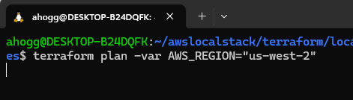
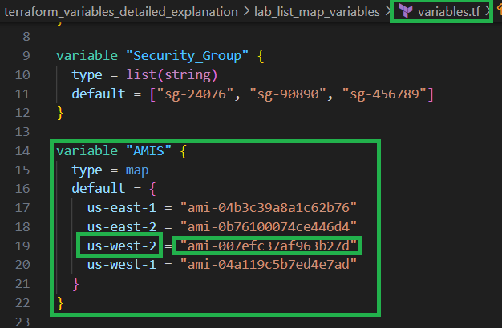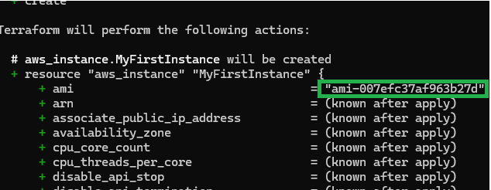

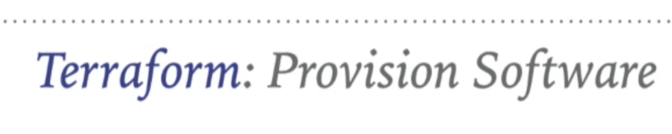

Machine launch is just 1% of the complete deployment operation, whenever we launch the machine, we launch it for some purpose, and that purpose is execution of the software or application that also needs support of other software as well, lets see how we can provision software on AWS machines.

Chef and Packer are tools to help you make custom AMIs, they are “cloud agnostic” so can do google cloud because not tied down to a provider.

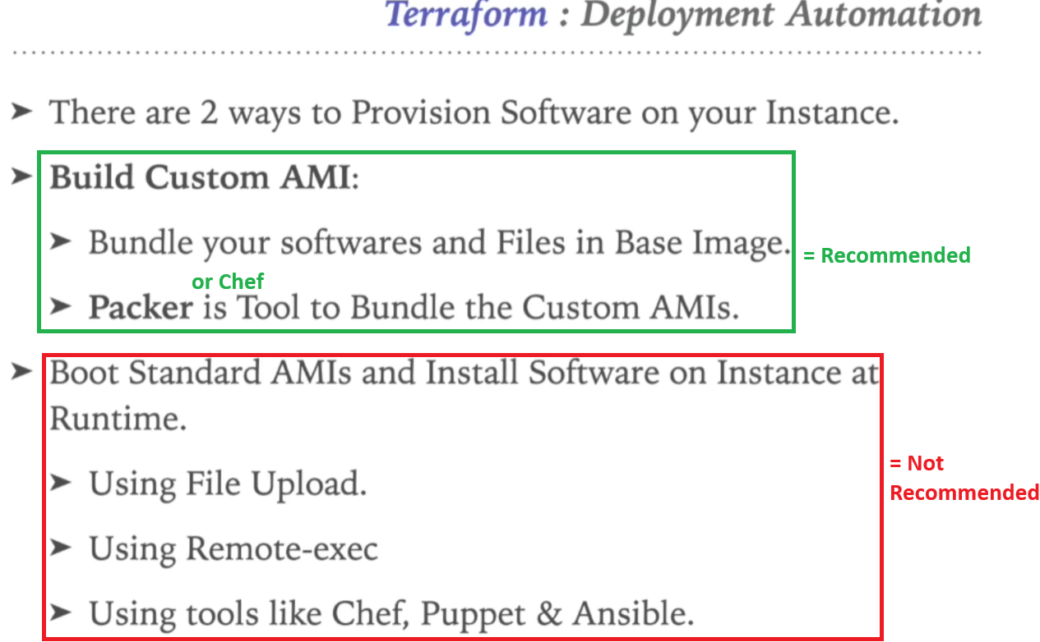
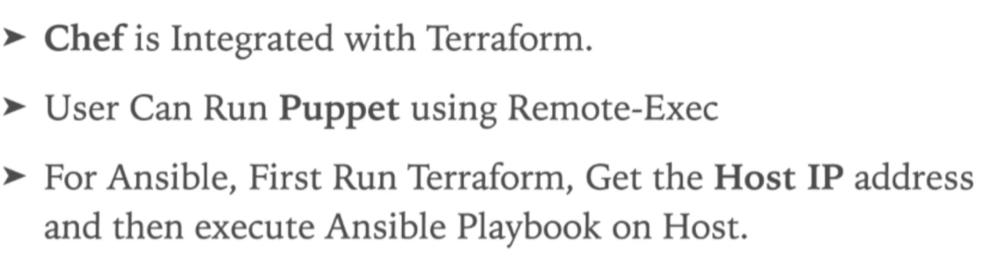
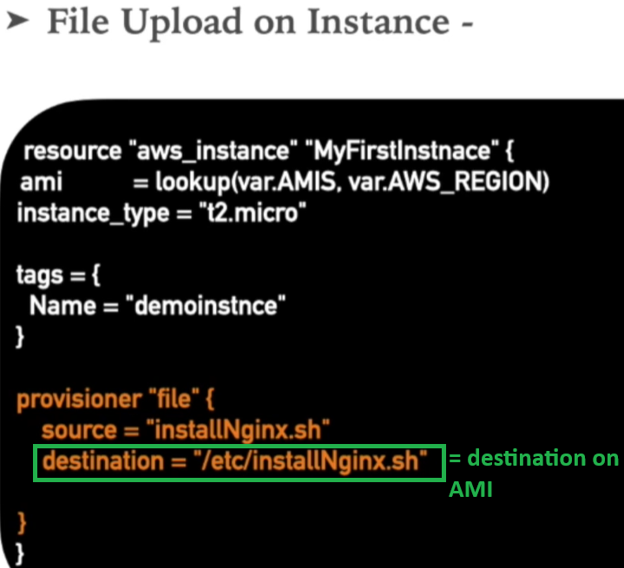
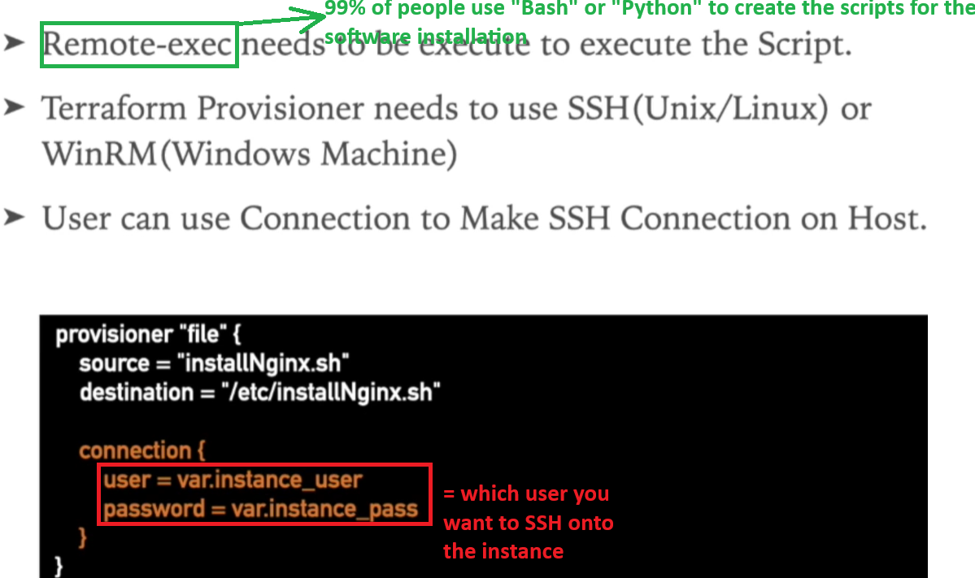

For the 2nd way to install Software

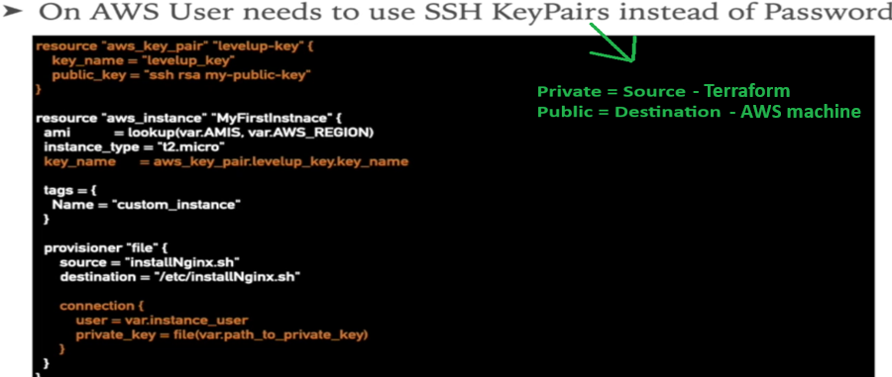
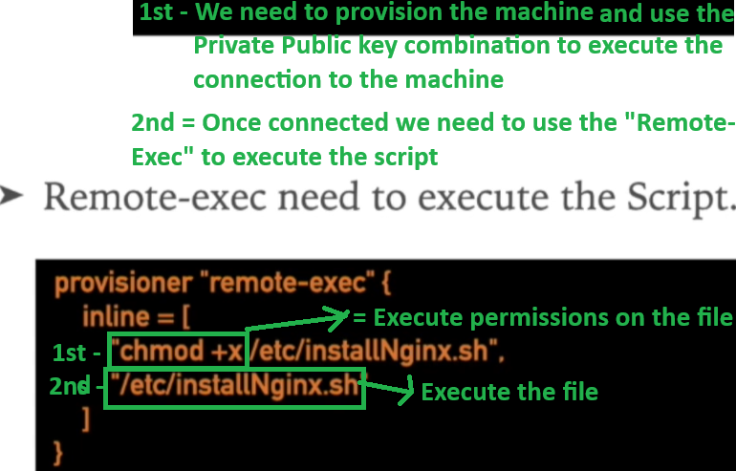

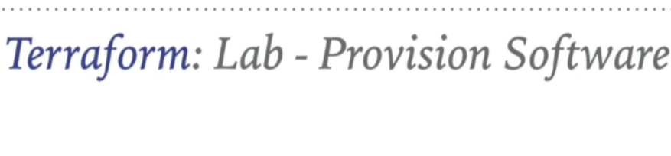
We are going with the second approach where we will upload the file on the running instance
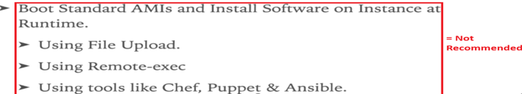
- Boot
- Upload the file on the running instance using – File Upload
- Run the file using – Remote-exec
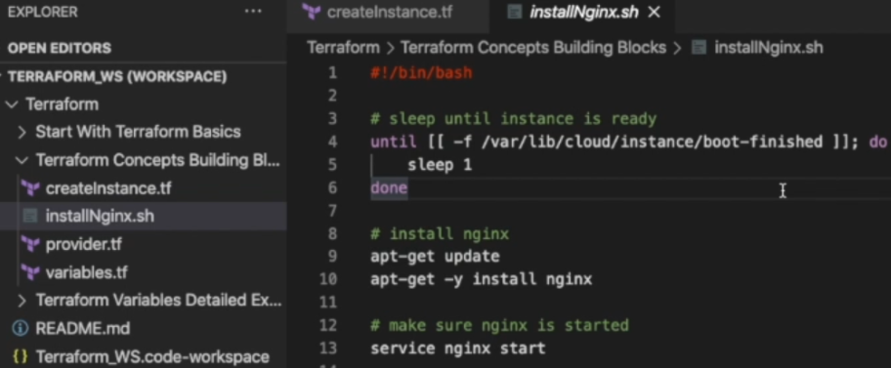

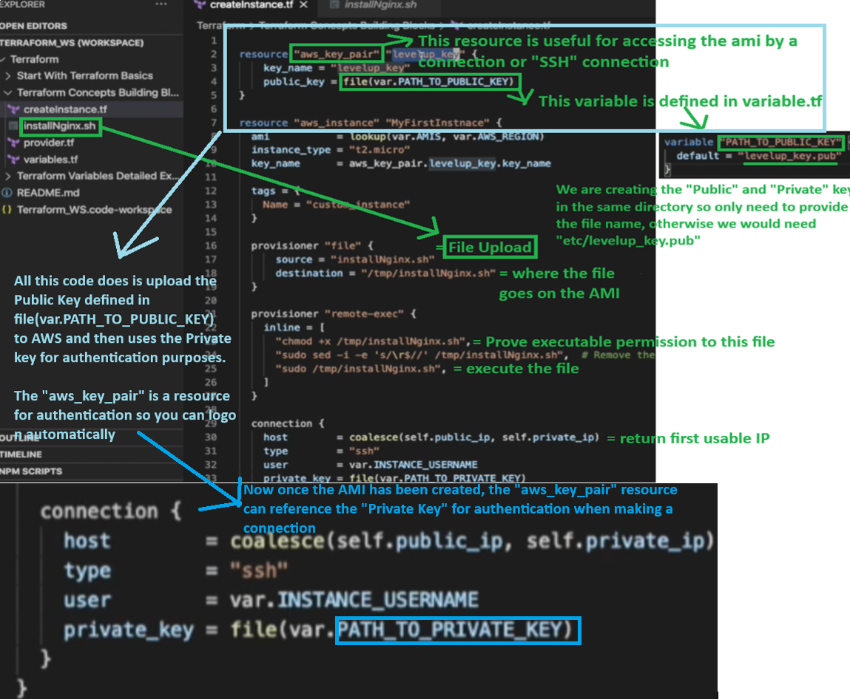
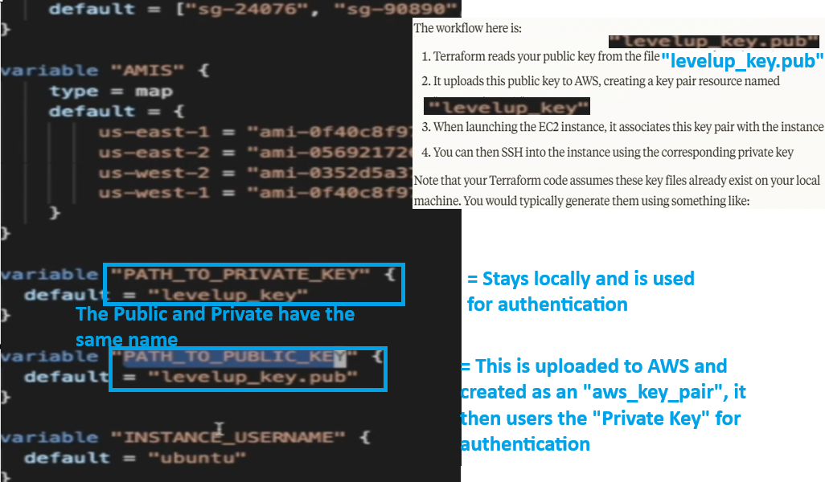
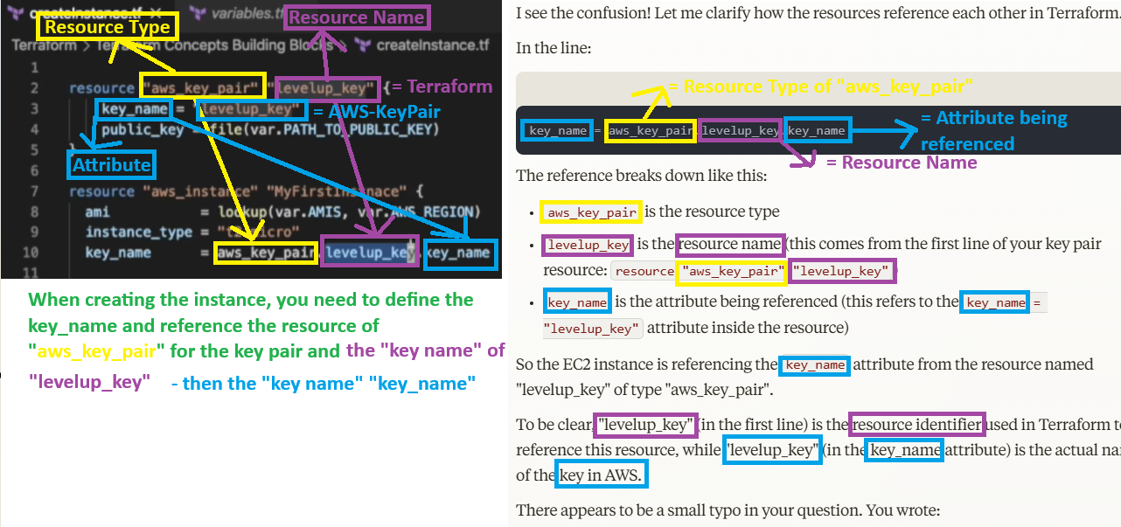
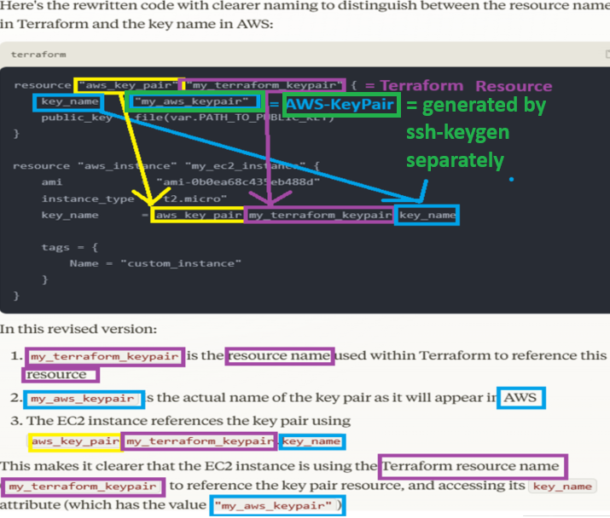
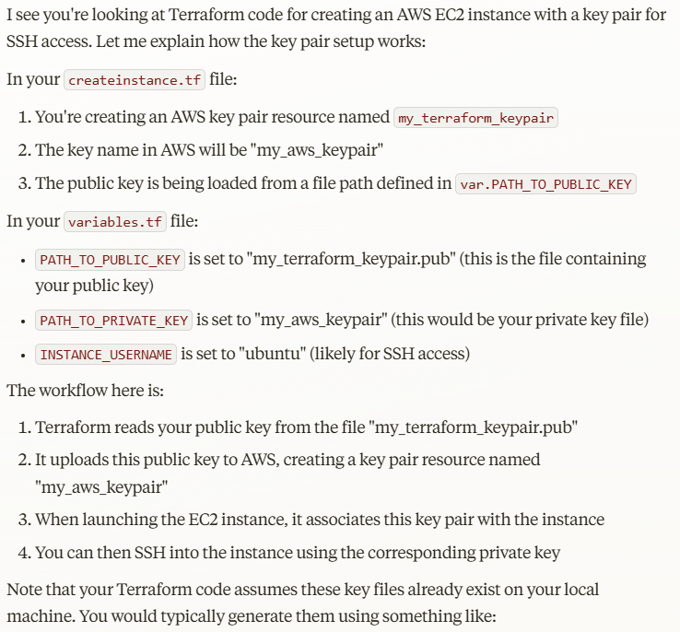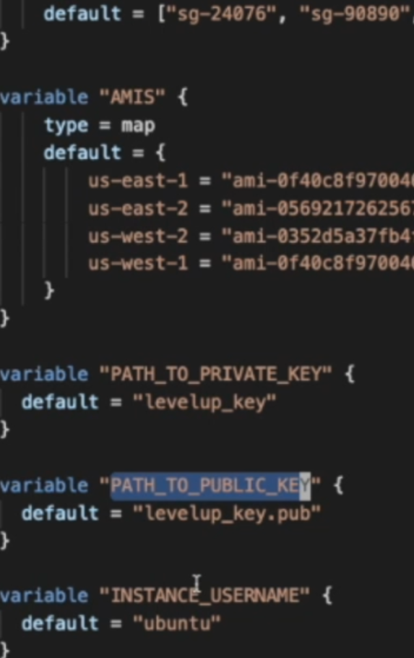
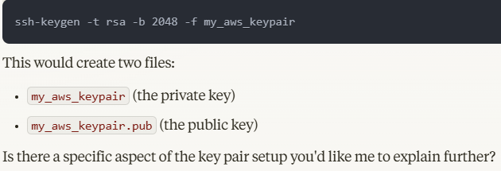

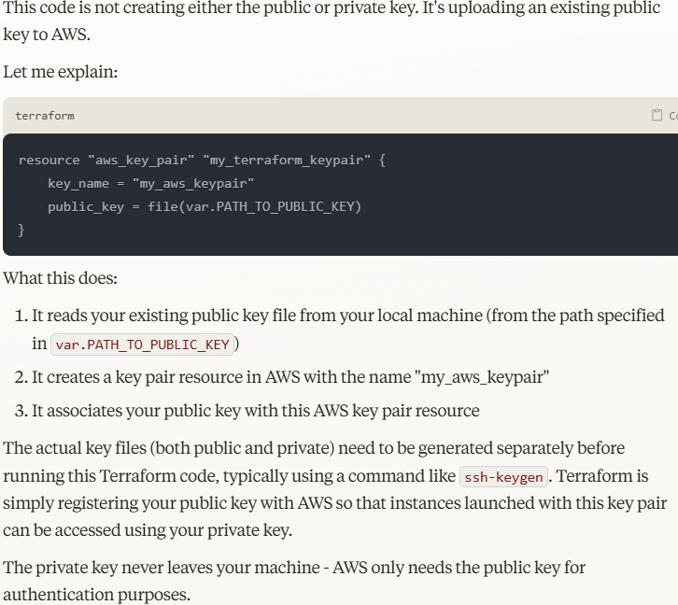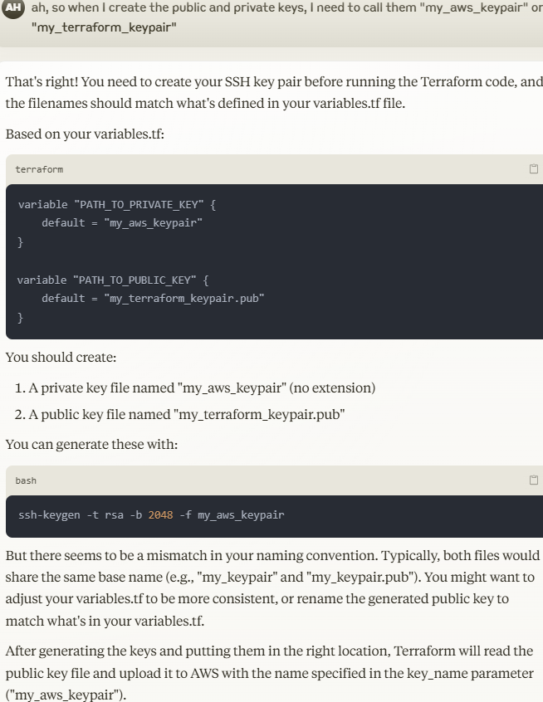
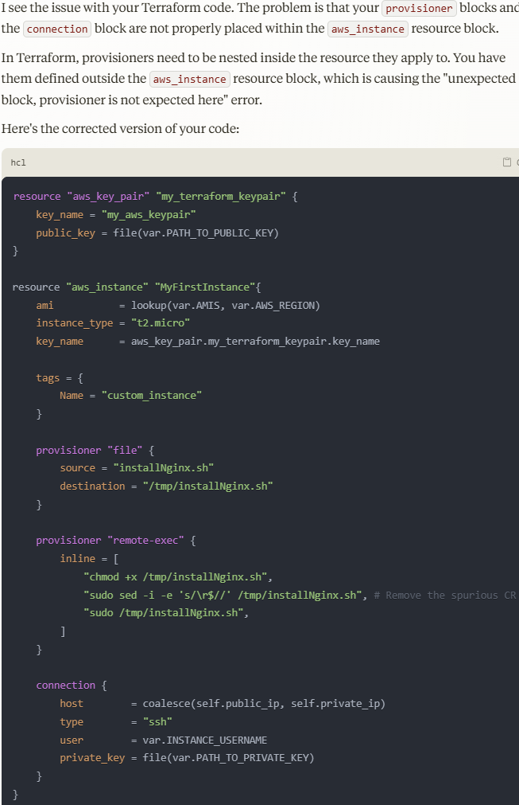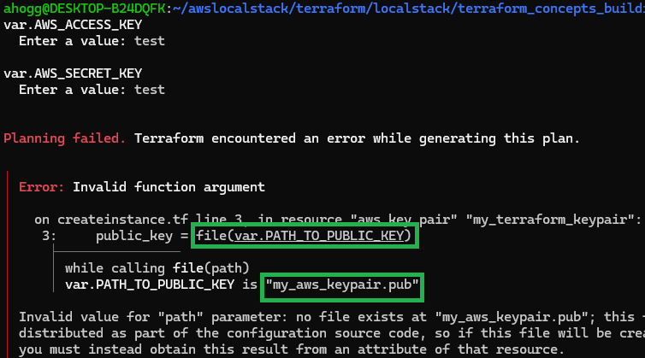

Key Pair
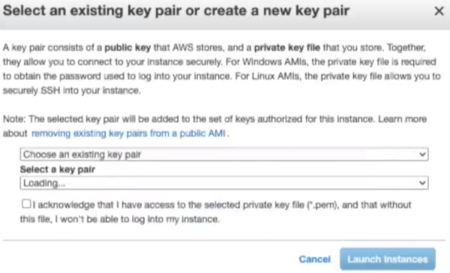
We need to create generate the following

Public = AWS “Key_Pair” resource for authentication
Private = stays local for authentication, basically you keep it and use it to SSH onto machines and it needs to match the public key that is stored in AWS – To be extra clear, when you create an EC2-Instance, the following code used your local “Private-Key” to authenticate with the “Public-Key” stored on AWS

On “Linux” machines we need to generate “Public” and “Private” keys you can use the SSH utility ssh-keygen
On “Windows” machines, you can use “Putty SSH Generator”

Linux

“ssh-keygen –f my_aws_keypair
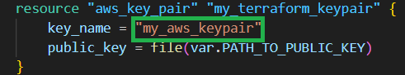

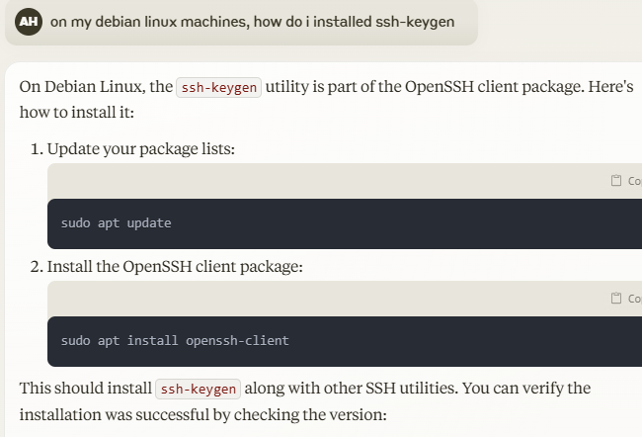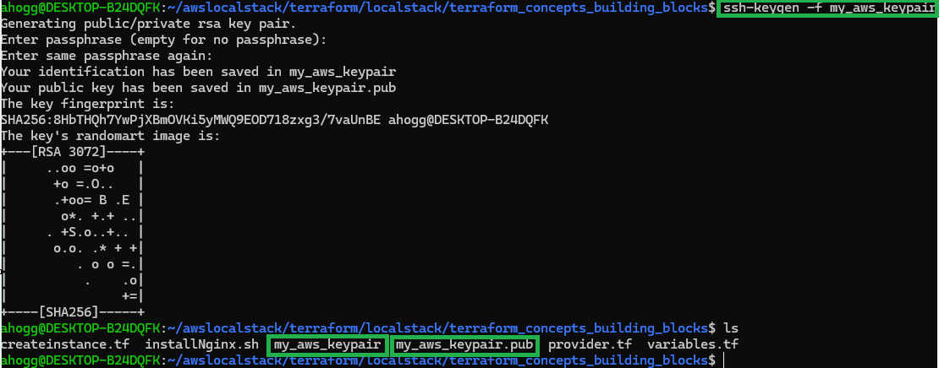

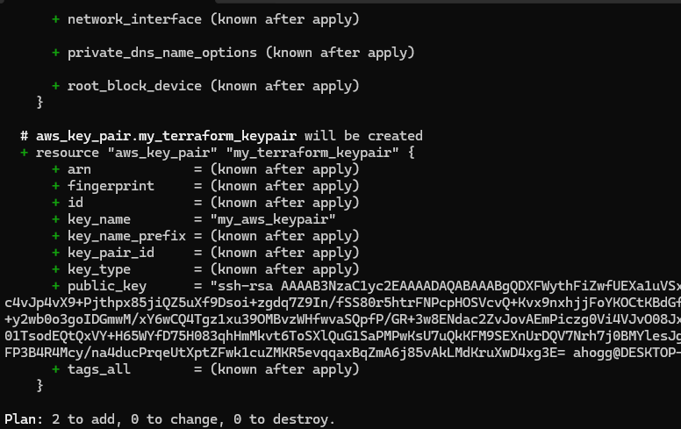
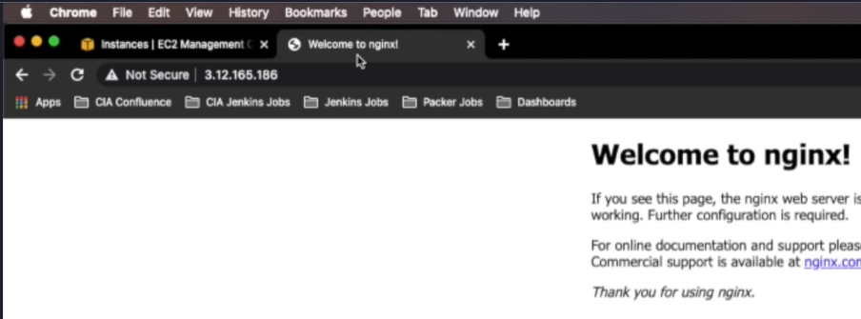

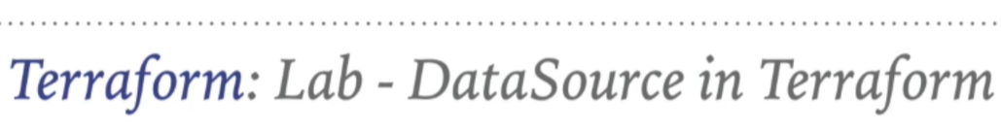

To Get Availability Zone Information in a script dynamically (at runtime) when a machine is deployed

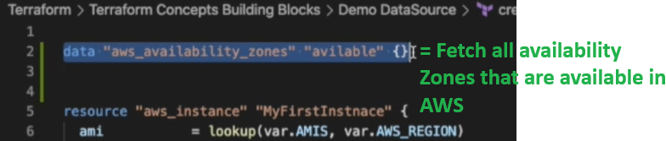

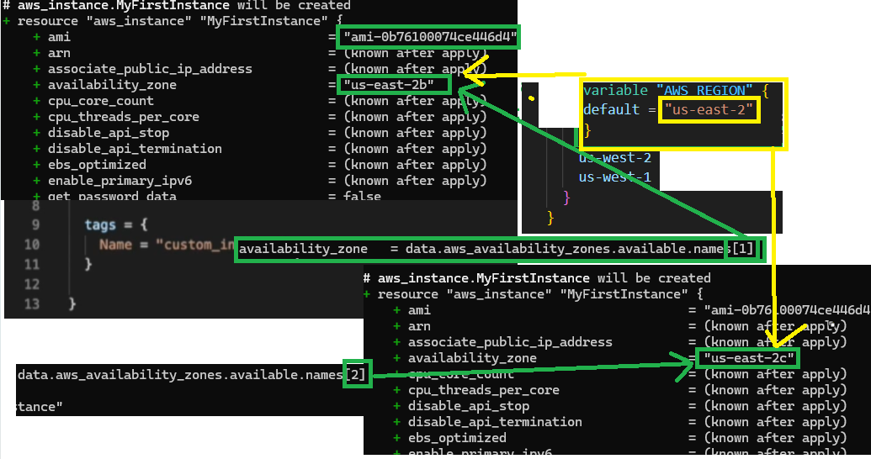

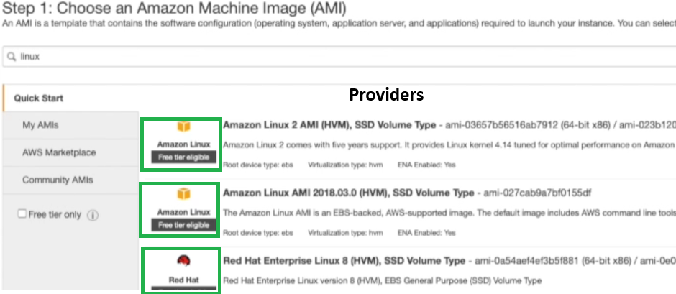
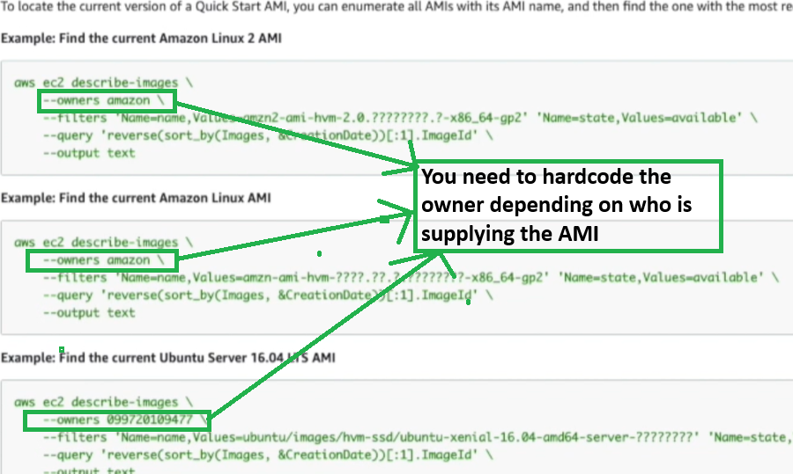

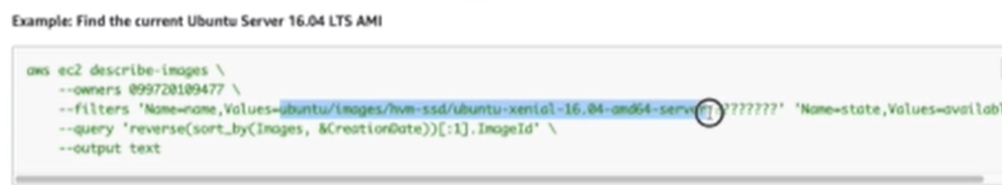

To Fetch the latest AMI at runtime (just like you did with the “Availability Zones”)

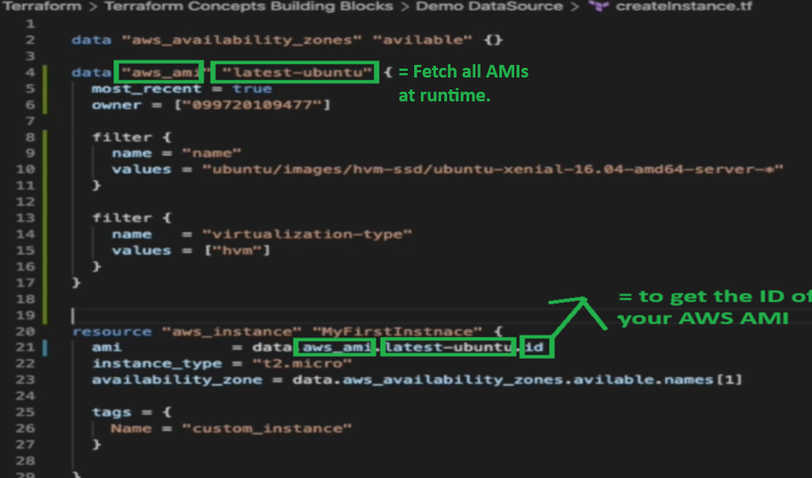
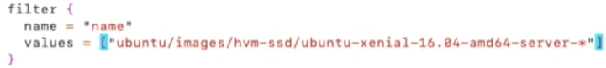Where we are getting the names of the images, this needs to be a list so [] square brackets is for lists

TEST that Failed on LocalStacks because we don’t have the support

I get the following AZs with the following variables

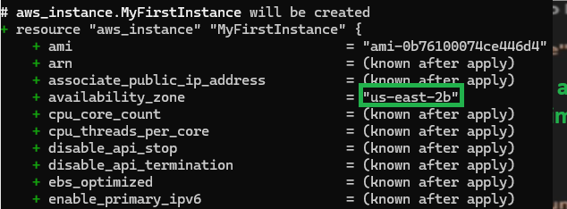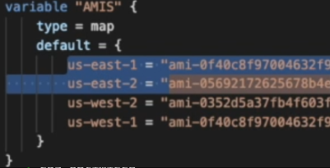

Now when I specify a custom region to terraform plan
terraform plan –var AWS_REGION=”us-east-1”

Now I should get a random AMI + the Availability Zone of 1b because of the following

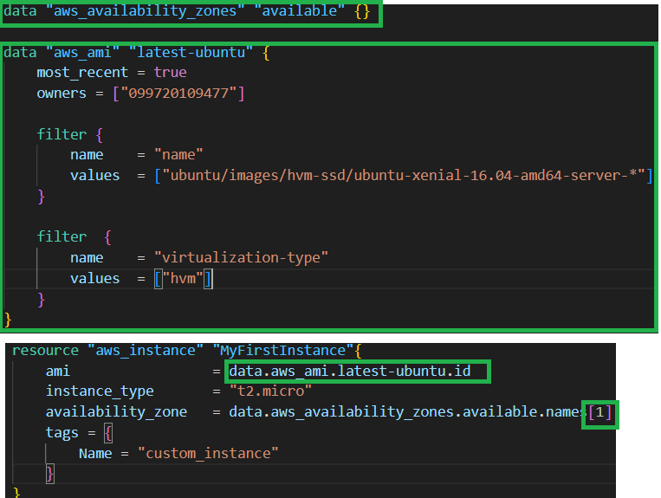

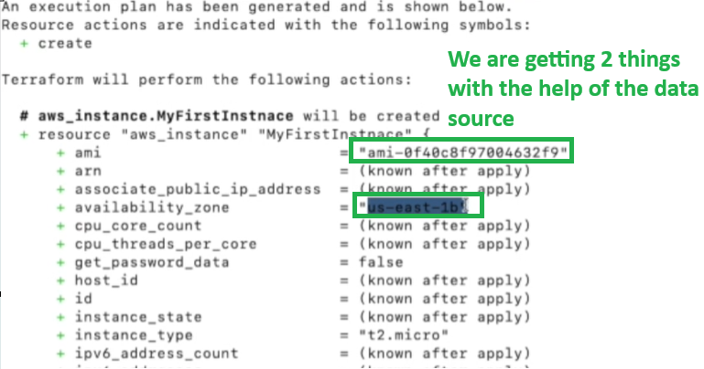

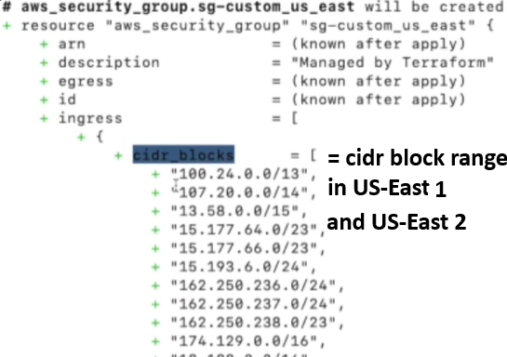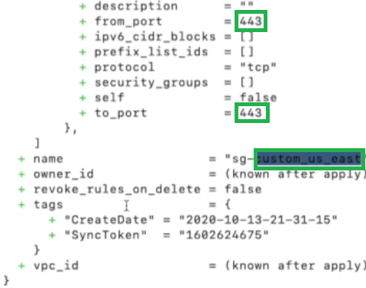
Creating “Security Groups” Dynamically with the help of the “DataSource” in Terraform

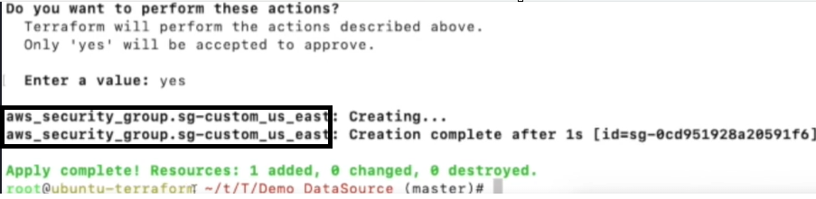
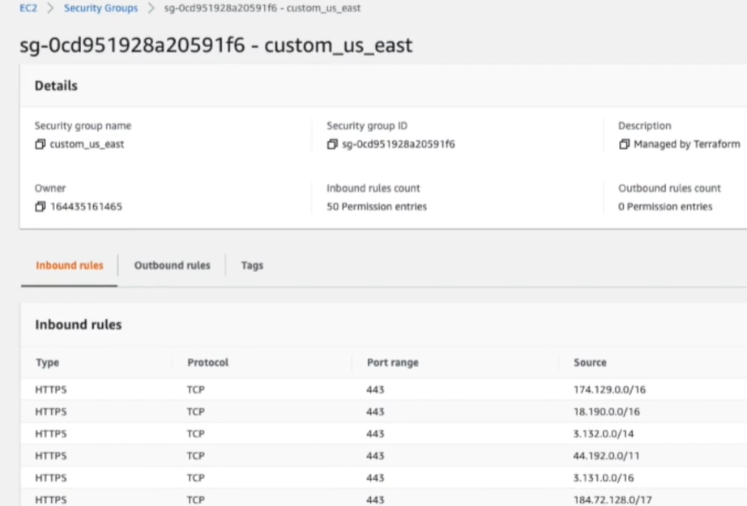

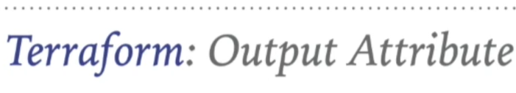
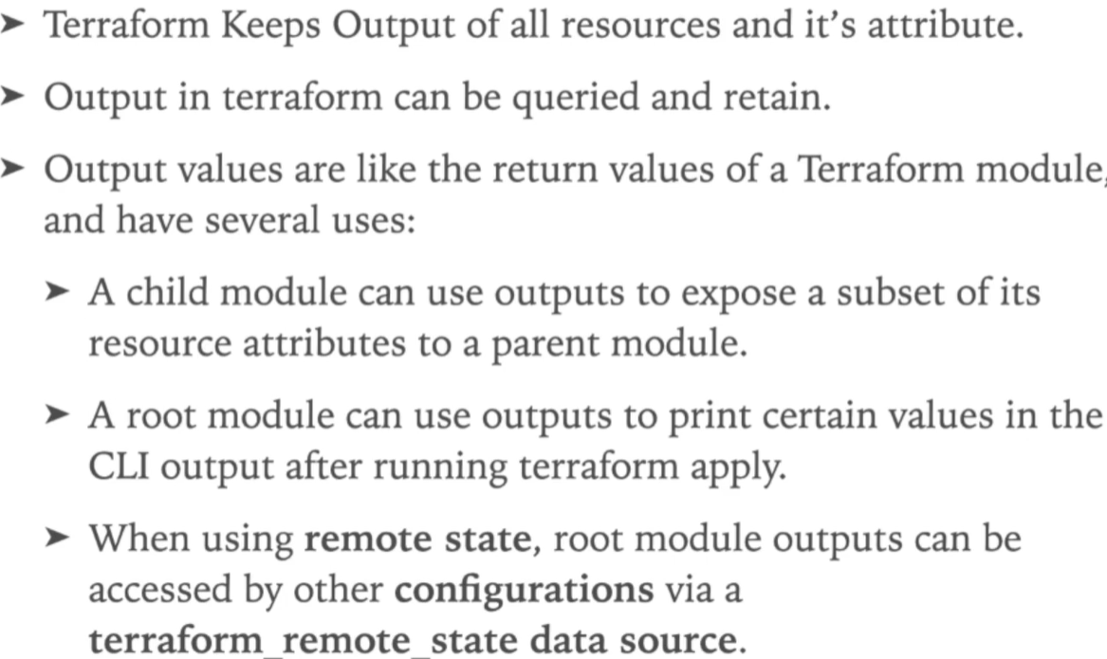
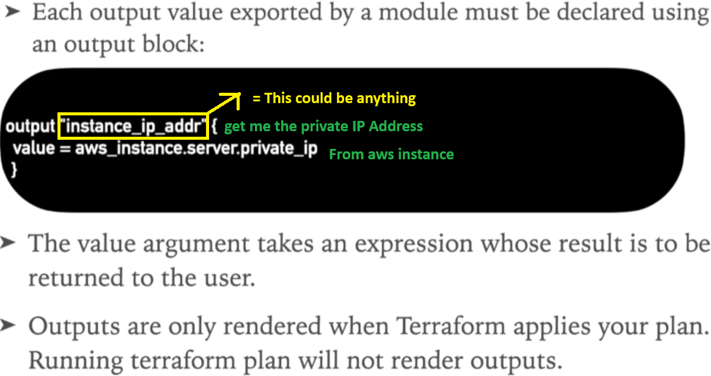
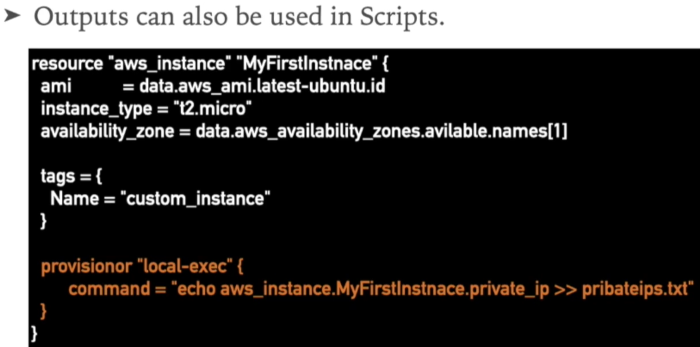

Suppose you want to execute some script and you want to capture the private IP in the file

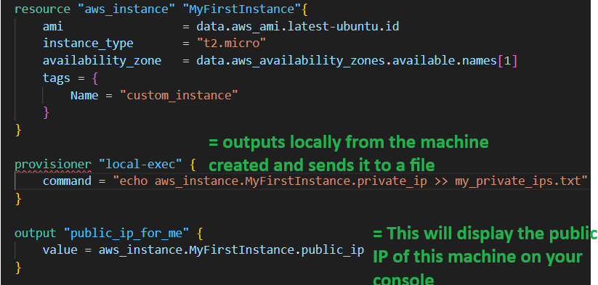

Terraform Plan Terraform Apply
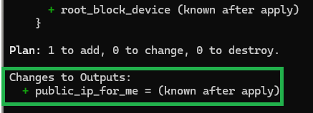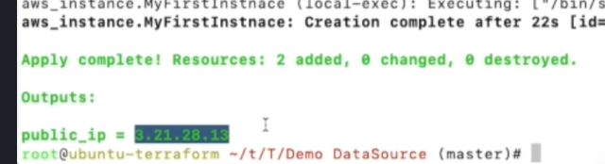

LocalStacks Works

