Phase 7 Edits

9/23/2024

* On the portal page, the videos in the Retailer Collections appear vertically. They should appear horizontally. Please fix this and make this update to the live site before making any other changes or updates. This is an immediate priority.
* On the mobile view, please keep the titles of the videos to 2 lines. This is to conserve space on the mobile experience.
* On the mobile view, there appears to be a grey outline around the advertisement (see picture below) and that prevents the outer region of the advertisement from displaying properly (Sephora logo is cut off). Please fix this.
* 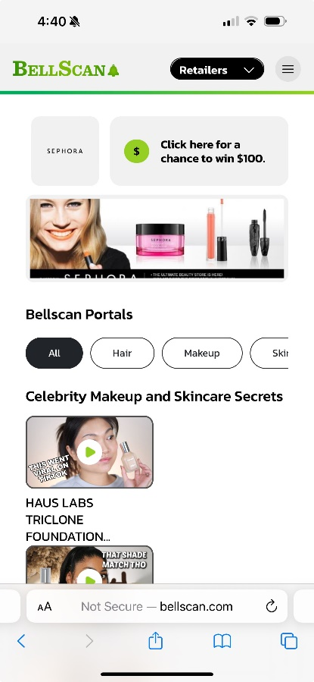
* Also in the mobile view, it appears that you can scroll left and right on the screen which removes the image above from appearing center in the screen. This should not be possible.
* When assigning an advertisement in the Admin Control Panel, once the retailer has been selected, only the advertisement ID’s that match that retailer should be visible.
* In the Dashboard Tab of the Control Panel, “Monthly User Visitor” should be changed to “Total Monthly Visits” as the title.
  + Also, when hovering over the data points, it currently says “Sales.” It should instead say “Visits.”
* Currently there is no place to add or remove a portal where an advertisement will appear within. To change this, in the Assign Advertisement tab you should still see the data table with the various advertisements (see picture below). However, clicking edit should allow you to 1) add a new portal for the advertisement to be visible in, or 2) remove a portal where that advertisement would be visible in.
  + Also, “Select store” should be “Select Store” with a capitalized “S.”

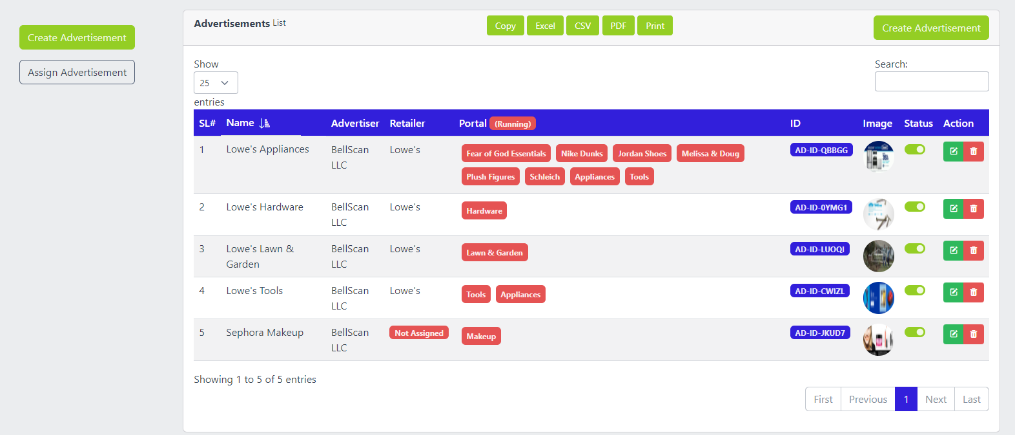

* Even though the advertisement for “Sephora Makeup” has been assigned, it still says “Not Assigned” to a retailer. Please fix so that it displays accurately.
* When creating a new advertisement, the “Select Retailer(s)” entry box says “Choose Store Portals.” Please change this to “Choose Retailer(s).”
* [ QUESTION ] Do we need separate website and mobile images?
* [ QUESTION ] Several advertisements have been added to Lowe’s as you can see in the picture above. However, none of the ads are visible on the live website. Is there a fix for this issue, or do I need to delete the old Lowe’s advertisements?
* Please make sure the “Store Details” page (when “All” portals are selected) appears as an option so that you can assign an advertisement to it.
* The “Advertiser” and “Retailer” columns in the Portal Advertisements Tab of the control panel (pictured above) should have arrows next to them so that you can sort them alphabetically.
* The Sephora logo looks stretched and blurry (see picture below). Please make sure that all logos appear clear, even if that means adjusting the size of the logo accordingly.
* 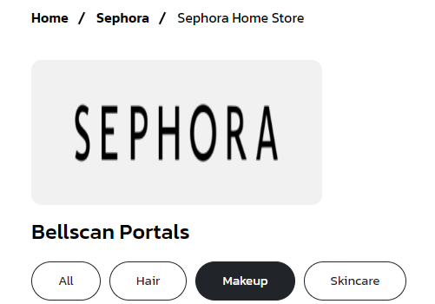

# Round 2 Edits

* WE NO LONGER NEED TASK 10 (search bubbles at the top of the screen) AS A PART OF PHASE 7
* Can’t add a video to more than one Retailer Collection. Please make this possible.
* Dropdown video for Retailer Collections should be made alphabetical.
* Once you assign a video to a Retailer Collection, you can’t remove it from all Retailer Collections. You can only replace the Retailer Collection that the video is part of with a different Retailer Collection. Instead, you should be able to deselect all retailer collection so that the video does not appear in any of them.
* When on a portal page, instead of having to click on a new page, when you scroll to the bottom of the screen, the next page of content should automatically begin to load.
* When you click the “Hair” portal in Sephora, it says no videos are added to this portal, however, there are videos in that portal. Please fix this bug.
* Currently on the Sephora portal page, there is an advertisement on the store details page. However, there is no advertisement assigned to that page in the admin control panel. This is a bug, please fix.
  + Also, the advertisement has been assigned to the Skincare portal but that portal does not show the advertisement. Please fix.