Phase 7 Developments – Amended

(9/17/2024)

1. Replace the current BellScan logo with the new logo design.
2. Create a “Retailer Collections” tab in the admin control panel.
   1. This should be a tab in the admin control panel and retailer control panel that is designed similarly to the Product Category tab. This tab should require you to pick a retailer if you’re in the admin control panel. In the retailer control panel, the retailer should already be selected. After the retailer is selected, you must name the retailer collection and click submit. Next, there must be an area added to the influencer video tab. When adding a new influencer video, add an entry box for retailer collection. You should be able to tag each video with multiple retailer collections because the same video may fit multiple different categories.
3. Upload the new admin control panel designs.
   1. This includes restructuring the tabs based upon the new control panel structure outlined in Appendix 1. Which control panel each tab should be included within is explained in Appendix 1.
4. Create a new Tab called “Chatbot” in order to enter the script for each retailer. You should need to select a retailer and then enter the script for that retailer. This tab should exist as a sub-tab underneath the Retailer Management top-level tab.
5. Display additional data metrics in the Dashboard tab of the control panel for the admin, retailers, and stores.
   1. The data to be tracked and which control panel each metric should be included within is explained in Appendix 2.
6. When logged in as a Store, the following should be updated:
   1. The Video Type, Influencer and Influencer Video tabs should not be visible. (we will likely update this in the future).
   2. Clicking on the profile picture of the store should take you to the store details page.
   3. There should be a dropdown menu option next to the profile picture just like in the Admin control panel. The options should be:
      1. Store – takes you to the store details page.
      2. Control Panel
      3. Home – takes you to BellScan home page.
7. When logged in as a Retailer, the following should be updated:
   1. The Video Type and Influencer tabs should not be visible.
   2. On the Influencer Video tab, you should not see the trash icon to delete a video.
8. On the User Profile page there needs to be an “Upload Video” button and a “Add New Collection” button. I will provide the designs.
   1. When a user uploads a new video, it should post automatically to a collection on their profile page. They should have the ability to add to any retailer. You first select the retailer, up to 3 topics, and then enter the product name(s). As you’re typing, the product names should auto-fill below based upon available products on BellScan. The user should not see the entry boxes for video type, influencer, portal, and product category. Only the product name, video title, topics, and video link entry boxes should be visible for users.
9. On the Product Category tab, there should be a sorting arrow next to the “Retailer Name” column to indicate that you can click on it to make the list alphabetical.
10. When you’re searching on an item, or when you’ve selected a filter, there should be a text bubble at the top of the screen that shows the specific filter or search that has been added. There should be an “X” in the text bubble so that the user can click the x and the will revert to if that search had not been carried out, or if there are multiple filters selected, the filter will revert to the remaining filters available and will not include the option that has been deselected. Please see Appendix 3 for a picture.
11. Let’s redesign the coupon reward schedule so that each coupon can be earned for doing certain acts that have been chosen specifically for that coupon. To do this, please do the following. When creating a new coupon, please add an entry box for reward schedule. The options in this dropdown menu should include:
    * Video time watched
      + Action for Coupon Administration: If “Video time watched” is chosen, there should be a selection box that allows you to pick the minimum amount of video watch time needed to earn the coupon.
    * Refer a friend
      + Action for Coupon Administration: Offer a coupon to users who share products or videos from the BellScan platform with friends who then go on to visit that retailer’s store.
      + Goal: This not only increases platform engagement but also leverages word-of-mouth marketing, encouraging both the sharer and the new user to visit the store.
    * Promoted Video
      + Action for Coupon Administration: If a user watches a specific video during a certain window of time, they can receive a coupon.
      + Goal: This would be for if a product has had trouble selling and the retailer wants to encourage sales).
    * Repeat Visits Reward
      + Action for Coupon Administration: Offer a coupon when a user scans the retailer's portal on BellScan multiple times within a certain period, say three visits within a week.
      + Goal: This incentivizes users to keep coming back, increasing the likelihood of converting browsing into purchasing.
    * Bundle or Cross-Sell Incentive:
      + Action for Coupon Administration: Provide a coupon when a user watches videos about products that are commonly purchased together, or after they add one of these items to a virtual cart or wishlist.
      + Goal: This encourages the user to purchase the complementary item, increasing the overall basket size and enhancing the shopping experience.
    * User Milestone Celebration:
      + Action for Coupon Administration: Issue a coupon when a user reaches a significant milestone on the platform, such as their 10th login, 50th video watched, or 1-year anniversary of using the app.
      + Goal: This creates a personalized touchpoint that can boost loyalty and emotional connection with the brand, nudging the user toward making a purchase as a form of celebration.

# Appendix 1 – Control Panel Structure

- The tabs to be included in each control panel are described below:

* Green Tabs should be visible in the Admin, Retailer, and Store control panels.
* Yellow Tabs should be visible in the Admin and Retailer control panels only.
* Blue Tabs should be visible in the Admin control panel only.

**1. Dashboard**

* **Top-Level Tab:** Main overview of all metrics and data analytics.

**2. Retailer Management**

* **Top-Level Tab:** Central hub for all retailer-related functionalities.
* **Sub-Tabs:**
  + **Retailer:** Add new retailers.
  + **Store:** Create new stores for each retailer.
  + **Portal:** Create and manage retailer portals.
  + **QR Code:** Manage QR codes and their associations.
  + **Chatbot:** Manage the chatbot script for each retailer.

**3. Mall Management**

* **Top-Level Tab:** Create new malls and manage their associations.

**4. Product Management**

* **Top-Level Tab:** All product-related settings and categorizations.
* **Sub-Tabs:**
  + **Product:** Add new products to retailer.
  + **Product Category:** Hierarchical categorization within portals.
  + **Product Department:** Manage product departments.
  + **Product Type:** Define product certifications and tags.

**5. Content Management**

* **Top-Level Tab:** Centralized management for all content-related functionalities.
* **Sub-Tabs:**
  + **Video Type:** Define content submitters.
  + **Influencer:** Manage influencer profiles.
  + **Influencer Video:** Upload and manage influencer videos.
  + **Influencer Video Topic:** Manage video topics and tags.

**6. Promotions & Advertising**

* **Top-Level Tab:** Oversee all promotional materials and advertisement settings.
* **Sub-Tabs:**
  + **Coupon:** Create and distribute coupons.
  + **Portal Advertisement:** Manage advertisements within specific portals.
  + **Advertiser:** Add and manage advertiser profiles.
  + **Like Leader:** Manage the video sharing competition for the specified retailer.

**7. Settings**

* **Top-Level Tab:** Manage all aspects of user roles and permissions.
* **Sub-Tabs:**
  + **Roles:** View of available roles on BellScan.
  + **Role Assign Permissions:** Set and view permissions for various roles.
  + **User Role Assign:** Assign roles to specific users.
  + **Settings:** Change admin settings like email and password.

# Appendix 2 – Data Tracking Metrics

1. The data metrics should be visible in the corresponding control panel:
   1. Green Data should be visible in the Admin, Retailer, and Store control panels.
   2. Yellow Data should be visible in the Admin and Retailer control panels only.
   3. Blue Data should be visible in the Admin control panel only.
2. The new data to be tracked and displayed includes the following:
   1. **[1.01] Total Number of Scans:** The cumulative count of QR code scans across all store locations.
   2. **[1.02] Unique User Scans:** Identification and count of first-time scans by new users versus repeat scans by returning customers.
   3. **[1.07] Scans Over Time:** Tracking the change in scan volume over days, weeks, and months to understand temporal trends.
   4. **[1.09] Scan Duration:** The length of time between scanning a QR code and closing BellScan, indicating engagement level.
   5. **[1.12] Total Number of Scans per Retailer:** The cumulative count of QR Code scans across one specific retailer.
   6. **[1.13] Total Number of Scans per QR Code:** The cumulative count of QR code scans for each specific QR Code.
   7. **[2.01] Average Viewing Time:** How long, on average, users watch each specific influencer video.
   8. **[2.09] Video Sharing Metrics:** Total number of instances where users share the video content with others through various means (e.g., social media, messaging apps), demonstrating endorsement and extended reach.
   9. **[2.10] Comments and Interactions:** Total number of user likes and comments on the video content, across BellScan.
   10. **[2.11] Total Watch Time:** Total amount of time spent watching videos across BellScan.
   11. **[2.12] Total Retailer Watch Time:** Total amount of time spent watching videos across each specific retailer.
   12. **[2.13] Retailer-Specific Video Sharing Metrics:** The total amount of times that a video that tags a specific retailer has been shared.
   13. **[2.14] Video-Specific Sharing Metrics:** The total amount of times a specific video has been shared.
   14. **[2.15] Retailer Comments and Interactions:** Total number of user likes and comments on the video content, across each retailer.
   15. **[2.16] Video-Specific Comments and Interactions:** Total number of user likes and comments on each specific video.
   16. **[3.01] Content View Counts:** The number of times each piece of influencer content is viewed, providing insights into popularity and relevance.
   17. **[3.02] Interactions Per Video:** The number of likes, shares, comments, or other interactions for each video, which can help gauge content engagement and resonance with the audience.
   18. **[3.05] User Content Preferences:** Tracking the types of content (e.g., product categories, topics) that receive the most engagement to understand consumer interests.
   19. **[4.01] Initial Navigation Post-QR Scan:** Where users go immediately after scanning a QR code, which can inform on the effectiveness of the call-to-action in the video content.
   20. **[4.05] Click-Through Rates (CTR):** The percentage of clicks on links provided in the content relative to the number of video views, indicating the level of user interest in further engagement.
   21. **[5.01] Age Range:** Group users by age brackets to understand which demographics are most engaged with the BellScan platform.
   22. **[5.02] Gender Distribution:** Identify the gender breakdown of users to tailor content and influencer partnerships accordingly.
   23. **[6.02] Frequency of Visits:** How often users return to the BellScan website or app, which can be indicative of ongoing interest and loyalty.
   24. **[6.05] Referral Rates:** The number of users who come to BellScan via referral links, which could indicate word-of-mouth promotion and customer satisfaction.
   25. **[11.01] Repeat Visitor Frequency:** How often the same users return to interact with BellScan content in a given period.
   26. **[11.03] Returning vs. New User Ratio:** The proportion of repeat users to new users, which can indicate the growth and retention balance.
   27. **[11.04] User Churn Rate:** The percentage of users who do not return after their first interaction within a specific period.
   28. **[12.05] Session Duration by User Segment:** Comparing average session lengths across different user demographics or behavioral segments.
   29. **[12.08] Engagement Depth:** Measurement of how deep into the content users go during a session (e.g., how many pages deep or how many linked videos they watch).
   30. **[18.01] Daily Active Users (DAU):** The number of unique users who engage with the app daily.
   31. **[18.02] Monthly Active Users (MAU):** The number of unique users who engage with the app on a monthly basis.

# Appendix 3 - Filter Bubbles

In the 1st screenshot below, the filters for “Men’s” and “Short Sleeve” are selected.

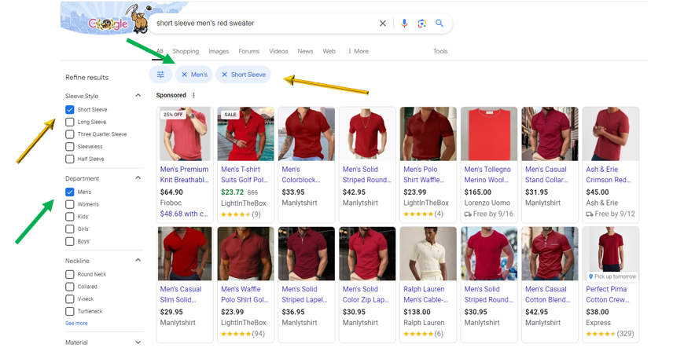

If you click the “X” on the “Short Sleeve” filter, the short sleeve requirement will be removed. You will then see the picture below which will show you long sleeve options as well:

