TaskFlow — Task Management System
Design Document · Angular 20 + ASP.NET Core (.NET 10) + SQL Server

1. System Design — High Level (HLD)
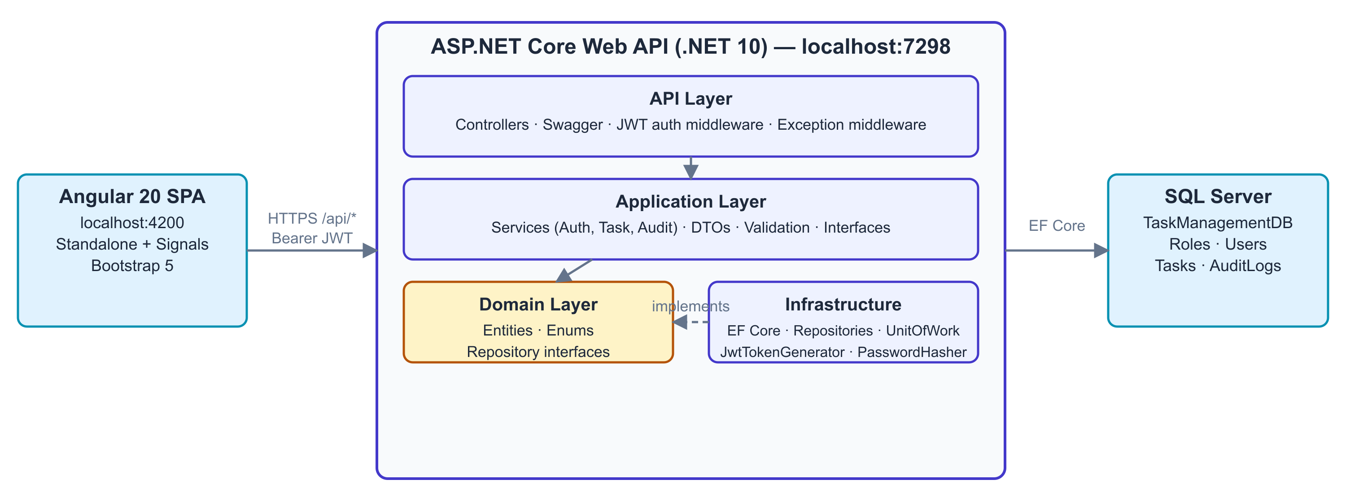
- Three-tier, stateless. Angular SPA → REST API → SQL Server. No server-side sessions: every request self-authenticates with a JWT, so the API can scale horizontally.
- Clean Architecture. Dependencies point inward to the Domain layer. Infrastructure implements Domain interfaces, so EF Core / SQL Server could be swapped without touching business rules.
- Thin controllers. Controllers only translate HTTP ⇄ DTOs; all business logic lives in Application services behind interfaces (testable in isolation).
- DB-first schema. The SQL script is the source of truth; EF Core Fluent configurations mirror it exactly (CHECK constraints, defaults, indexes).

How I approached the build
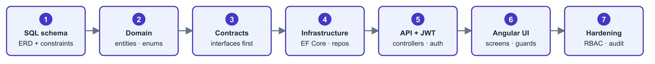
- Contract-driven, inside-out. Schema and interfaces were locked first, so each layer was built and verified against a stable contract — the Angular UI was written against Swagger before any screen touched real logic.

2. Low-Level Design (LLD) & Database
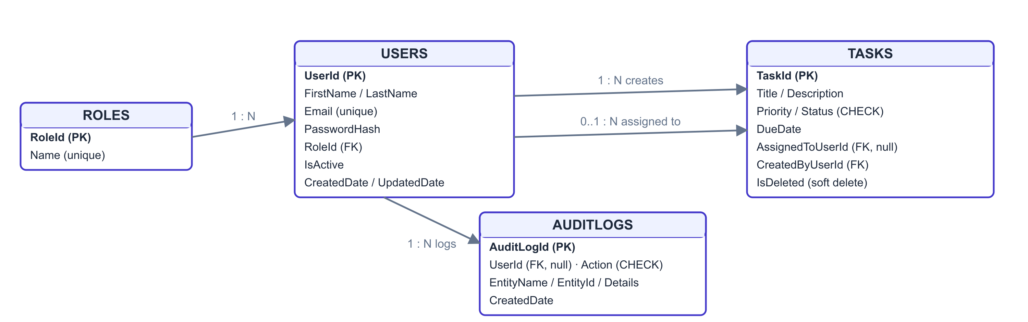

Key design patterns
Pattern | Where & why
Repository + Unit of Work | All repositories share one DbContext; a use case touching Tasks + Users + AuditLogs commits in one transaction.
Service layer + DTOs | Entities never leave the API; request/response shapes are explicit and validated.
Soft delete | Tasks.IsDeleted flag; every read filters it out. Data is recoverable and history is preserved.
Enum-as-string | Priority / Status / Action stored as names ("High", "InProgress") and enforced by SQL CHECK constraints — readable and safe.
Audit trail | AuditLogs row written on login and on task create / update / delete: who, what, which entity, when.
Lazy repositories | UnitOfWork instantiates repositories on first use; unused ones cost nothing.

Business rules
Rule | How it is enforced
New tasks always start as ToDo | Server sets the status; the create form has no status field — status changes only via edit.
Due date can never be in the past | [FutureDate] rejects with 400 before the controller runs; domain invariant is the backstop.
Assignee must be an active user | Service validates against Users before commit; dropdown shows every active user as "Name (Role)".
Only Admin / Manager mutate tasks | [Authorize(Roles = "Admin,Manager")] on create/update/delete; Employee sees disabled controls.
Registration is safe by default | Unique email (DB index), password ≥ 6 chars stored as a PBKDF2 hash, role picked from the Roles table.
Nothing disappears silently | Deletes are soft (IsDeleted flag); login and every task mutation writes an AuditLogs row.

3. Security & Architecture Decisions
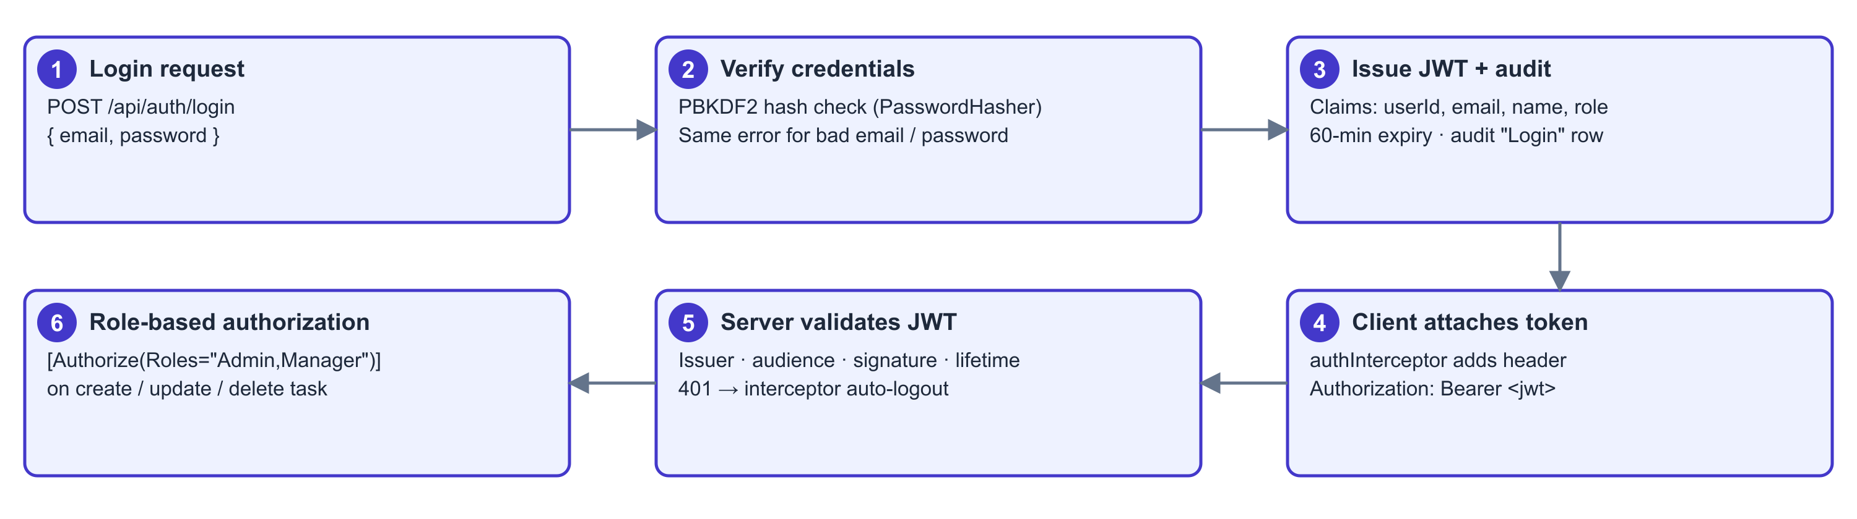
Concern | Implementation
Password storage | ASP.NET Core PasswordHasher — salted PBKDF2. Plain text is never stored or logged.
Authentication | JWT Bearer: issuer, audience, signature and lifetime all validated; 60-min expiry. Login returns the same generic error for wrong email or password (no user enumeration).
Authorization (RBAC) | Enforced server-side: [Authorize] on all task routes; Roles = "Admin,Manager" on create/update/delete. The UI disable is UX only — the API is the gate.
CORS | Explicit allowlist: only the SPA origin (localhost:4200) is accepted.
Validation in depth | DataAnnotations reject bad input with 400 before the controller runs → service-level checks (assignee exists, unique email) → domain invariant backstop (due date not in past).
Error handling | One exception middleware maps known exceptions to 400/401/404 JSON; anything unexpected returns a generic 500 — internals never leak to clients.

4. UI & Business Flow
- How I thought about the UI. The screens follow the user’s journey, not the data model: Registration → Login → Dashboard (what needs attention?) → Task list (find it) → Add / Edit / Delete (act on it). Each screen answers exactly one question.
- Role decides what is actionable. The same screens serve every role — Admin/Manager get working Add / Edit / Delete controls, Employees see them disabled with a tooltip. Capabilities stay discoverable, and the API re-checks every action regardless.
Capability | Admin | Manager | Employee
View dashboard, task list, search & sort | ✓ | ✓ | ✓
Create task | ✓ | ✓ | —
Edit task / change status | ✓ | ✓ | —
Delete task (soft) | ✓ | ✓ | —
Be assigned a task | ✓ | ✓ | ✓

Delivered features
✓ JWT auth: login + registration with a DB-driven role picker | ✓ Full audit trail: login, task create, update, delete
✓ Server-enforced RBAC; Employee controls disabled in the UI | ✓ Dashboard with live status counts and recent tasks
✓ Task CRUD with debounced search and column sorting | ✓ Resilient UX: auto-logout on 401 + "server unreachable" banner
✓ Assignee dropdown: every active user shown as "Name (Role)" | ✓ Swagger UI with Bearer authorize — API testable without the UI

Complete workflow
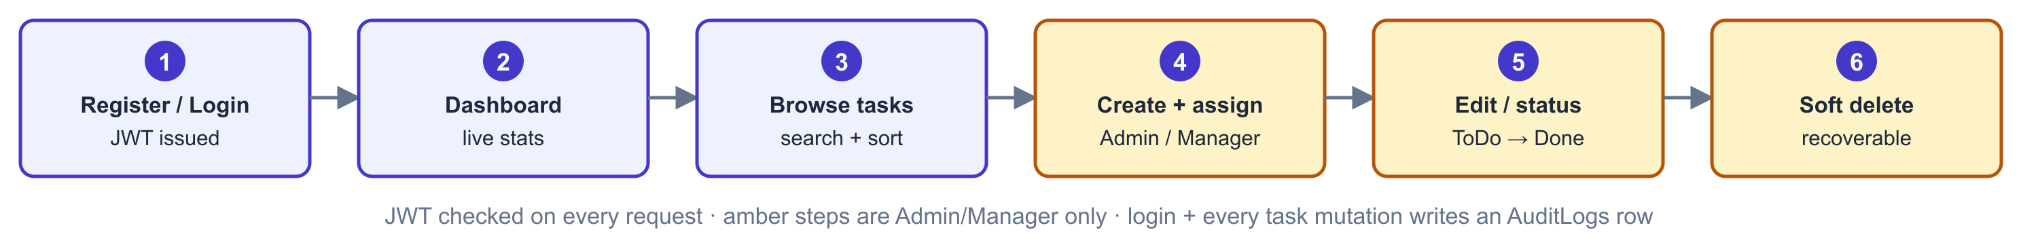

5. Frontend Design
- Angular 20, standalone + signals. No NgModules; component state via signals/computed. All feature routes lazy-loaded.
- Guards. authGuard (must be logged in) and manageTasksGuard (blocks /tasks/new and /tasks/:id/edit for Employees, even by direct URL).
- One HTTP interceptor. Attaches the Bearer token; on 401 clears the session and returns to login; on network failure (status 0) raises a global "server unreachable" banner.
- Role-aware UI. Employees see Add / Edit / Delete controls disabled with an explanatory tooltip — mirroring, not replacing, the server-side rule.
- Dev proxy. ng serve proxies /api → https://localhost:7298, so services use relative URLs and CORS never bites in development.

6. Backend API Design
Method | Endpoint | Access | Purpose
POST | /api/auth/login | Public | Authenticate → JWT (audited)
POST | /api/auth/register | Public | Create account → JWT
GET | /api/auth | Public | Role list for the registration form
GET | /api/tasks | Any role | Task list with search + sort
GET | /api/tasks/{id} | Any role | Single task
GET | /api/tasks/assignable-users | Any role | "Name (Role)" list for the assignee dropdown
POST | /api/tasks | Admin, Manager | Create task (audited)
PUT | /api/tasks/{id} | Admin, Manager | Update task (audited)
DELETE | /api/tasks/{id} | Admin, Manager | Soft delete (audited)

- Conventions. Resource nouns, proper verbs and status codes (200 / 201 / 204 / 400 / 401 / 404); errors always return the same JSON shape { status, message }.

7. Scaling — How to Take This Big
Area | Recommended next step
Scale-out | Containerize (Docker) and run N stateless API instances behind a load balancer — JWT already makes this safe. Move to Kubernetes when instance count grows.
Database | Server-side pagination first, then Redis cache for hot reads (roles, dashboard counts); read replicas when reads dominate writes.
Search | SQL full-text search or Elasticsearch once task volume outgrows LIKE queries.
Async work | Message queue (RabbitMQ / Azure Service Bus) + Hangfire: assignment emails, overdue reminders, report generation.
Realtime | SignalR to push task changes live to open dashboards and boards.
Auth hardening | Refresh tokens, password reset, account lockout; OpenIddict or Microsoft Entra ID when SSO is required.
Product features | Comments + file attachments (blob storage), Kanban board view, in-app notifications, reporting, teams / multi-tenancy.
Quality & ops | Structured logging (Serilog) + OpenTelemetry tracing, health-check endpoints, CI/CD with xUnit + Playwright test gates.

Revision Notes & UI Design Decisions
Dashboard designed as landing page showing task health and recent tasks.
Menu: Dashboard, Tasks, Create Task, Audit Logs.
Status/Priority moved from Sort to Filter.
Sorting retained for Due Date and Title.
Pagination added.
Admin/Manager can Create/Edit/Delete; Employee actions disabled.
Assign To displays Name (Role).
Audit log records Login, Create, Update and Delete.
Scalability
Server-side searching/filtering/sorting.
Server-side pagination.
Return page + total count.
Future: Redis, Full-text search, Read replicas.
Login
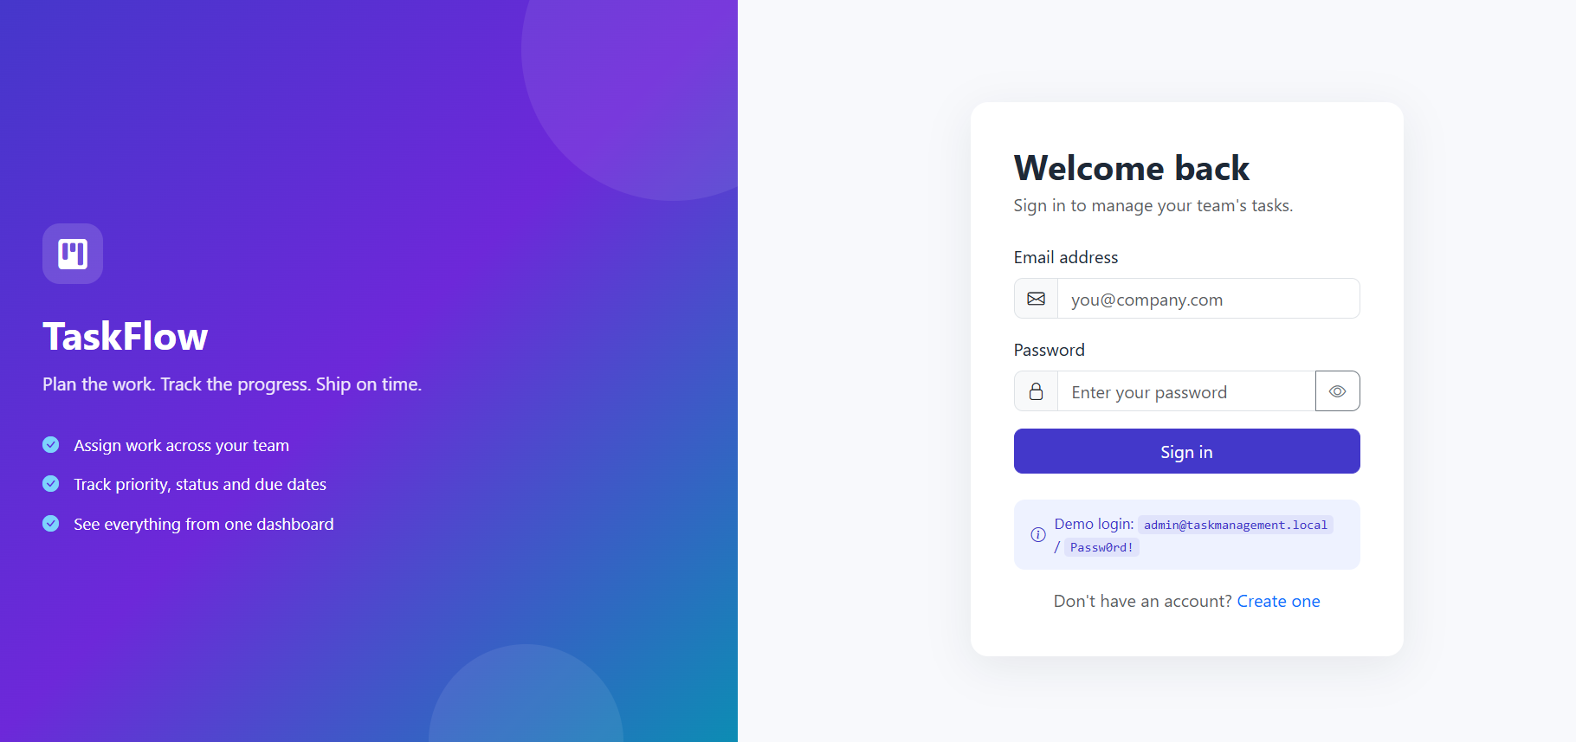
Dashboard
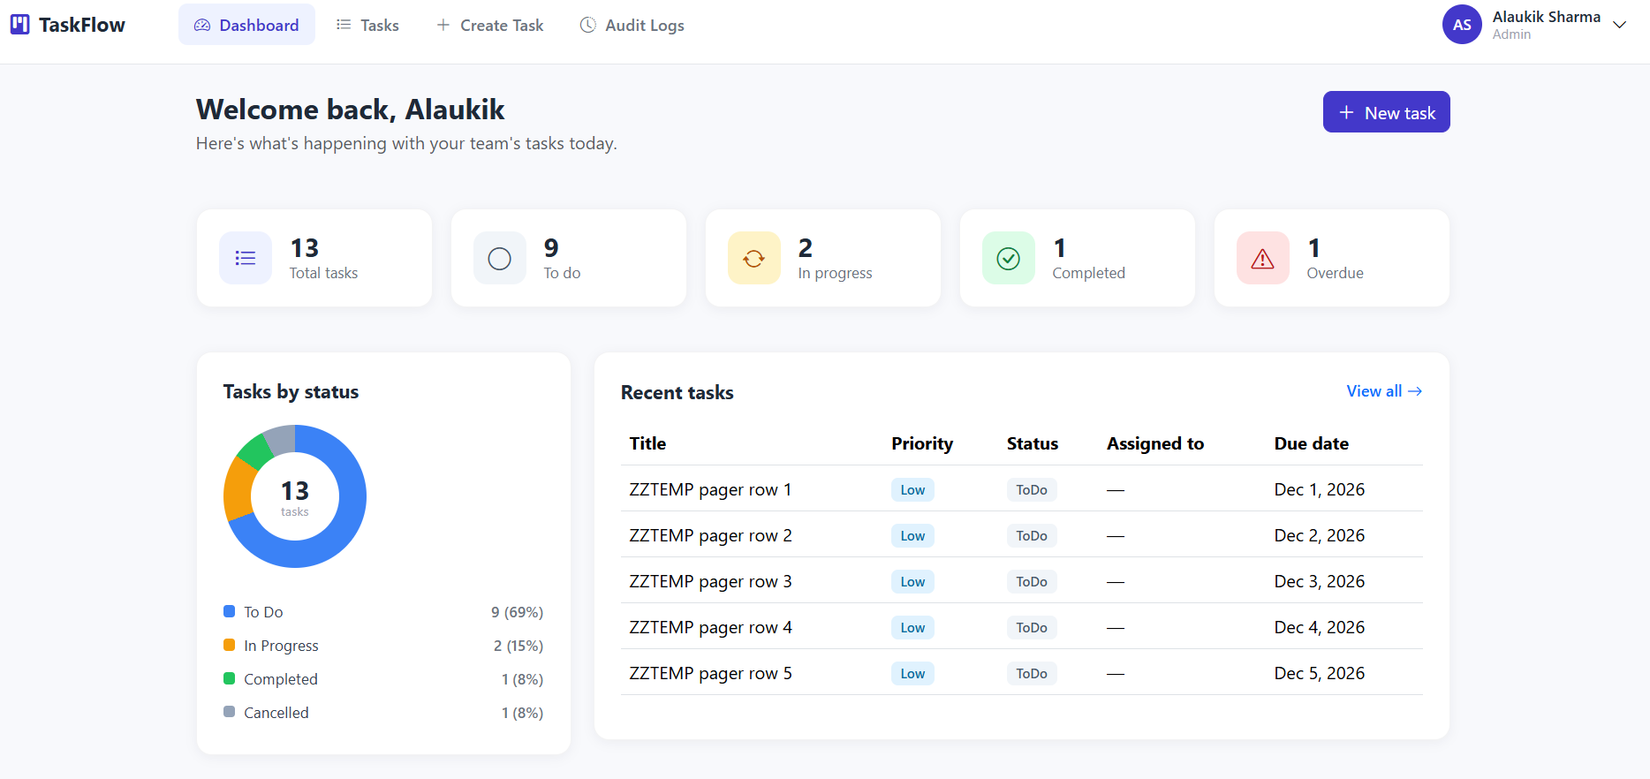
Tasks
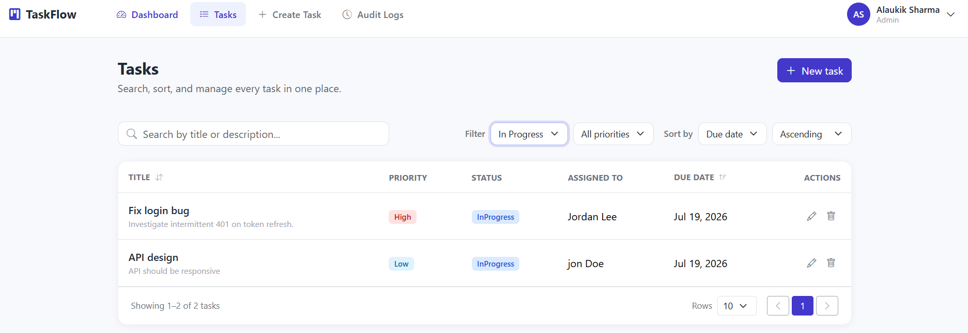
Create Task
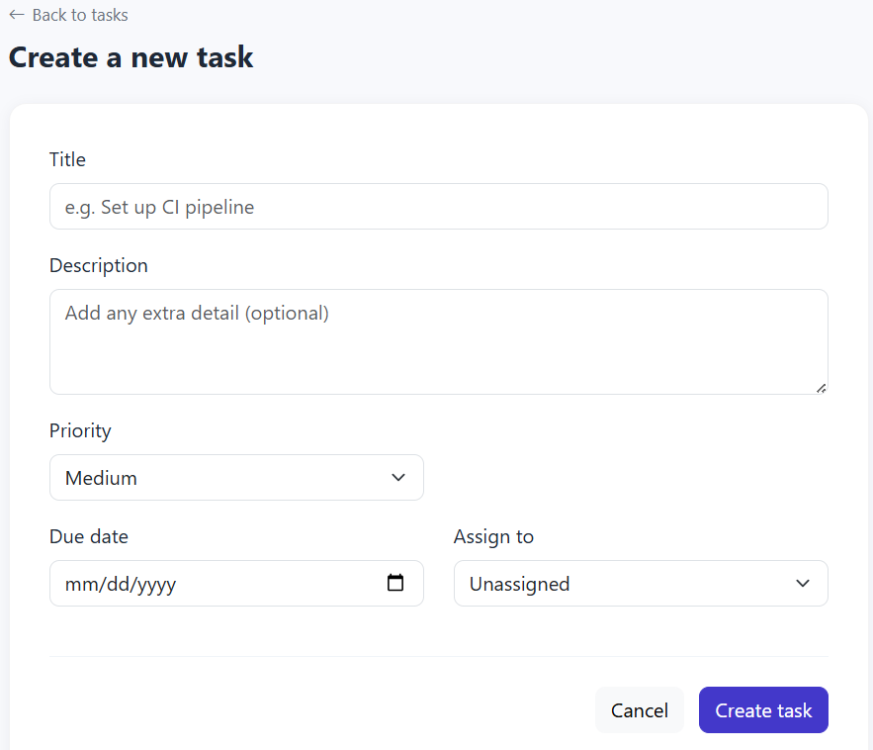
Audit Logs
