AAAA

REVA UNIVERSITY

SCHOOL OF COMPUTER SCIENCE AND ENGINEERING

WEB TECHNOLOGY PROJECT

FOLKLORE

**BY**

LAVANYA .A – R20EF237

JOTHIKA .B – R20EF233

USHA M .G – R20EF272

**FOLKLORE**

**ABSTRACT:**

The Indian folk dance is a creative work with the artistic steps and postures being accompanied by the rhythmical movements of vocal or instrumental music. Folk dance celebrates the cultural roots of a particular group of people. The identified aim of this project is to promote the Folklore, and so this will be the focus of the project. However, the promotional website of Folklore aims to target the age group of 20 and below it who have an interest in 'The Folk dance' such as Bharatanatyam, Kathak, Kathakali, Odissi, Yakshagana.

The users can register to the school through this website looking at the dances they are interested into. This website can provide the info about the features of the dances, can have the schedule of the school and can register to interested dance, fee’s structure is also provided and can pay through online. Since Human Computer Interaction (HCI) has moved beyond simply designing for desktop use, the website will also allow the user to access the website through multiple devices such as laptop, the smartphone, as well as tablet i.e., with a view to responsive design and a screen reader option will make the website more accessible for users with a visual impairment.

**INTODUCTION:**

Welcome to the wonderful world of dance! You are about to experience folk dancing, the oldest form of dance. It is the basis for many other dance forms. The term folk dancing is usually defined as "the dance of the common people." Just where or when it began is impossible to document. Archaeologists and historians say it was a basic part of early peoples' culture as they used dance to communicate their emotions through movement and rhythm. People have danced and still dance for celebration, for survival, to socialize, to communicate with the spiritual, and to express their membership and identity in communities

**TOOLS:**

Visual Studio Code

Google Chrome

**LANGUAGES:**

HTML

CSS

JavaScript

**DESCRIPTION:**

HOME PAGE

Name of the Dance School. The name of the Dance School is FOLKLORE which is top left of the homepage. There is a menu bar at the top right of the homepage which contains link registration page, payment page. Cards give a brief information about the available dances in the Folklore. Cards hover when mouse point is moved on it. When clicked on the pictures present in the cards the video of the respective dance is played. There is a contact section at the last which contains the address, telephone number, and email.

Front End View created is shown below:

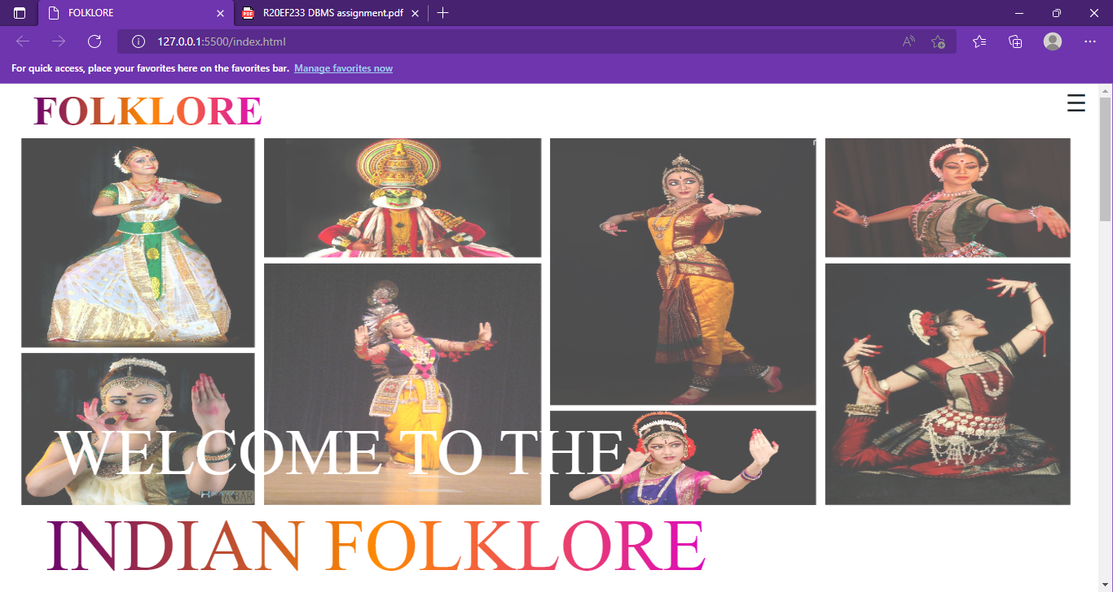

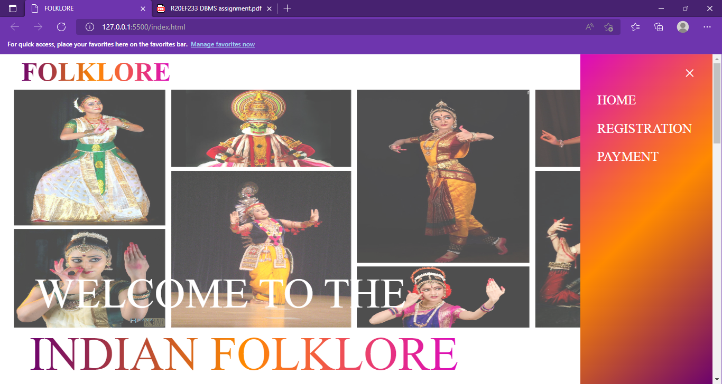

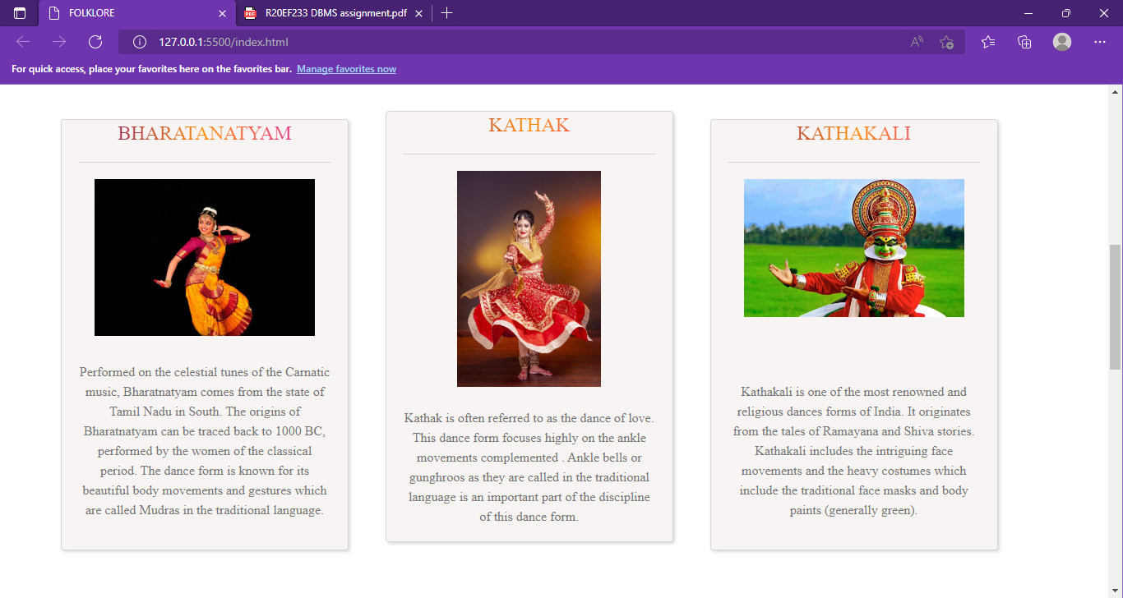

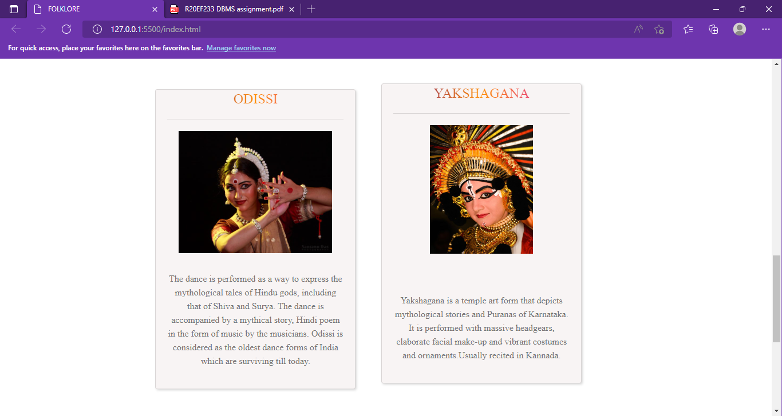

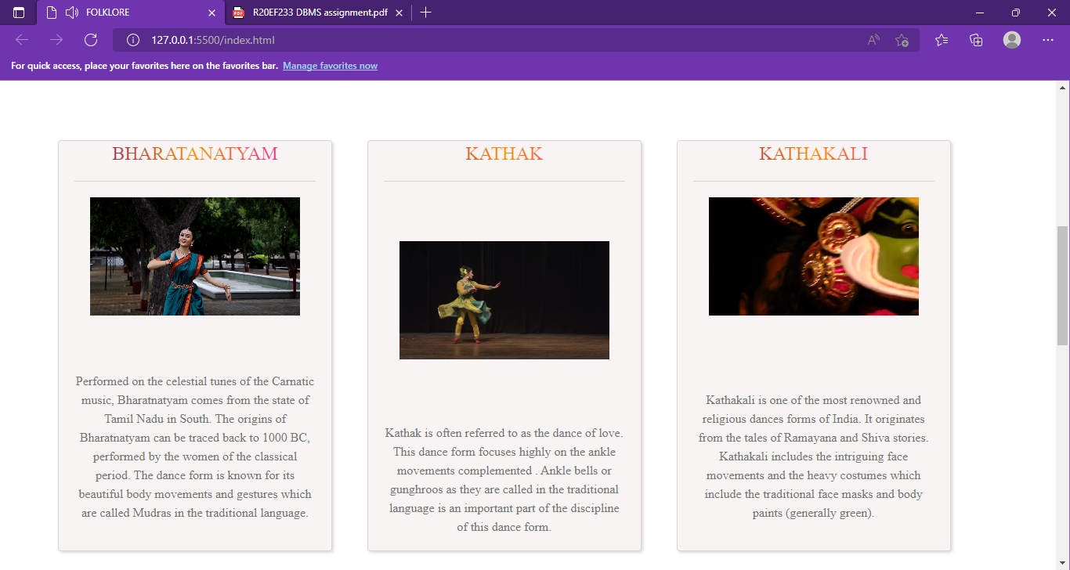

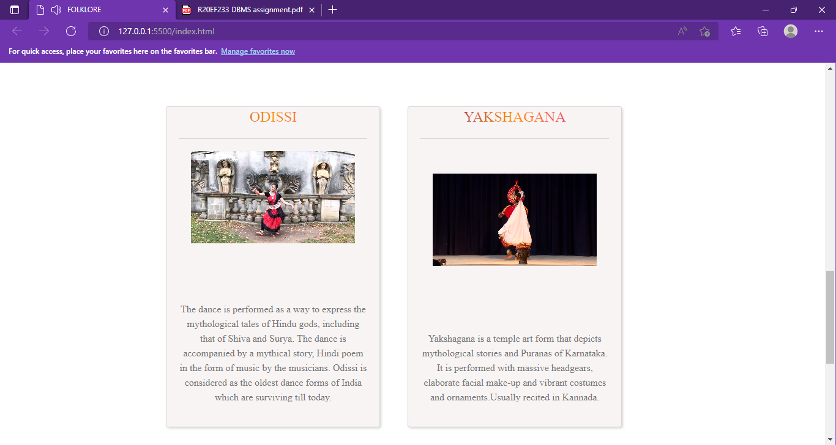

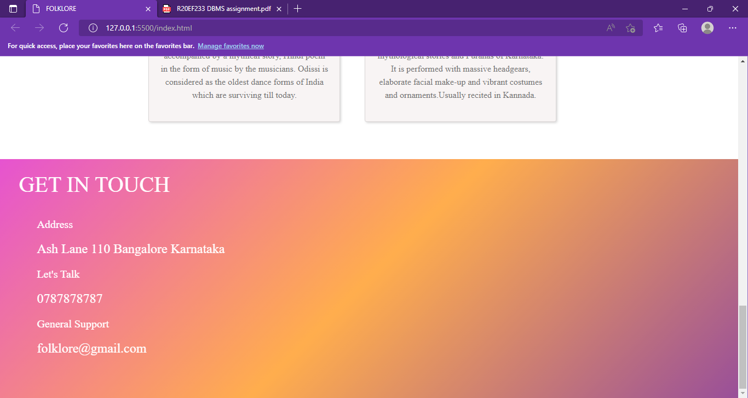

REGISTRATION PAGE

Name of the Dance School. The name of the Dance School is FOLKLORE which is top left of the homepage. There is a menu bar at the top right of the homepage which contains link home page, payment page. This page gives the information about the registration form. The folks can register here by providing their First name, Last name ,Age, Gender, Email, and the dances they are interested in. And can click on the submit button to get register.

Front End View created is shown below:

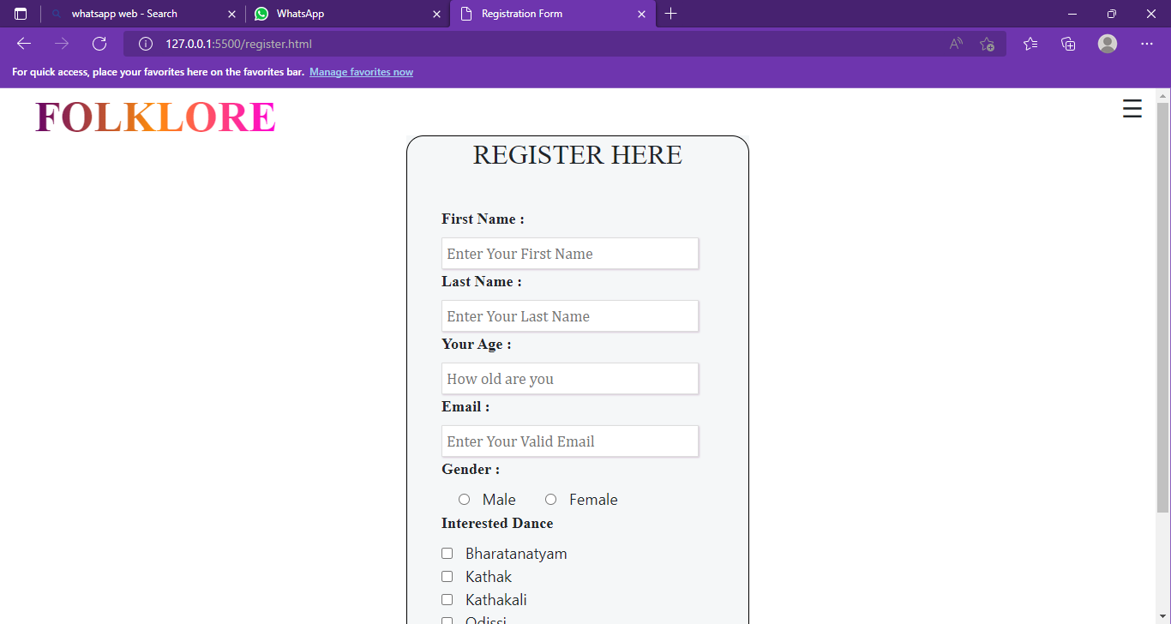

PAYMENT PAGE:

This page is useful for payment to register the folk dances and it display the payment option’s which one user wants they can pay easily and with secure. we accepted many cards like pay pai, visa, master card and American Express and also we accepted easy payments like UPI, credit card and debit card etc. we give an example to understand the user to follow same options or fill similar way without doing any mistake by the user, we accepted only one time payment with secure details and we had detail information about user who paid and his amount details etc. with secure. for example, any user facing any issues by paying we can help the user.

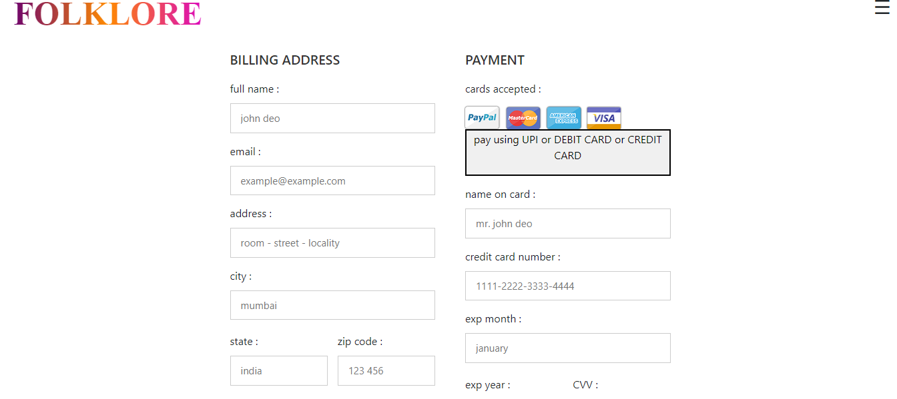

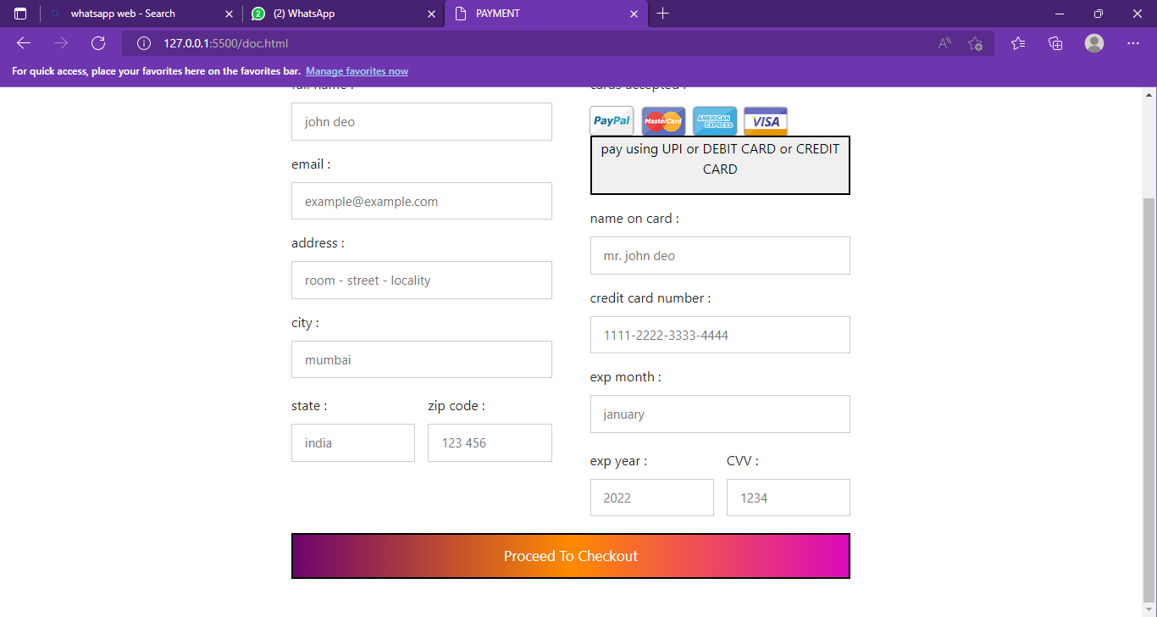

REFERENCES:

www.w3schools.com, https://stackoverflow.com, https://youtu.be/UEZ60e4MsgA.