**HTML-Hyper Text Markup Language**

SHORTCUT – html tab  
Does not need a server  
File must end with .html extension  
Runs in a web browser  
index.html is the root/home page of a website

Web Browser - to view the HTML (Google chrome)  
Text Editor - to write the HTML (Sublime text)

**Start:**Create a folder (htmlcheatsheet)  
Create a new text document called index.html  
view🡪options🡪view🡪uncheck hide extension for known file types🡪apply  
rename the document by removing .txt

**Tag Syntax:**  
<tagname>content</tagname>  
e.g. <p>This is a paragraph</p>

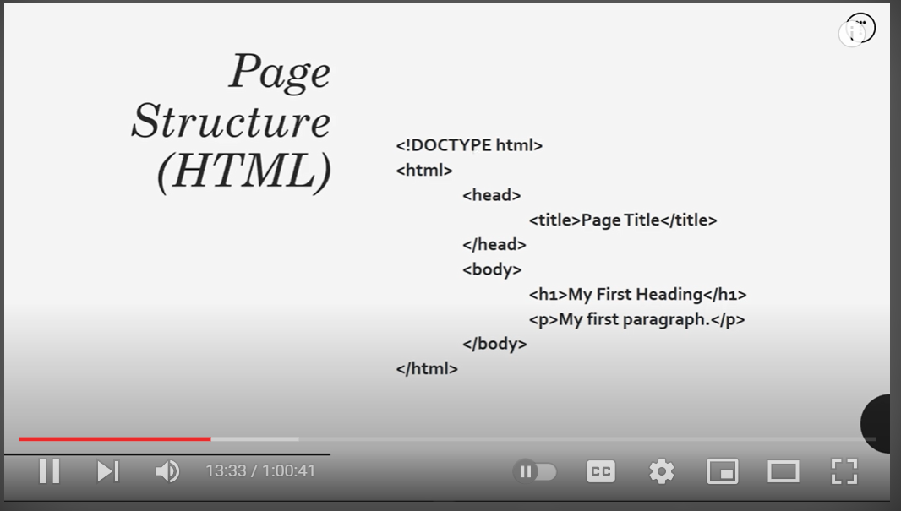  
  
**Inline Elements:** (<span> , <img> , <a> )  
Do not start a new line  
Take only the necessary width

**Block Elements:** (<div> , <h1> - <h6>, <p> , <form> )  
Start on a new line  
Take full width available

Making texts **bold** 🡪 <strong> </strong>  
Making texts **italic** 🡪 <em> </em>

Making texts wrapped in a **link** but opening in SAME tab 🡪 <a href= “https://google.com”> </a>  
Making tests wrapped in a **link** but opening in a NEW tab 🡪 <a href= “https://google.com” target= “_blank”> </a>

**Lists:**  
Unordered (bullet point list): <ul> </ul> & <li>any content </li>   
Ordered (numbered point list): <ol> </ol> & <li> List item 1</li>

**Tables:**<thead> </thead>  
 <tr> </tr>  
 <th>Name</th>

<tbody> </tbody>  
 <tr> </tr>  
 <th>Alavi</th>

**Line Break:**<br>

**Line on a page:**<hr>

**Align text that is sideward to be downward:**  
<div> </div>

**Forms:** (can’t add functionality to the form, only the look of the form)  
<form action = "process.php" method = "POST" > </form>  
Post = Add data to a database  
Get = See the data filled in the URL

Used for **SMALL textarea:**  
 <label>First Name</label>  
 <input type="text" name="firstName">

Used for **BLURRING out** information on an input area:  
 <input type="text" name="lastName" placeholder= "enter first name">

Used for **BIG textarea:**  
 <label>Message</label>  
 <textarea name = “message"> </textarea>

Used for **MANY options:**  
 <label>Gender</label>  
 <select name = "gender">  
 <option value = "male" > Male </option>  
 <option value = "female" > Female </option>  
 </select>   
  
  
Used for **SUBMIT button** inside a form:  
 <input type="submit" name="submit" value ="Submit">

**Buttons:**<button>Click me</button>

**Image:**Within the **same folder**:  
<img src="sample1.jpeg">

Another **sub folder:**  
<img src="image/sample2.jpeg">

If directory is not mentioned correct or you don’t want it to display the picture and **mention a text instead**;  
<img src="image/sample3.jpeg" alt = “no image”>

Adjusting **width & height:**img src="sample1.jpeg" width = "200" height="150">

Wrapping a **link around** it: (Open up in browsers by clicking on it)  
<a href="image/sample2.jpeg">  
 <img src="image/sample2.jpeg" alt= "no image" width = "200">   
</a>

**Quotations:** (Better use CSS for this)  
<blockquote cite = https://traversymedia.com>  
Lorem ipsum  
</blockquote>

**Abbreviation:**<p> The <abbr title = "World Wide Web">WWW</abbr> is awesome </p>

**Semantic tags:** (describes its meaning to both the Browser and the Developer)

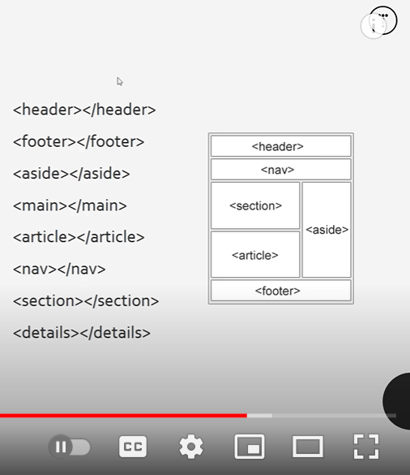

**Copyright symbol:**<footer>  
 <p>Copy Right &copy; 2017, My Website</p>  
</footer>

**Adding a link to another webpage:**

<body>  
<a href="index.html">Go to index</a>  
</body>

<body>  
<a href="blog.html">Go to blog</a>  
</body>