Term Project 667 - Scrabble

**Table of Contents**

Team Information 3

Github Repository Link: 3

Game Overview 4

Wireframes 5

Login page 5

Forgot Password Page 6

Lobby Page 7

Game Page 8

Account Page 9

# 

# 

# Team Information

**Team Name:** term-project-667-project-alavi-chalke-mazumdar

**Team Members:** Ali Alavi

Ajinkya Chalke

Neharika Mazumdar

# Github Repository Link:

<https://github.com/sfsu-csc-667-fall-2017/term-project-667-project-alavi-chalke-mazumdar>

# 

# 

# Game Overview

Scrabble is a word game in which two to four players score points by placing tiles bearing a single letter onto a board divided into a 15×15 grid of squares. The tiles must form words which, in crossword fashion, read left to right in rows or downwards in columns, and be defined in a standard dictionary or lexicon. A sample board is shown below.

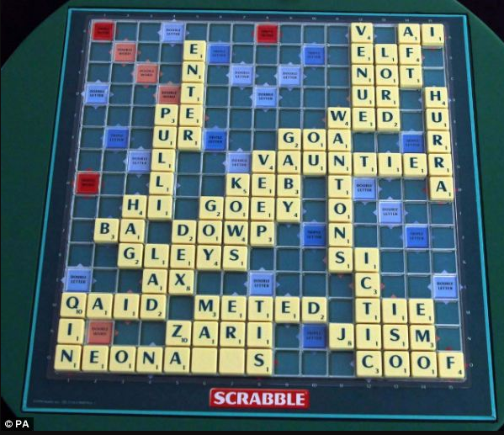

A standard game contains 100 letters and each player starts with 7 letters on their rack which are distributed randomly. Each letter has a score associated with it and the total score for a word depends on the sum of all individual letters. The board has premium squares, identified by unique colors, which multiply the letter or word points based on the square.

The game finishes when one player plays every tile on his or her rack, and there are no tiles remaining in the bag (regardless of the tiles on his or her opponent's rack). The player with the highest score at that point wins.

More information: <https://en.wikipedia.org/wiki/Scrabble>

# 

# Wireframes

## Login page

1. Basic information about the game and a link to the rules
2. Login form for returning users along with a link to the forgot password page
3. Signup form for new users

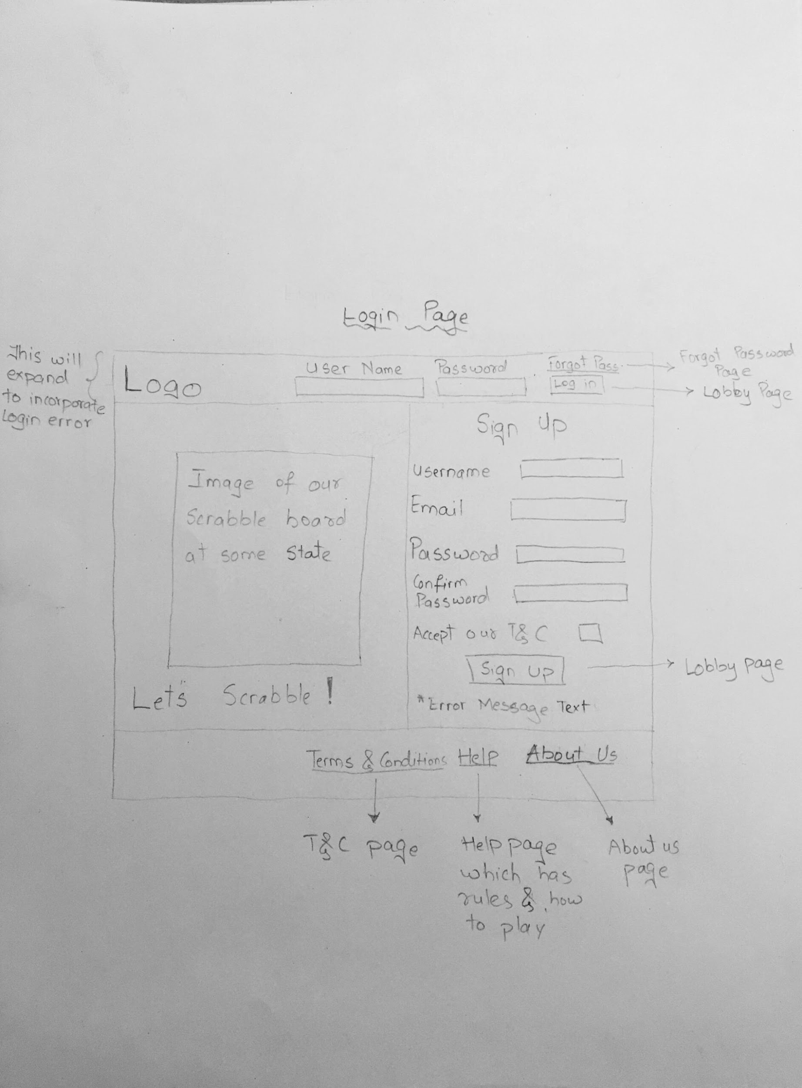

## Forgot Password Page

1. For sending password reset instructions to the email address provided in the form

## 

## Lobby Page

1. A chat window to chat with all active users in the lobby
2. Create game option to start a game with the minimum number of players you want
3. A table displaying the current games in progress and an option to either join or spectate based on the game status. This table is searchable and sortable.
4. A view of the leaderboard.

## 

## Game Page

1. Displays the game board, a 15 X 15 grid which shows the current game state.
2. An alphabet rack which displays the current letters the user can play with on their turn
3. The possible actions the user can take on their turn
   1. Play - Place letters on the board and make their move if the word is a legitimate one. This will be checked by making a call to the API.
   2. Pass - .Forfeit their turn.
   3. Swap - Replace upto 7 tiles in the rack with remaining alphabets in the tile bag. This counts as a turn.
4. Displays the other users’ names and their current score.
5. A chat window to interact with the users in the game.
6. Displays the number of remaining tiles in the bag.
7. The user can forfeit the game at any point in time.
8. User will be given options for continuing or forfeiting the game on navigation to another URL.

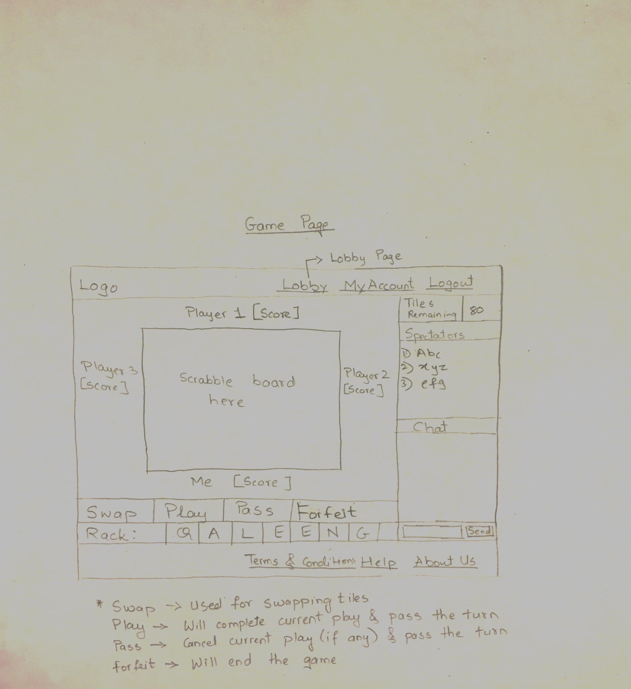

## Account Page

1. Displays the user’s details along with the reset password functionality.
2. Displays basic stats such as average score per game, percentage of games won, e.t.c
3. Lists the user’s history of games in a table which is sortable and searchable.

