Carleton University


SYSC 5104
Methodology for Discrete-Event Modelling and Simulation

Assignment 1

Student Name: Iman Alavi Fazel
Student No: 101261338

Table of Content

Introduction 2
Formal specification of atomic models 3
Generator 3
Load balancer 4
Server 6
Transducer 7
Formal specification of coupled models 9
Load Balancing System 9
Top Level Model 9
Testing 10
Simulation Result 15

Introduction
Load balancing is a common technique used in computer networks to reduce response time and increase throughput of the users’ traffic. In this project, we modeled a load balancing system with priority queue scheduling using the DEVS formalism, and simulated it with different parameters. The architecture of this project which is depicted in Figure 1, consists of four atomic models which are the generator, balancer, servers and transducer.
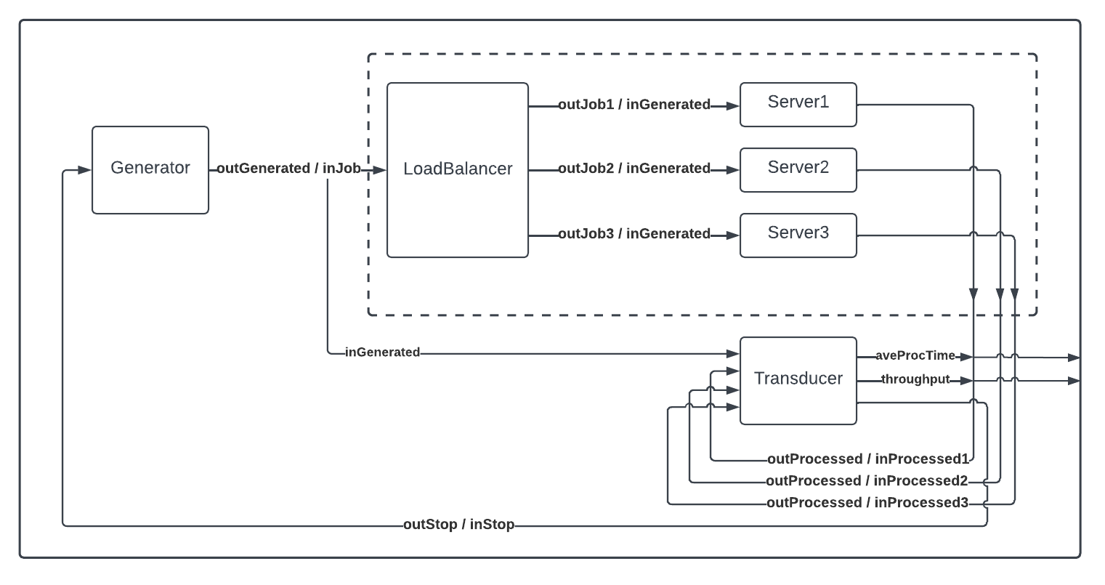
Figure 1. Diagram of the load-balancing model.

Formal specification of atomic models

Generator
The generator atomic model periodically generates jobs, and alongside a randomly-generated priority, sends to the balancer and the transducer models.
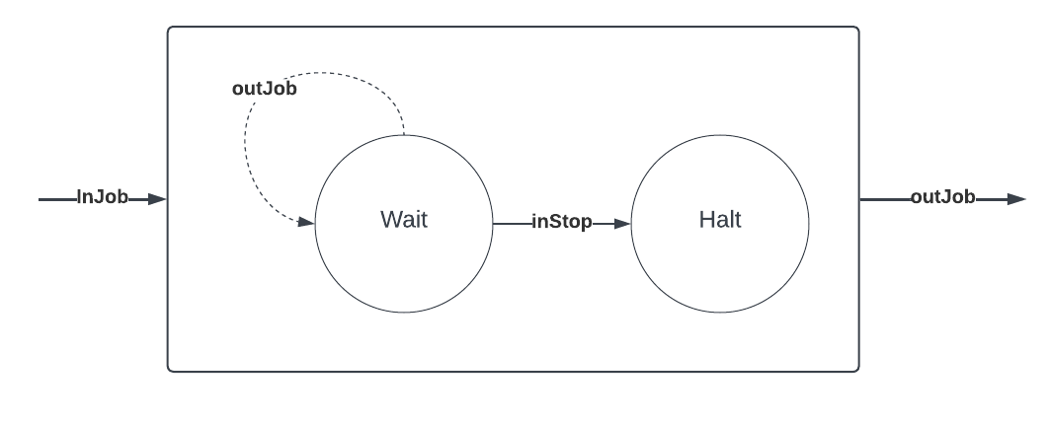
Figure 2. The atomic model for generator.
Each job that the generator model creates is a tuple consisting of the unique ID of the job, the time it was created, and the time it was processed. Hence, the set of Jobs is defined mathematically as:
Furthermore, a pair of job and its corresponding priority is defined as:
The formal specification of the generator model is defined as below:
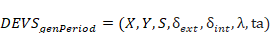
where
{
case phase
Active:
ta(state) = ;
jobCount = jobCount + 1;
Passive:
// Do nothing
break
}
{
clock = clock + e;
ta(state) = Infinity;
phase = Passive;
}
{
jobPair = JobPair(randInt(1,5), Job(jobCount, clock + sigma));
send jobPair to port outGenerated;
}

Load balancer
The load balancer model receives jobs from the generator, and dispatches them to its connected servers according to their priorities. This atomic model is modelled as a queue with a fixed dispatch time delay.
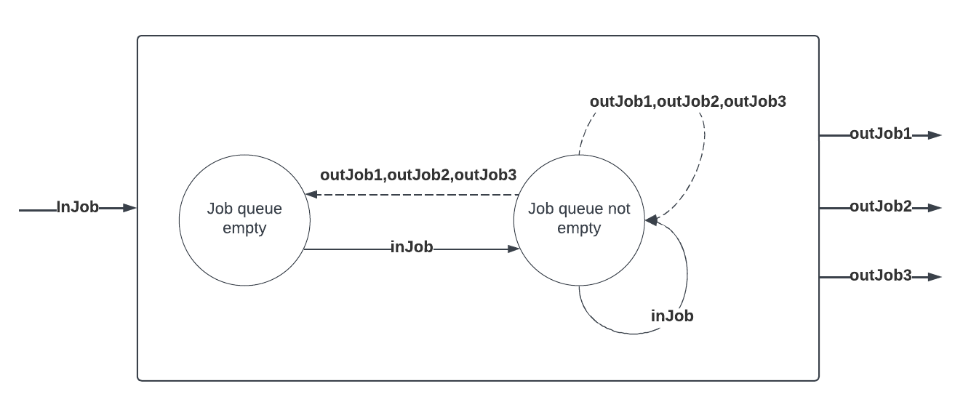
Figure 3. The atomic model for load balancer.
The formal specification of the load balancer model is defined as below:
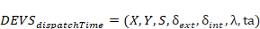

{
jobQueue.pop();
if Empty(jobQueue)
phase = Passive;
ta(state) = Infinity;
else
ta(state) = dispatchTime;
}
{
newJob = x.inJob
// Add job to the jobQueue queue, according to the priority
jobQueue.add(<priority, job>);
case phase
Active:
ta(state) -= e;
Passive:
ta(state) = dispatchTime;
phase = Active;
}
{
// Retrieve the job with the highest priority
job = jobQueue.top().job;
// Dispatch jobs based on the remainder of their ID.
// This results in a normal round-robin scheduling of priority of
// consecutive jobs are the same.
if (job.id % 3 == 0)
send job to port outPort[0];
else if (job.id % 3 == 1)
send job to port outPort[1];
else
send job to port outPort[2];
}

Server
The server model receives jobs from the load balancer and process them in exponentially distributed time. Similar to the load balancer, it is a form of queue and jobs will accumulate in its buffer until the server processes them.
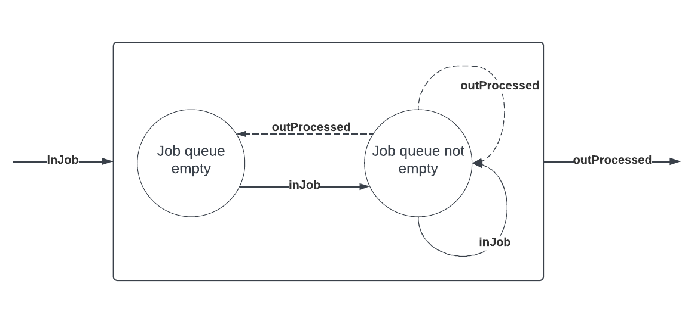
Figure 4. The atomic model for server.
The formal specification of the server model is defined as below:
where
{
jobQueue.pop();
if Empty(jobQueue)
phase = Passive;
ta(state) = Infinity;
else
ta(state) = getExpDistributionProcessingTime();
}
{
newJob = x.inJob;
processingTime = getExpDistributionProcessingTime();
// Add job to the queue
jobQueue.add(Job(newJob.id, newJob.timeGenerated, newJob.timeGenerated + processingTime));
case phase
Active:
ta(state) -= e;
Passive:
ta(state) = processingTime;
phase = Active;
}
{
send jobQueue.top() to port outProcessed;
}

Transducer
Transducer collects information about the generated and the processed jobs, and calculates the overall throughput and average processing time of the simulation run. Moreover, this atomic model is responsible for sending the outStop signal to the generator after a specific time to end its execution. The transducer model has two parameters, namely, obsTime and processingTimeMean. The first one specifies the total duration of a simulation run, and the later refers to the average processing time of the servers. The processing time of servers is captured to estimate a period of time to wait for servers to finish processing before generating its output.
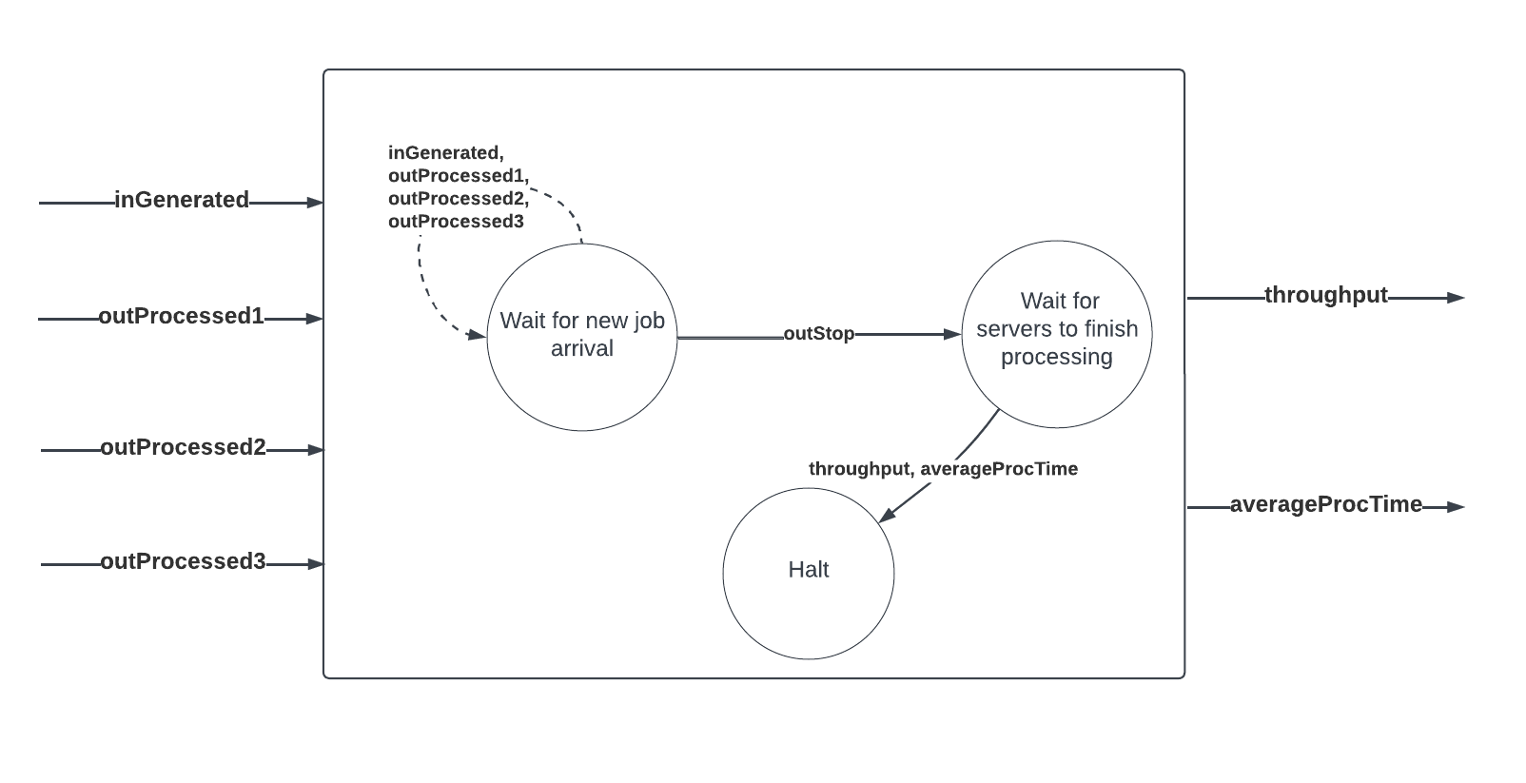
Figure 5. The atomic model for transducer.
The formal specification of the transducer model is defined as below:
where
{
case waitingForServersProcessing
true:
waitingForServersProcessing = true;
sigma = serverProcessingExpMean * nJobsGenerated;
false:
sigma = Infinity;
}
{
sigma -= e;
clock += e;
for job in inGenerated
nJobsGenerated++;
for job in inProcessed1
nJobsProcessed++;
for job in inProcessed2
nJobsProcessed++;
for job in inProcessed3
nJobsProcessed++;
}
{
case waitingForServersProcessing
true:
if nJobsProcessed > 0
send (totalProcessingTime / nJobsProcessed) to port averageProcessingTime;
if clock > 0
send (totalTA / nJobsProcessed) to port throughput;
false:
send true to port outStop;
}

Formal specification of coupled models

Load Balancing System
where
EOC = {( (Server1, outProcessed1), (Self, outProcessed1) ); ( (Server2, outProcessed2), (Self, outProcessed2) ); ( (Server3, outProcessed3), (Self, outProcessed3) )}
IC = {( (Balancer, outJob1), (Server1, inGenerated) ); ( (Balancer, outJob2), (Server2, inGenerated)); ( (Balancer, outJob3), (Server3, inGenerated) )}

Top Level Model
where
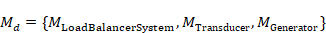
EOC = {(
IC = {((Generator, outGenerated), (
((Generator, outGenerated), (Transducer, inGenerated));
((Transducer, outStop), (Generator, inStop)) }

Testing
For each atomic model, a separate program was developed to test the model in isolation and verify its correct behavior. The test programs use IEStream component of Cadmium to provide inputs data in different timestamps. The input data file of the test programs has the following format:
<TIME> <DATA1> <DATA2> …
Here, the <TIME> represent the timestamp we want the test case to execute, and the subsequent data entries <DATA1>, <DATA2>, … correspond to the values which are used to create inputs for a given atomic model. For instance, if a specific model accepts objects of type Job as inputs, and the constructor of this type has the following signature:
Job(int jobId, double timeGenerated, timeProcessed);
Then, input file should be comprised of following entries:
<TIME> <jobID> <timeGenerated> <timeProcessed>
This results in creation of a Job object with specified parameters, and be sent to the model at time <TIME>.

Generator
The generator model creates jobs periodically according to the genPriod (specified by its instantiation), until it receives a Boolean inStop signal. To test this model, the inStop signal was triggered at an arbitrary time during the simulation and it was observed whether the signal caused the generator to passivate.

The input data
Provided input data (generator_test_input.txt):
6 1

Result
time;model_id;model_name;port_name;data
0;1;generator;;0
0;2;iestream;;6
0;1;generator;outGenerated;{0,0,-1, P: 2}
0;1;generator;;1
2;1;generator;outGenerated;{1,4,-1, P: 4}
2;1;generator;;2
4;1;generator;outGenerated;{2,6,-1, P: 1}
4;1;generator;;3
6;1;generator;outGenerated;{3,8,-1, P: 5}
6;1;generator;;4
6;2;iestream;out;1
6;2;iestream;;inf
6;1;generator;;4
6;2;iestream;;inf

Observation
As the execution run shows, after the time in which the generator received inStop input (at time 40), the model got halted and stopped creating jobs.

Balancer
To test the load balancer, the dispatchTime parameter was set as a high value. This resulted in the jobs to queue up and facilitated the observation of its behavior with a small set of test input data.

The input data
Provided input data (balancer_test_input.txt):
1 4 1 1 -1
2 1 5 5 -1
3 1 6 6 -1
4 7 3 3 -1

Result
time;model_id;model_name;port_name;data
0;1;balancer;;inf
0;2;iestream;;1
1;1;balancer;;5
1;2;iestream;out;{2,2,-1, Priority: 8}
1;2;iestream;;1
2;1;balancer;;4
2;2;iestream;out;{5,5,-1, Priority: 1}
2;2;iestream;;1
3;1;balancer;;3
3;2;iestream;out;{6,6,-1, Priority: 1}
3;2;iestream;;1
4;1;balancer;;2
4;2;iestream;out;{3,3,-1, Priority: 7}
4;2;iestream;;inf
6;1;balancer;out3;{5,5,5}
6;1;balancer;;5
11;1;balancer;out1;{6,6,6}
11;1;balancer;;5
16;1;balancer;out1;{3,3,3}
16;1;balancer;;5
21;1;balancer;out3;{2,2,2}
21;1;balancer;;inf
21;1;balancer;;inf
21;2;iestream;;inf

Observation
The log of the simulation line indicated after receiving different jobs from the generator, the ones with the highest priority (having the smallest rank) were dispatched first (time 6 and 11 in the log output). This order of the generated outputs verified that the priority queueing scheduling was working properly.

Server
To test the server model, we provided three different jobs and observed the time and order get processed.

The input data
Provided input data (server_test_input_generator.txt):
1 5 1 -1
2 6 2 -1
3 7 3 -1

Result
time;model_id;model_name;port_name;data
0;1;server;;inf
0;2;iestream;;1
1;1;server;;7.32355
1;2;iestream;out;{5,1,-1}
1;2;iestream;;1
2;1;server;;6.32355
2;2;iestream;out;{6,2,-1}
2;2;iestream;;1
3;1;server;;5.32355
3;2;iestream;out;{7,3,-1}
3;2;iestream;;inf
8.32355;1;server;outProcessed;{5,1,8.32355}
8.32355;1;server;;26.3904
34.7139;1;server;outProcessed;{6,2,12.9657}
34.7139;1;server;;21.2524
55.9663;1;server;outProcessed;{7,3,16.4371}
55.9663;1;server;;inf
55.9663;1;server;;inf
55.9663;2;iestream;;inf

Observation
The output of the run showed that the 3 jobs were successfully queued up and processed according to the intended FIFO policy.

Transducer
In test the transducer model, we created job at arbitrary times and passed to the inGenerator port of the trasducer, and verified that the throughput and average processing time were calculating correctly.

The input data
Provided input data (transducer_test_input_generator.txt):
1 4 1 1 -1
2 4 2 0 -1
3 5 3 1 -1
4 6 4 0 -1
5 1 5 1 -1
6 1 6 0 -1

Provided input data (transducer_test_input_processed.txt):
1 1 1 2
4 2 0 5
7 3 1 10
9 4 0 10
10 5 1 11
20 6 0 13

Result
time;model_id;model_name;port_name;data
0;1;transducer;;{0,0,0}
…
22;1;transducer;outStop;1
22;1;transducer;averageProcessingTime;8
22;1;transducer;throughput;0.315789
22;1;transducer;;{48,6,6}
22;1;transducer;;{48,6,6}
22;2;iestream;;inf
22;3;iestreamProc;;inf
22;4;iestreamGen;;inf

Observation
The output of the test input shows that the throughput and the average processing time were calculated as expected.

Simulation Result
After developing and testing each model, the complete load balancing system was simulated for different values for job arrival rate. In different runs, the mean processing time was set as a constant value, 2. The throughput of the system in different runs are shown in Table 1.

Table 1. Result of the simulation for mean server processing time = 2.
Arrival rate | Throughput
10 | 0.1016
5 | 0.2014
1 | 0.9924
0.7 | 1.3444
0.5 | 1.4901
0.1 | 1.4894
0.05 | 1.4931
0.01 | 1.4915
The result shows that by increasing the job arrival rate, the throughput increases until the servers become bottleneck and hits a certain limit. The throughput limit in our simulation is turned out to be around 1.5 which matches with the result of utilization law in queuing theory. This law states that the saturation throughput in an open-system is calculated by the reciprocal of the total system demand. Mathematically:
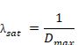
In the example run, the mean processing time of each server was chosen to be 2. Since the jobs visit each server one third of the times on average, the service demand of each server is (1/3)*2 = 2/3. Hence, the saturation throughput is calculated as:

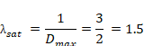
Which was identical to the ones that was observed in our simulation.

