Assignment 2 SYSC5104

Modeling and simulation of water quality in a pond using Cell-DEVS

Overview
Water quality is a key factor in determining agriculture and aquafarming production. In this project we simulated the parameters of temperature, pH and oxygen, which determines whether the water quality is up to par to allow aquatic animals to survive and grow. The models are based on the paper titled “Cellular Automata-Based Simulation Model for Water Quality Management of Pangasius Ponds” by Huynh et al. The cells in this project are considered with hexagonal neighborhoods as depicted in the figure below:

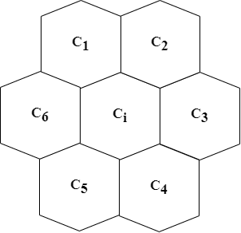

This type of neighborhood allows a more realistic representation of the phenomena under study, especially the temperature. In this case, each cell gets the average of its neighboring cells taking account the tendency of warmer water (hence lower density) to be located in the upper layers.

Modeling pH
Various factors, such as fish food and the amount of rainfall, impact the pH level in ponds. The transition rule for this parameter is a simple averaging, which is defined as:
- If only one neighborhood has a known value, set that value on the cell C_{i} (i = 1,2,…,6)
- Otherwise, set average(C₁, C₂, C₃, C₄, C₅, C₆).
The implementation of this model for CD++ is done by specifying a 10 by 10 grid, with nowrap configuration. Since the neighborhood type for the cells are hexagonal, the rules were written in a separate file (.rule file) and then converted to the Neumann neighborhood by ltrans program. These rules assess whether their neighboring cells lie inside the grid and have a known value by checking cell values against the character literal ?. For instance, to implement the first rule, the file contain:

...
rule: { ([6]) } 100 { stateCount(?)=5 and [1] = ? and [2] = ? and [3] = ? and [4] = ? and [5] = ?}
rule: { ([5]) } 100 { stateCount(?)=5 and [1] = ? and [2] = ? and [3] = ? and [4] = ? and [6] = ?}
…

To automate the creation of these, a Python script was developed for this project (the script is present in the pH_level subdirectory).

Modeling temperature and Dissolved Oxygen (DO)
The primary source of heat in ponds is sunlight, and for oxygen, it is the photosynthesis of aquatic organisms. The spread of dissolved oxygen (DO) levels is similar to that of temperature, and they use the same transition rules. These rules consist of:
- If only one neighborhood has a known value, set that value on the cell C_{i} (i = 1,2,…,6)
- If the state of two middle neighborhoods (C₃ and C₆) are known, use their average.
- If the state of two upper-level neighborhoods (C₁ and C₂) are known, use the maximum value between them.
- If the state of two lower-level neighborhoods (C₄ and C₅) are known, use the maximum value between them.
- If there is no thermal stratification, i.e., min(C₁,C₂) − max(C₄, C₅) ≤ 2, set average(C₃,C₆ max(C₄,C₅), min(C₁,C₂)).
- If there is thermal stratification, i.e., min(C₁,C₂) − max(C₄, C₅) > 2, set average(C₃,C₆, max(C₄,C₅)).
Similar to the temperature model, the implementation of this cellular automata is done by specifying a 10 by 10 grid, with the nowrap setting.

Simulation result
The project root folder is comprised of three subdirectories for the models under study, and each one contains a batch file that runs a simulation for the specified duration. The initial cell values and the result after simulation are presented below.

pH level parameter
Initial cell values:
9.03 9.03 9.03 9.03 9.03 9.03 9.03 9.03 9.03 9.03
9.03 9.03 9.03 9.03 9.03 9.03 9.03 9.03 9.03 9.03
8.32 8.32 8.32 8.32 8.32 8.32 8.32 8.32 8.32 8.32
8.32 8.32 8.32 8.32 8.32 8.32 8.32 8.32 8.32 8.32
7.49 7.49 7.49 7.49 7.49 7.49 7.49 7.49 7.49 7.49
7.49 7.49 7.49 7.49 7.49 7.49 7.49 7.49 7.49 7.49
6.78 6.78 6.78 6.78 6.78 6.78 6.78 6.78 6.78 6.78
6.78 6.78 6.78 6.78 6.78 6.78 6.78 6.78 6.78 6.78
6.29 6.29 6.29 6.29 6.29 6.29 6.29 6.29 6.29 6.29
6.29 6.29 6.29 6.29 6.29 6.29 6.29 6.29 6.29 6.29

Result of the simulation:
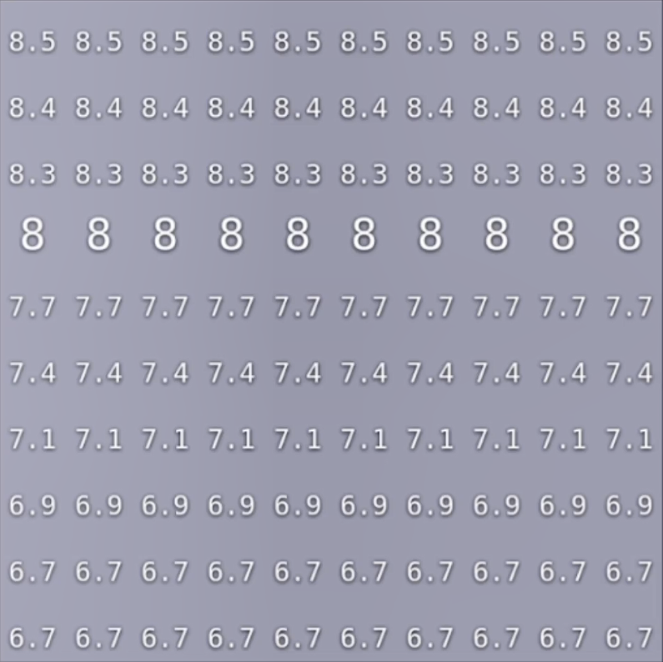

Temperature parameter
Initial cell values:
5 5 5 5 5 5 5 5 5 5
5 5 5 5 5 5 5 5 5 5
5 5 5 5 5 5 5 5 5 5
5 5 5 5 5 5 5 5 5 5
3 3 3 3 3 3 3 3 3 3
3 3 3 3 3 3 3 3 3 3
3 3 3 3 3 3 3 3 3 3
3 3 3 3 3 3 3 3 3 3
3 3 3 3 3 3 3 3 3 3
Each cell value corresponds to one of the following ranges of temperature values:
Value | Temperature range
1 | <26
2 | >=26 and <28
3 | >=28 and <=30
4 | >30 and <=32
5 | >32

Result of the simulation:
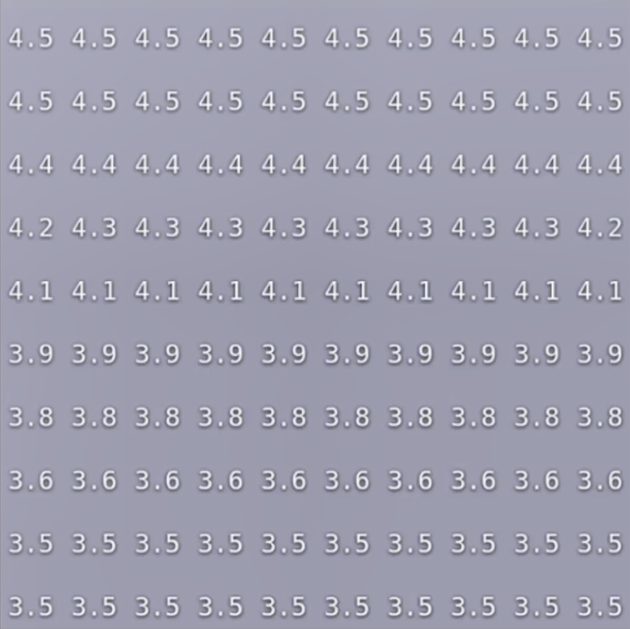

DO parameter
Initial cell values:
7.29 7.29 7.29 7.29 7.29 7.29 7.29 7.29 7.29 7.29
7.29 7.29 7.29 7.29 7.29 7.29 7.29 7.29 7.29 7.29
6.65 6.65 6.65 6.65 6.65 6.65 6.65 6.65 6.65 6.65
6.65 6.65 6.65 6.65 6.65 6.65 6.65 6.65 6.65 6.65
5.67 5.67 5.67 5.67 5.67 5.67 5.67 5.67 5.67 5.67
5.67 5.67 5.67 5.67 5.67 5.67 5.67 5.67 5.67 5.67
5.52 5.52 5.52 5.52 5.52 5.52 5.52 5.52 5.52 5.52
5.52 5.52 5.52 5.52 5.52 5.52 5.52 5.52 5.52 5.52
5.42 5.42 5.42 5.42 5.42 5.42 5.42 5.42 5.42 5.42
5.42 5.42 5.42 5.42 5.42 5.42 5.42 5.42 5.42 5.42

Result of the simulation:

The acceptable range of values for parameters in which the aquatic animal can survive is discussed in the original paper.

