**Applied Data Science Capstone Project**

**The Battle of Neighborhoods (Week 2)**

# **Introduction: Problem Description**

This project report explains search for a restaurant businessperson for best location for his business with less competition in Dublin, Ireland.

Idea of this project is If a business person wants to open a restaurant in Dublin, help him analyse which area would be better depending on competition and population within Dublin.

# **Background**

In recent years Migrations to Ireland are increased and most of the migrant are based at Dublin location. Due to increased housing prices in Dublin city area, people are preferring to locate little away from Dublin, but they find difficult to locate good restaurants near their homes. In such scenario, restaurants like Asian, Chinese or Italian cuisine restaurant would be blessing for people and they won’t need to visit Dublin city central always.

# **Data**

Dublin has postal districts 1-24 or Greater Dublin with 4 major regions can be scrapped from below sites,

 https://en.wikipedia.org/wiki/County_Dublin

For the problem mentioned we would need data

* Location data for Dublin postal districts and greater Dublin
* Venues data around all Dublin postal districts and for Greater Dublin regions
* Also population data for 4 major regions of Dublin

With Four square API, nearby venues within 1km region for each of Dublin Postal Districts or greater Dublin region are found.

*Shared IBM Notebook at*: <https://github.com/alavikunhu/Applied-Data-Science-Capstone-Week5.git>

# **Methodology**

This project will check the density of restaurants in all Dublin postal districts. Also separate check of density of restaurants in each of 4 major regions of Dublin.

Distance between Dublin postal districts varies, range around ~2km is considered to fetch venues for around in each district also venues within ~8km distance is considered for 4 major Dublin regions.

Plot bar charts for restaurants in Dublin postal districts. Plot bar chart for % of Restaurants and population for greater Dublin regions.

# **Results**

* **Restaurants counts for all postal districts of Dublin**

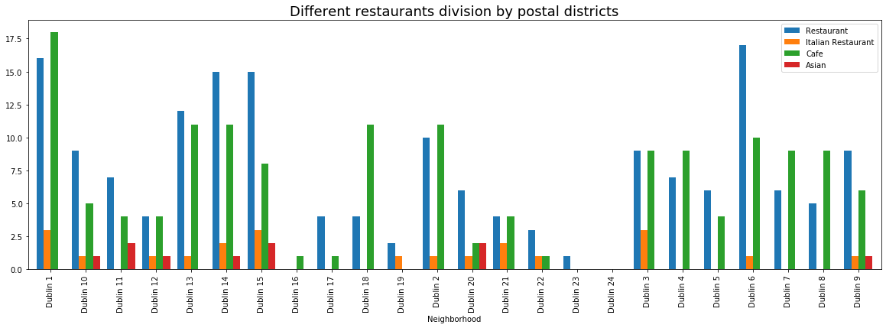

Asian Restaurants have less existence in Dublin City (Dublin 1, Dublin 2) , Fingal and Dun-Laghorie areas.

* **% of Restaurants for postal districts**

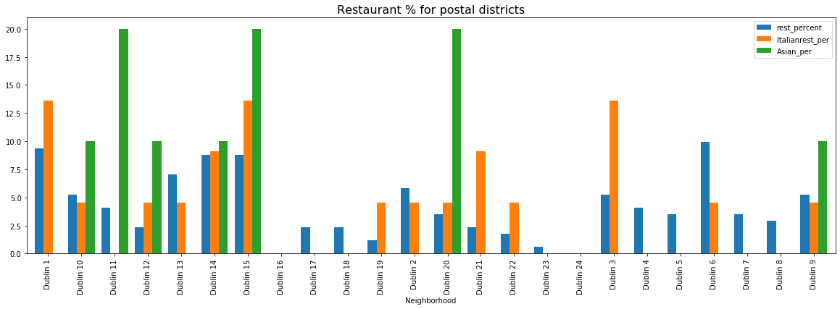

* **% of Population, Restaurants for major regions of Dublin**

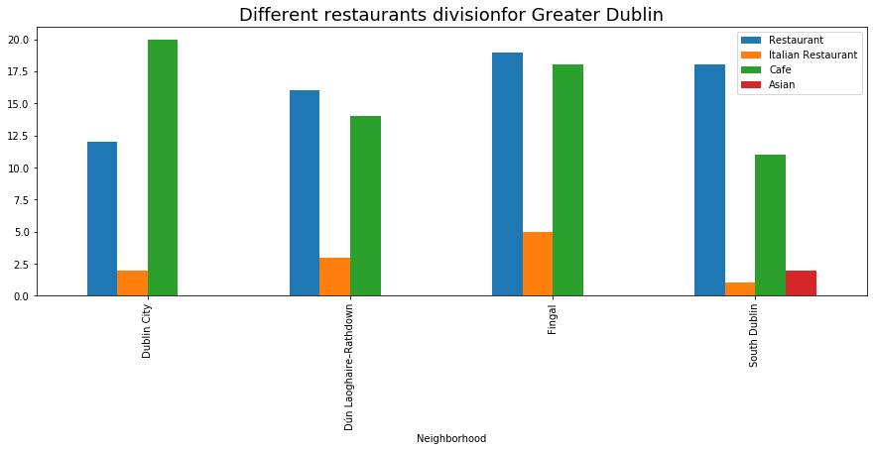

Both Dublin major area wise plots above indicates need of Asian restaurant

* **Map:**

**'Asian': 'red'**

**'Italian': 'green'**

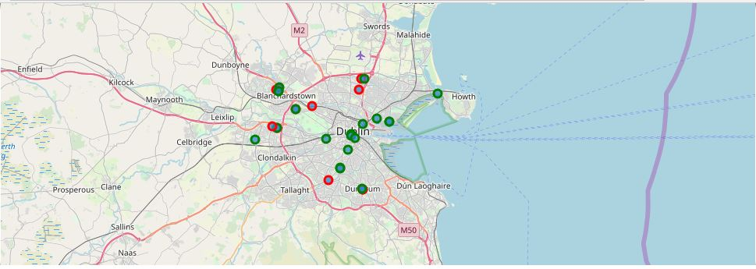

# **Analysis**

Overall Asian Restaurants have less existence in Dublin City (Dublin 1, Dublin 2), Fingal and Dun-Laghorie areas, region which has plenty of restaurants and cafe otherwise.

Assuming Asian migrated peoples are settling in Dublin 15, Dublin 2, Dublin 4 postal districts majorly, hence Dubin2 and Dublin4 can be a good potential area for Asian restaurant. Also map shows less Asian restaurants in overall Dublin, specifically in Dublin City.

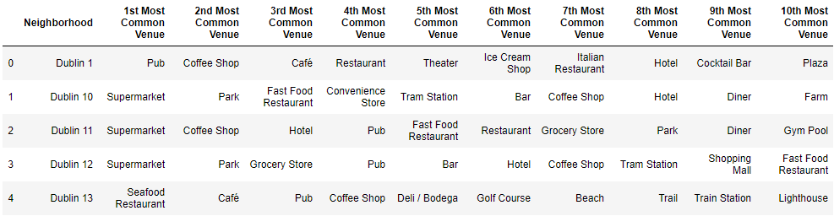

# **Conclusion**

*Dublin City, Fingal* and Dun-Laghorie would be potential regions to open an *Asian Restaurant.* Assuming increasing population in Dublin 4, Dublin 8 and Fingal region, *Asian restaurants* would have good potential in these areas of Dublin