**Supplemental Information for:**

**Comparable response of wild rodent gut microbiome to anthropogenic habitat contamination**

Anton Lavrinienko1,2*, Anni Hämäläinen2, Rasmus Hindström1, Eugene Tukalenko1,3, Zbyszek Boratyński4, Kati Kivisaari2, Timothy A. Mousseau5,6, Phillip C. Watts1,2, Tapio Mappes2

1Ecology and Genetics, University of Oulu, Oulu, 90014, Finland

2Department of Biological and Environmental Science, University of Jyväskylä, Jyväskylä, 40014, Finland

3National Research Center for Radiation Medicine of the National Academy of Medical Science, Kyiv, 04050, Ukraine

4CIBIO-InBIO Associate Laboratory,Research Center in Biodiversity and Genetic Resources, University of Porto, PT-4485-661 Vairão, Portugal

5Department of Biological Sciences, University of South Carolina, Columbia, SC 29208, USA

6SURA/LASSO/NASA, ISS Utilization and Life Sciences Division, Kennedy Space Center, Cape Canaveral, FL, United States

*Corresponding author: Anton Lavrinienko, email: [anton.1.lavrinienko@jyu.fi](mailto:anton.1.lavrinienko@jyu.fi)

Tel. +358 44 237 2121

Running title: Gut microbes of mice from radioactive forest

**Supplementary Methods**

*External radiation dose rate estimation*

Several capture-mark-recapture studies using thermoluminescent dosimeters (TLDs) attached to free-ranging animals indicate that external radiation dose absorbed by small mammals (*e.g.* *Myodes glareolus*, *Microtus* spp. and *Apodemus flavicollis*) inhabiting the Chernobyl Exclusion Zone (CEZ) can be predicted from ambient radiation dose rate at their trapping location (Beresford et al., 2008; Chesser et al., 2000; Lavrinienko et al., *submitted*). While there are no studies testing the relationship between ambient radiation and animals’ external radiation exposure using TLD technology in Japan, such general relationship is expected to be consistent across Chernobyl and Fukushima accident sites. Indeed, several studies have already applied knowledge derived from the experiments within the CEZ to infer external radiation doses absorbed by *A. speciosus* and *A. argenteus* inhabiting areas within the Fukushima Evacuation/Exclusion Zone (FEZ) (Kubota et al., 2015; Onuma, Endoh, Ishiniwa, & Tamaoki, 2020).We conducted a capture-mark-recapture pilot study and implanted TLDs in *A. flavicollis* mice (*n*=10) from contaminated and uncontaminated areas within the CEZ to directly measure external radiation exposure in the field (*in vivo*). Briefly, TLDs preparation and readings were completed following the previously described procedure (Møller & Mousseau, 2018). The lithium fluoride TLDs (3.8x3.8x0.8 mm, model GR-200A, CHP Dosimetry, Oak Ridge, TN, USA) were implanted subcutaneously under the inhalative isoflurane (Baxter, Unterschleißheim, Germany) anaesthesia. All animals were uniquely marked using subcutaneous passive integrated transponder (PIT) tags (Microtransponder, Trovan Ltd, UK) for identification upon recapture. Animals were kept in the laboratory to allow recovery after surgery and after an average of 7 days, were returned to their original contaminated or uncontaminated trapping sites within the CEZ. After 35-50 days, we recaptured three mice (identified via the unique PIT number) fitted with TLDs, animals were humanely euthanized and the TLDs were collected for further processing using a Teledyne 310 TLD reader (Teledyne Brown Engineering, USA). Despite the low number of recovered TLDs (*n*=3), their readings appear to be (1) similar (in a range of 13-35%) to external dose rate estimates inferred from ambient radiation measurements (Supplementary Table 3), and (2) conform closely to those reported in other studies (Beresford et al., 2008). That said, low *A. flavicollis* recapture rate (<25%) prevented such trials in other species, thus external radiation doses absorbed by mice captured around Chernobyl and Fukushima accident sites were inferred from the ambient radiation dose rates at their trapping locations (Figure 1).

We have measured ambient radiation dose rate at mouse trapping locations in Ukraine and Japan using a hand-held Geiger counter (Gamma-Scout, GmbH & Co., Germany) placed at 1 cm above the soil surface. We used an average of at least nine such radiation dose rate measurements per each mouse trapping location for the external dose rate estimation analysis. Contaminated areas within the CEZ and FEZ (Chernobyl High, CH, mean radiation level=22.75 µGy/h; range, 6-70.1 µGy/h; Fukushima High, FH, mean=8.54 µGy/h; range, 3.69-16.7 µGy/h) had significantly higher levels of radiation (*χ2*=43.47, *p*<0.001, Kruskal–Wallis test and *W*=0, *p*<0.001, Wilcoxon rank-sum test, respectively) compared with uncontaminated areas (Chernobyl Low, CL, mean=0.22 µGy/h; range, 0.12-0.3 µGy/h and Kyiv Low, KL, mean=0.23 µGy/h; range, 0.15-0.3 µGy/h; Fukushima Low, FL, mean=0.56 µGy/h; range, 0.28-1.12 µGy/h) (Supplementary Table 1). Consequently, in all the four species studied, individuals inhabiting contaminated areas within the CEZ (CH) and FEZ (FH) were characterised by significantly (*p*<0.05, Kruskal–Wallis and Wilcoxon rank-sum tests, respectively) higher external radiation dose rates than did animals from uncontaminated areas (CL, KL and FL). Summary statistics for each mouse species are provided in the Table 1 of the main manuscript text.

*Internal radiation dose rate estimation*

The relationship between ambient radiation dose rate and animals’ internal radiation exposure derived from ingested particles (*e.g.* contaminated food, water, soil) is not always straightforward due to inter-individual variation, for example, in diet preferences or local availability of dietary components (Chesser et al., 2000). Thus, all sampled mice were subjected to gamma*-*spectrometry to estimate the whole-body radionuclide (134Cs and 137Cs) burden and thus internal radiation exposure.

We measured the radiocaesium activity for each individual using a SAM 940 radionuclide identifier system (Berkeley Nucleonics Corporation, San Rafael, CA, USA) equipped with a 3"x3" NaI detector. The detector was enclosed in 10 cm thick lead shielding to reduce the noise from the background radioactivity. The system was calibrated with reference standard sources. After correcting for the background radiation, the 134Cs and 137Cs activities were assessed from the obtained spectra in the energies range 0.753-0.841 MeV (with photopeak of 134Cs at 0.796 MeV) and 0.619-0.743 MeV (with photopeak of 137Cs at 0.662 MeV), with the use of a phantom with known activity and similar to sample geometry. Animals were weighed prior to measurements and individual body mass was used to standardise readings across individuals. For each measurement, we determined the critical level of detection (*Lc*, decision threshold) using the following formula: *Lc=k[Rb/Tb(1+Tb/Ts]1/2,* where *Lc* is the critical level; *k* is 1.65 (coefficient, which determines 0.05 probability of type I error or false positive); *Rb* is the background radiation rate; *Tb* is the background radiation rate measurement exposition; *Ts* is the time of sample measurement (Isaev, Babenko, Kazimirov, Grishin, & Ievlev, 2010). Only the radiocaesium activity values above the critical level of detection were used in internal dose rate estimation analysis, otherwise the radiocaesium activity in a given sample was assumed to be zero.

For each sampled individual, we calculated the daily internal radiation dose rate from the 137Cs (mGy/d) as a product of the whole-body 137Cs activity (Bq/kg), and the sum of all electron, positron and photon energies absorbed by tissues per decay of the 137Cs and its daughter radionuclide 137mBa. The energies were calculated taking into account the absorbed fractions of electron, positron and photon of the specific energy line, the intensity (or emission frequency) of the specific energy line, under assumption of uniform activity distribution throughout a 20 g homogenous tissue-equivalent sphere (ICRP, 1983; Stabin & Konijnenberg, 2000). The absorbed radiation dose rates from the 134Cs (Fukushima) were estimated using a similar method. The daily internal radiation doses (mGy/d) for mice inhabiting areas around the FEZ were considered as the sum of exposures from both caesium radioisotopes, 134Cs and 137Cs. Note that due to the use of gamma-spectrometry in the present study, our estimates of the absorbed internal radiation dose take into account exposure from radiocaesium only. However, one other radionuclide, 90Sr, is considered to contribute an additional ~50% to the total dose from internal exposure for *Apodemus* mice inhabiting the CEZ (Beresford et al., 2020). Importantly, most of this additional dose is relevant only to bones and red marrow due to a tissue-specific distribution of 90Sr/90Y (ICRP, 1993). Internal dose contributions from transuranic elements (plutonium and americium, <5%) isotopes can be neglected because of their relatively low bioavailability (Beresford et al., 2020).

The internal radiation dose rates from radiocaesium exposure varied even among individuals captured at the same location (Supplementary Table 1). The average internal dose rates were considerably smaller than the average external dose rates (Table 1, main manuscript text). However, in all mouse species studied, individuals inhabiting contaminated areas within the CEZ (CH) and FEZ (FH) were characterised by significantly (*p*<0.05, Kruskal–Wallis and Wilcoxon rank-sum tests, respectively) higher internal radiation dose rates than did animals from uncontaminated areas (CL, KL and FL). The implication is that animals inhabiting areas contaminated with radionuclides are chronically exposed to radiation derived from both external and internal (through ingested particles in food, water, soil) sources.

*Total radiation dose rate estimation*

We have determined the total radiation exposure of each mouse from the sum of the external and internal radiation dose rates (Supplementary Table 1). Similarly, as with the external and internal exposures, total radiation dose rates of mice inhabiting contaminated areas within the CEZ (CH) and FEZ (FH) were significantly (*p*<0.05, Kruskal–Wallis and Wilcoxon rank-sum tests, respectively) higher than those of animals from uncontaminated areas (CL, KL and FL). Notably, in both uncontaminated areas within (CL) and outside (KL) the CEZ in Ukraine, *A. flavicollis* and *A. sylvaticus* were on average characterised by similar (*p*>0.05, Kruskal–Wallis test) total radiation dose rates of 0.006 and 0.007 mGy/d, respectively (Table 1, main manuscript text).

Total radiation exposure differed somewhat between species (Table 1, main manuscript text). Although consistently, most (from ~78% to >96%) of the total radiation exposure in all mice is derived from external sources; *i.e.* animals are exposed to radiation simply by living in a contaminated area (Beresford et al., 2020; Kubota et al., 2015; Onuma et al., 2020). The average total radiation dose rates for mice captured from contaminated areas were 0.51 mGy/day in CEZ and 0.21 mGy/day in FEZ, which is 1-2 orders of magnitude more than exposure received by mice from uncontaminated areas (Table 1, main manuscript text). These radiation doses are similar to those reported in other studies of rodents from Chernobyl and Fukushima accident sites (Beresford et al., 2020; Kubota et al., 2015; Onuma et al., 2020). For context, the dose rates in *A. flavicollis* and *A. speciosus* are equivalent to about 2-4 chest radiography scans (*ca.* 0.10-0.15 mGy) each day (Baker et al., 2017; Brenner & Hall, 2007). The implication of the radiation dosimetry data is that mice inhabiting the contaminated (CH, FH), but not uncontaminated (CL, KL, FL), areas in Ukraine and in Japan experience chronic radiation exposure (Table 1, main manuscript text). Such a notable contrast in radiation exposure of animals living in different study areas, provide further support for appropriate study design and adequate selection of mouse trapping locations (Figure 1).

**Supplementary Tables**

|  |  |
| --- | --- |
| Primer name | Sequence (5'-3') |
| 515F_1 | ATCTACACTCTTTCCCTACACGACGCTCTTCCGATCT**GTGCCAGCMGCCGCGGTAA** |
| 515F_2 | ATCTACACTCTTTCCCTACACGACGCTCTTCCGATCTca**GTGCCAGCMGCCGCGGTAA** |
| 515F_3 | ATCTACACTCTTTCCCTACACGACGCTCTTCCGATCTgca**GTGCCAGCMGCCGCGGTAA** |
| 515F_4 | ATCTACACTCTTTCCCTACACGACGCTCTTCCGATCTagcaatt**GTGCCAGCMGCCGCGGTAA** |
|  |  |
| 806R_1 | GTGACTGGAGTTCAGACGTGTGCTCTTCCGATCT**GGACTACHVGGGTWTCTAAT** |
| 806R_2 | GTGACTGGAGTTCAGACGTGTGCTCTTCCGATCTca**GGACTACHVGGGTWTCTAAT** |
| 806R_3 | GTGACTGGAGTTCAGACGTGTGCTCTTCCGATCTatct**GGACTACHVGGGTWTCTAAT** |
| 806R_4 | GTGACTGGAGTTCAGACGTGTGCTCTTCCGATCTtctact**GGACTACHVGGGTWTCTAAT** |

**Supplementary Table 2.** Primer sequences used to amplify the V4 region of the 16S ribosomal RNA (rRNA) gene. The 515F/806R primer sequence marked in bold text, spacers in the primers used to ensure balanced nucleotide diversity in the Illumina MiSeq run are shown in small letters.

**Supplementary Table 3.** The comparison of absorbed external radiation doses either directly measured using thermoluminescent dosimeters (TLDs) fitted on study animals or inferred based on ambient radiation dose rate at mice trapping location.

|  |  |  |  |  |
| --- | --- | --- | --- | --- |
| Sample ID | TLD-based  external dose, mGy | Inferred  external dose, mGy | Time mice spent  in field, days | Ambient radiation  dose rate, mGy day-1 |
| C4 | 17.315 | 19.629 | 43 | 4.565x10-1 |
| C20 | 0.186 | 0.147 | 35 | 4.203x10-3 |
| C33 | 9.434 | 12.771 | 50 | 2.554x10-1 |

|  |  |  |  |  |  |  |  |  |
| --- | --- | --- | --- | --- | --- | --- | --- | --- |
| Predictor variables | Host species | Number of samples | ASVs  richness | | Shannon  index | | Faith’s phylogenetic  diversity | |
| *n* | *rho* | *p*-value | *rho* | *p*-value | *rho* | *p*-value |
| total radiation dose rate | *A. flavicollis* | 115 | 0.09 | 0.32 | 0.06 | 0.51 | 0.02 | 0.84 |
| *A. sylvaticus* | 27 | 0.11 | 0.57 | 0.24 | 0.22 | 0.16 | 0.43 |
| *A. speciosus* | 77 | 0.26 | **0.02** | 0.22 | **0.05** | 0.30 | **0.01** |
| *A. argenteus* | 53 | 0.00 | 1.00 | -0.06 | 0.66 | 0.07 | 0.62 |
| body condition index | *A. flavicollis* | 115 | -0.04 | 0.67 | 0.03 | 0.73 | 0.01 | 0.93 |
| *A. sylvaticus* | 27 | 0.12 | 0.54 | 0.11 | 0.59 | 0.15 | 0.44 |
| *A. speciosus* | 77 | 0.09 | 0.43 | 0.07 | 0.53 | 0.15 | 0.19 |
| *A. argenteus* | 53 | 0.28 | **0.04** | 0.16 | 0.26 | 0.33 | **0.02** |

**Supplementary Table 7.** Spearman’s rank correlations between predictor variables and the mice gut microbiota alpha diversity estimates. Significant *p*-values shown in bold.

**Supplementary Figures**

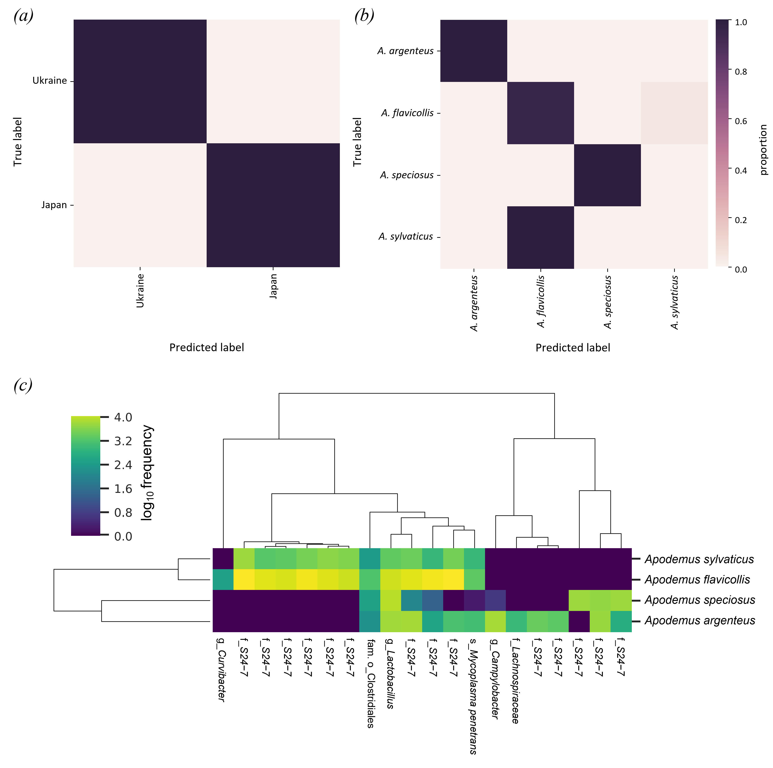

**Supplementary Figure 1.** Random Forest (RF) classification accuracy of gut microbiota of four mouse species, *i.e.* *Apodemus flavicollis*, *A. sylvaticus*, *A. speciosus*, *A. argenteus*. Each row of the confusion matrix represents (a) the country of origin (*i.e.* from Ukraine or Japan) or (b) host species; the colour intensity corresponds to the proportion of samples that were assigned by the RF classifier to belong to the class (predicted country of origin or host species) specified by each column. (c) Top 20 ASVs with the highest importance score in host species-classification RF. The heatmap colour intensity corresponds to ASVs abundance per group. Average clustering was performed using the Bray-Curtis dissimilarity metric. The ASVs feature table was normalised by adding a pseudocount of 1 and then taking the log10 of the table to aid plotting.

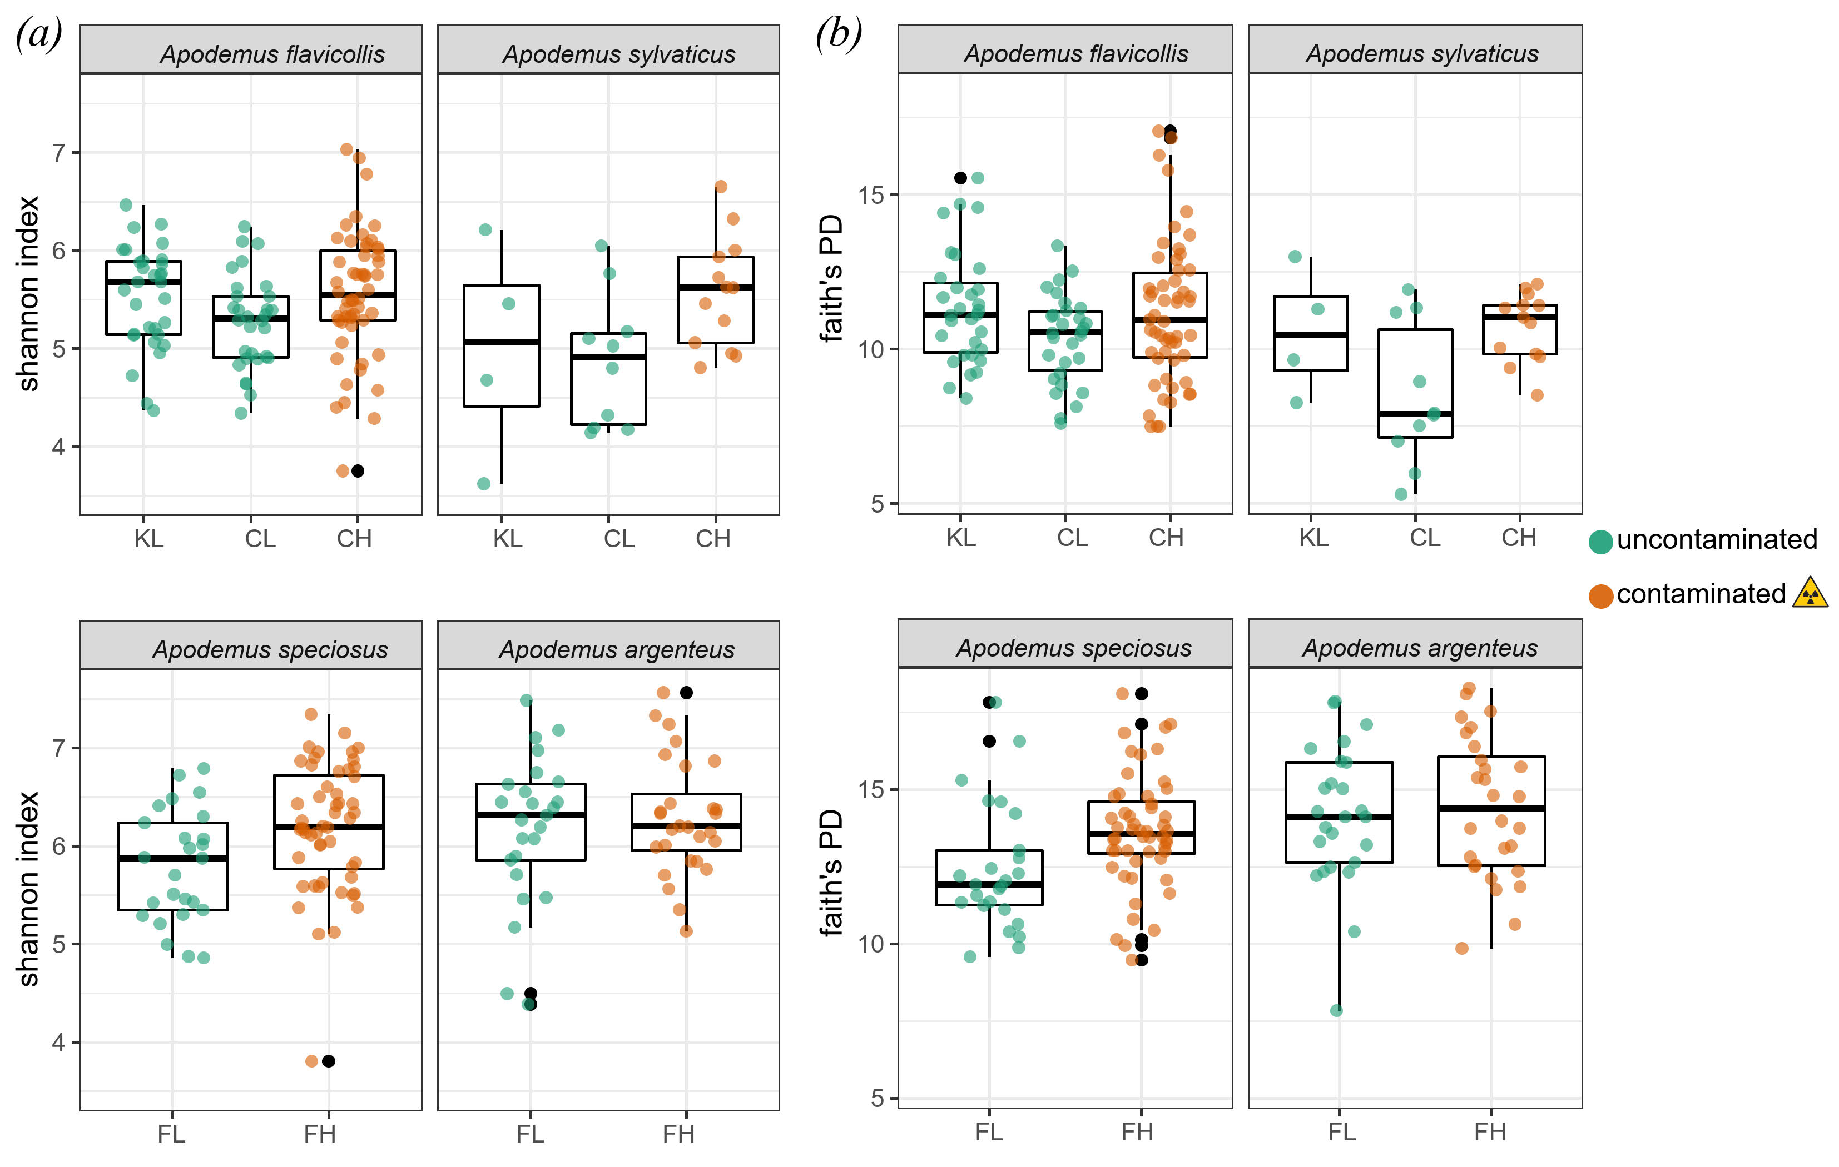

**Supplementary Figure 2.** Measures of alpha diversity for the gut microbiota of four mouse species inhabiting areas that differ in levels of radionuclide contamination. Box-and-whisker plots represent the median and interquartile range of (a) Shannon index and (b) Faith’s phylogenetic diversity estimates. Each box plot represent samples from contaminated with radionuclides (CH, FH) or uncontaminated (KL, CL, FL) areas surrounding either the Chernobyl (*Apodemus flavicollis*, *A. sylvaticus*) or Fukushima (*A. speciosus*, *A. argenteus*) nuclear accident sites.

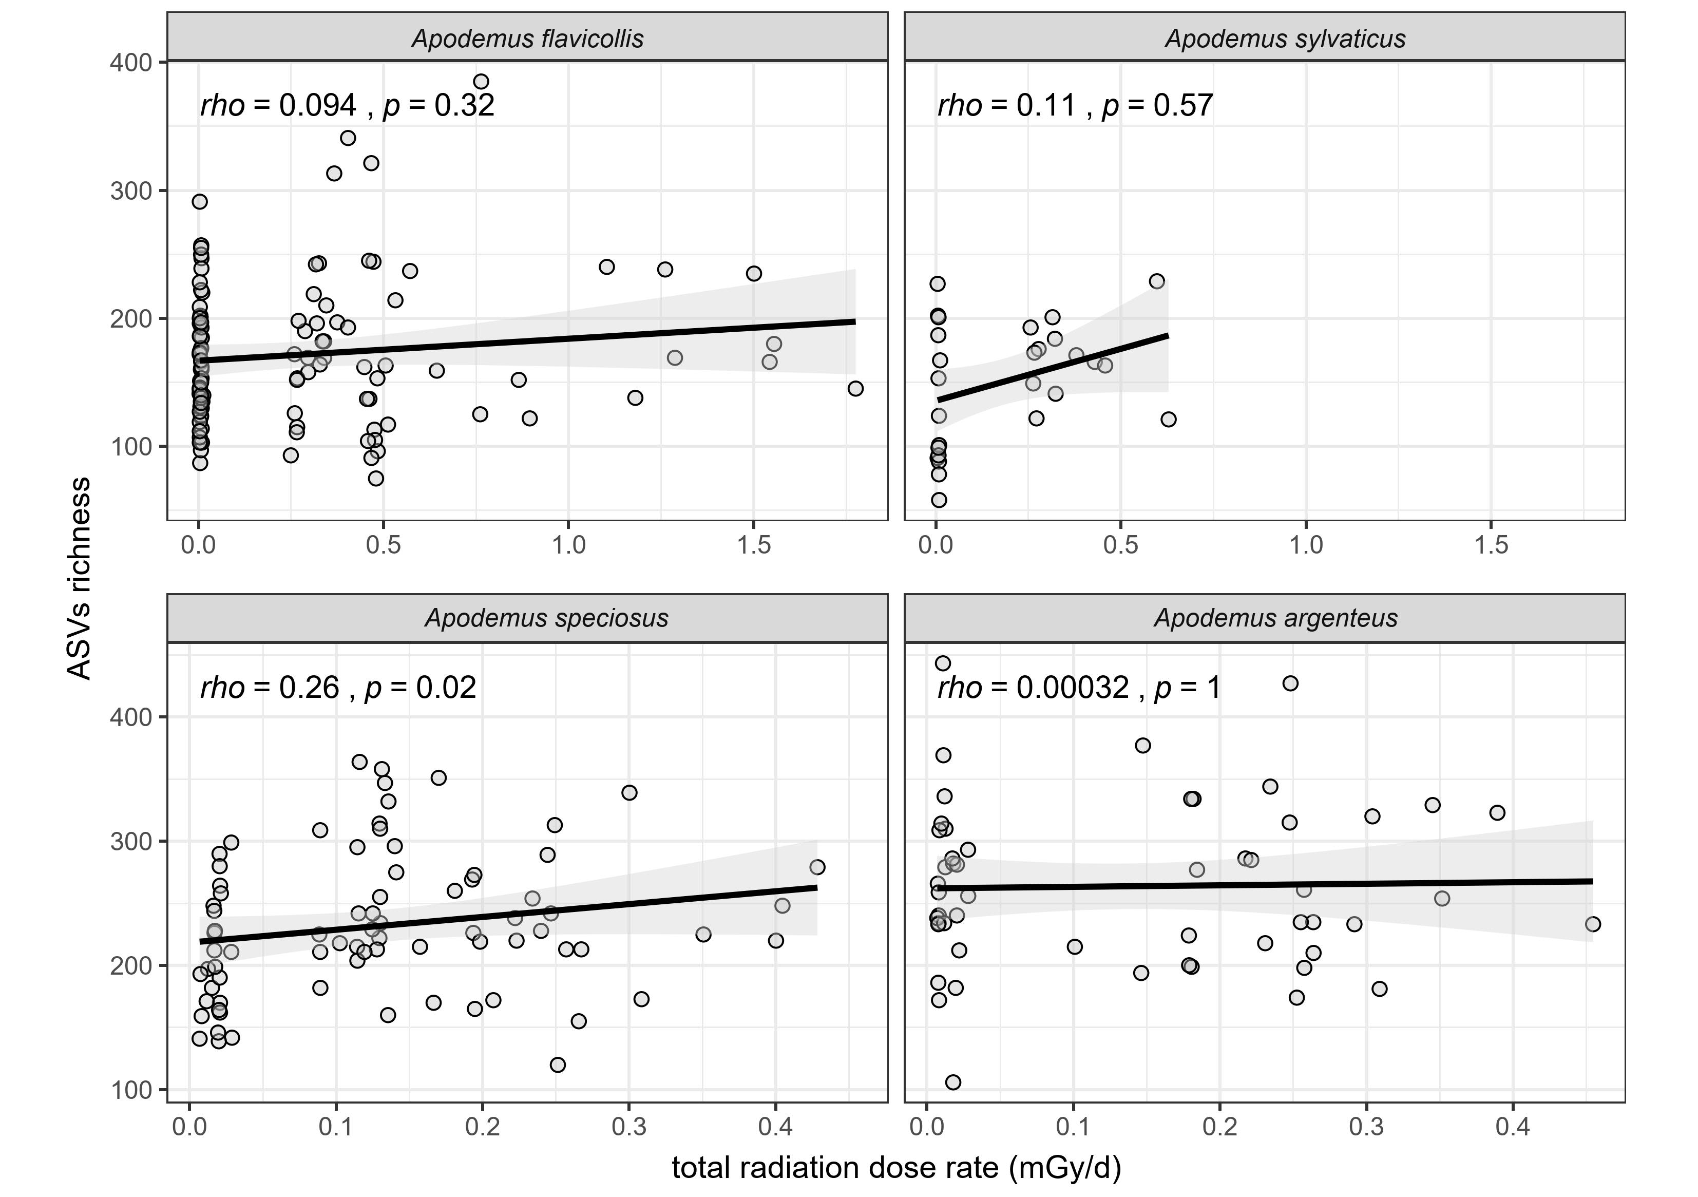

**Supplementary Figure 3.** Spearman’s rank correlations between the mice gut microbiota alpha diversity (ASVs richness) estimates and total radiation exposure. The gut microbiota of four mouse species inhabiting contaminated with radionuclides and uncontaminated areas surrounding either the Chernobyl (*Apodemus flavicollis*, *A. sylvaticus*) or Fukushima (*A. speciosus*, *A. argenteus*) nuclear accident sites are shown. Black line represents linear regression with shaded 95% confidence intervals.

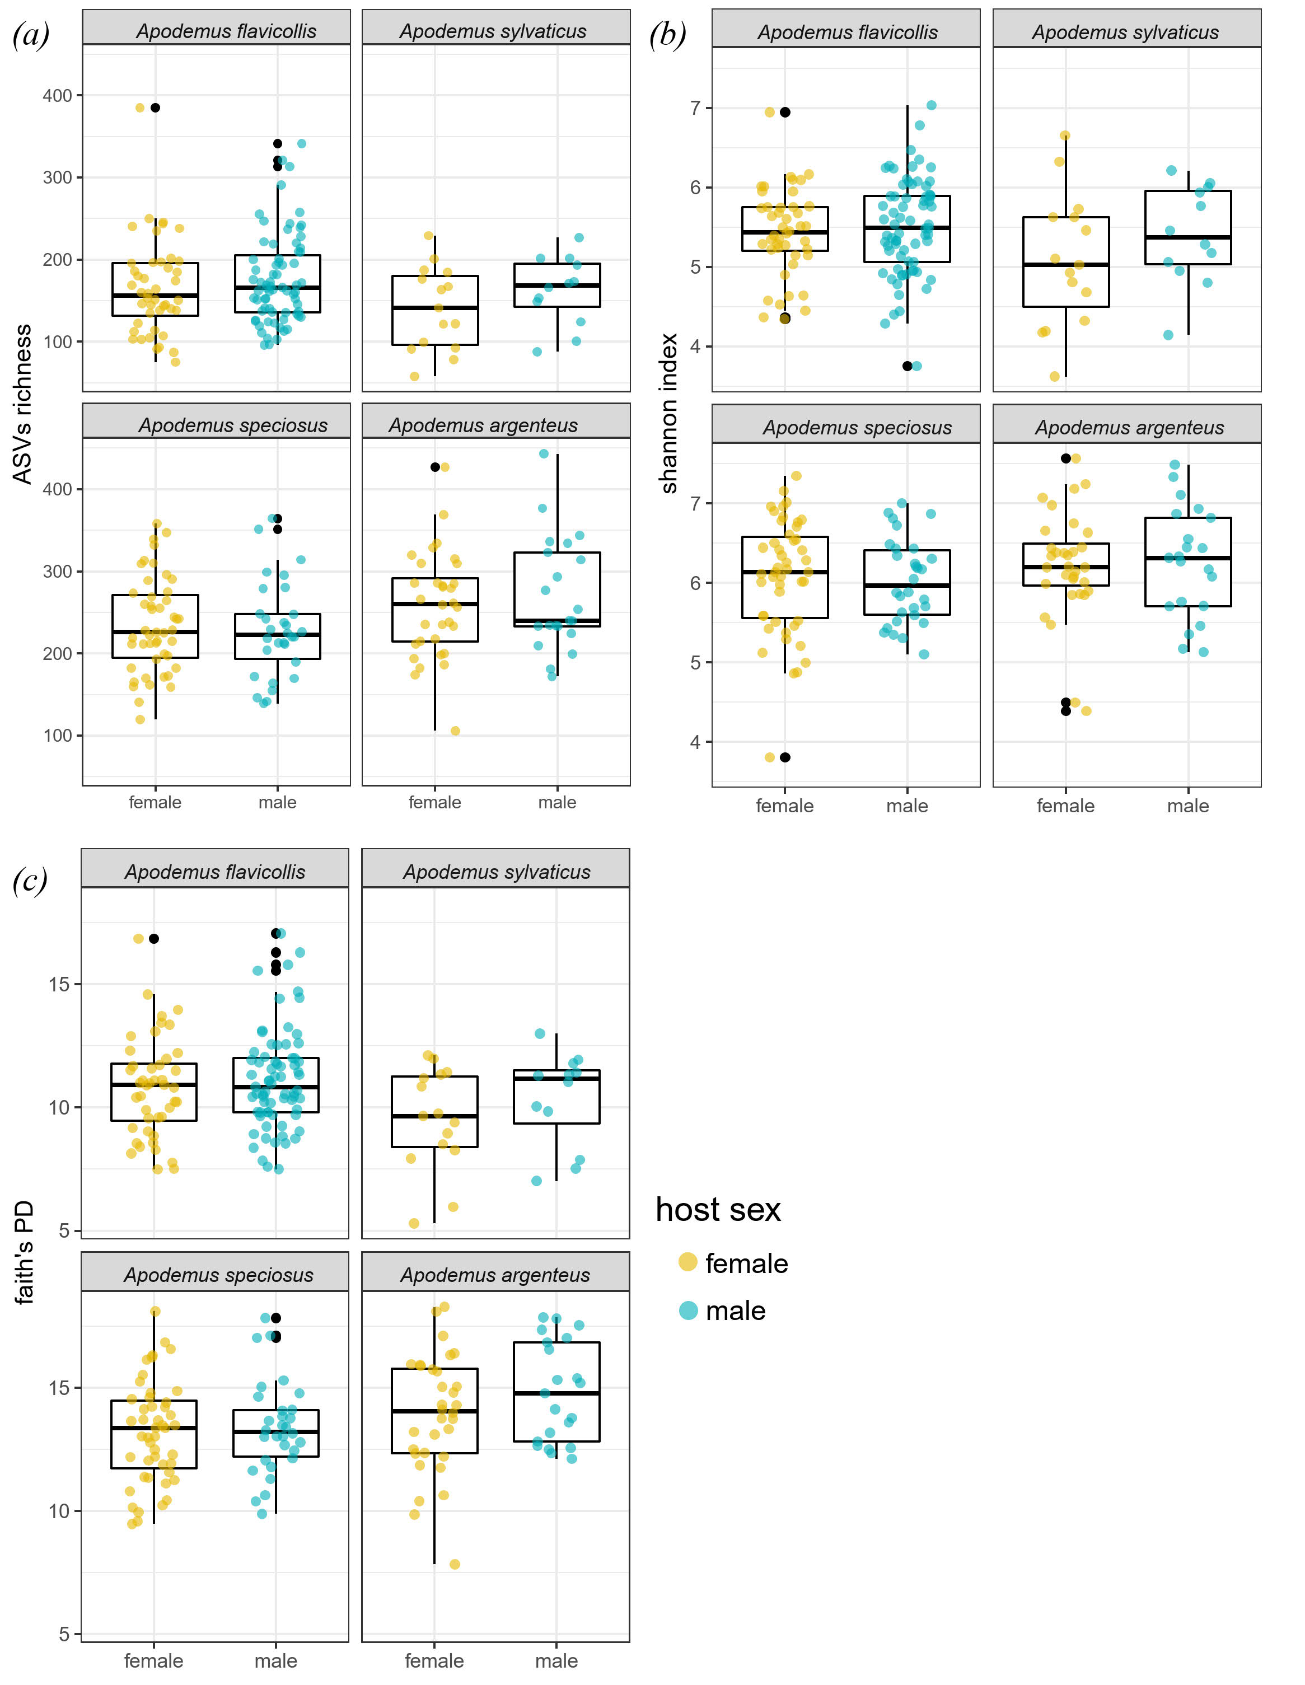

**Supplementary Figure 4.** Measures of alpha diversity for the gut microbiota of female and male individuals of four mouse species inhabiting areas that differ in levels of radionuclide contamination. Box-and-whisker plots represent the median and interquartile range of (a) ASVs richness, (b) Shannon index and (c) Faith’s phylogenetic diversity estimates. Each box plot represents samples from female or male mice inhabiting contaminated with radionuclides and uncontaminated areas surrounding either the Chernobyl (*Apodemus flavicollis*, *A. sylvaticus*) or Fukushima (*A. speciosus*, *A. argenteus*) nuclear accident sites. All comparisons were non-significant (*p*>0.05, Wilcoxon rank-sum test).

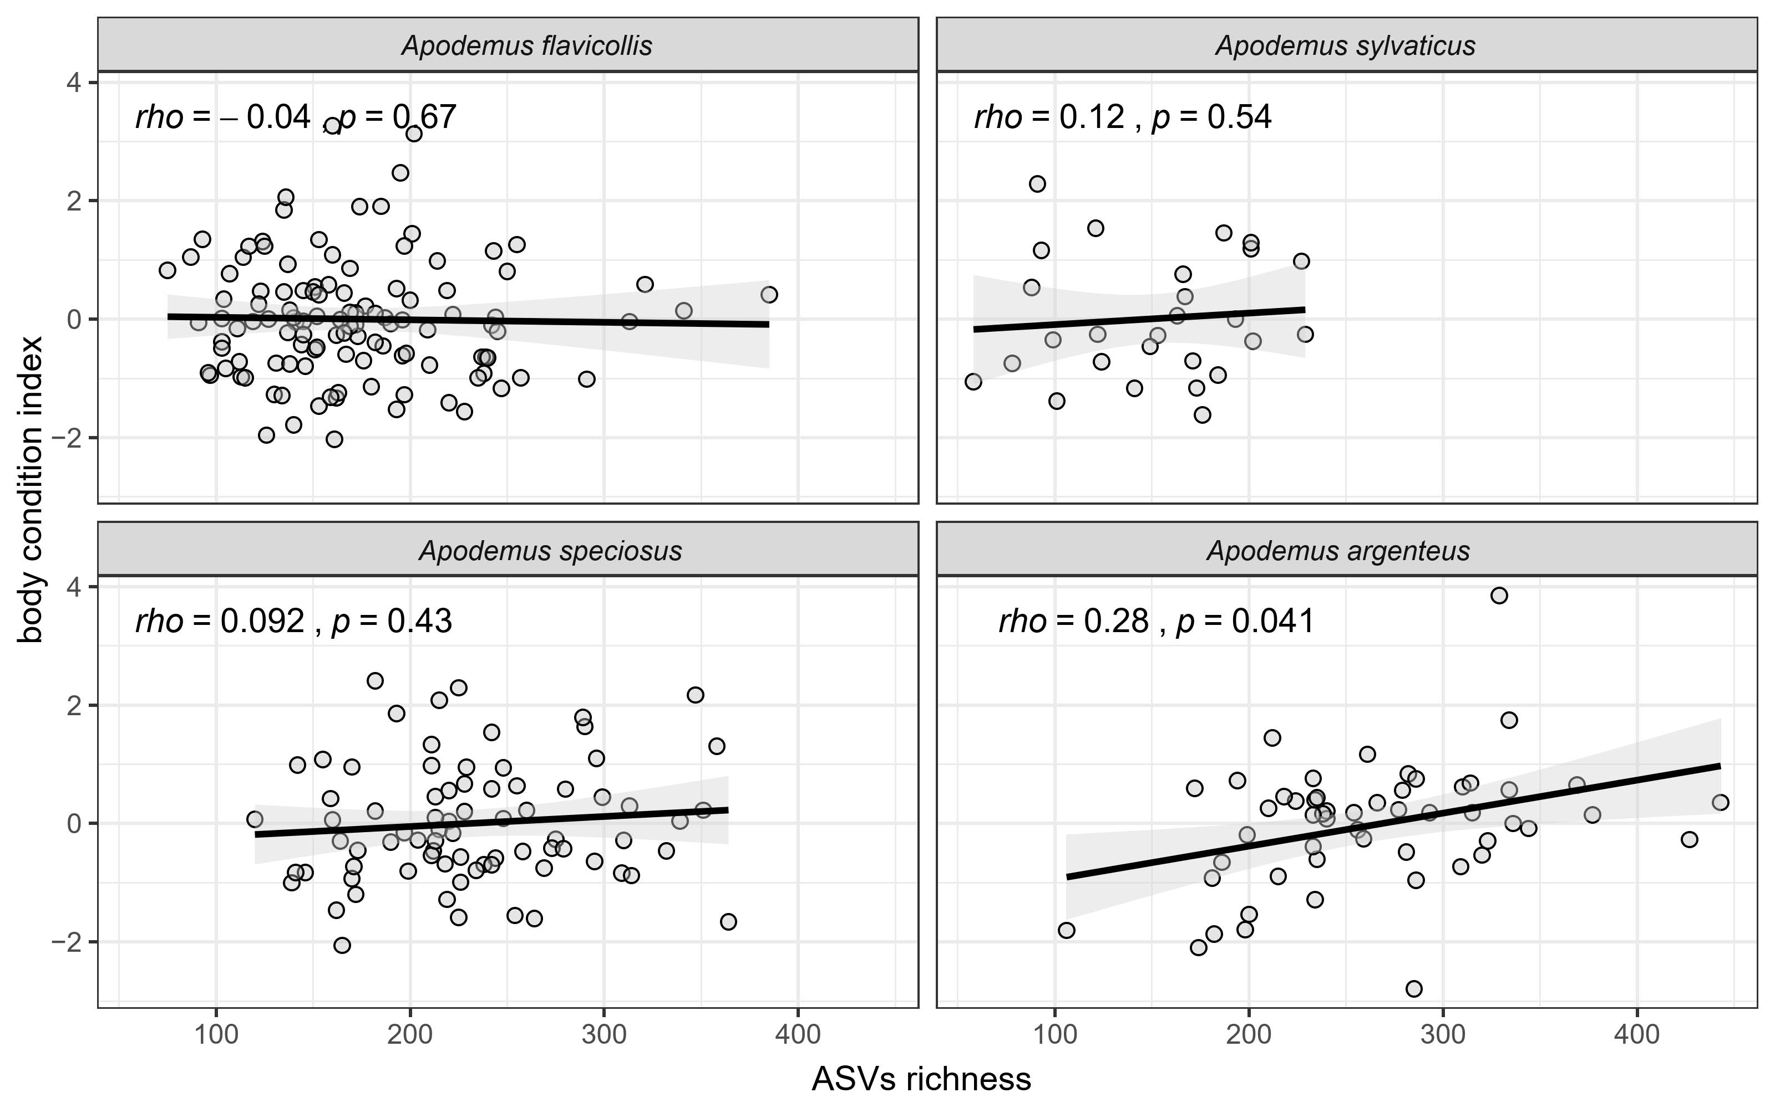

**Supplementary Figure 5.** Spearman’s rank correlations between the mice gut microbiota alpha diversity (ASVs richness) estimates and body condition index. The gut microbiota of four mouse species inhabiting contaminated with radionuclides and uncontaminated areas surrounding either the Chernobyl (*Apodemus flavicollis*, *A. sylvaticus*) or Fukushima (*A. speciosus*, *A. argenteus*) nuclear accident sites are shown. Black line represents linear regression with shaded 95% confidence intervals.

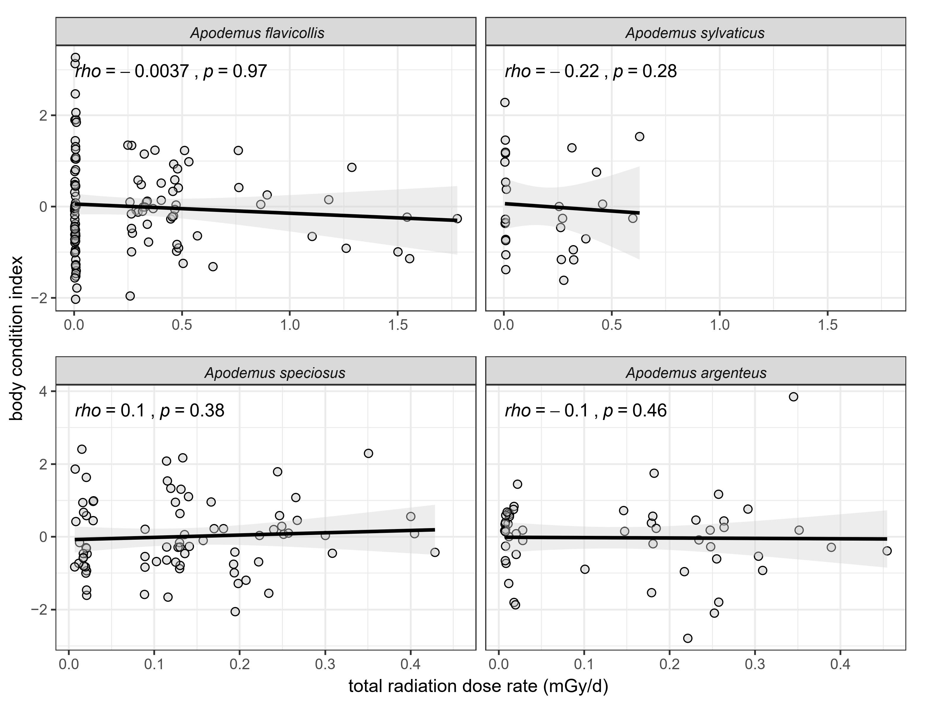

**Supplementary Figure 6.** Spearman’s rank correlations between the mice total radiation exposure and body condition index. The samples of four mouse species inhabiting contaminated with radionuclides and uncontaminated areas surrounding either the Chernobyl (*Apodemus flavicollis*, *A. sylvaticus*) or Fukushima (*A. speciosus*, *A. argenteus*) nuclear accident sites are shown. Black line represents linear regression with shaded 95% confidence intervals.

**References**

Baker, R. J., Dickins, B., Wickliffe, J. K., Khan, F. A. A., Gaschak, S., Makova, K. D., & Phillips, C. D. (2017). Elevated mitochondrial genome variation after 50 generations of radiation exposure in a wild rodent. *Evolutionary Applications*, *10*(8), 784–791. doi: 10.1111/eva.12475

Beresford, N. A., Barnett, C. L., Gashchak, S., Maksimenko, A., Guliaichenko, E., Wood, M. D., & Izquierdo, M. (2020). Radionuclide transfer to wildlife at a ‘Reference site’ in the Chernobyl Exclusion Zone and resultant radiation exposures. *Journal of Environmental Radioactivity*, *211*, 105661. doi: 10.1016/j.jenvrad.2018.02.007

Beresford, N. A., Gaschak, S., Barnett, C. L., Howard, B. J., Chizhevsky, I., Strømman, G., … Copplestone, D. (2008). Estimating the exposure of small mammals at three sites within the Chernobyl exclusion zone - a test application of the ERICA Tool. *Journal of Environmental Radioactivity*, *99*(9), 1496–1502. doi: 10.1016/j.jenvrad.2008.03.002

Brenner, D. J., & Hall, E. J. (2007). Computed Tomography — An Increasing Source of Radiation Exposure. *New England Journal of Medicine*, *357*(22), 2277–2284. doi: 10.1056/NEJMra072149

Chesser, R. K., Sugg, D. W., Lomakin, M. D., van den Bussche, R. A., DeWoody, J. A., Jagoe, C. H., … Baker, R. J. (2000). Concentrations and dose rate estimates of 134,137 cesium and 90 strontium in small mammals at Chornobyl, Ukraine. *Environmental Toxicology and Chemistry*, *19*(2), 305–312. doi: 10.1002/etc.5620190209

ICRP. (1983). *Radionuclide transformations: energy and intensity of emissions. ICRP Publication 38*. Retrieved from https://www.icrp.org/publication.asp?id=ICRP Publication 38

ICRP. (1993). Age-dependent doses to members of the public from intake of radionuclides: Part 2. Ingestion dose coefficients. ICRP Publication 67. *Annals of the ICRP*, *23*(3–4), 1–167. Retrieved from http://www.ncbi.nlm.nih.gov/pubmed/7978694

Isaev, A. G., Babenko, V. V., Kazimirov, A. S., Grishin, S. N., & Ievlev, S. M. (2010). The minimum detectable activity: main concepts and determinations. *Safety Issues of Nuclear Power Plants and Chernobyl [in Russian]*, (13), 103–110.

Kubota, Y., Takahashi, H., Watanabe, Y., Fuma, S., Kawaguchi, I., Aoki, M., … Yoshida, S. (2015). Estimation of absorbed radiation dose rates in wild rodents inhabiting a site severely contaminated by the Fukushima Dai-ichi nuclear power plant accident. *Journal of Environmental Radioactivity*, *142*, 124–131. doi: 10.1016/j.jenvrad.2015.01.014

Møller, A. P., & Mousseau, T. A. (2018). Reduced colonization by soil invertebrates to irradiated decomposing wood in Chernobyl. *Science of The Total Environment*, *645*, 773–779. doi: 10.1016/J.SCITOTENV.2018.07.195

Onuma, M., Endoh, D., Ishiniwa, H., & Tamaoki, M. (2020). Estimation of Dose Rate for the Large Japanese Field Mouse (Apodemus speciosus) Distributed in the “Difficult-to-Return Zone” in Fukushima Prefecture. In *Low-Dose Radiation Effects on Animals and Ecosystems* (pp. 17–30). doi: 10.1007/978-981-13-8218-5_2

Stabin, M. G., & Konijnenberg, M. W. (2000). Re-evaluation of absorbed fractions for photons and electrons in spheres of various sizes. *Journal of Nuclear Medicine*, *41*(1), 149–160.