Assignment #1

Name: Adrian Law

Email: [alaw@bu.edu](mailto:alaw@bu.edu)

1)

a) CPU utilization = (5/15) = 33.3%

Disk utilization (6/15) = 40%

Network utilization (4/15) = 26.6%

b) Throughput = 1/0.015 = 66.67 requests/sec

c) CPU utilization = (10/16) = 62.5%

Disk utilization (12/16) = 75%

Network utilization (8/16) = 50%

d) Throughput = 2/0.016 = 125 requests/sec

e) Capacity = 3/0.018 = 166.67 requests/sec

f) No, while the dual-core will help with the CPU capacity and lower its utilization, the bottleneck is at the disk, so installing dual-core won’t affect the capacity unless the disk is sped up as well

g) 6/4 = 1.5x speedup for Disk

5/4 = 1.25x speedup for CPU

h) 3/0.012 = 250 requests/sec

2)

a) $\frac{1}{(1-0.2)+0.2(0.75)}$ = 1.0526x

b) $\frac{1}{(1-0.35)+0.35/(6/5)) }$ = 1.0619x

c) 5.26 / 1000 = 0.00526% per $

6.19 / 4000 = 0.0015475% per $

The processor improves the speedup more per dollar than the I/O device.

d) $\frac{1}{(1-0/55) + 0.2(0.75) + 0.35(0.83)}$ = 1.1229x

e) 1/(1-0.2) = 1.25x

f) 1/(1-0.35) = 1.53846x

3)

a) $\frac{1}{(1-0.3448) + 0.3448/2) }$ = 1.2083x speedup for main memory optimization

$\frac{1}{(1-0.6552) + 0.6552*0.75) }$ = 1.1958x speedup for cache optimization

b) $\frac{h+10(1-h)}{(h+5*(1-h)) }$ = $\frac{h+10(1-h)}{0.75*h+10*(1-h) }$, h = 0.9524. If hit rate > 0.9524, optimize cache, else if hit rate < 0.9524 then optimize main memory. If hit rate = 0. 9524 then pick cheaper optimization.

c) $\frac{h+10(1-h)}{0.75*h+5*(1-h)}$

4)

a) 10mb = 1310720 B /1500 = 873.81 packets

$floor\left(873.81*{\left(1-p\right)}^{H}\right)*\frac{1200}{131072}$

b) $floor\left(873.81*{\left(1-0.01\right)}^{1}\right)*\frac{1200}{131072}$ = 7.91 mbps

c) $floor\left(873.81*{\left(1-p\right)}^{H}\right)*\frac{1200}{131072}$ = 6 mbps

P = $1-{0.7500251}^{\frac{1}{L}}$

5)

a) Residual graphs:

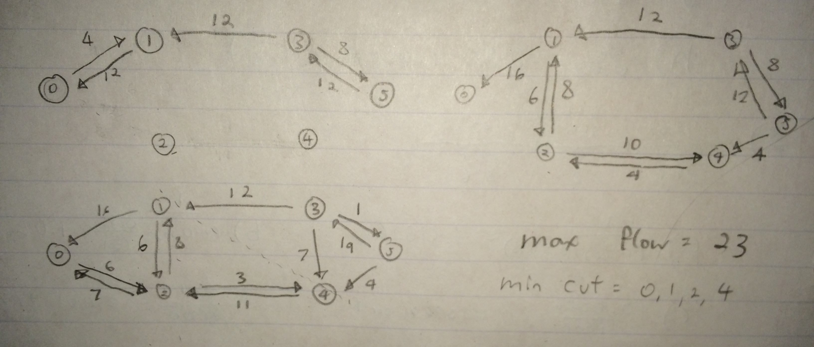

b) After running Ford-Fulkerson on a graph and coming up with

residual graphs, reduce the capacities of relevant edges on the

regular graph and run BFS from the source node to the sink node while taking into account the “remaining” capacities along each path. If a path is found between the source and the sink where all edges but one are non-zero, then this path has only one bottlenecked edge that could be upgraded to increase the max flow of the network.

c) 3, the link between 4 and 5 can be upgraded by 3 since 0-2 still has 6 capacity remaining and 2-4 has 3 capacity remaining, thus this is the highest amount the capacity can be raised by one single link

d) 1-3, this link has the highest amount of flow besides the ingress and exgress links, so taking down that link will cut the capacity by 12 since there is no alternative path that the remaining units can take to the sink node.