HW3/4

Adrian Law

1. To run simulator, run MM1simulator file (Main method generates output)   
   1. *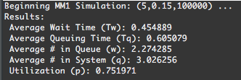 $λ=5,T_{s}=0.15$*  
        
      Analytical Results: Simulation Results $$T_{w}=0.45 \\ T_{q}=0.6 \\ w=2.25 \\ q=3 \\ ρ=0.75$$
   2. $λ=6,T_{s}=0.15$ 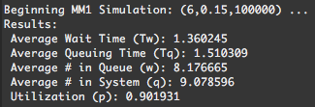  
      Analytical Results: $$T_{w}=1.35 \\ T_{q}=1.5 \\ w=8.1 \\ q=9 \\ ρ=0.9$$
   3. $λ=6,T_{s}=0.15$ 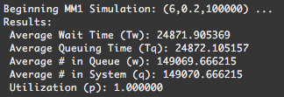Analytical Results: $$T_{w}=N/A \\ T_{q}=N/A \\ w=N/A \\ q=N/A \\ ρ=1.2$$

1. To run simulator, run MM1Ksimulator file (Main method generates output)   
   1. 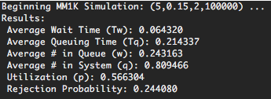 $λ=5,T_{s}=0.15, K=2$ 
        
      Analytical Results: Simulation Results $$T_{q}=0.21315 \\ q=0.81 \\ P(rejection)=0.24 \\ ρ'=0.57$$
   2. $λ=6,T_{s}=0.15, K=2$ 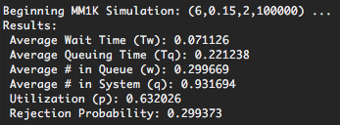Analytical Results: $$T_{q}=0.21828 \\ q=0.92988 \\ P(rejection)=0.29 \\ ρ'=0.639$$
   3. $λ=6,T_{s}=0.2, K=2$ 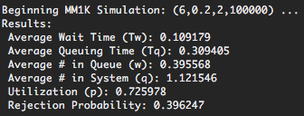Analytical Results: $$T_{q}=0.3088 \\ q=1.12 \\ P(rejection)=0.3956 \\ ρ'=0.7253$$
   4. $λ=5,T_{s}=0.15, K=4$ Analytical Results: 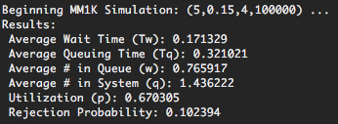

* 1. 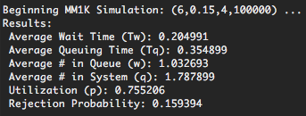  
       
     Analytical Results:
  2. 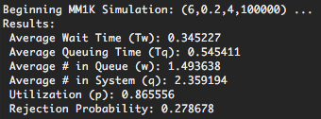Analytical Results:
  3. Analytical Results: 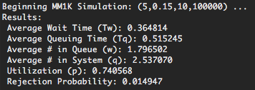
  4. Analytical Results: 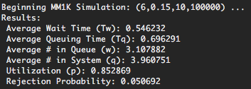
  5. 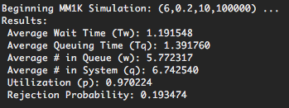  
       
     Analytical Results: