HW4

Adrian Law

1. To run simulator, run the Controller.java file (has Main method to generate results)   
   1. lambda --------> **CPU** -------------------P(0.5)-->  
       ^ |  
       |---------**Net** <----P(0.4)   
       | ^ |  
       | P(0.5) |  
       | | |  
       P(0.5)----**Disk** <----P(0.1)

* 1. Network, it has the highest utilization (p = 0.9)

1. 1. The System reaches a steady state at around 11-12 seconds: there is a consistent pattern of spikes and drops in CPU queue size that continues after that point, which suggests CPU Q is entering a steady pattern
   2. 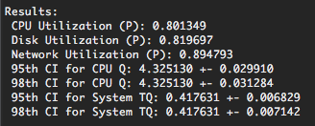
   3. The analytical and simulation results are pretty close to each other
2. 2. In this system, it reaches steady state around the 30-second mark. After that point, apart from a few spikes it consistently stays around a queue size of 2 to 3
   3. 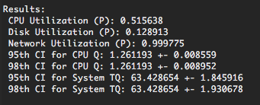
3. 1. Analytical Capacity = 44.44
   2. Simulator Capacity = 44~45

