# Deliverable #1

## Team Name:

D-Team

## Team Members:

1. Ahmed Alawaji
2. Juan Pablo Garcia Saavedra

## Project Proposal:

Wearing the right clothes for the right weather is a major issue for many people around the world. The weather is inconsistent and current solutions are inaccurate. We are proposing an IoT device and platform that can help people make better clothing decisions by measuring the temperature and then propose the best combination of clothes you should wear. The solution will also take into account the location you are travelling too. For example, wearing clothes for work is not the same as when going for a concert.

## Technologies that will be used:

* Hardware
  + Tessel
    - Temperature sensor
    - Ambient sensor
* Software
  + Node.JS
  + MySQL
  + JSON
  + HTML
  + And many data mining and machine learning tools

## Technology Demonstration

* **Hardware:** Juan Pablo has started a sport wearables startups at MIT Delta V and he is the technical cofounder of the company. He has extensive experience in building prototypes very fast and also building hardware components processes from scratch.
* **Software:** Ahmed worked as a data scientist before coming to MIT. He also developed a navigation app used by over 50,000 people (ymdiapp.com). The app has been featured in many media including Wall Street Journal and NY times.

## Competitive Landscape

There are several apps that make a connection between clothes and outside temperature. However, different approaches can be seen among them. There are some that just give an answer of whether you should wear pants or not. Some others are an ecommerce for shopping the clothes that you should have for a certain temperature. And others are focused on sports, so give advice on what is the best outfit for running or cycling.

|  |  |  |  |  |  |  |  |  |  |
| --- | --- | --- | --- | --- | --- | --- | --- | --- | --- |
| App/website | Gender | Full outfit advice | Partial outfit advice | Shopping | Sports | User comfort check | Mobile Friendly? | Link | |
| What should I wear running | Both | Yes | - | No | Yes | No | No | | http://www.runnersworld.com/what-to-wear |
| What to wear cycling | Both | Yes | - | No | Yes | No | Yes | | http://www.whattowearcycling.com |
| Oshare Weather | Both | Yes | - | No | No | No | Yes | | https://itunes.apple.com/us/app/oshare-weather/id557835389?mt=8 |
| MetoDress | Female | Yes | - | No | No | No | No | | https://www.shopbop.com/meto-dress-just-female/vp/v=1/1578984058.htm |
| Should I wear Pants? | Female | - | Yes | No | No | No | No | | http://jenrefat.com/projects/pantstoday/#02141 |
| Daily Dress Me | Both | Yes | - | Yes | No | No | No | | http://dailydressme.com |

Even though there are several options, these apps are not user friendly are some of them have too many options.

But more importantly, none of these apps check what actually happened with the user once the app suggested a certain outfit.

## Storyboard

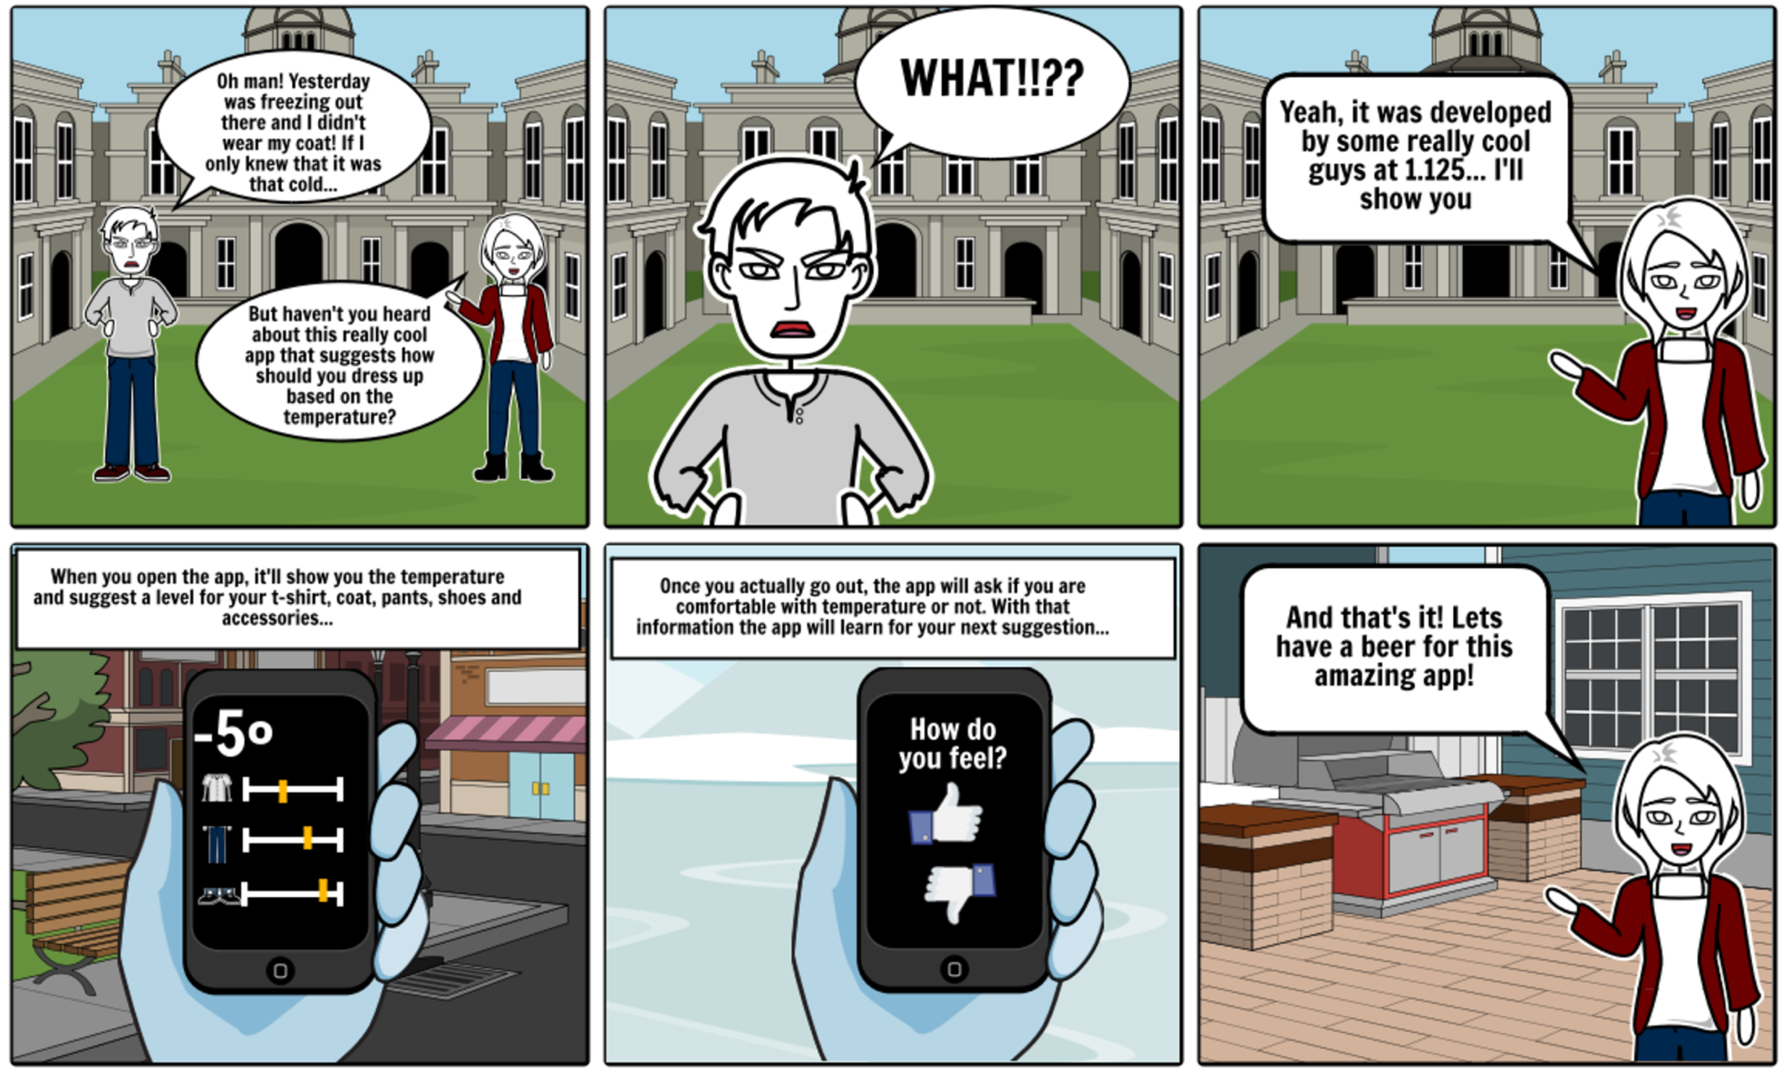

## Code Artifacts

Hardware: For the hardware part, we are mostly measuring and recording temperature and adjusting the data mining assumptions accordingly. The use of Tessel 2 was an obvious choice due to our familiarity with both JavaScript and Tessel 2 various modules.



**Machine Learning:**

Our solution will use advanced machine learning models to recommend the correct clothing for the right place, temperature, and time. In order to prototype this technology fast, we utilized an existing recommendation machine learning model provided by Microsoft Cognitive API. The API interface and integration makes it easy for us to test and utilize different version of the model quickly and efficiently.

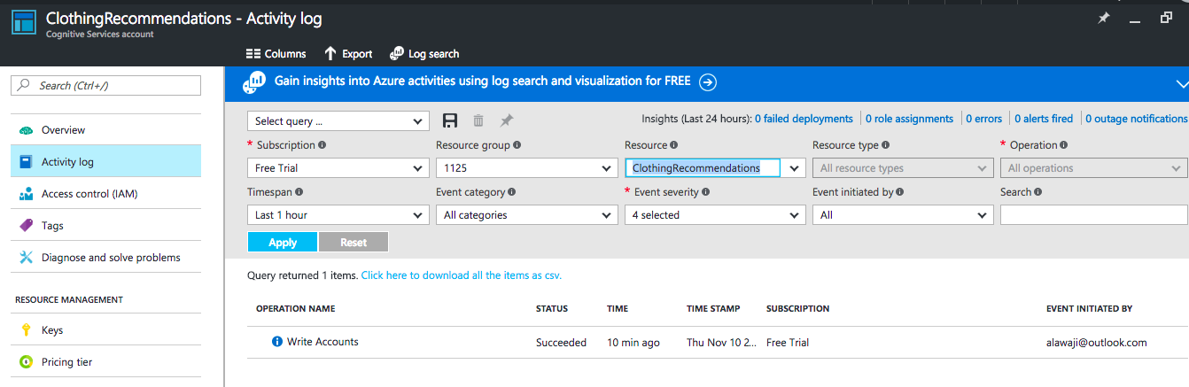

**Node.JS:**

The software component will be developed using HTML, Node.JS, and MySQL. The code below is a sample of how will we deal with the database integration.



**MySQL:**

We started developing our databases tables schemes

