Exploratory Data Analysis (EDA) - Visual Report
This document presents key visualizations and interpretations from the Exploratory Data Analysis (EDA) conducted on the Retail Sales Dataset. The figures illustrate data distributions, outliers, relationships among variables, and overall trends in the dataset.

bar product category
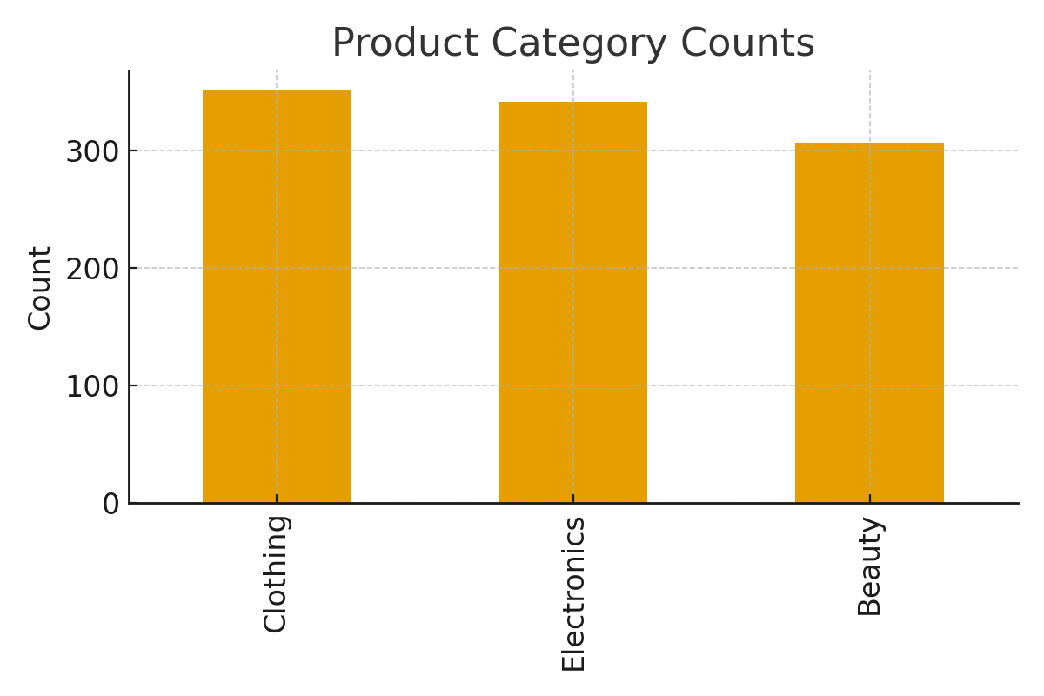
The bar chart shows the frequency of transactions across product categories. Certain categories are more popular, contributing significantly to total revenue.

box Age
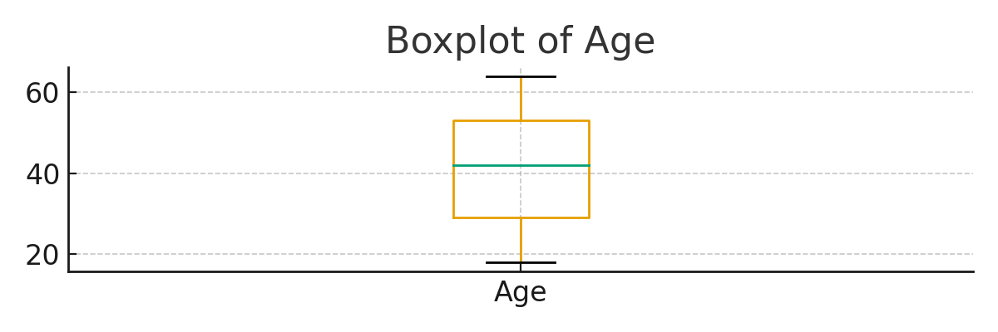
The boxplot highlights potential outliers and the spread of the data. Outliers represent unusually high or low transaction values, which may reflect significant sales events.

box Price per Unit
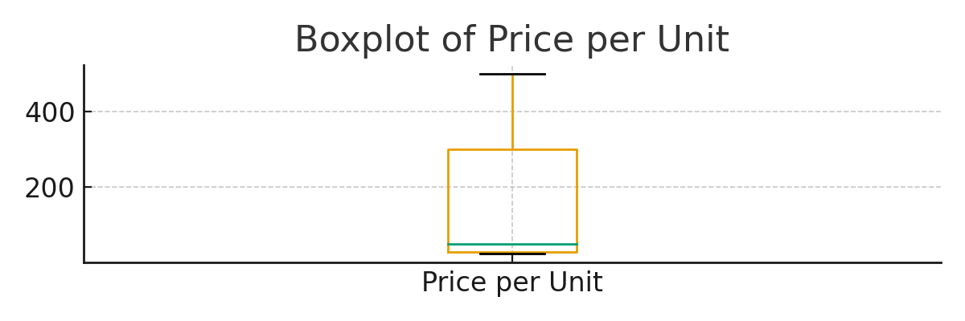
The boxplot highlights potential outliers and the spread of the data. Outliers represent unusually high or low transaction values, which may reflect significant sales events.

box Quantity
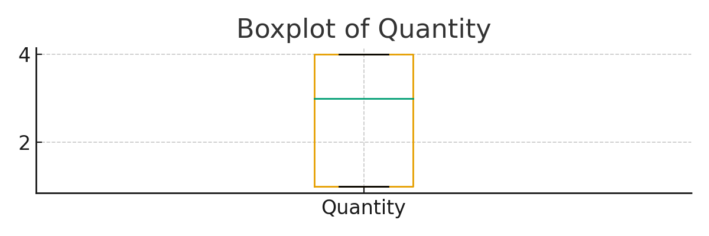
The boxplot highlights potential outliers and the spread of the data. Outliers represent unusually high or low transaction values, which may reflect significant sales events.

box Transaction ID
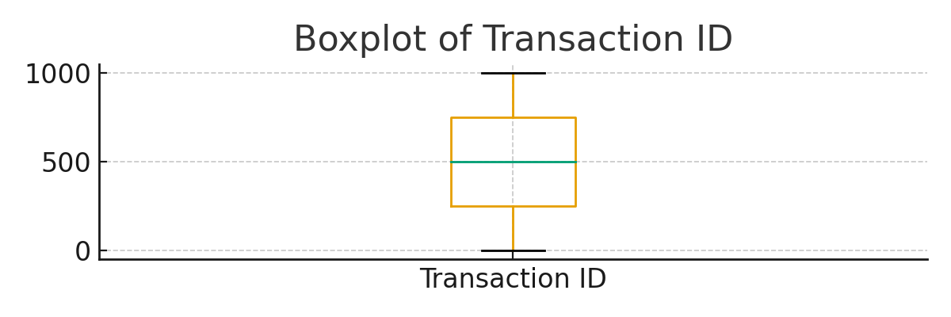
The boxplot highlights potential outliers and the spread of the data. Outliers represent unusually high or low transaction values, which may reflect significant sales events.

hist Age
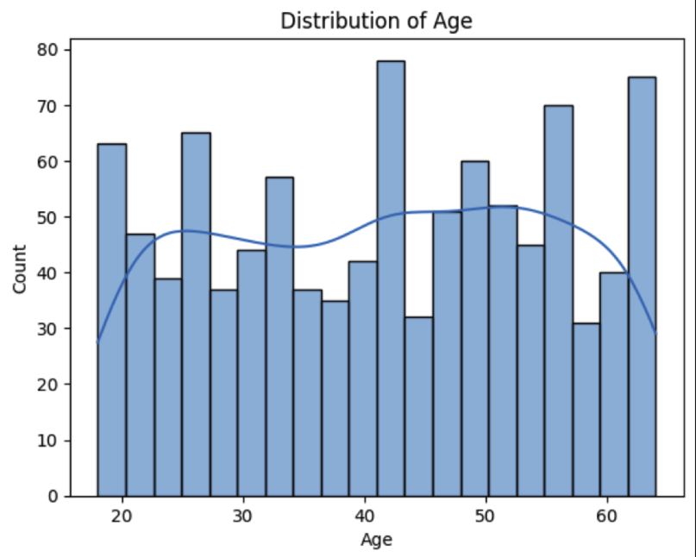
The histogram above illustrates the distribution of the respective numeric variable. The data appears moderately skewed, indicating variability in transaction behavior and sales patterns.

hist Price per Unit
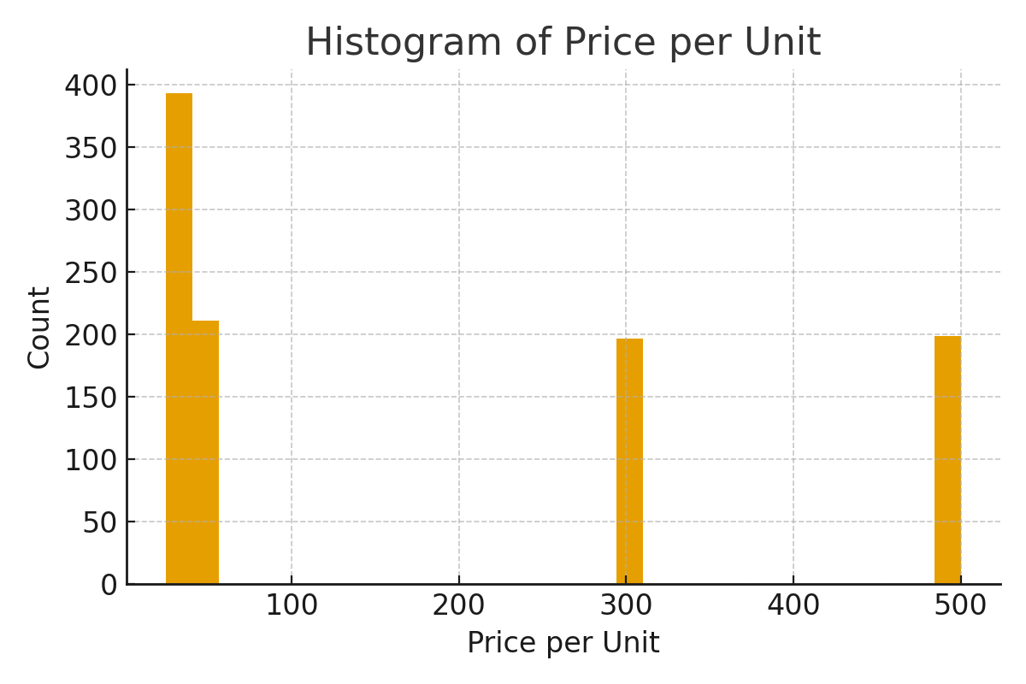
The histogram above illustrates the distribution of the respective numeric variable. The data appears moderately skewed, indicating variability in transaction behavior and sales patterns.

hist Quantity
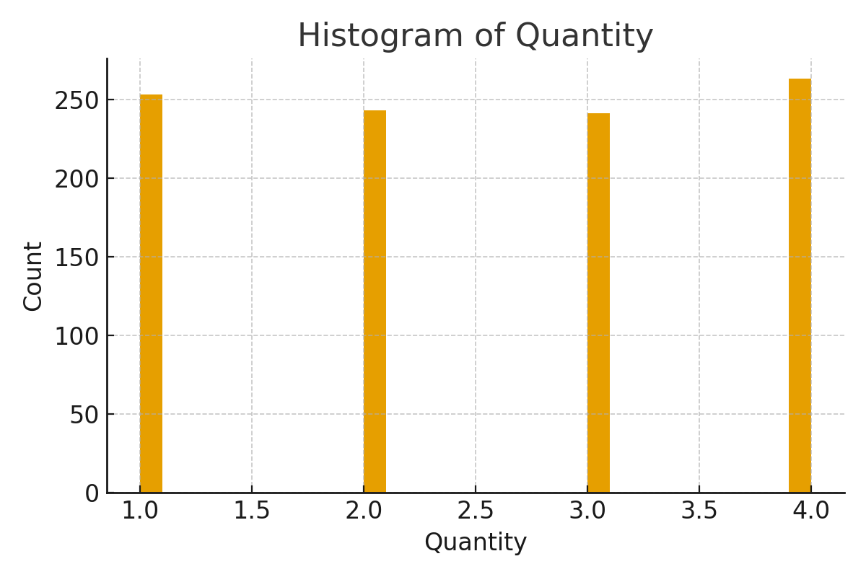
The histogram above illustrates the distribution of the respective numeric variable. The data appears moderately skewed, indicating variability in transaction behavior and sales patterns.

hist Transaction ID
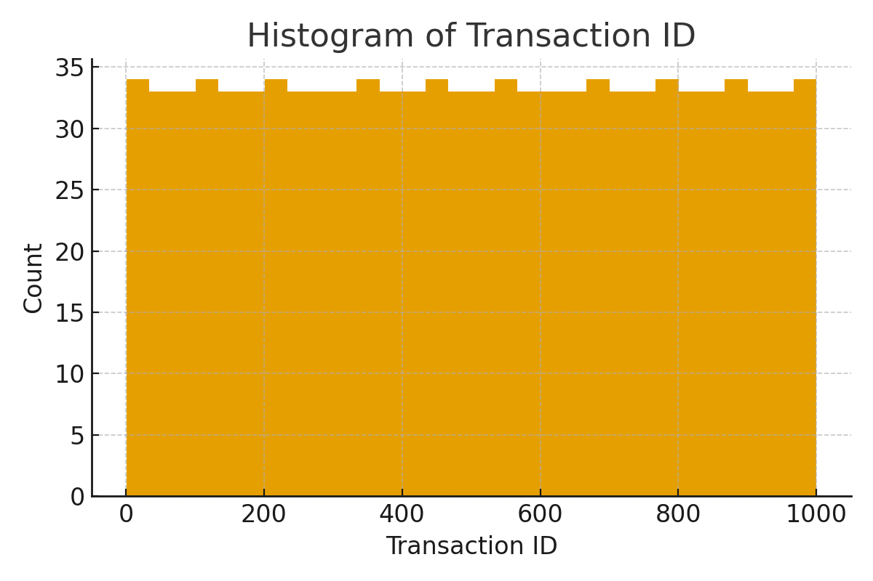
The histogram above illustrates the distribution of the respective numeric variable. The data appears moderately skewed, indicating variability in transaction behavior and sales patterns.

scatter matrix Transaction ID Age Quantity
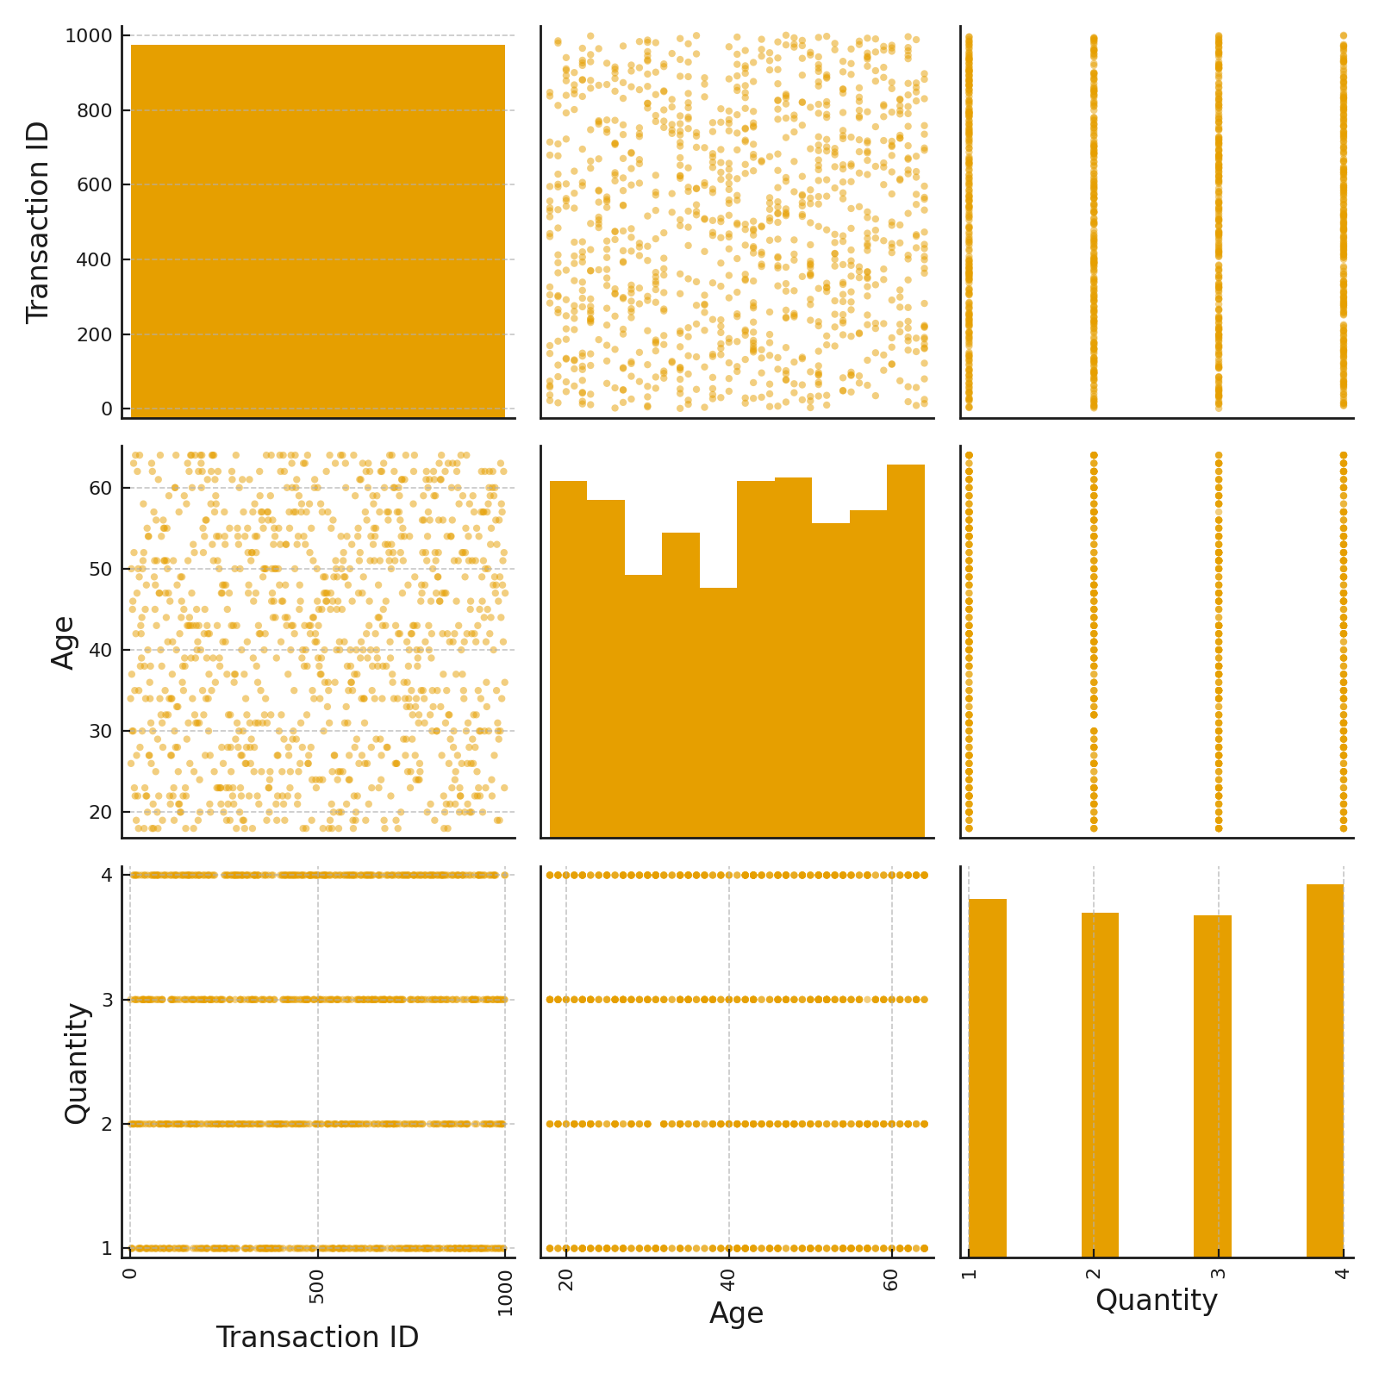
The scatter matrix demonstrates relationships between numeric variables. Positive relationships can be observed between Quantity and Total Amount, indicating proportional scaling.

timeseries total amount
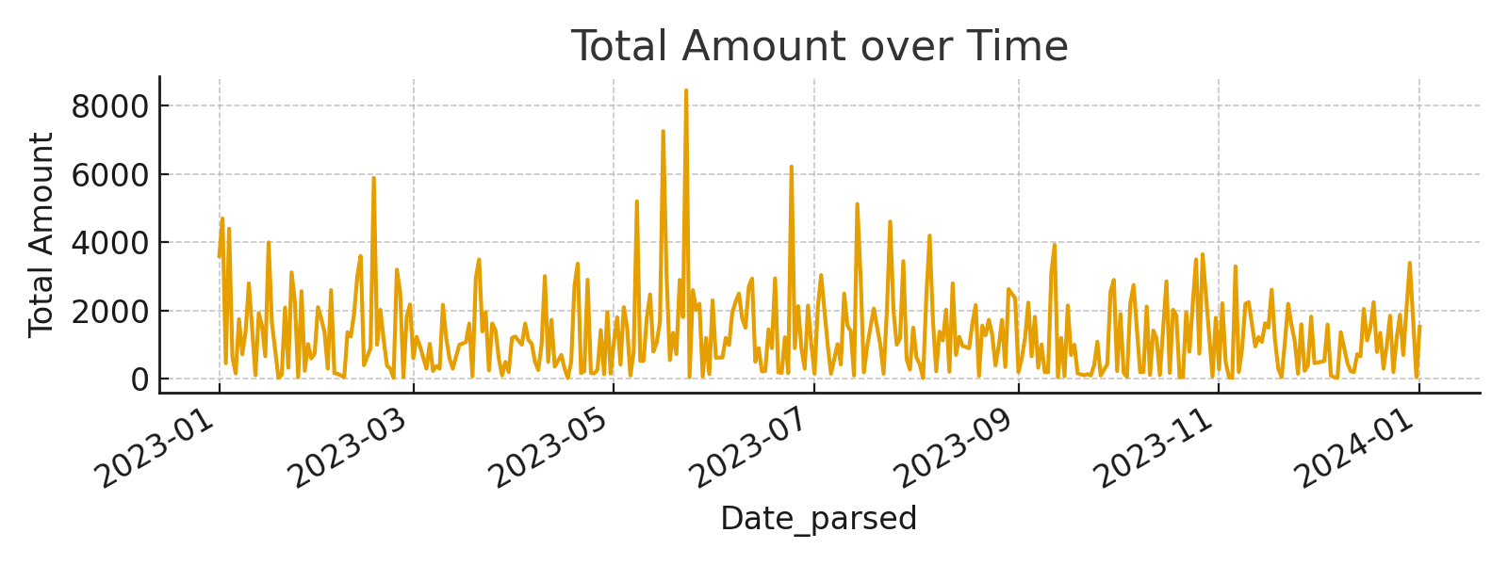
The time series plot illustrates total sales over time. Noticeable fluctuations suggest seasonal or promotional effects.

Summary of Insights
The visual analysis confirms that sales transactions vary significantly across product categories and customer demographics. Total sales display temporal fluctuations, suggesting potential seasonality. Numeric variables such as Quantity and Total Amount are positively correlated, while outliers in pricing may represent high-value purchases. These patterns indicate that the dataset is well-suited for subsequent regression, classification, and clustering analyses.

