Flow Shop with Blocking Condition – Simulation Report

Ali Owlia 810801056

1. System Description
A two-stage flow shop was simulated for 8 hours (480 minutes) in Arena. Parts arrive with inter-arrival time EXPO(3) minutes (~160 parts total). Stage 1 has 2 machines with TRIA(2,3,5) min processing. Stage 2 has 2 machines with TRIA(5,7,10) min processing. A buffer of capacity 3 exists before Stage 2; if full, parts remain blocked on Stage 1. Each part needs one AGV (7 available); if no AGV is free, the order is lost.

2. Best Configuration (Machines + AGVs)
The profit formula used for each scenario:
Profit = (Completed × 100) − (Lost × 100) − (Total Machines × 1000) − (AGVs × 500)
Config | M1 | M2 | AGV | Completed | Lost | Profit
2+2 Mach, 5 AGVs ★ | 2 | 2 | 5 | 124 | 36 | 2300
2+2 Mach, 7 AGVs | 2 | 2 | 7 | 123 | 37 | 1100
2+2 Mach, 9 AGVs | 2 | 2 | 9 | 128 | 32 | 1100
2+2 Mach, 12 AGVs | 2 | 2 | 12 | 128 | 32 | -400
3+2 Mach, 7 AGVs | 3 | 2 | 7 | 128 | 32 | 1100
2+3 Mach, 7 AGVs | 2 | 3 | 7 | 128 | 32 | 1100
3+3 Mach, 7 AGVs | 3 | 3 | 7 | 131 | 29 | 700

Best Choice: 2 machines in Stage 1, 2 machines in Stage 2, 5 AGVs → Profit = 2,300 units
Adding more machines or AGVs increases costs more than the additional revenue generated. 12 AGVs actually results in a loss (−400). The minimum viable AGV count of 5 maximizes profit.

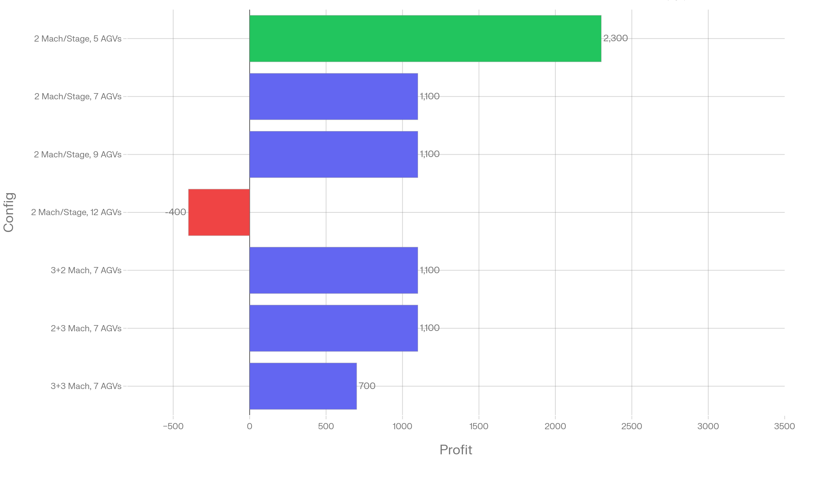
Profit Chart:

3. Effect of Buffer Capacity (3 to 5)
Increasing the buffer space before Stage 2 allows more parts to wait instead of blocking Stage 1 machines, which increases overall throughput.
Buffer Capacity | Parts Completed | Change vs Buffer=3
3 | 128 | —
4 | 130 | +2
5 | 133 | +5

A larger buffer reduces blocking time on Stage 1, freeing machines to process new arrivals sooner. However, the gain diminishes and must be weighed against physical space cost.
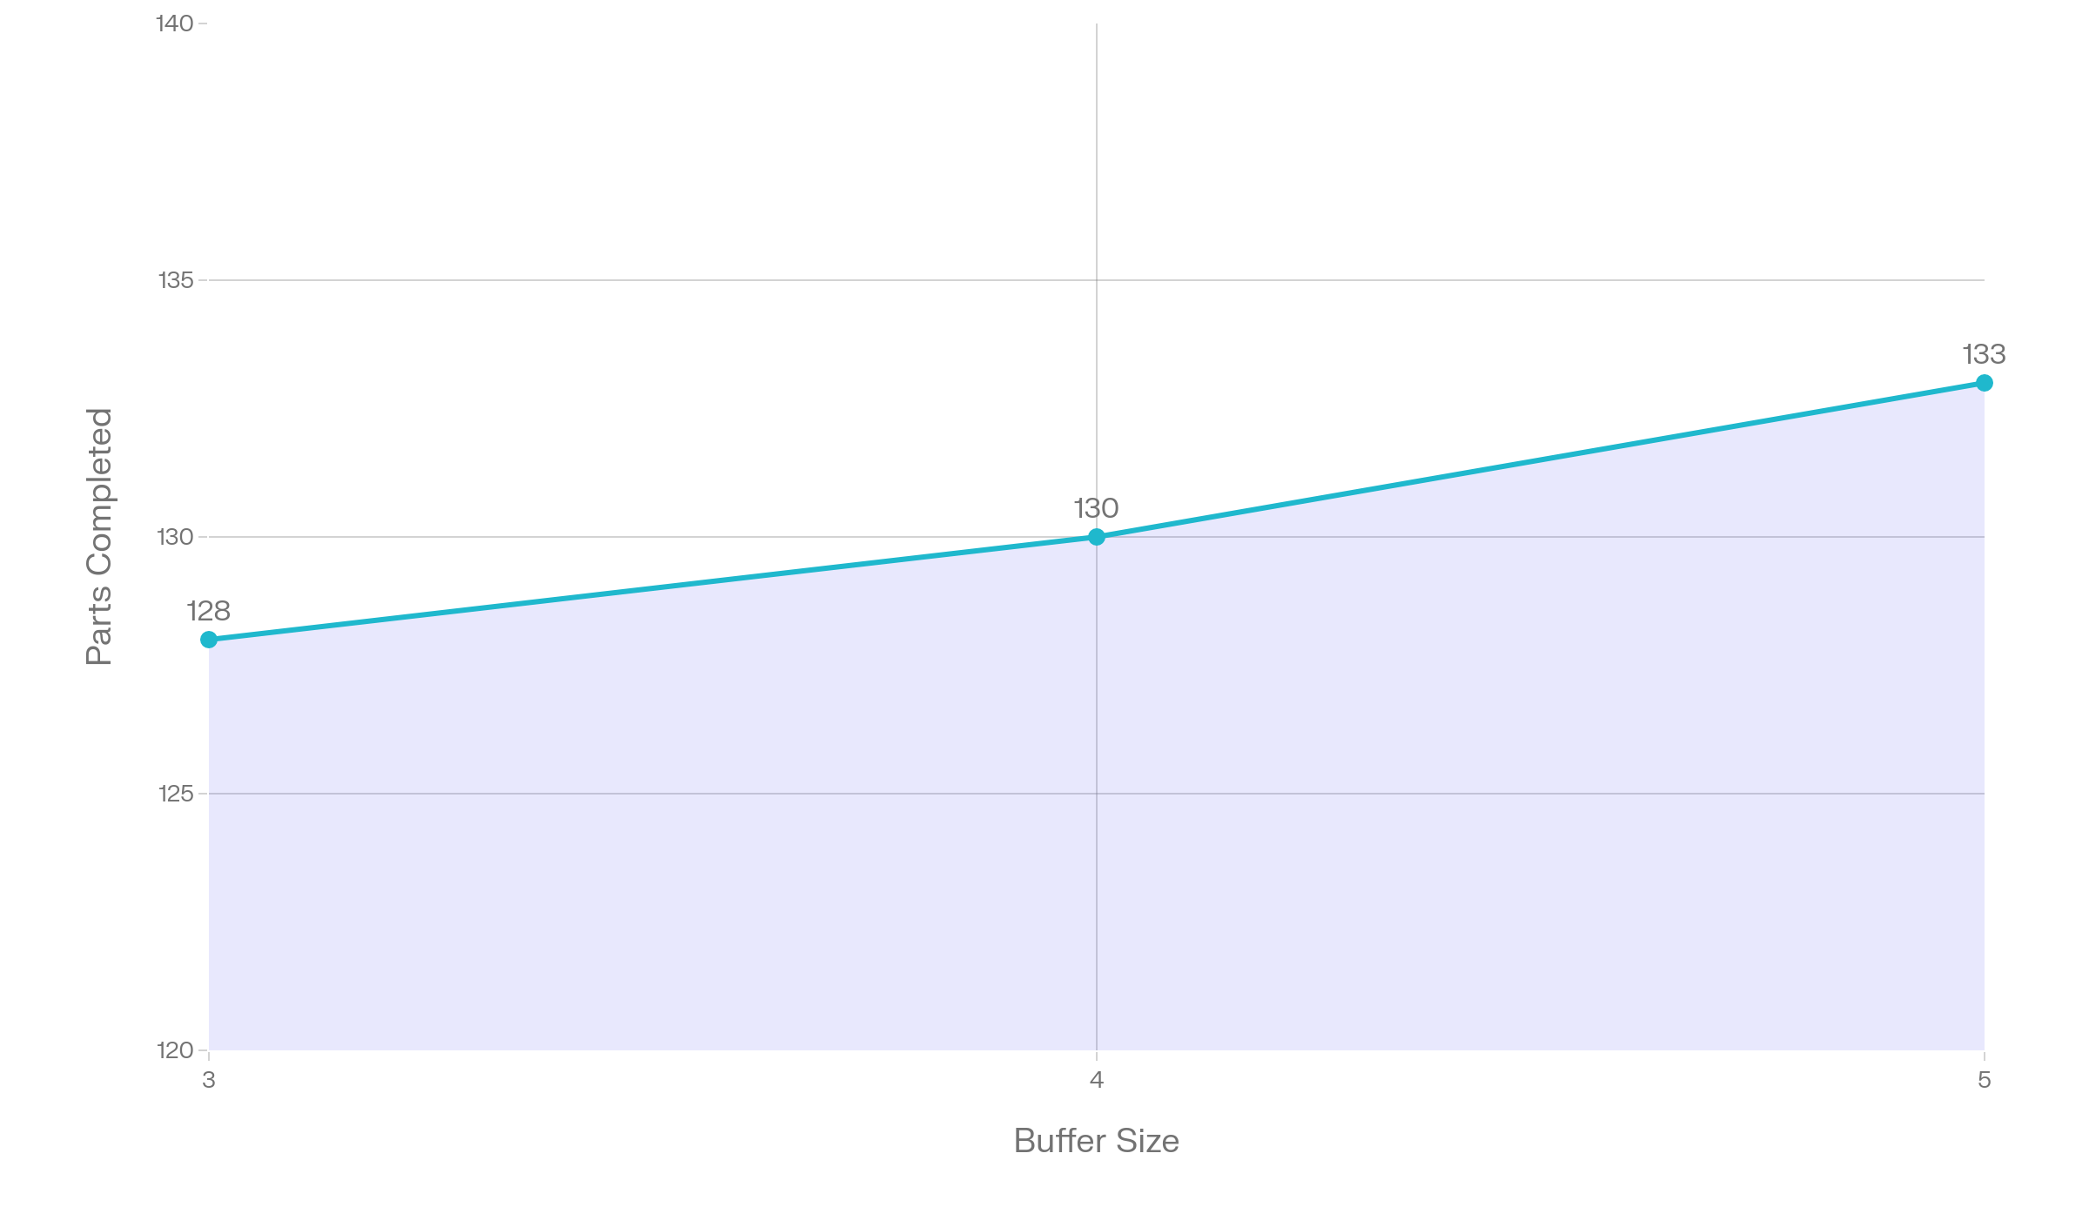
Buffer Effect Chart:

