* changing z-offset and steps/mm for FTDI damaged arduino but already have the MARLIN software

scope-
we needed to change the z offset and Esteps/mm for 3d printer which we have upgraded the marlin software to the latest version available at February 2017, after a while th FTDI of the arduino board damaged then we needed to change the extruder which made this changes very necessary.

Requirements-
- USB type B cable
- arduino board with ramps 1.4 shield
- 4 lines female to female cable

working steps-

1- connect the serial port of the ftdi damaged arduino with the ftdi working arduino
the connections at AUX-1 of both

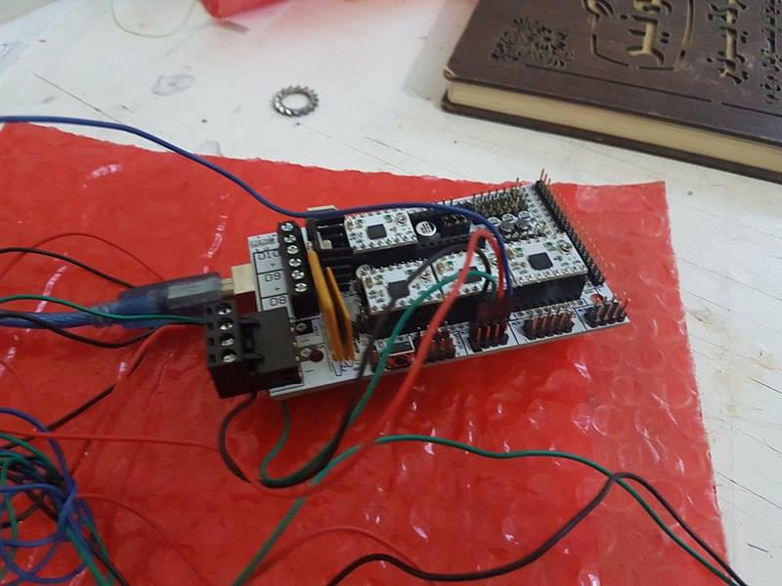
the ftdi working arduino
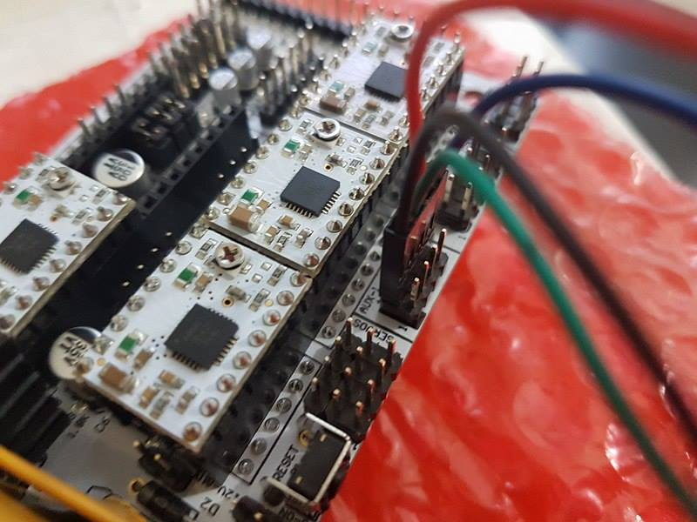
this figure shows how to connect the 4 lines cable

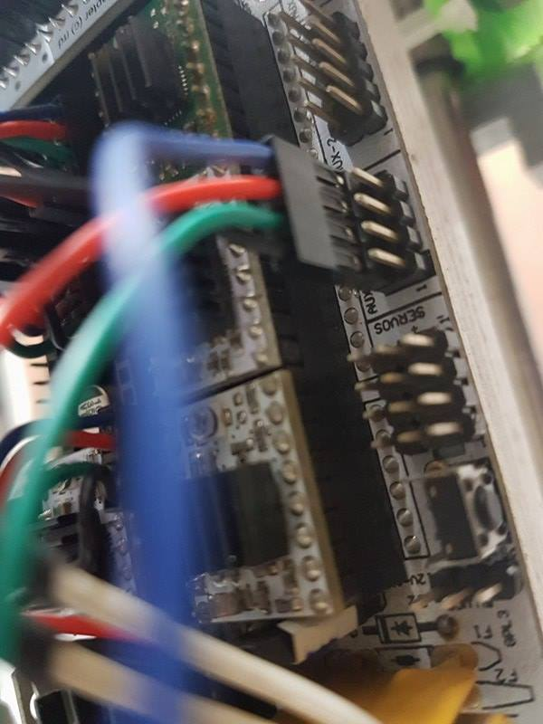
the connection should be exact between the two boards

3- connect the USB cable to your PC and the working FTDI board and run PRONTERFACE
4- to change Z-offset send “M851 z-1” this makes the offset =-1
5- to change the Steps/mm send “M92 X80 Y80 Z4000 E145.5” this order will transform to
80 step for x axis to move 1mm
80 step for y axis to move 1mm
4000 step for z axis to move 1mm
145.5 step for Extruder axis to move 1mm of filament
6- send “M500” to store ths variables in the arduinos EEPROM

