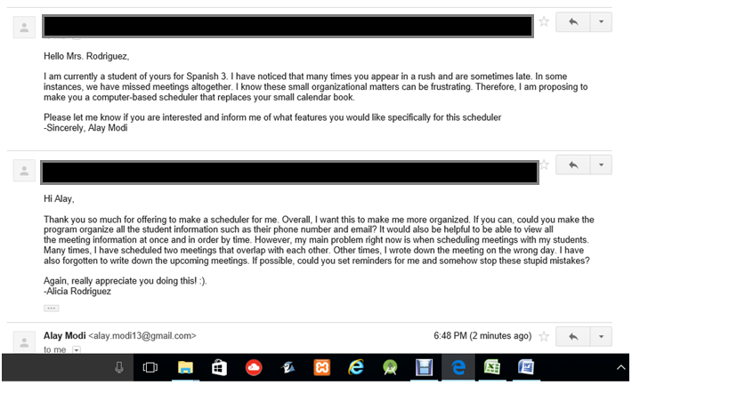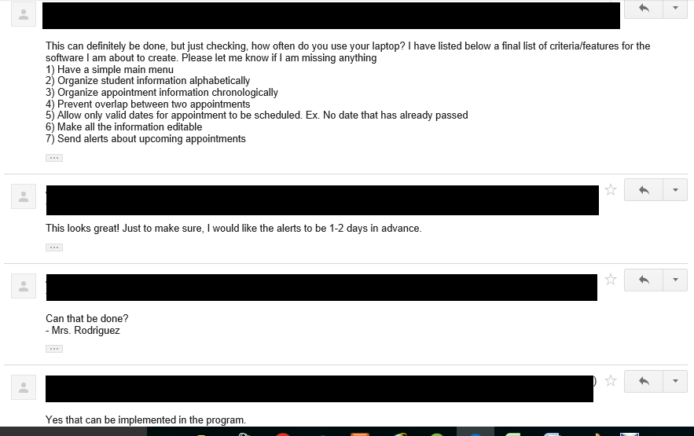Appendix 1: Evidence of Discussion and Meetings with Client

1) The following conversation is the proposal part. I asked Mrs. Rodriguez if she would like a scheduler system. We then came up with criteria and features that needed to be a part of the program.

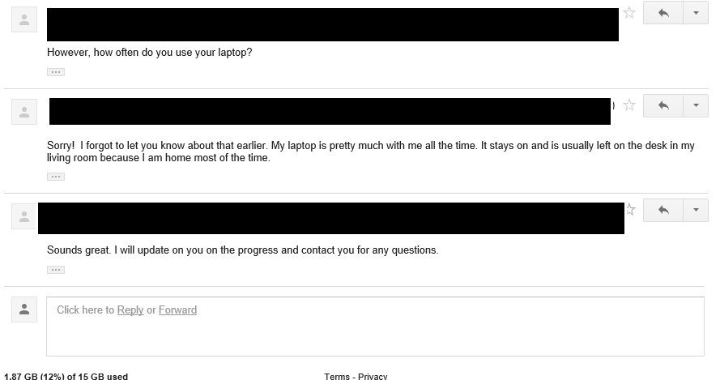2) Transcript of meeting with computer science teacher.

\*To protect privacy of teacher and student:

T = Teacher

S = Student (me)

S: Hello Mr.(teacher name), I was wondering if I could explain the idea that I was thinking about programming for the Internal Assessment

T: Sure go ahead.

S: So, right now for Spanish 3, I have a tutor and she's pretty unorganized. Like a few times she showed up late to our meeting and other times she forgot she was tutoring me that day.

T: Okay, so I am guessing you want to be making some sort of scheduling system for her.

S: Yah! Exactly, I was going to make it so she could store student information and appointment information. Then, maybe add reminders and alerts if she needs them as well.

T: Sounds good so far, but wouldn't she already have similar application on her phone or maybe laptop?

S: That’s what I was thinking, but I have seen her phone and it’s a very basic phone that does not have those capabilities. Also, I am not sure if her computer does, but when she brings it to our meetings its also pretty old. She complains a lot that its complicated to use.

T: I see. Well, I think it should work. I suggest you learn how to use GUI for it makes programs look nice. Console is actually fine in this case too, just make sure prompts are pretty clear and stuff.

S: Thank you! I will definitely look into GUI.

3) The following conversation is for feedback on the first prototype and

