In the cases of many of the extreme sports activities, the uninitiated will sometimes use the term of adrenaline junkie to refer to people who do these things, but that is a bit of a misnomer. The people described by such a term aren’t after an adrenaline rush, not at all. The adrenaline only rushes in when things are starting to go wrong. What those people are actually addicted too is getting into the flow state.
There has been extensive research that has been done surrounding flow theory, as introduced in the 1970s by Mihaly Csikszentmihalyi, that outlines very well why Tricking has the benefits it does. Many of the fields that study human consciousness, psychology, cognitive psychology and behavioral sciences have further explored the initial ideas that Csiksszentmihalyi laid out in his various written works.
Essentially the Flow Theory revolves around this concept of a Flow State. A flow state refers to the experiential sense of being an individual feels when engaging with certain tasks. Specifically the tasks that have them feeling, as well as performing their best. Flow theory is a descriptive model of the attributes that lead to the experience of these flow state. This descriptive model has led to a variety of prescriptive models in its wake. Specifically the field of Positive Psychology which directly came as a result of more and more people looking into the findings of Flow Theory.
Csikszentmihaly had originally set out to understand how people feel when they most enjoy themselves and why that was the case. He was basically interested in what happiness is, and whether or not it can be cultivated. What he found in this search was that people generally tended to describe a similar experience of flow. Most notable in his findings were the types of activities these individuals were engaged in when these feelings arose. More often than not the activities they described were not leisure activities, but rather activities that had them engaging in some difficult tasks. Participants in the study would often describe the times of highest enjoyment as those when they were engaged in solving difficult problems often times in terms of their professional work.
The term flow state derives from the many interviews Csikszentmihalyi conducted where participants described their optimal state of performance as instances where their actions seemed to flow from one to the next. Or in the case of artisans, the work seemed to flow out of them with little effort. Participants often describe a sense of timelessness and that every tasks seems almost effortless and things just “come together”.
As he studied these flow states he developed a generalized list of the conditions that accompany flow. Typically these flow inducing activities have (1) Clear Goals with a distinctively defined objective and immediate feedback, (2) the performers skills are adequately suited for the challenge, (3) during the activity the performers action and awareness merge, (4) the perfomer has a deep concentration on the task at hand, (5) the performer experiences the potential for control, but not a certainty, (6) the performer may experience a loss of their sense of self, a sense of growth, or a connection to something bigger than themselves, (7) an altered sense of time, where it may appear to pass slower or faster than usual, and (8) the experience becomes a goal in itself, it is auto-tellic.
It is not required that an experience contain all 8 of these conditions, nor is this an exhaustive list of all of the possible experiences that accompany a flow state. It is however a great general starting point for understanding what a flow state is and why people pursue them. Initially it was thought that these experiences were reserved for a certain subset of society to enjoy, only the best at their particular task could ever really be “in the zone”. Over time though, there was a realization that a diverse range of activities engender this experience, and at a vast range of skill levels.
It was a long held belief that these types of “peak experiences” were only available as a reward for operating at an elite level. As Csikzentmihalyi, and the many who followed him, discovered these “peak experiences” felt in these flow states were actually the very thing that would lead someone to eventually operate at an elite level. It wasn’t chasing being the best that made them the best, it was having a love for the activity that brought them back to train in it over and over until they eventually developed the skills.
It’s not so much the objective skill measured within an activity, but rather the performers subjective perception of their skill in comparison with the task at hand. When the performer feel’s they are capable to encounter some difficult task just outside of their current skill level is where the magic happens. Instead of seeing the difficult task as an obstacle to overcome, the performer will see an opportunity for action. One that they are adequately equipped to attempt. This balance of the skill to the challenge level of any given task is one of the most important elements to generating a flow experience.
Csikzentmihalyi has described flow as an escape forward into higher complexity. In order to maintain flow states a re-balancing of the ratio between Skill and Challenge must constantly take place. This keeps us in the Flow channel. The flow channel is the area where the ratios between challenge and skill are being matched with each other adequately regardless of their overall difficulty level.
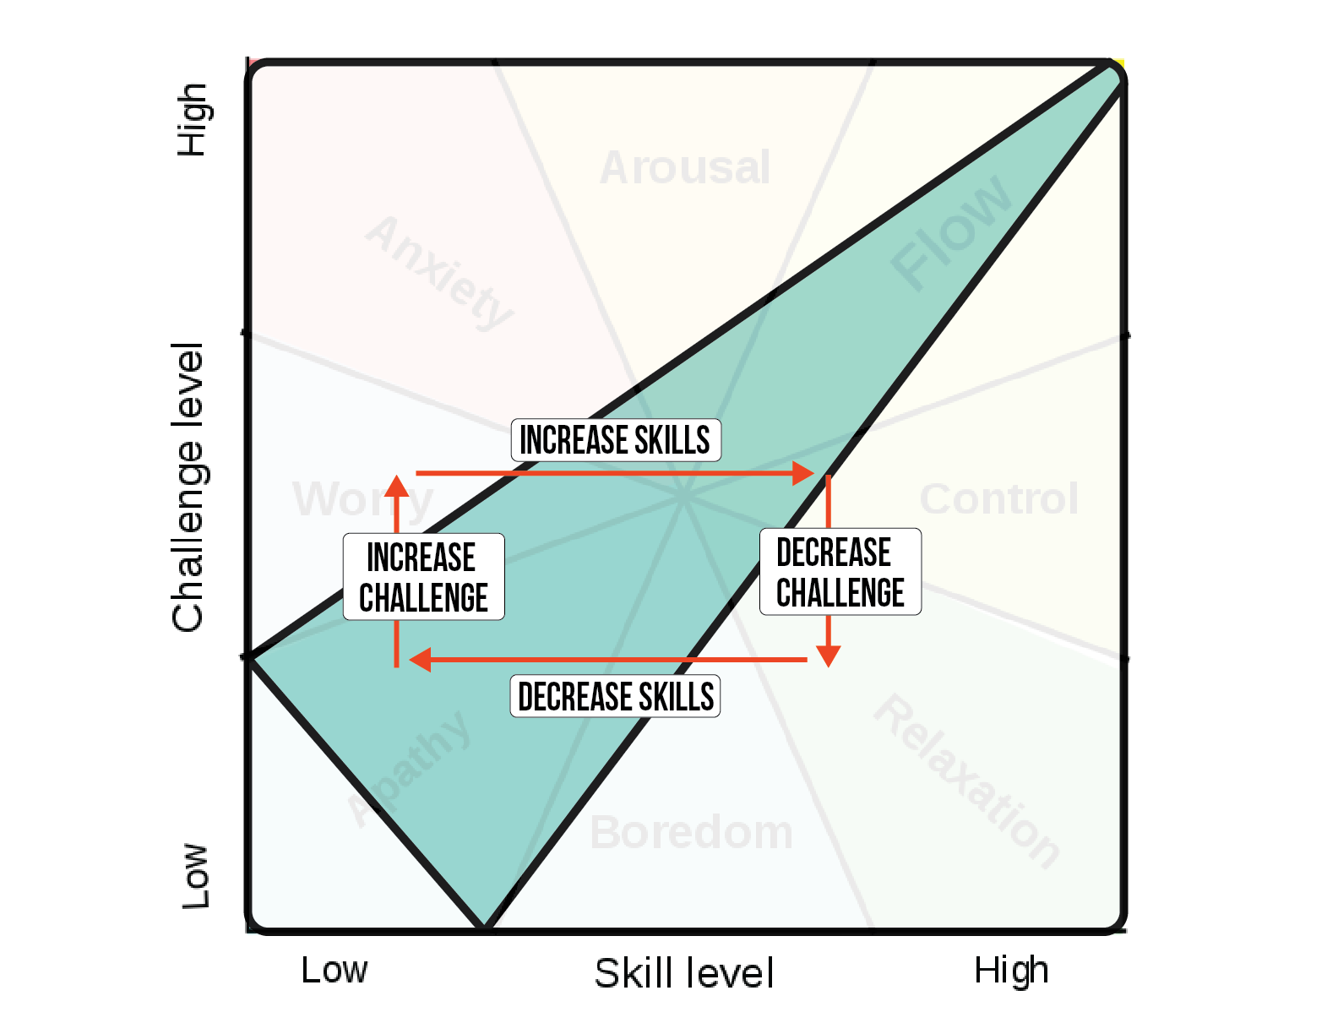
Below we can see the various states people often report feeling based on their subjective measure of skill to challenge. Apathy, Boredom, Anxiety, and Flow being the most important to keep track of.
