Before we can start to discuss the variations to these base inverts there is one more piece of the puzzle we need to understand and that is the axes. In the photo below we can see the three main axes. For our model we will be using a Z is forward approach. Where X is the Horizontal, Y is the Vertical, and Z is the forward/backward direction. This set of axes belongs to the local world space. This can be thought of as the x, y, and z axes that are "attached" to our bodies when we move. The local world space is contained within the global world space. This is the x, y, and z axes that are static to the environment and we can move within. Both of these world spaces work together allowing for a range of movements within them.
In the graphic below the red circle shows the rotation around the x-axis this is the axis we flip around. The green circle shows the rotation around the y axis, this is the axis that we rotate around when twisting. The blue circle shows us the rotation around the z-axis and is where the angle of our flips can be manipulated. It's the rotation angle around this z-axis that allows for flatspin to be generated around the y axis. Flatspin is when there is a degree of rotation around the global Y-axis in relation to the performer.
Each of these elements, Flip, Rotation, Angle of flip, and Flatspin are in a constant balancing act with each other. Where if we change one the other parameters will change in response. It's the combination of these elements that allow us to describe the Axes in the way we do within Tricking. In most disciplines, the path of an axis is locked to rotate around its origin. Within Tricking when we describe the axis of a Trick we are describing the interplay between all of these elements and axes in one motion.
In order to easily refer to a complex axis path we refer to the Axis often by which Trick takes that path. Using the terms like Flip, Cork, Aerial, BTwist, Raiz, Alien, Vert Kick, Laid Back Kick. For the base inverts each of these descriptors is giving us information about the Flip, Psuedo-Rotation(discussed later), Angle of Flip, and Flatspin. We use these descriptors because they allow for more information to be shared within a simple term. Each axis referenced within Tricking has more than one freedom of movement, meaning it is not restricted to rotating around one axis at a time. It can combine the axes at varying rates. This gives us the ability to create some very unique paths through space.

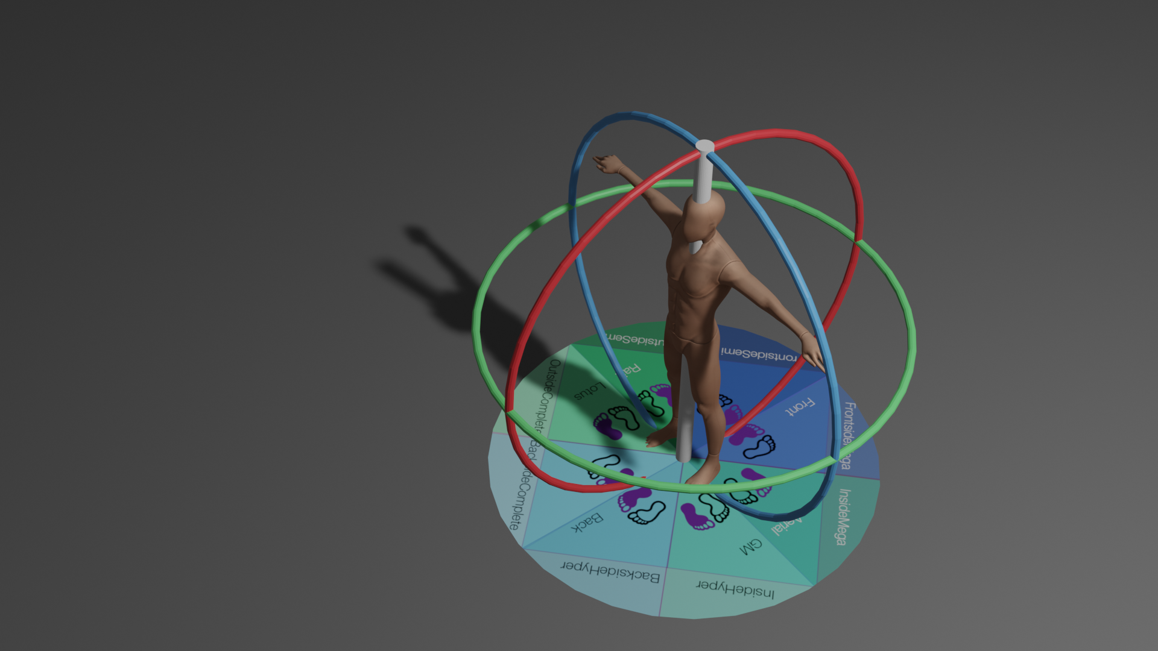

Axes
Vertical (Flip)
Horizontal(FlatSpin)
Cork (Flip/Flatspin)
Raiz (Flip/Torsion)
Alien(Dleg) (PsudeuoFlip/Torsion)

