Flips, or more accurately invert tricks. These are the basis for all of the higher level tricks. We can start with the two footed take off flips. This is where the early Trickers started when bringing these moves into the martial arts they were doing. It began with the Backflip, Frontflip, and occasionally the left or right sideflips. Within the framework we laid out before we can give these a more accurate names. The Backflip and the Frontflip need no change to line up easily with our BIFO grid, however instead of referring to the sideflips by left or right, we can use Inside(left for left twisters) and Outside(right for left twisters.
In each of the cases of these flips, BackFlip, Frontflip, InSideFlip, OutSideFlip. We can see they tell us the orientation of the Trickers body throughout the flip by designating which BIFO stance they are performed in. Which immediately tells us where our momentum is going by its definition! Each of these flips when performed follow the same general pattern of jump in air> somersault> land on ground. Nothing particular fancy going on just a head over heels tumble through the air. It is these inverts that give us the baseline for the formation of a striking majority of the other possible tricks.
Starting to variate these 4 basic inverted flips we can first look at their one footed counterparts. This brings us into our Advanced Stances grid that covers the full range of BIFO x CHMS potentials. These inverts take off from a single foot and utilize a swing of some form to assist the jumping leg in generating power. The various swings are discussed in a later section but it is important to note that the swings we will be talking about next will all be counter to your DOM.
***Insert Graphic DOM & Swing Direction***
We effectively have 6(8 if you count the Darkside gainer/webster (bad swing leg)). Each of these uses the one of the 4 base flips and manipulates them in some way. Backside gives us Gainer. Inside Gives us Aerial and GMS. Frontside gives us webster. Outside gives us Raiz and Lotus. We will start first with the Gainer and the Webster, then we will move into the Aerial, Raiz and eventually the GMS and Lotus.
A Gainer is a backflip swung off of one leg. In the case of a left twister this is generally done with the Left foot used as a plant foot and the right foot generating the swing up into the air in front of the performer. After swinging into the air the Tricker performs a backflip and comes back into the Backside or Backside Complete landing position. The webster is the front flips version of this. It is typically swung off of the left plant leg with the right swing leg generating an arc up behind them, after jumping into the air a front flip is performed and the Tricker lands in a Frontside or Frontside Semi landing position.
An aerial is an inside flip performed off of the leading leg(inside (left)) where the performer swings the trailing leg (right) up in the direction that is counter to their DOM. The Raiz is an outside flip performed off the leading leg (outside(right) where the performer swings the trailing leg (left) up in the direction counter to their DOM.
GMS stands for GrandMasterSwipe and is an inside flip performed off of the trailing (outside(right)) leg. Where the swing is performed by the leading (inside(left)leg). This move is similar to an aerial but takes off from the opposite foot. Lotus can be thought to be similar to the raiz in the same way. It is an outside flip performed off of the trailing (inside(left)leg).
This covers all of the base flips can be used to build up to a vast majority of the other Tricks. Before we start adding more parameters to use in variations we should discuss at more length the swings. There are effectively 6 base swings. Each of these are named in convention with the Tricks that they come from and can be mapped out using the advanced circle of swings as pictured below. As we can see in the graphic the Direction of Swing will always go counter to the Direction of Momentum for these swings.
*** Insert Graphic Advanced Circle of Swings***
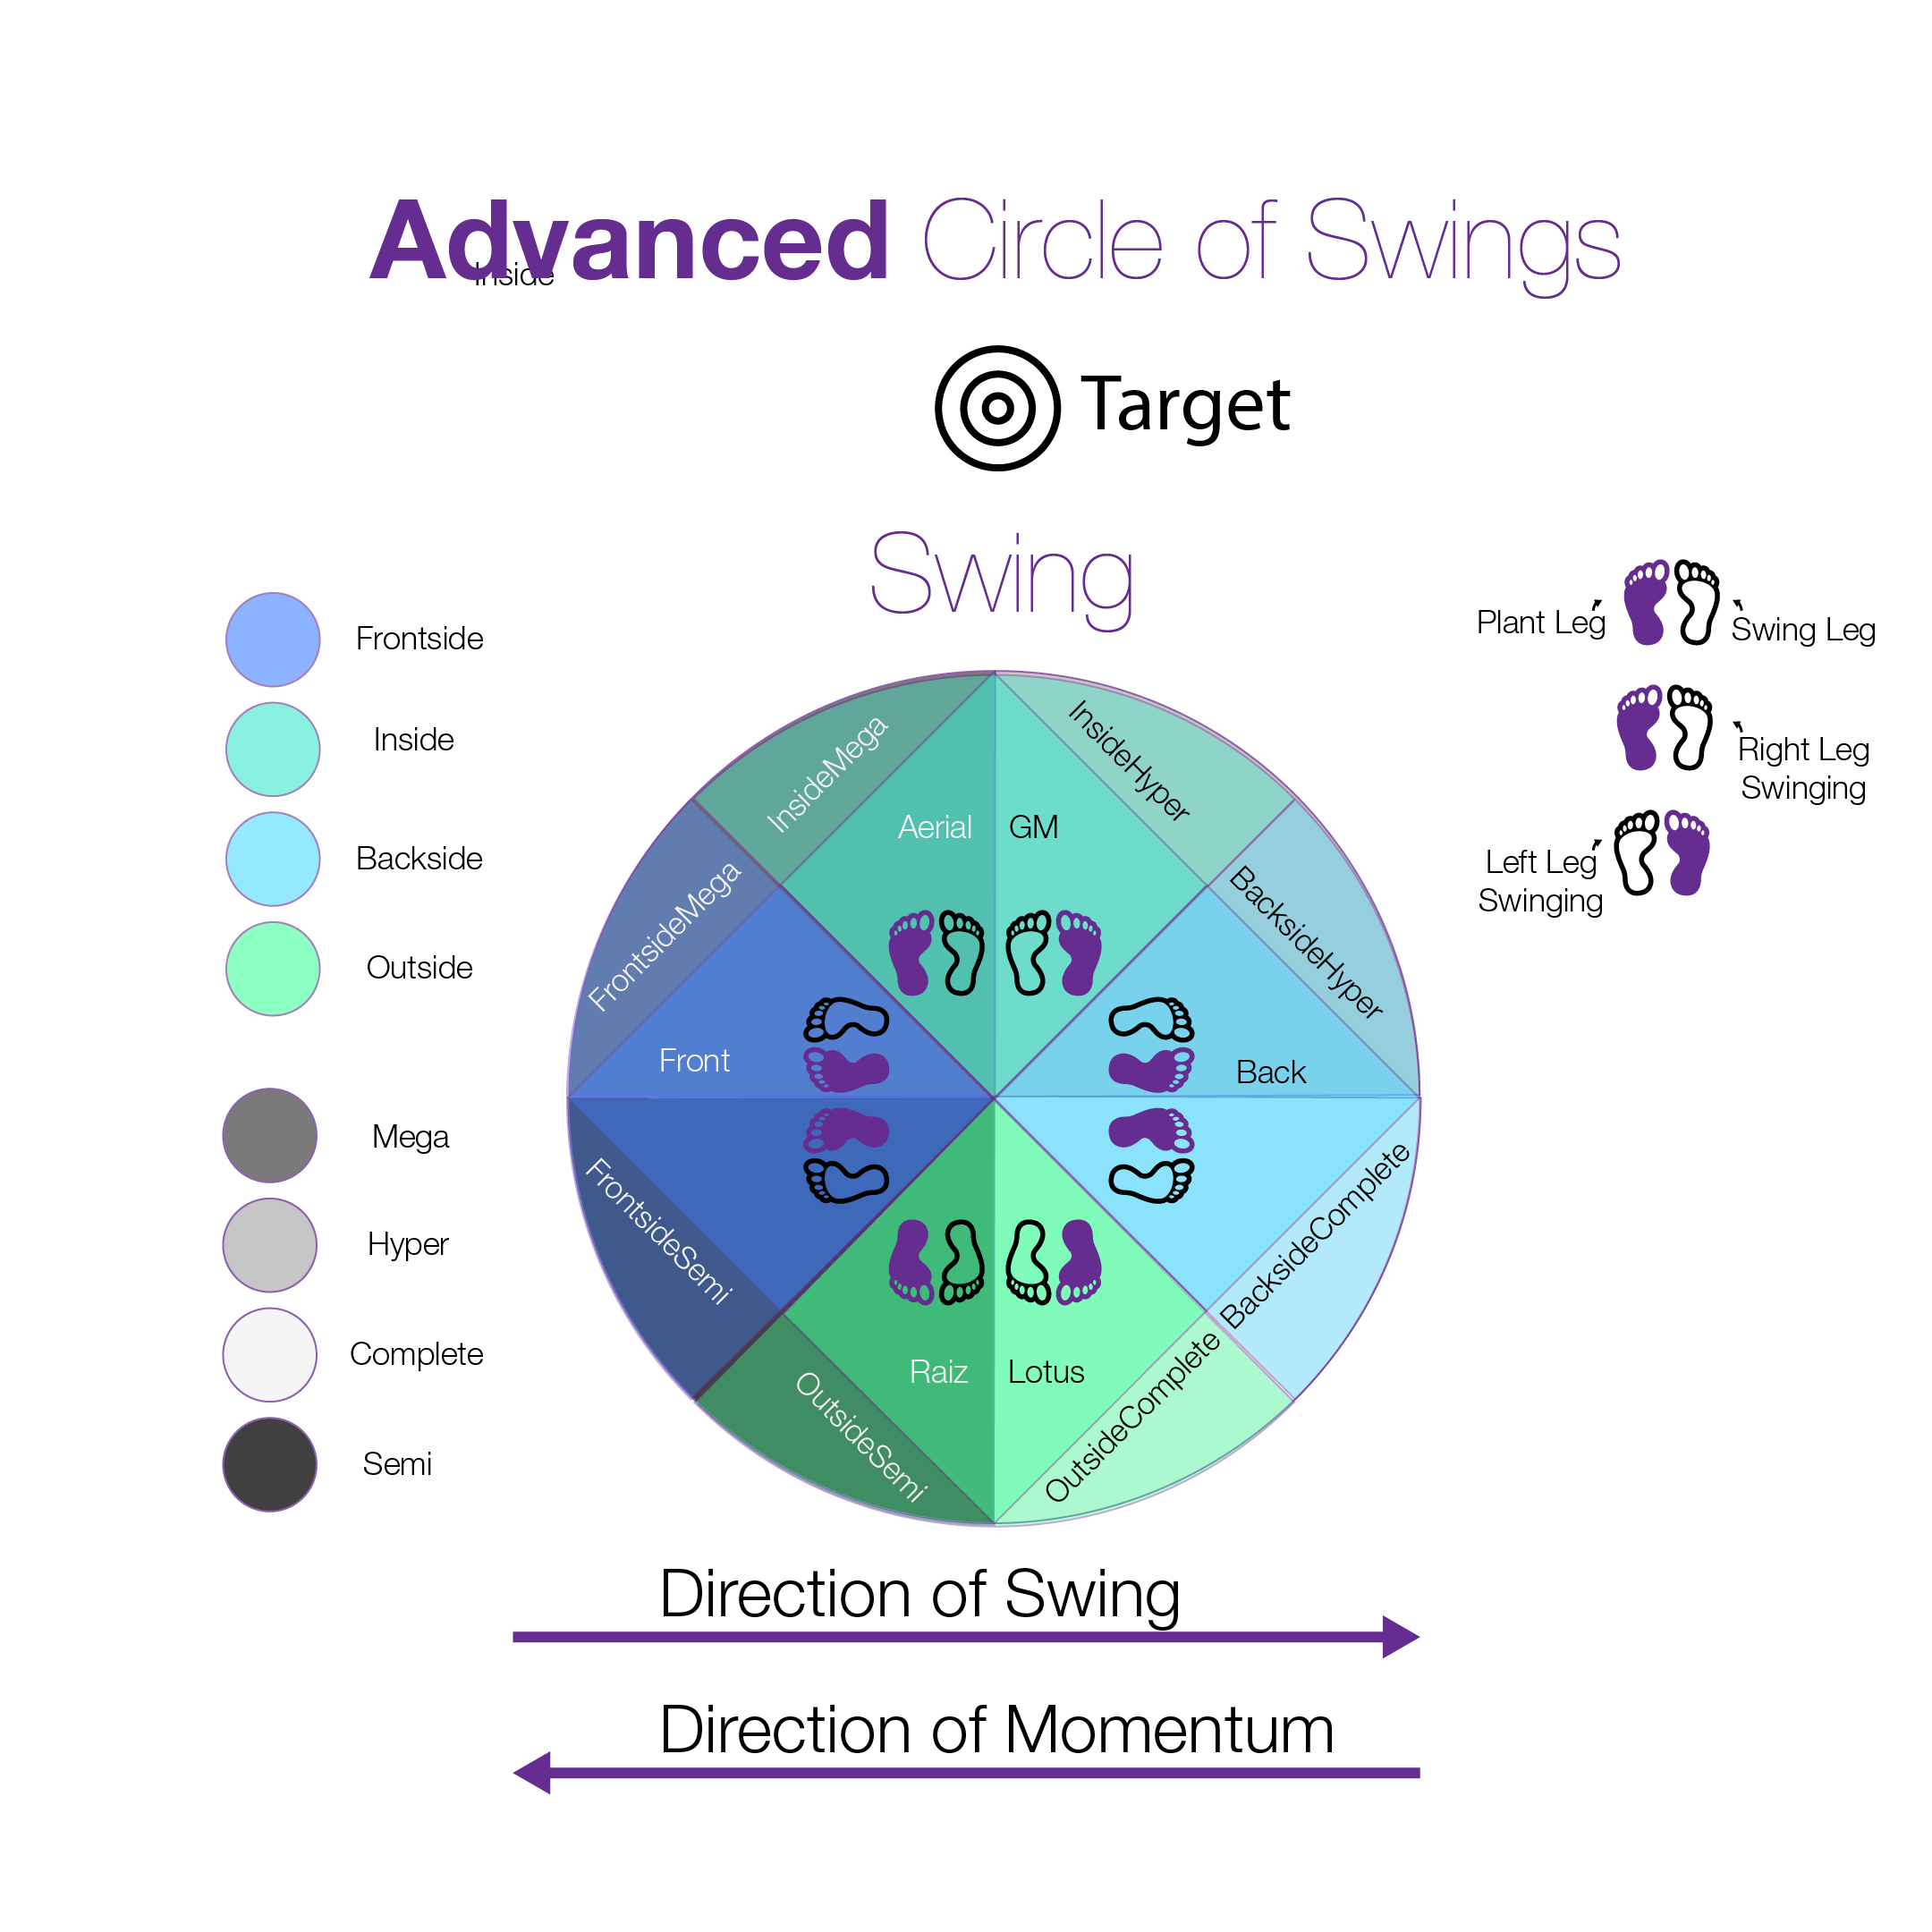
These swings cover the swings out of backside, frontside, inside, and outside stances. In the cases of backside and frontside. Both can be performed by either leg although the left twisting (counter-clockwise) Tricker typically defaults to using their left leg to plant and their right leg to swing. In the case of backswing the swing starts behind the performer and swings in front of them to generate lift into a back fliping motion. In the case of frontswing the swing starts in front of the performer and swings behind them to generate lift into a forward swinging motion. The inside swings are both performed when the performers hips are effectively facing inside. The inside swings include the Aerial Swing which takes off from the leading leg (left) and the GrandMasterSwing(GM-Swing) which takes off from the trailing leg (right). The outside swings include the Raiz Swing and the Lotus Swing. Both of these are performed when the performers hips are effectively facing outside. The Raiz Swing takes off from the leading leg(right) and the Lotus Swing takes off from the trailing leg(left).
Many people will often refer to the aerial and raiz swings as frontswings because they move in a similar front to back motion, however this ignores the hip placement that the performer gets into during the swing. By using these 6 different swings we have a more accurate way of referencing the orientation of the performers legs to their hips during the swing into the Trick they will perform. This is only necessary when breaking the tricks down into their pieces to be understood as the swing is implied by simply stating the Trick being performed. Such as Gainer (backswing), Webster(frontswing), Aerial(AerialSwing) etc. Knowing how to break these down into smaller elements that can be utilized within the anatomy of a trick allows for the performer to start putting things in places they don't typically appear and finding something new and interesting.
Simply take the concept of swings we just laid out. That the Direction of Swings usually go counter to their DOM. What would happen if we rotated this to swing perpendicular to our DOM? We would quickly discover a whole new set of swings that can be utilized to create never been seen before Tricks! Some people have already started playing with some ideas like this in the case of things like the Tunnel, and Bullet flips. Not to mention a list of tricks that have yet to begin being named but are already being performed.

