CMSC 461 Project Report

Project Overview
Pluto Realty requires a database to keep track of the properties and clients that it manages. The goal of this project is to develop that database using the constraints and information listed out by the company. This entails creating a relational schema, ER model, creating and populating a database in SQL, and testing that database for functionality.

Relational Model and Schema
  - Entity Descriptions
- Employee: The employee table will hold their employee id number, their first and last name, each part of their address (in separate columns), their phone type and number, their role within the company, and their list of emails. Their id number will be the unique primary key used to identify different employees.
- Owner: The owner table will also hold a unique id number automatically generated whenever the new owner is added to the system, their name, address, phone, email, and also their employee partner’s id, which will be a foreign key to the employee table. The owner’s id number will be the primary key of the table.
- Client: The client table will also hold a unique id number, name, address, email and phone. This table will also hold the client’s preferences for properties; this will just be held in a large string. We will also hold their maximum monthly rent preference as an integer. Their auto-generated id will be the primary key.
- Property: The property table will hold each property’s id number, address, the number of bedrooms and bathrooms, the owner’s id number, the type of property, the square footage, associate’s id, the asking rent, the management fee, and whether or not it’s currently being advertised. The id number will be the primary key and the owner attribute variable will be a foreign key to the owner table. The associate’s id will be a foreign key to the employee table.
- Viewing: The viewing table will hold information on each viewing administered by an associate. A viewing id number will be automatically generated for each new viewing. The property, client, and employee id (for the associate administering the viewing), will also be held within the table. Also, the date and time of the viewing will be held. The property, client, and associate ids will be foreign keys to their respective tables. The viewing id will be a primary key to this table.
- Lease: The lease id will be automatically generated each time a new lease is added to the system. The ids for the client, property, partner, and owner will be held within the table. The date of the signing of the lease will be stored, along with the start and end dates that the lease will be active. We can also store the duration of the lease, and the monthly rent within the table. The ids for the client, property, partner, and owners will be foreign keys to their respective tables. The lease’s id will be the primary key to this table.
  - Relation Descriptions
- Partnered: Each owner will be partnered exactly one partner (employee). A partner may represent more than one owner.
- Owns: Each owner owns at least one property, and every property has exactly one owner.
- Manages: Each property is managed by exactly one associate, but an associate may manage 0 to 5 properties.
- Hosts: Viewings must be hosted by an employee, an employee may host 0 to many viewings.
- Viewed: Properties may have 0 to many viewings, however each viewing only relates to one property.
- Attends: Clients may attend viewings. This is a many to many relationship.
- Signs: Each lease is singed by exactly one client, and a client may sign 0 or 1 leases.
- Leased: A property may have 0 to many leases tied to it, however each lease only corresponds to exactly one property.
- Eemail: Email owned by an employee. Many emails can be owned by a single employee, but all emails are only owned by one employee.
- Oemail: Email owned by an owner. Many emails can be owned by a single owner, but all emails are only owned by one owner.
- Cemail: Email owned by an client. Many emails can be owned by a single client, but all emails are only owned by one client.
  - ER Diagram
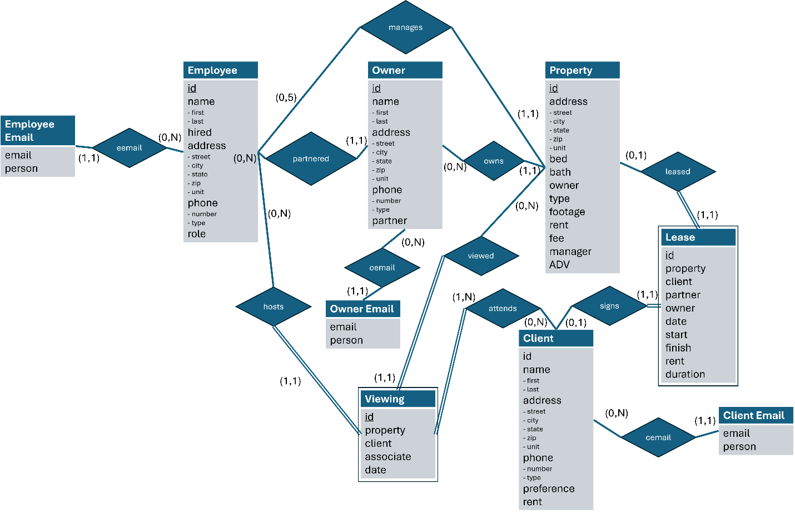

Table Layout

Table Structure
employee(**id**, first, last, street, city, state, zip, unit, pNumber, pType, hired, role)

owner(**id**, first, last, street, city, state, zip, unit, pNumber, pType, partner_id)
FK partner_id → employee(id)
client(**id**, first, last, street, city, state, zip, unit, pNumber, pType, preference, rent)

property(**id**, street, city, state, zip, unit, bed, bath, type, footage, rent, fee, ADV, owner_id, manager_id)
FK owner_id → owner(id)
FK manager_id → employee(id)

lease(**id**, date, sign_date, start_date, end_date, client_id, owner_id, partner_id, property_id, rent)
FK client_id → client(id)
FK property_id → property(id)
FK partner → employee(id)
FK owner_id → owner(id)

viewing(**id**, date, property_id, client_id, employee_id)
FK property_id → property(id)
FK client_id → client(id)
FK employee_id → employee(id)

emp_emails(**email**, person)
FK person → employee(id)

own_emails(**email**, person)
FK person → owner(id)

cli_emails(**email**, person)
FK person → client(id)

    - Tables Explained
Separate email tables were made for each class of person (employee, owner, and client) since the values for their ids are not unique across classes even though they’re unique within their classes. The emails needed their own tables rather than being attributes to begin with, since each person can have multiple emails.

User Interface
The users of the app will be the employees of Pluto. This section defines how the user interface allows them to use the app to help their dealings.
  - Interactions
    - Activities
- Edit property attributes.
- Create new clients.
- Enter information for new viewings.
- Discard a given property.
- Change the partner assigned to an owner.
    - Queries
- List the names of all (unique) clients.
- Find the unique names of owners and total square footage of all the properties they own.
- Find the properties shown by each associate in a given month.
- Find the most popular properties (in terms of number of viewings) in a given period (range of dates).
- Find the total rent due to each property owner in a given month year. 4/5 2/19/2026 UMBC CMSC 461 Spring 2026 Project
- Find the unique names of clients that were ever shown at least three or more unique residential properties owned by a given owner.
- Find the unique names of owners that have a residential property in every city where Pat Doe owns a commercial property.
- Find the top-3 partners with respect to number of properties leased in the current year.
- Write a SQL function to compute the total management fees due to Pluto in the last 3 months.
- Create a SQL trigger to automatically set to FALSE the ADV flag of a property when it is leased.

