ORGANIZATIONAL REQUIREMENTS

**Environmental**

• By the administrative point of view, documents such as patient’s personal info will be imported from e-Albania system into our system, because otherwise it can’t be proceeded with other phases of medication by the dentists of other specialties. Of course, the assistants and dentists will take into consideration that all other legal and ethical issues concerning confidentiality for patient’s sensitive information aren’t exploited.

**Operational**

• The application will be available to the user 24/7.

• The information entered to the system shall be accessed only by the people who are previously registered to the system.

• Create, Read, Update and Delete users.

• Create, Read, Update and Delete examinations.

• Create periodic reports.

• Create drug recipe.

• Create medical visit.

• Update agenda.

**Development**

• The development process to be used must be explicitly defined and must be conformant with ISO 9000 standards.

• Reports setting out the effort expended on each identified system component must be produced every week.

• A disaster recovery plan for the system development must be specified.

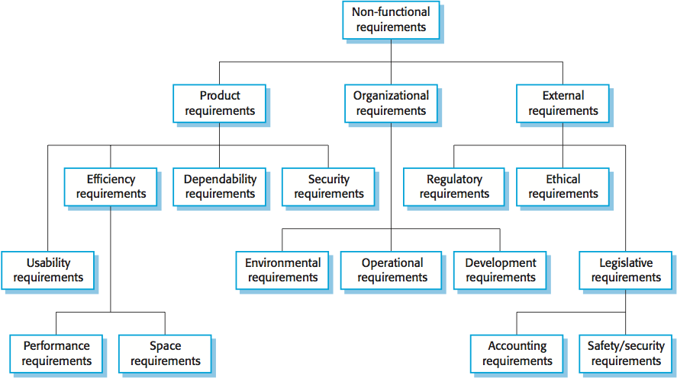

EXTERNAL REQUIREMENTS

* Regulatory requirements.
* Ethical requirements.
* Legislative Requirements:

1.Personal information of a patient should not be revealed to a third party without their consent.

2. This project should not break the laws of the Ministry of Health in Albania.