Smart Sustainable Meal Optimizer
Final Capstone Technical Report

Executive Summary
This project explores how food choices can be compared across four considerations: protein, calories, price and environmental impact. Using a combined dataset of foods with comparable price information, the analysis created a weighted recommendation score and used K-Means clustering to group foods with similar characteristics. In the baseline ranking, lentils, kidney beans, black beans and chickpeas received the four highest recommendation scores. These results suggest that several plant-based protein foods can perform well across the selected nutrition, cost and environmental measures.
The model comparison does not show an improvement from the experimental weighting adjustment: both models had a test silhouette score of 0.622, while the baseline had lower test inertia (0.649 versus 0.672). The practical recommendation is to treat the current output as a screening and decision-support tool, not an automatic meal planner. A food-service or meal-planning team could use the ranking to identify promising ingredients for further review, then validate portions, complete-meal nutrition, prices and environmental data before making purchasing or menu decisions.

Business Problem
People and organizations making food choices often need to balance nutrition, affordability and environmental considerations. Looking at only one factor can produce an incomplete picture: a food may be high in protein but expensive, or inexpensive but have a larger environmental footprint. The project asks: how can available food data be combined to identify and group foods that offer a useful balance of protein, calories, cost and greenhouse-gas impact?
This question could support early-stage menu planning, ingredient screening and consumer education. It matters because it makes trade-offs more visible, while keeping the analysis grounded in measurable attributes rather than a single definition of a 'good' food.

Data and Methodology
The project combines food nutrition information from USDA FoodData Central, environmental-impact information from the University of Michigan dataFIELD dataset and USDA Economic Research Service price information. The notebook documents data cleaning and quality checks, including missing environmental values, price availability and outliers. The initial cleaned analysis included 52 foods; 48 foods had comparable price data and were used for the recommendation and clustering analysis.
Four features were used: protein (grams), calories, price per 100 grams and CO2-equivalent emissions per kilogram. The baseline recommendation score assigned 40% weight to protein and 20% each to calories, affordability and environmental impact. Cost and environmental scores were oriented so that lower values improved the score. K-Means was selected as an exploratory unsupervised method because the project has numerical features but no pre-existing target labels. Features were scaled before clustering. The baseline used three clusters, random_state=42 and n_init=10.
For model evaluation, the notebook used an 80/20 train/test split (38 training foods and 10 test foods) and compared silhouette score and inertia. A refined model multiplied the scaled protein feature by 1.5 and environmental-impact feature by 1.2, leaving calories and price at 1.0. These weights were experimental choices intended to test a different balance of priorities, not proven optimal weights.

Key Findings
The baseline recommendation ranking placed lentils first (0.861), followed by kidney beans (0.831), black beans (0.823) and chickpeas (0.818). Oats, almonds, turkey, chicken, walnuts and pearled barley rounded out the top ten. The high ranking of several legumes is consistent with their combination of protein, price and environmental scores in this dataset. The ranking is a result of the chosen features and weights; it should not be interpreted as a universal nutrition ranking.
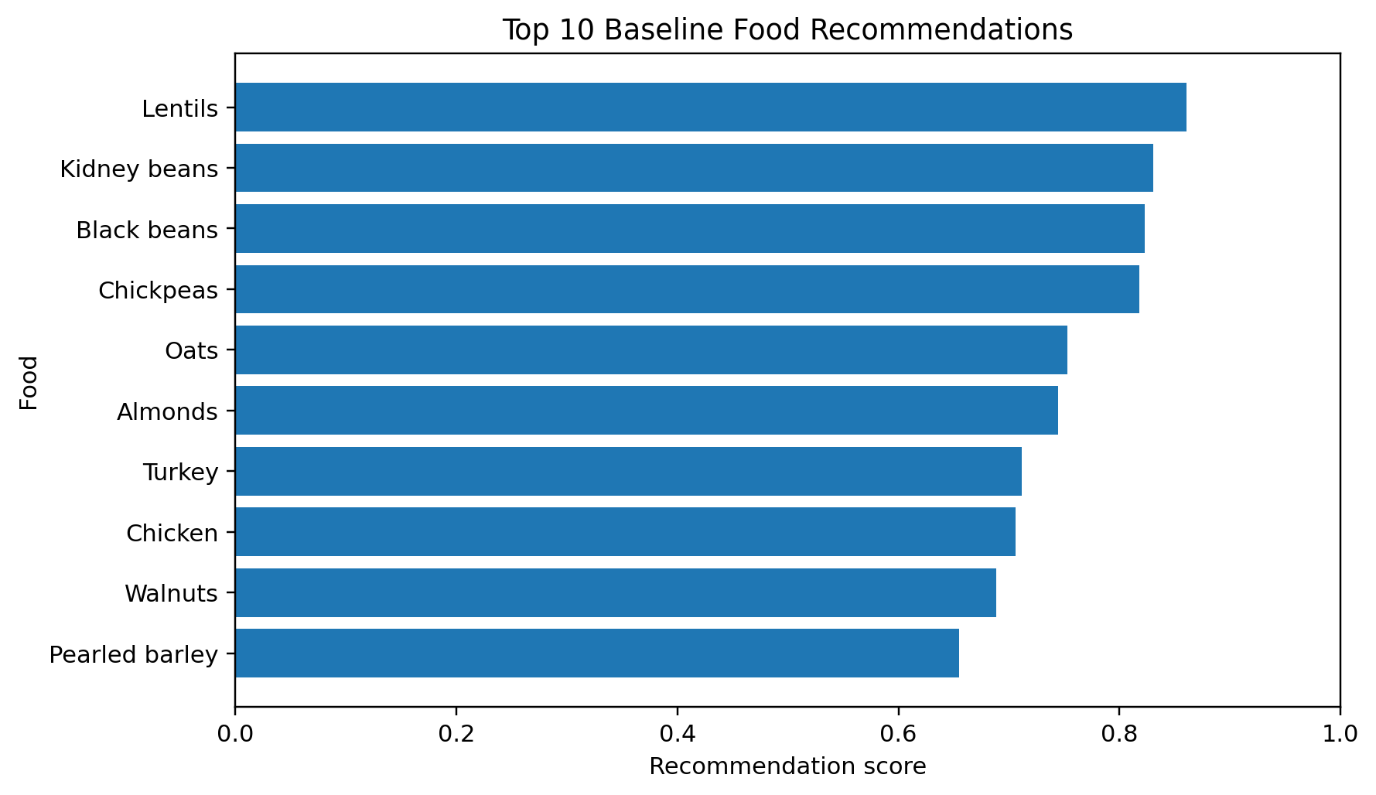
Figure 1. Top 10 foods by the project's baseline recommendation score.
The initial baseline clustering grouped 48 foods into three clusters with counts of 34, 9 and 5. The notebook reported a baseline silhouette score of 0.686 for that initial full-data model. In the later held-out comparison, however, both the baseline and refined models scored 0.622 on test silhouette. Test inertia was 0.649 for the baseline and 0.672 for the refined model. Since lower inertia indicates foods are closer to their assigned centers in the evaluated feature space, the baseline was slightly better on that measure as well.
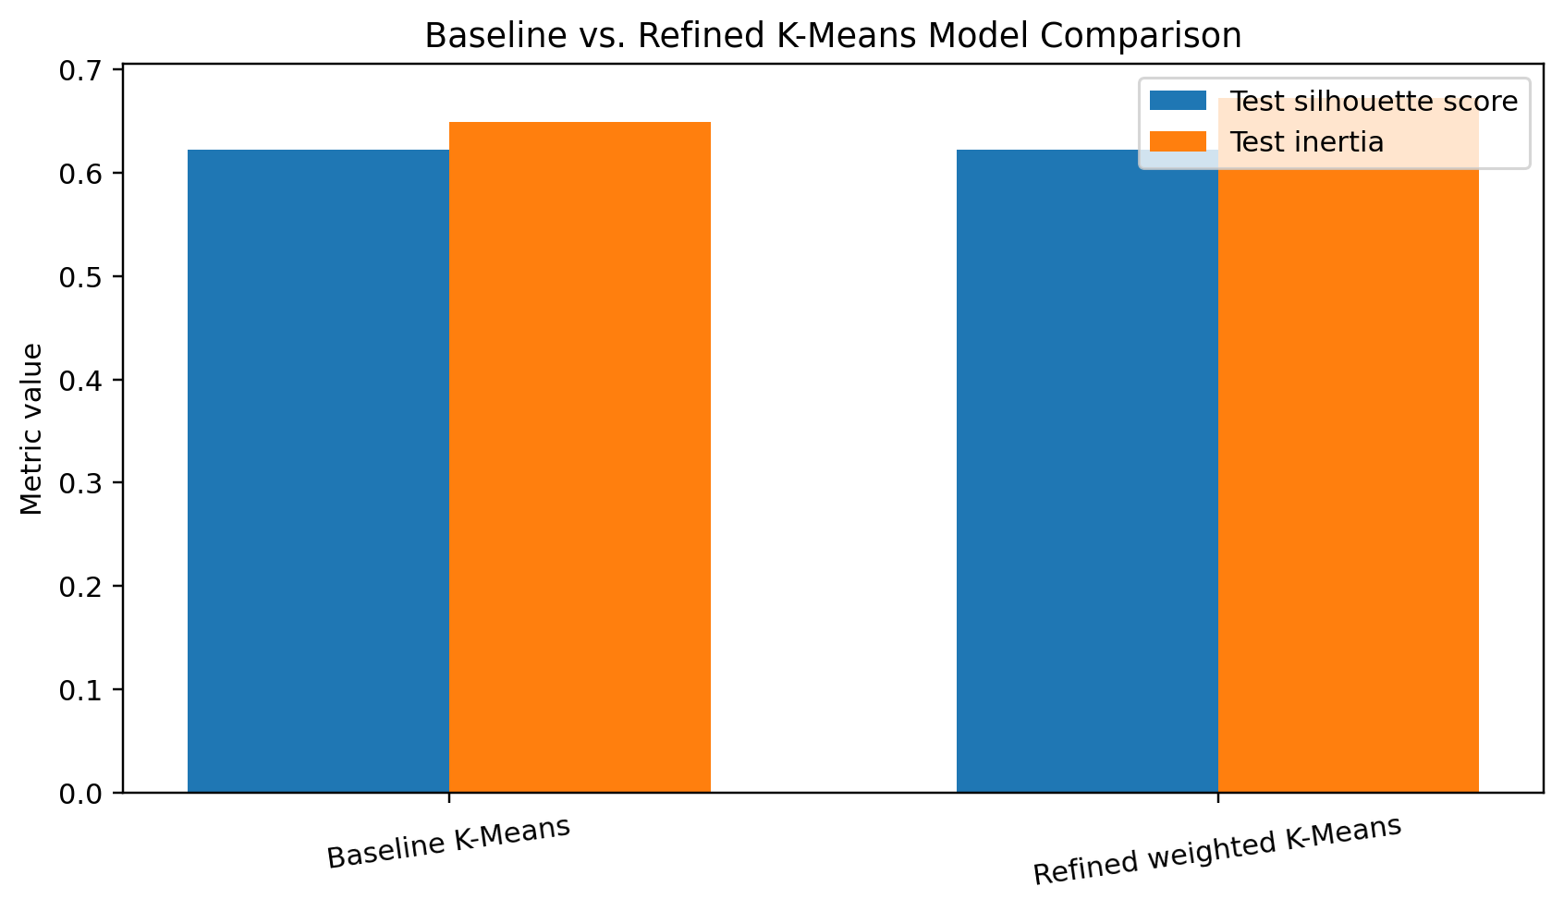
Figure 2. Held-out test metrics for the baseline and refined models.
The notebook's correlation analysis also found that protein had only a weak relationship with environmental impact (0.28), and calories had a weak relationship with protein (0.126). This supports considering nutrition and environmental impact as separate dimensions rather than assuming one can stand in for the other.

Business Recommendations
- Use the ranking as an ingredient-screening aid. Review high-scoring foods such as lentils, beans and chickpeas as candidates for recipes or menu concepts, rather than treating the ranking as a final purchasing decision.
- Keep the trade-offs visible. Present protein, calories, price and CO2-equivalent impact alongside the overall score so decision-makers can understand why an item ranks highly.
- Do not adopt the refined weights as an improvement yet. The current test results do not show that the experimental weighting outperforms the baseline. Test alternative weights on a larger and more representative dataset before selecting a final configuration.
- Build and validate meal-level logic as the next development phase. A future version should combine ingredients into portions and check complete-meal nutrition, total cost, dietary requirements and environmental impact.
- Improve data coverage before operational use. Prioritize reliable, comparable price and environmental records and document the source, date and assumptions for each measure.

Limitations and Next Steps
The dataset is small: 52 foods were in the cleaned analysis, 48 had comparable price data and only 10 foods were held out for testing. The test metrics are therefore preliminary and may change with more foods or a different split. K-Means is an exploratory grouping method; silhouette score and inertia measure cluster structure, not nutritional adequacy, user satisfaction or prediction accuracy. The recommendation weights are manually selected and have not been validated against user preferences or expert-defined meal goals.
The current system ranks and groups individual foods. It does not generate complete meals, confirm that a meal meets dietary requirements, account for serving sizes or guarantee a user's budget. Environmental and price data may also have missing values or differences in measurement and timing. Before deployment, the project should expand and validate its dataset, test the model across repeated splits or cross-validation where appropriate, evaluate recommendations with nutrition expertise and users, and implement meal-level constraints.

Conclusion
The capstone demonstrates a reproducible starting point for comparing foods across nutrition, cost and environmental impact. The baseline ranking highlights several promising ingredient candidates, while the model comparison shows that the experimental weighting change did not improve the measured test results. The strongest business use at this stage is informed screening and exploration, followed by human review and further validation before operational decisions.

Project Repository
GitHub: https://github.com/albabbitt13-commits/smart-sustainable-meal-optimizer

