
BY NXGEN

Auto Stream
Zone-Based Camera Streaming for Intrusion Alarms

Feature Guide
2026

GCXONE Security Management Platform | NXGEN Technology AG
© 2026 NXGEN Technology AG. All rights reserved.

Overview
Auto Stream is a GCXONE feature that automatically opens live camera feeds when an intrusion alarm is triggered at a site. It is designed for installations where alarm panels — infrared motion detectors, door contacts, or other sensor-based devices — are connected to Talos but have no video capability of their own. When one of these panels raises a burglary (BA) or intrusion alarm, Auto Stream bridges the gap: it instructs GCXONE to immediately begin streaming the cameras associated with the triggered zone, giving operators instant visual context without any manual action.
The feature is available in the Video Viewer application via the Auto Stream toggle. It works in combination with the zone mapping configured between Talos and GCXONE, and relies on the NXGEN Genesis–Talos Bridge browser extension to relay alarm messages between the two platforms.

How It Works
When an intrusion alarm arrives in Talos, the platform sends a trigger message through the Genesis–Talos Bridge to GCXONE. This message includes the zone identifier that raised the alarm. GCXONE looks up which cameras are mapped to that zone and starts streaming them automatically for the operator working the alarm. The full logic is as follows:

• Matching zone found: only the cameras mapped to that zone are streamed.
• No matching zone, or no zone in the alarm message: the entire site streams — all cameras across all devices at that site.
• Multiple alarms in one workflow: GCXONE aggregates the camera lists from all zones referenced across all alarms. Duplicate cameras are not repeated. If one zone has no mapping, the entire site is included in the stream.
• Motion alarm present in the same workflow: motion alarms take precedence. Quad view (multi-monitor) is shown instead of Auto Stream. If Auto Stream is on a separate screen, it continues streaming concurrently.
• Dynamic refresh: the stream updates automatically if new alarms are attached to the workflow while it is being worked. If a motion alarm arrives, the screen switches to quad view.

Important
Zones must be created in Talos before they are configured in GCXONE. If zone configuration is done in the reverse order, the sync to Talos will fail. Additionally, if no zone is configured in GCXONE, or no cameras match the zone in the alarm, the entire site will stream.

Prerequisites
Before configuring Auto Stream, ensure the following are in place:

• Genesis–Talos Bridge installed: this browser extension must be installed and active. It is the communication channel between Talos and GCXONE. All Talos customers will have this. Search for "Talos Genesis Bridge" in browser extensions if not already installed.
• NXGEN Genesis integration enabled in Talos: the Genesis integration must be active under Company → Integrations in Talos, with the correct service provider ID and access tokens configured.
• Auto Stream alarm codes configured: in Talos under Company → Integrations → NXGEN Genesis, specify which alarm codes should trigger Auto Stream (typically burglary alarms, code BA or BA 130).

Configuration Steps
Step 1 — Enable the NXGEN Genesis Integration in Talos
In Talos, navigate to Company in the left navigation, then open the Integrations tab. Locate the NXGEN Genesis integration and confirm it is enabled (shown with a green checkmark). This integration is what allows Talos to send Auto Stream triggers to GCXONE.
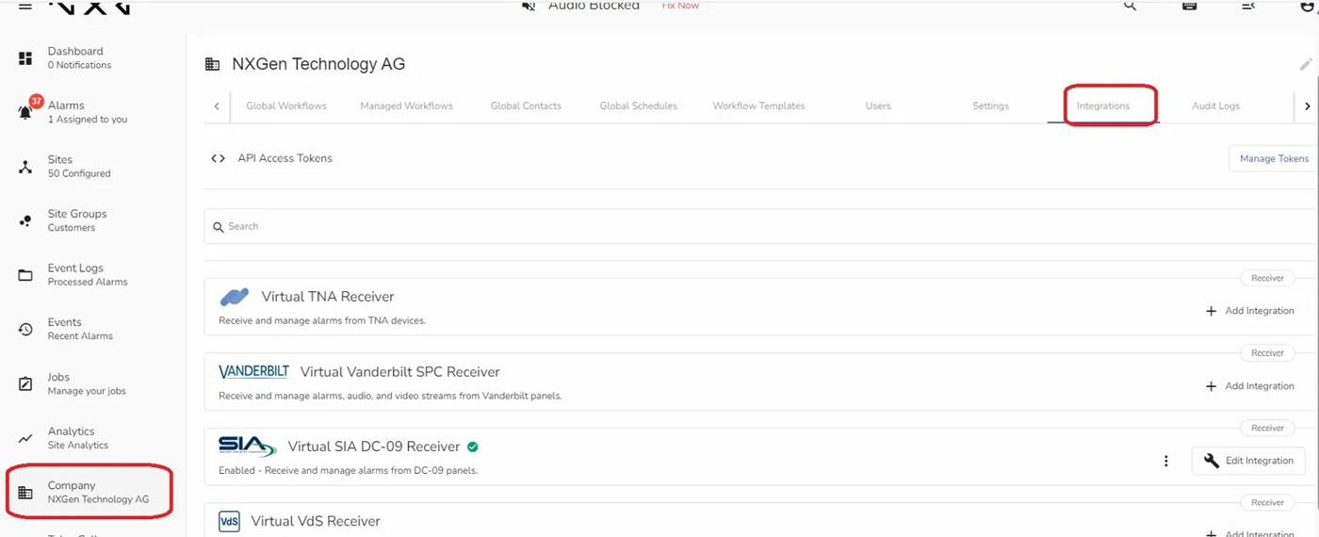
Figure 1: Talos Company → Integrations tab. The Virtual SIA DC-09 Receiver is also visible here as a separate integration.
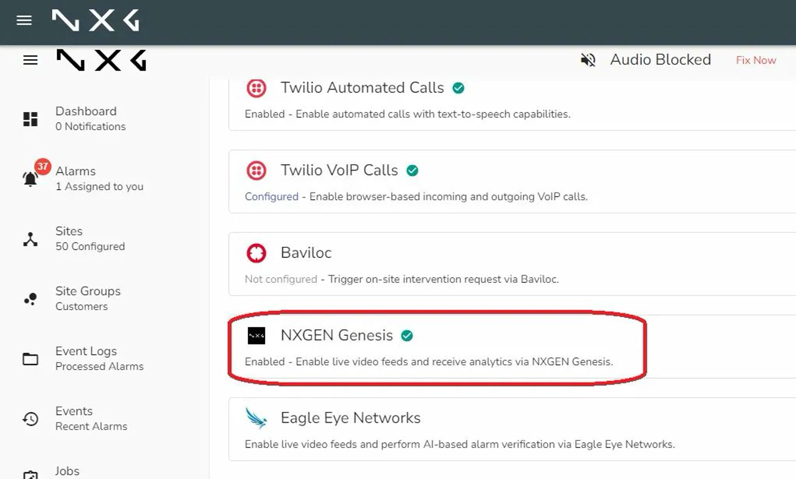
Figure 2: NXGEN Genesis integration confirmed as Enabled. This must be active for Auto Stream triggers to reach GCXONE.

Step 2 — Configure Auto Stream Alarm Codes in the Genesis Integration
Within the NXGEN Genesis integration settings in Talos, scroll down to the alarm stream configuration section. Here you define which alarm codes should trigger Auto Stream. Burglary alarm code BA (also referred to as BA 130) is the typical code used for intrusion panel alarms. Any alarm arriving in Talos with one of these codes and associated with a configured site will trigger the Auto Stream flow in GCXONE.

Step 3 — Create Zones in Talos
For each site where Auto Stream will be used, navigate to the site in Talos and open the Zones & Users tab. Add the zones that correspond to the physical areas of the site — for example, Zone 1 for the front entrance, Zone 2 for the server room, and so on. Assign a Zone ID and Zone Name to each. The Zone ID is what GCXONE will use to match incoming alarm messages to specific cameras.
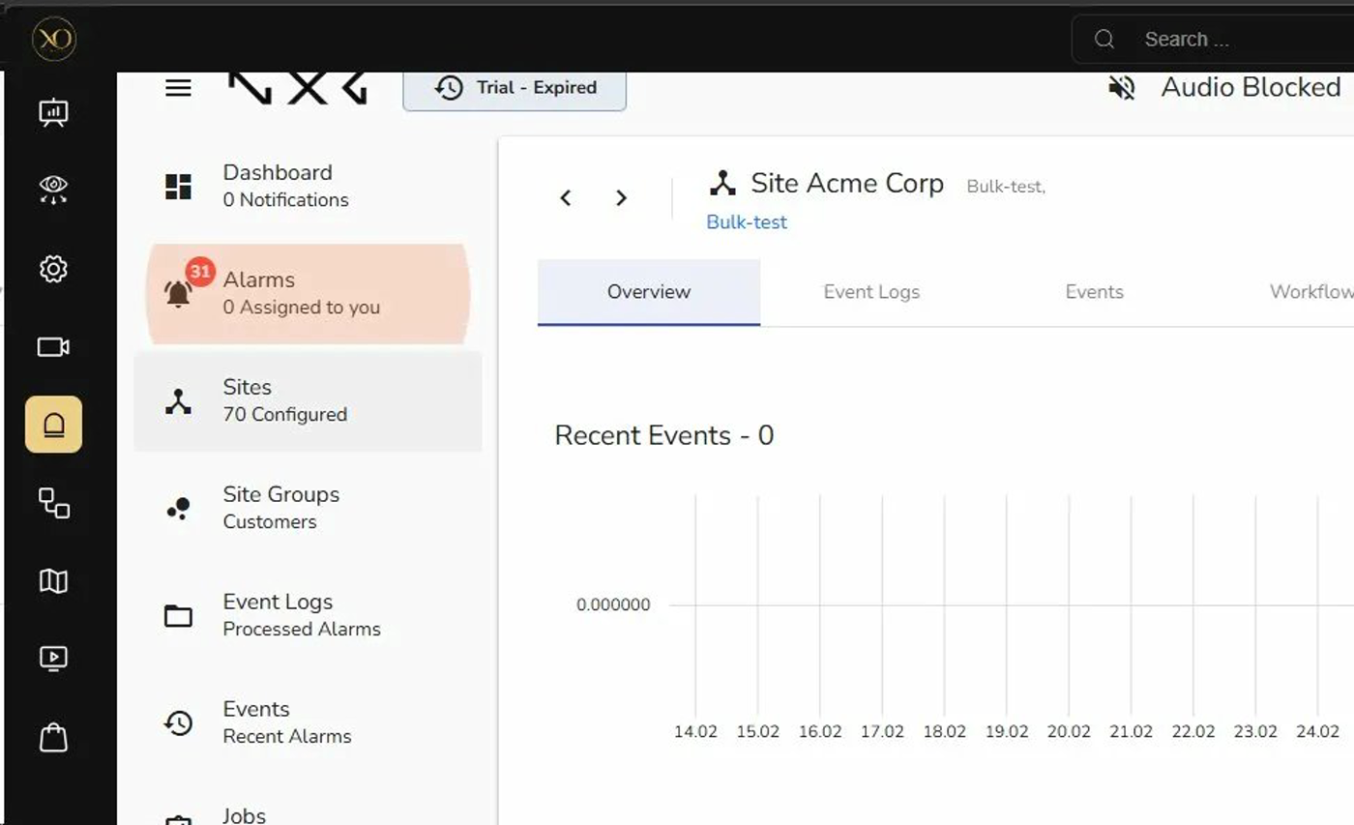
Figure 3: Talos site overview showing the site selected in the left panel. Navigate to the site before accessing Zones & Users.
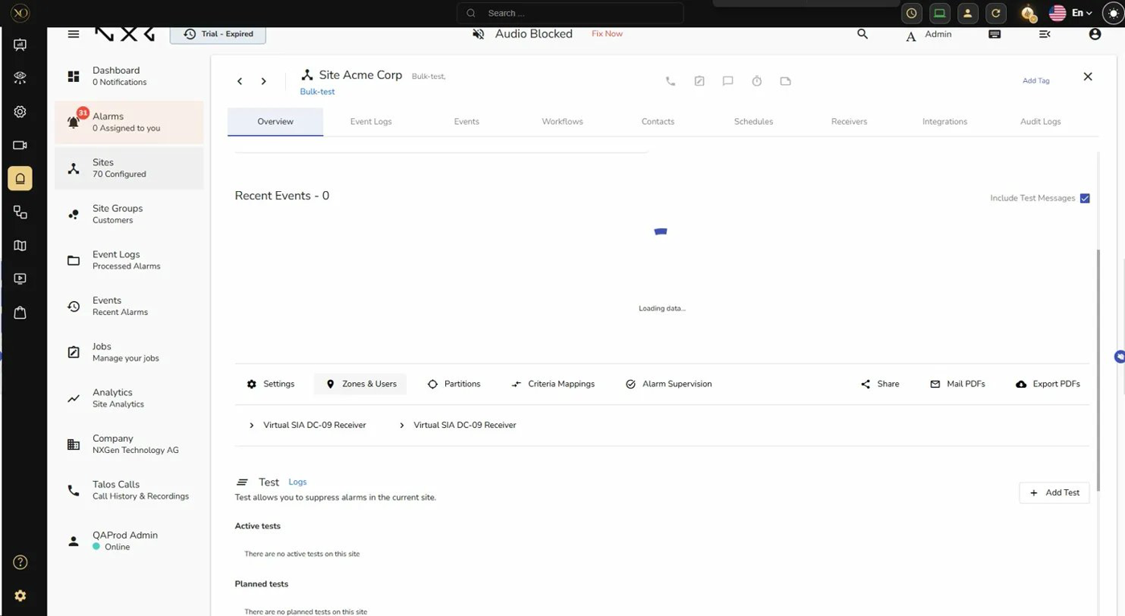
Figure 4: Talos site detail view. The Zones & Users tab is accessible from the top navigation within the site. Virtual SIA DC-09 Receivers are also visible here.
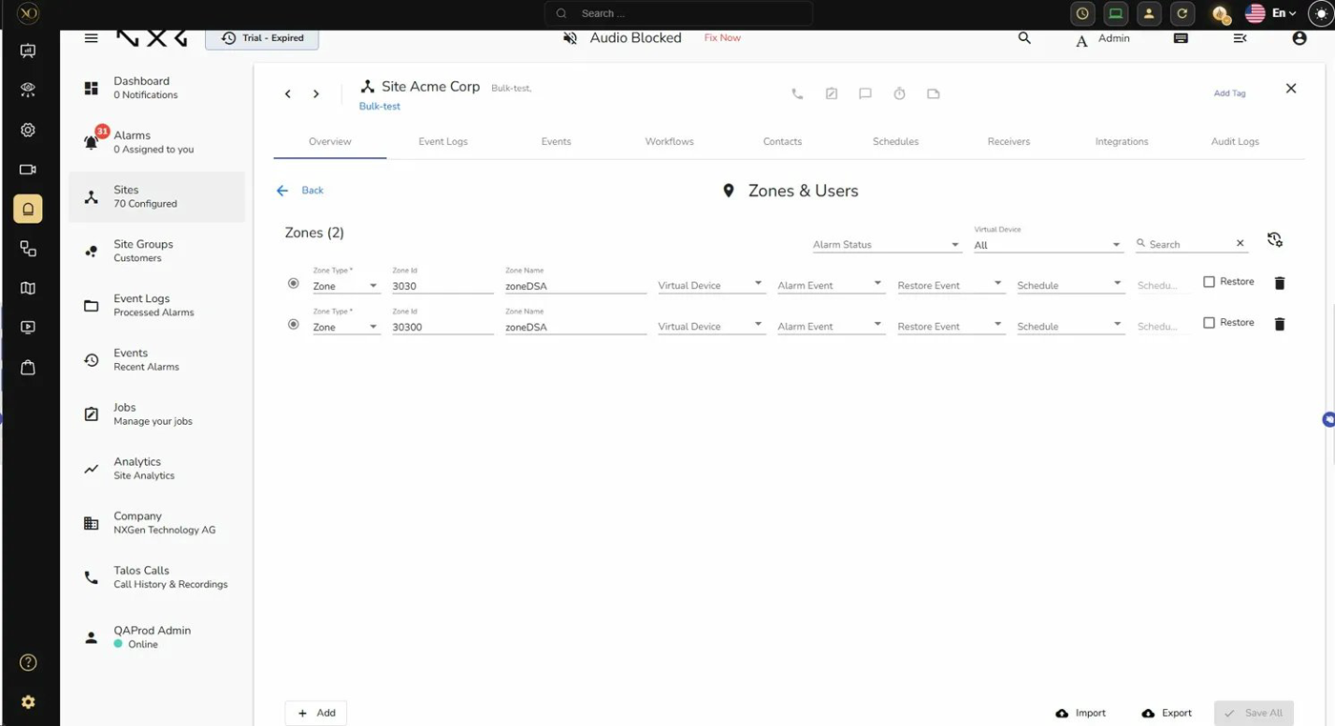
Figure 5: Zones & Users configuration in Talos. Each zone has a Zone Type, Zone ID, and Zone Name. These Zone IDs must be created here before configuring sensors in GCXONE.

Order matters
Always create zones in Talos first. When a zone is saved in GCXONE, it sends that zone's sensor mapping to Talos in real time. If the zone does not yet exist in Talos, the sync will fail and the cameras will not be associated correctly.

Step 4 — Assign Zones to Sensors in GCXONE
Once the zones exist in Talos, go to GCXONE and navigate to the sensor configuration for the site. Open the Edit Sensor dialog for each camera that belongs to a zone. In the Properties tab, locate the Zone field and enter the Zone ID that matches the zone created in Talos. Save the sensor.
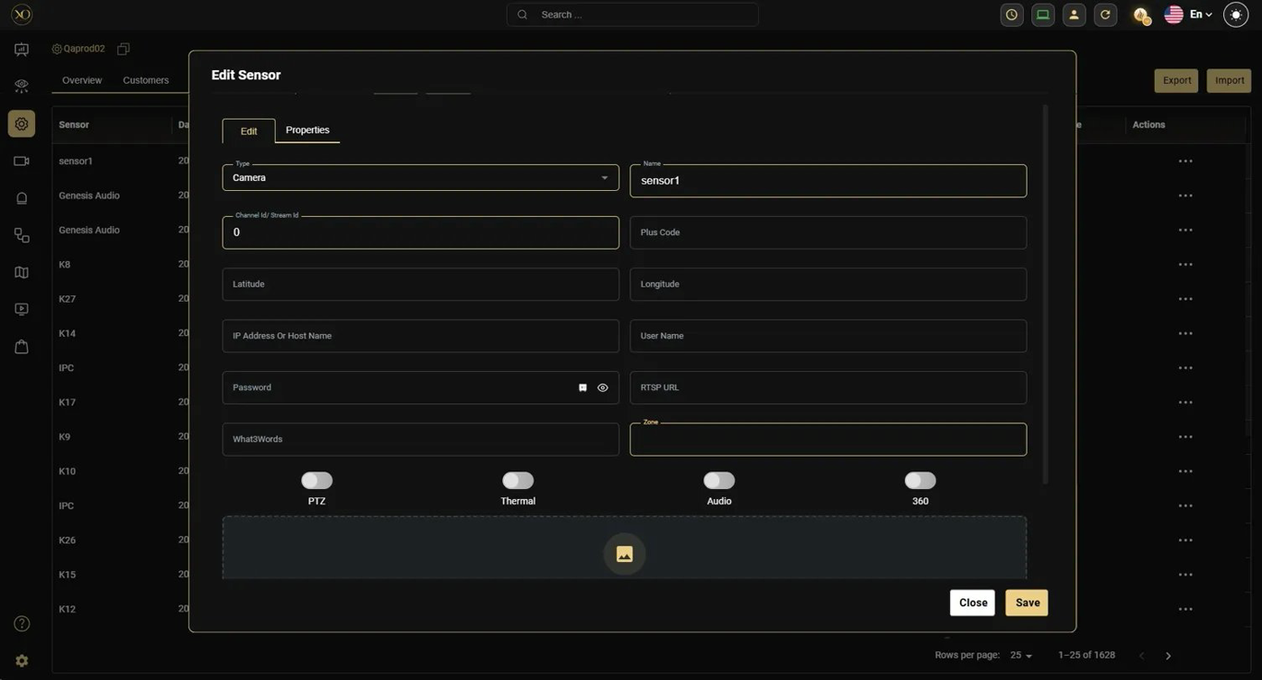
Figure 6: Edit Sensor dialog in GCXONE (Properties tab). The Zone field at the bottom right accepts the Zone ID from Talos. Assign the same Zone ID to all cameras that cover that physical area.
Repeat this for every camera that needs to be associated with a zone. Multiple cameras can be assigned to the same zone — all cameras sharing a zone ID will stream together when an alarm from that zone arrives. Cameras on different devices within the same site can all be assigned to the same zone.

Streaming Behaviour Reference
The table below summarises all possible streaming scenarios based on zone configuration and alarm content.

Scenario | Zone in alarm message? | Result
Zone configured in GCXONE, alarm contains matching zone | Yes — matches a configured zone | Stream only the cameras mapped to that zone
Zone configured in GCXONE, alarm zone does not match any camera zone | Yes — no matching zone found | Stream entire site
No zone configured in GCXONE for any camera | Yes or No | Stream entire site
No zone in the alarm message | No | Stream entire site
Multiple alarms, multiple zones | Yes — multiple zones | Aggregate all zone cameras; stream combined list (no duplicates)
Workflow contains both motion alarm and burglary alarm | Yes or No | Motion alarm takes priority — quad view shown; Auto Stream runs on secondary screen if available

Troubleshooting
Entire site streams even though zones are configured
This usually means zone data is not synced between GCXONE and Talos. Check that zones were created in Talos before being assigned in GCXONE. If the order was reversed, delete the zone assignment in GCXONE, ensure the zone exists in Talos, then re-assign. For existing sites with stale data, it is recommended to set up a clean test site rather than trying to repair existing zone mappings.
More cameras stream than expected
If a Zone ID was previously assigned to cameras that have since been deleted from GCXONE, those zone records may still exist in Talos. Talos retains zone-to-sensor mappings until explicitly removed. Deleting a sensor or device in GCXONE does not automatically clean up the corresponding zone entry in Talos. Verify zone mappings in Talos and remove any stale entries.
Auto Stream does not trigger
Confirm that the Genesis–Talos Bridge extension is installed and running in the browser. Verify the NXGEN Genesis integration in Talos is enabled and that the alarm code received matches one of the codes configured in the integration settings. Check that the site in GCXONE matches the site in Talos by name or ID.
Stream shows only a site name — no sensor list
This appears in the bridge message inspector when zone-to-sensor mapping has not synced correctly. A sensor list will only be present if at least one camera has a matching zone assignment. If only the site name is returned, GCXONE streams the full site. Re-check zone assignments on sensors and confirm the sync completed successfully after saving.

For technical support or configuration assistance, contact NXGEN Technology AG through the GCXONE support portal.

