The GenTaR Web Application Sandbox

[https://www.gentar.org/production-tracker-sandbox/#/](https://www.gentar.org/production-tracker-sandbox/)

A stable prototype for you to test

* Data replaced every Saturday
* **NOT** the final version
* feedback really welcome

# Sandbox data

Some public data from iMits has been loaded into the database.

For demonstration purposes a few changes have been made to the data:

Projects with genes starting with an ‘A’ have been made restricted

Projects with genes starting with a ‘B’ have been made protected

In iMits all the data is associated with CMG, but in the sandbox the project associated with the gene Atrx has been made an internal Baylor (BCM) project.

Difference in the data model compared to iMits:

* **Work Units / Work Group / Consortium**
  + GenTaR Work Units == iMits Centre (e.g. Harwell)
  + GenTaR Work Group == iMits Consortium (e.g. BASH)
  + GenTaR Consortium - collaborating projects - (e.g. CMG, [Kids First](https://commonfund.nih.gov/kidsfirst))
* **Projects & plans**
  + GenTaR project == iMits plan
  + GenTaR plan (production) == iMits mi_attempt
* A GenTaR production plan can have multiple Outcomes
* Outcomes are linked to a colony or a specimen (haplo-essential project)
* Projects, Plans and Outcomes have identifiers

# Working with the application

# Public data

If you are not logged into the system you can view and search public data

This is the project view showing all public projects. This opens by default, but you can also open this view from the “Search Projects” item of the “Search“ menu.

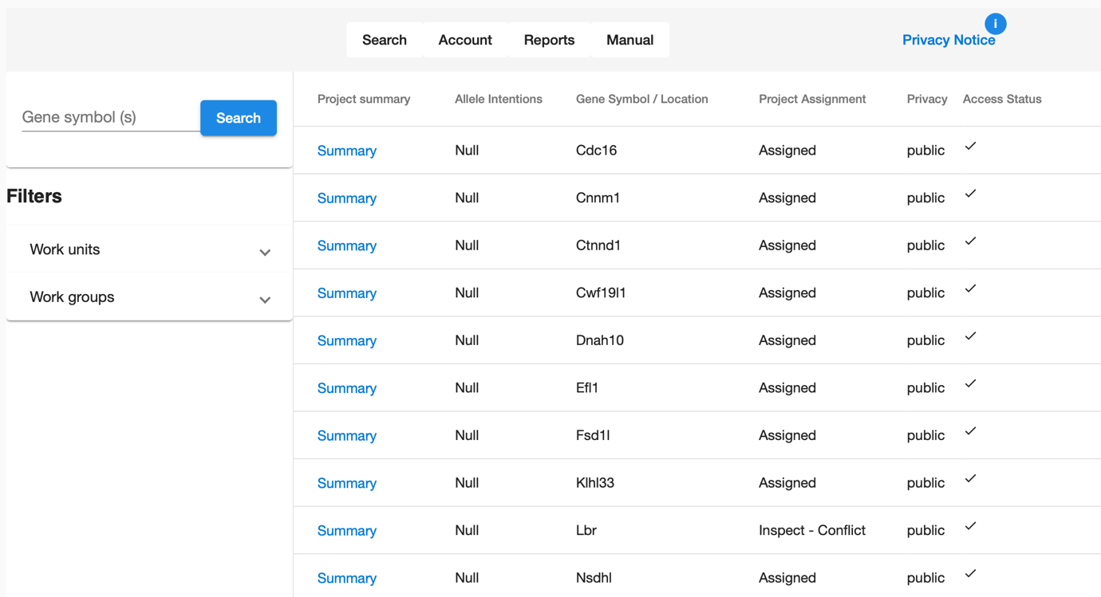

Specific projects can be found by gene symbol or synonym

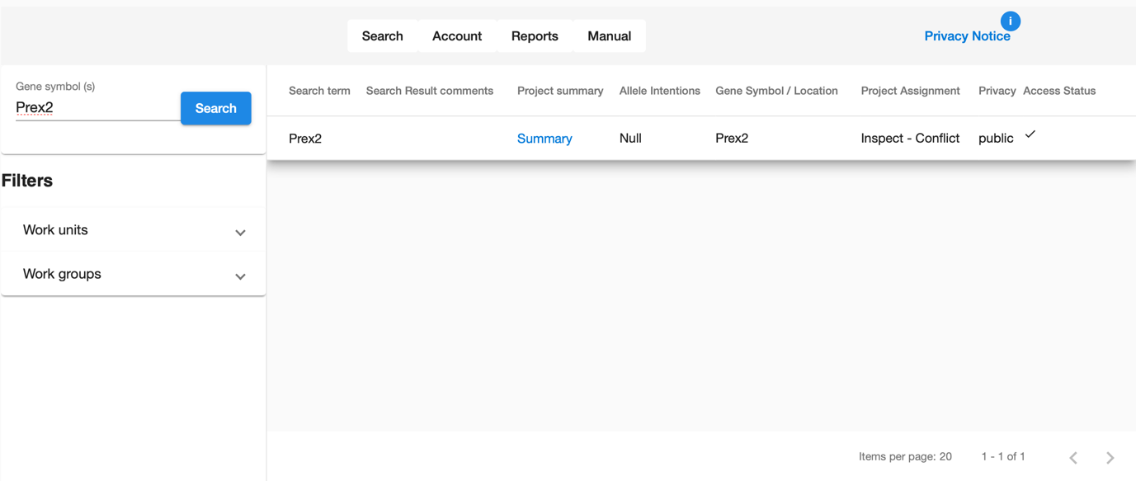

Alternatively, the projects can be filtered by Work Unit (a production centre such as TCP),

or by a Work Group (e.g. BASH)

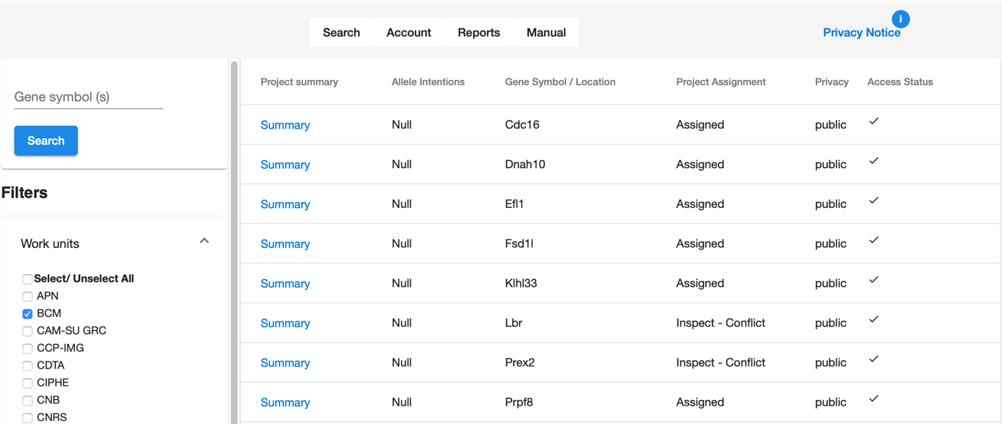

Clicking on the Summary link of a project gives you an overview of that project

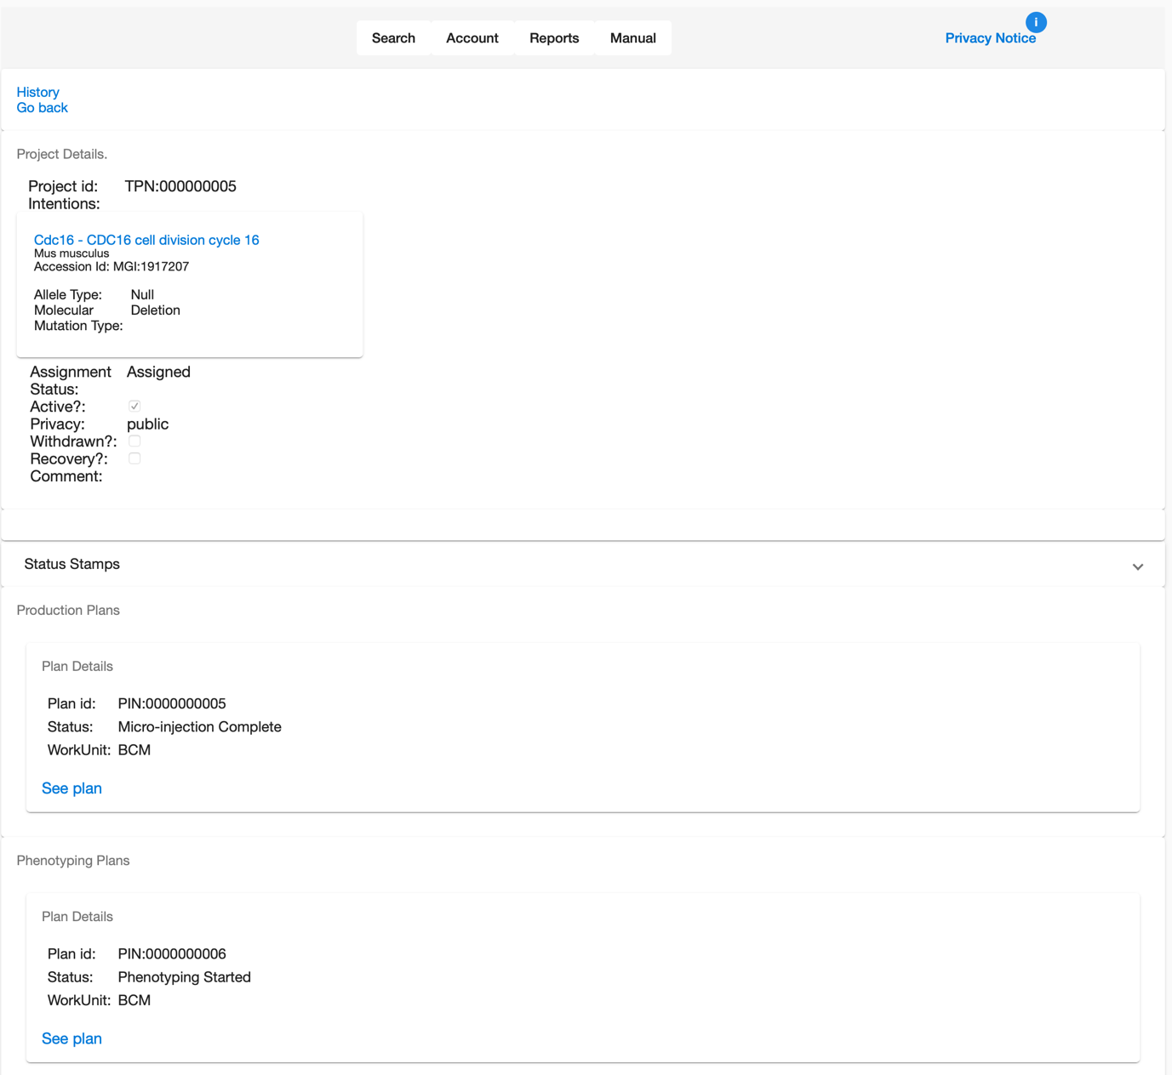

The project identifier

Production and phenotyping plans associated with the project

Each plan shows its current status

Clicking the “See plan” link shows detailed information about the plan.

# Production plan

A production plan has information about the strategy used to produce the mouse line

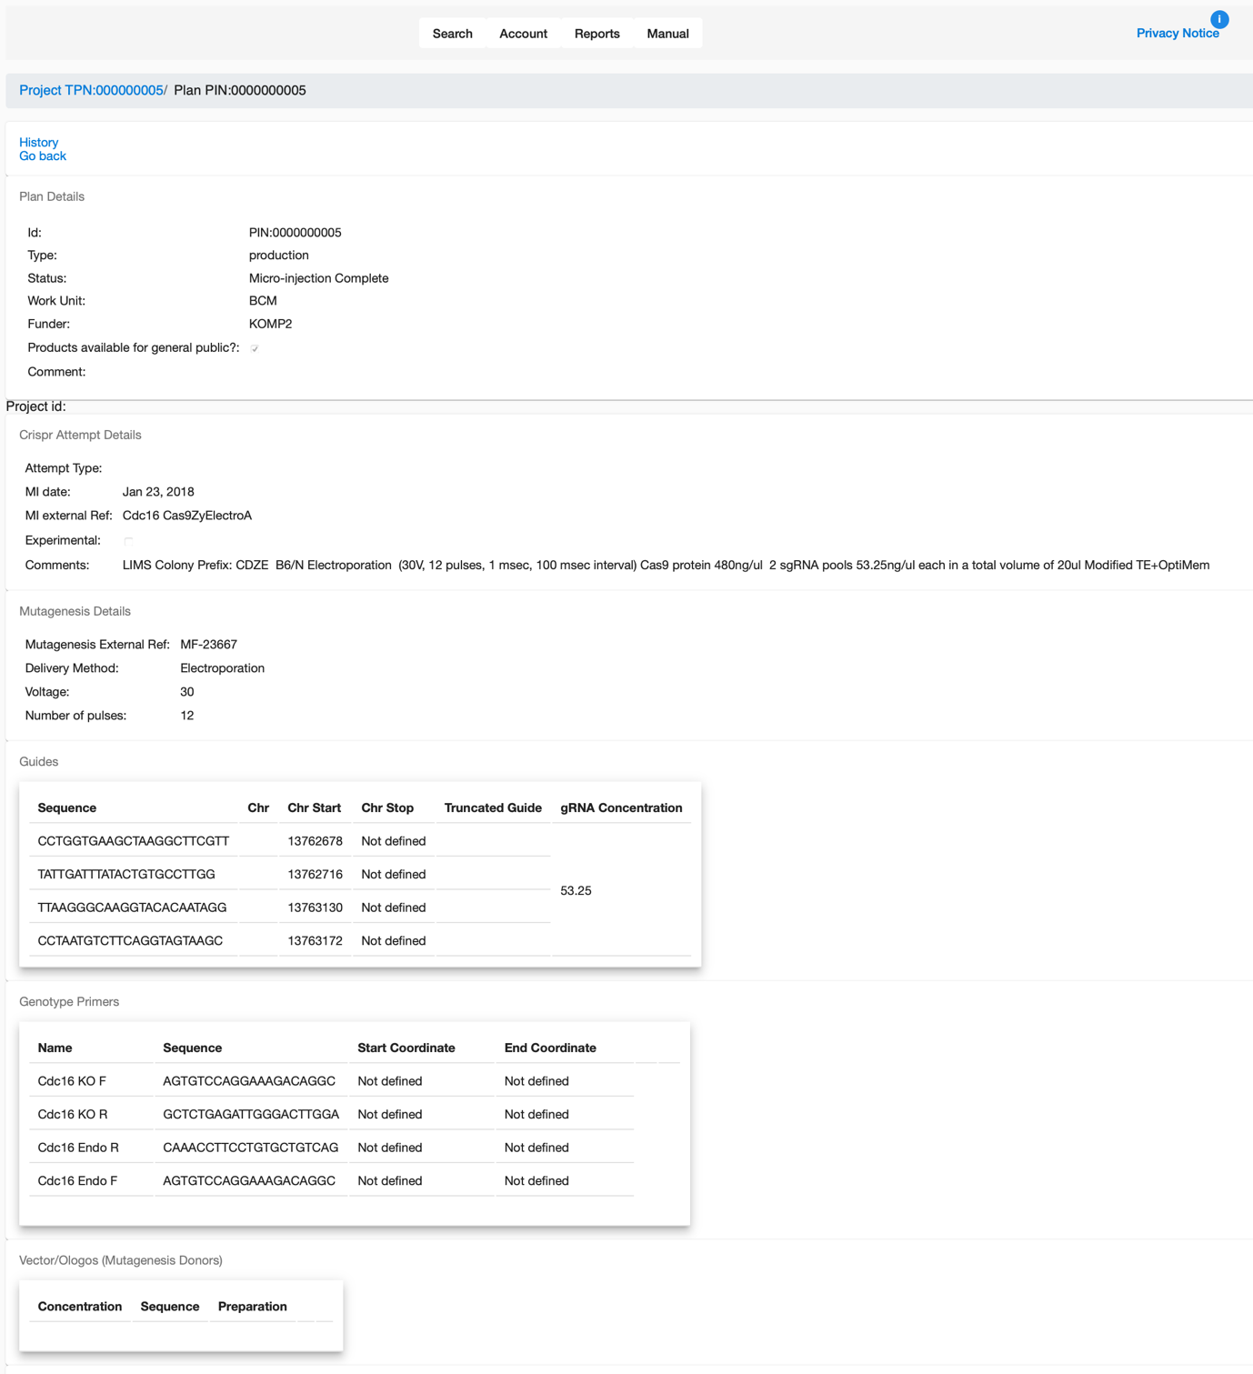

# Phenotype plan

A phenotype plan has details about who is phenotyping the mouse

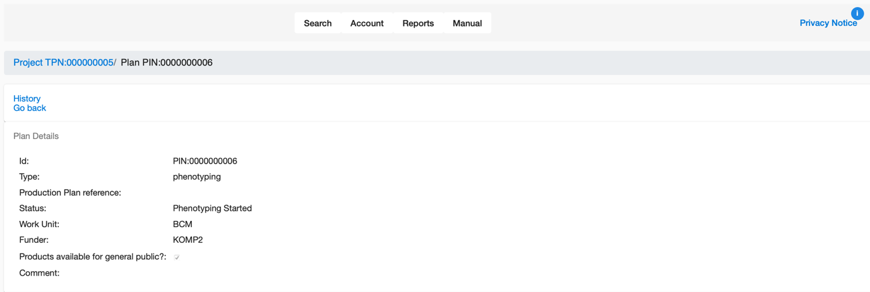

To edit the information, you need to log into the system

# GenTaR Sandbox Users

We have created a number of users in the sandbox so that you can explore the system from different perspectives.

|  |  |  |  |  |  |  |  |
| --- | --- | --- | --- | --- | --- | --- | --- |
| Name | E-mail | Password | Workunit | Work unit Role | Consortium | Consortium Role | Description |
| CMG Manager | cmg-manager@ebi.ac.uk | cmg-manager |  |  | CMG | Manager | CMG only user (manager) |
| CMG | cmg@ebi.ac.uk | cmg |  |  | CMG | General | CMG only user (general) |
| BCM Manager | bcm-manager@ebi.ac.uk | bcm-manager | BCM | Manager |  |  | BCM Manager |
| BCM | bcm@ebi.ac.uk | bcm | BCM | General |  |  | BCM General |
| TCP | tcp@ebi.ac.uk | tcp | TCP | General |  |  | TCP General |

# Logging into the Web Application

You can find the “Sign In” option under the Account tab

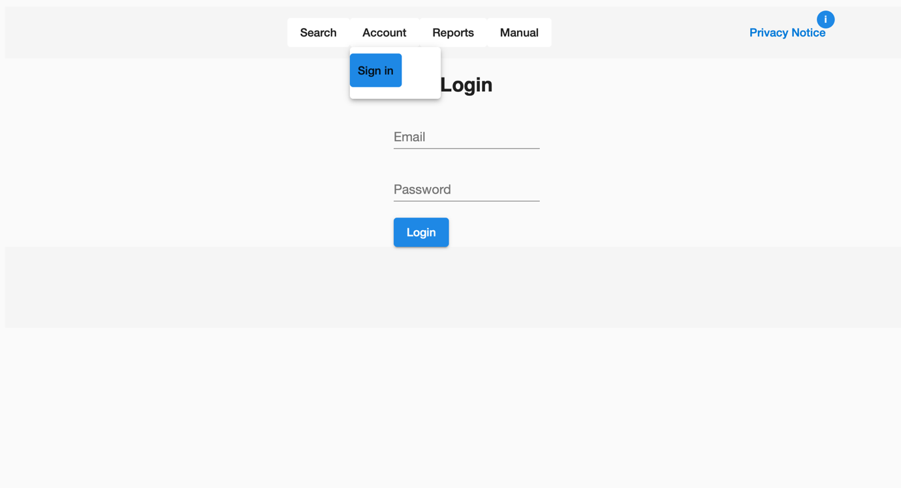

# Data Access – Protected and Restricted Projects

Signing in as the Baylor (BCM) general user:

Shows all the public, protected and restricted projects and their access status for the Baylor user. Baylor has an association with the CMG consortium, so all CMG projects are visible to the Baylor user.

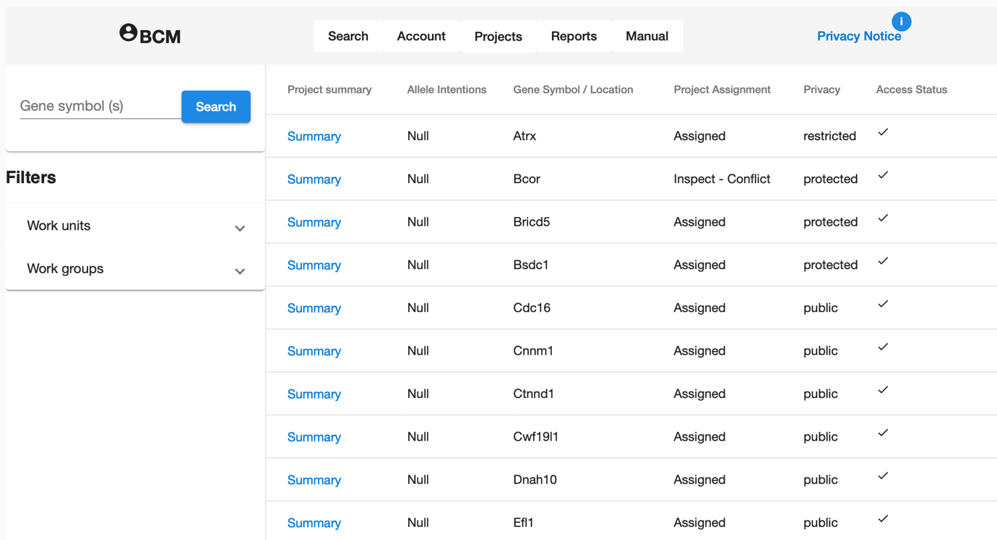

Signing in as the TCP general user:

TCP has an association with the CMG consortium, so all CMG projects are visible, however the restricted project specific to Baylor is flagged with a different access status.

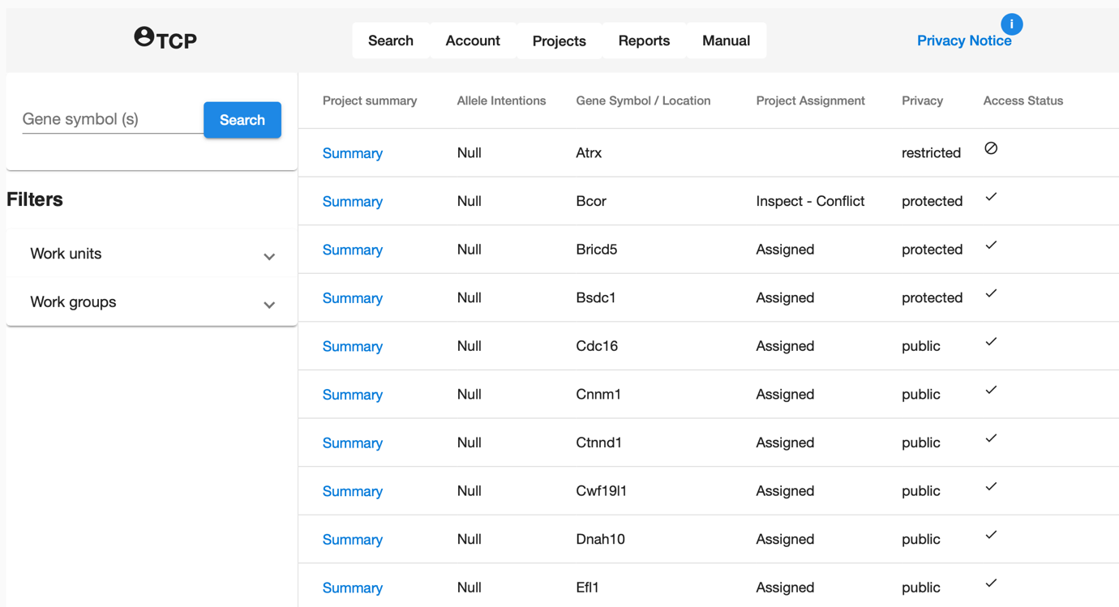

Clicking on the project summary link as a TCP user just shows high level information about the project, the plans associated with the project are not shown.

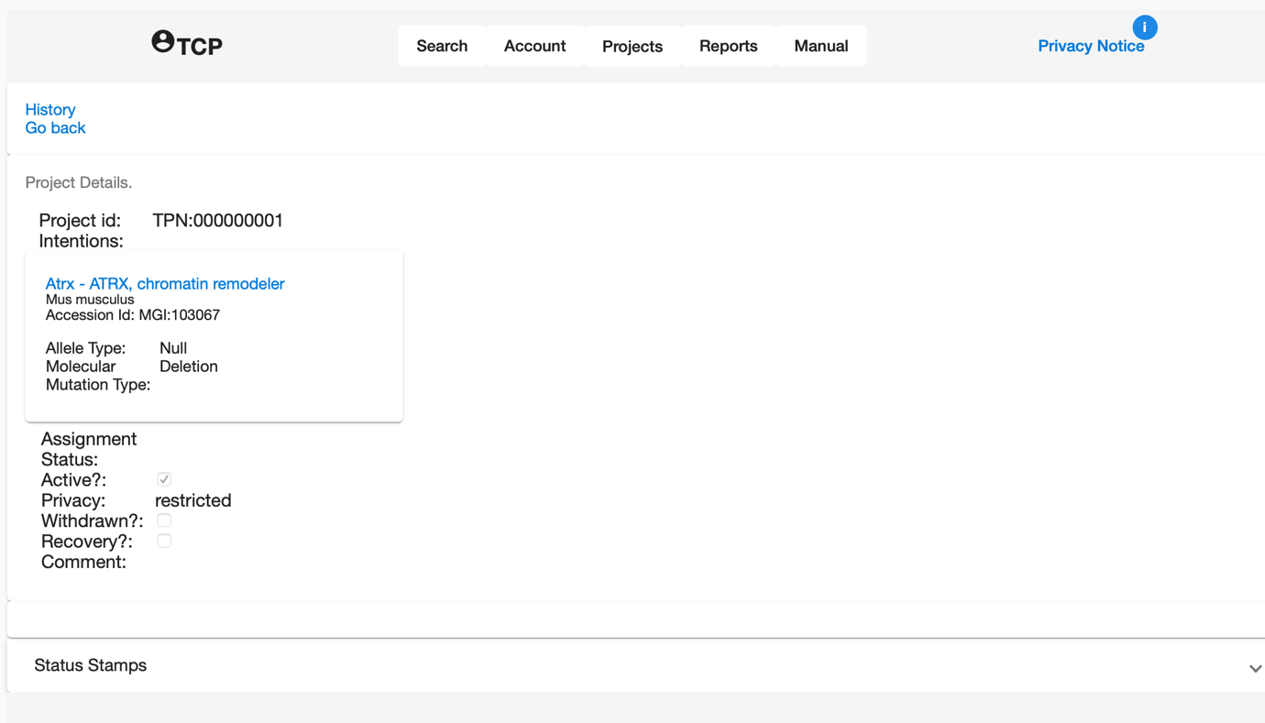

In contrast the BCM user has access to details of the plans to produce and phenotype the mice.

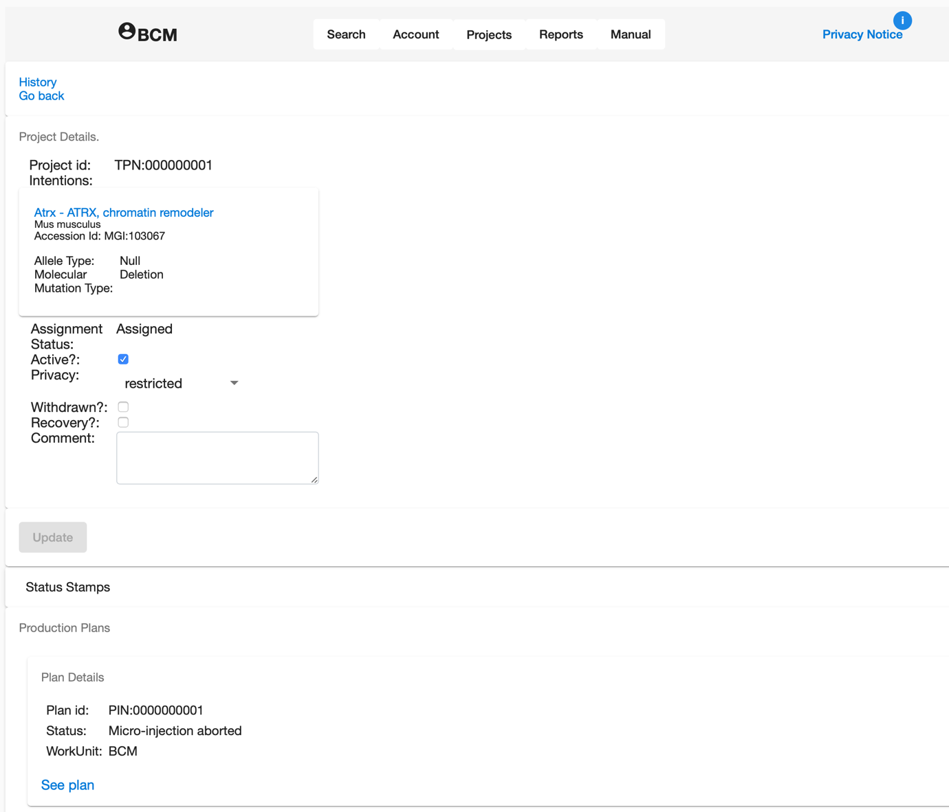

# Editing a Record

A user logged into the system from a Work Unit that is directly associated with a project or a plan has a different view of the data that allows them to update it.

Compare the view of a protected project between the BCM and TCP users

BCM user:

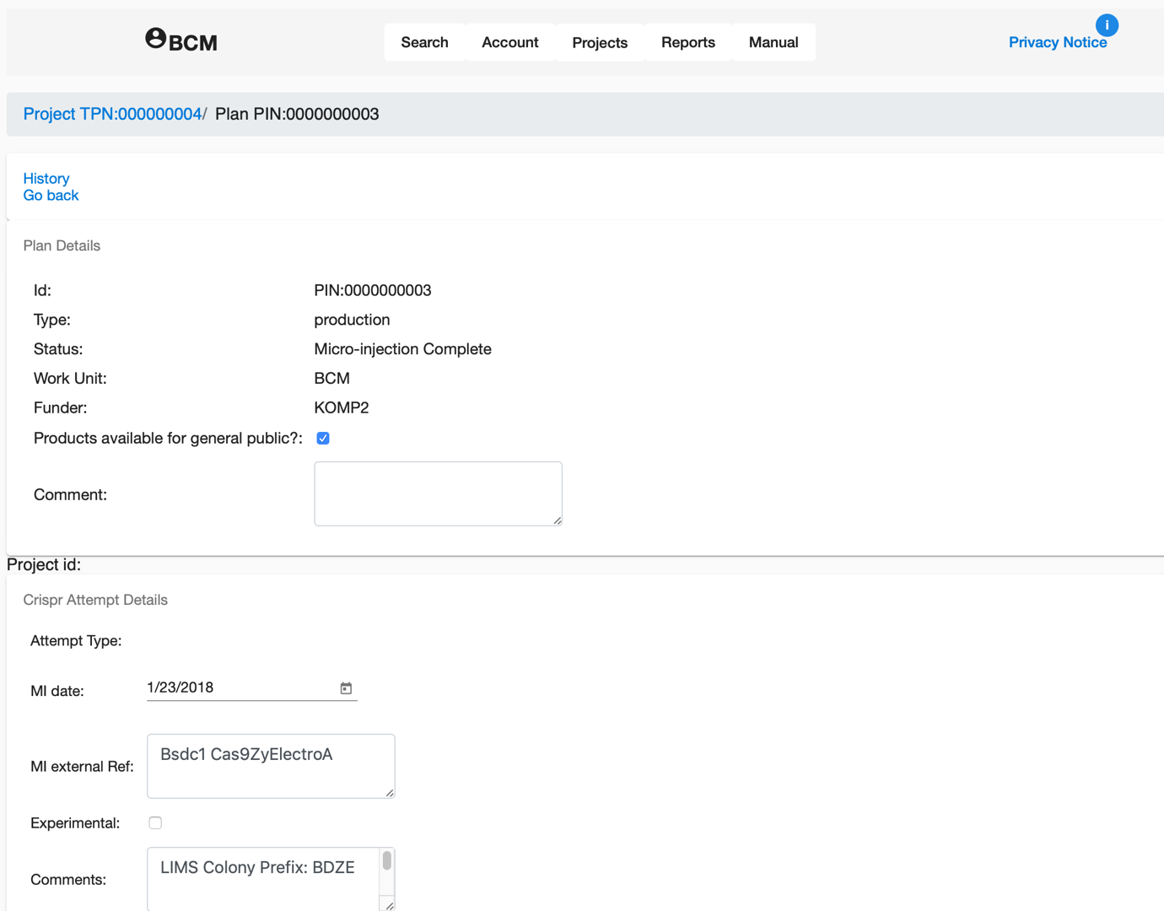

The data can be edited in this view.

The view for the TCP user of the same plan:

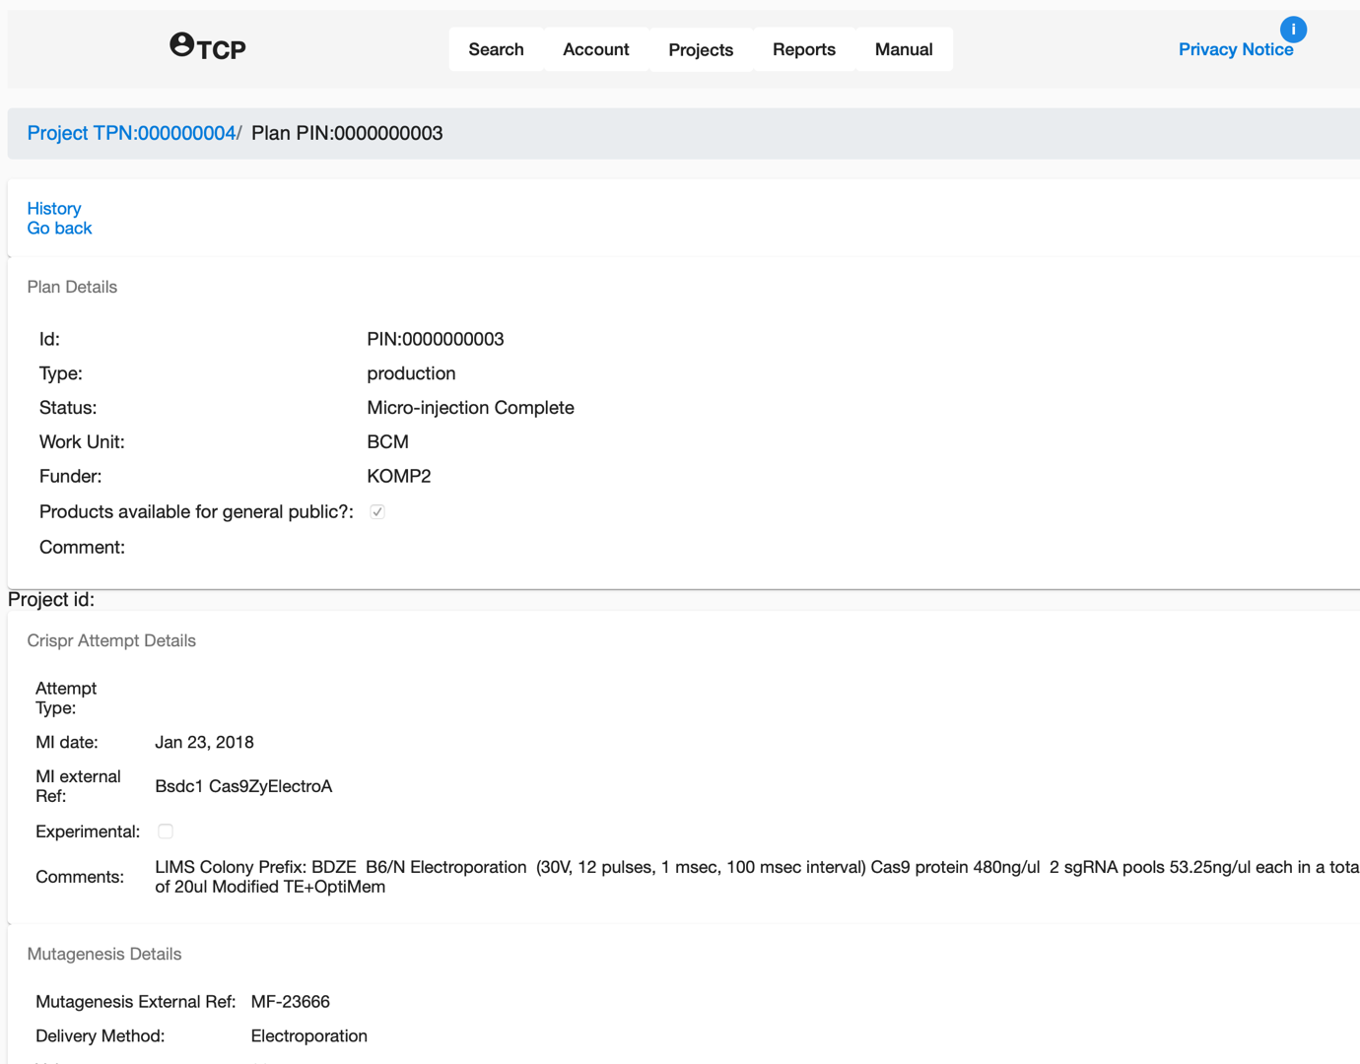

The TCP user can see the details but is not able to edit the data.

# Managed Projects

A list of all projects that you manage can be obtained under the Projects menu when logged into the system as a member of a work unit.

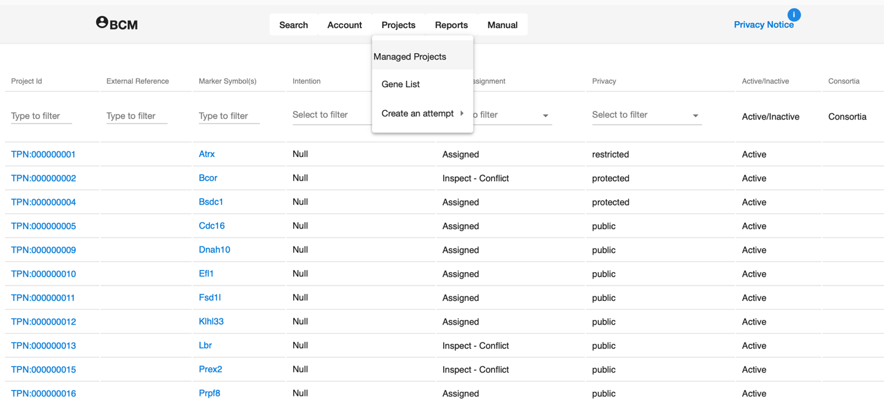

Filters present at the top of the list can be used to locate specific projects

Filtered by Marker symbol

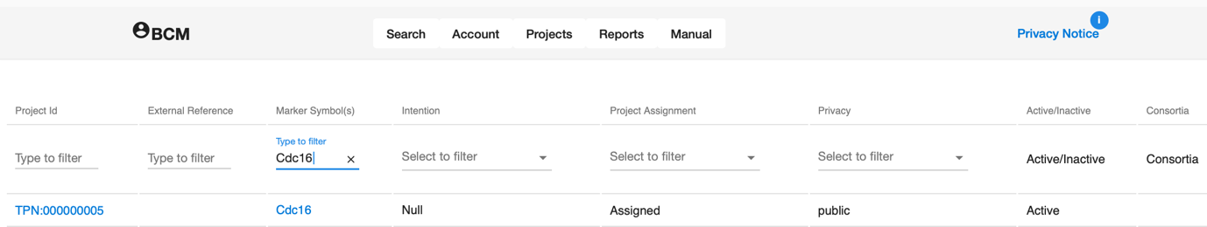

Filtered by data access policy

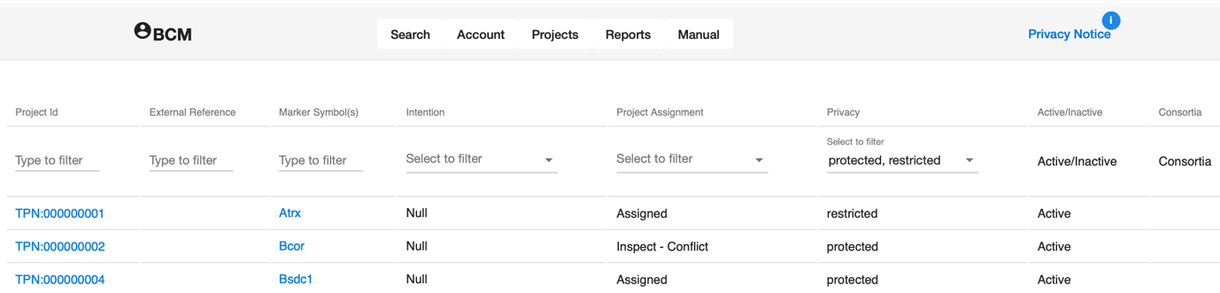

# Creating new users

Users who have the Manager role can create users associated with their Work Unit or Consortium.

This function is available from the “Admin” item of the “Account” menu, which only appears for a manager logged into the system.

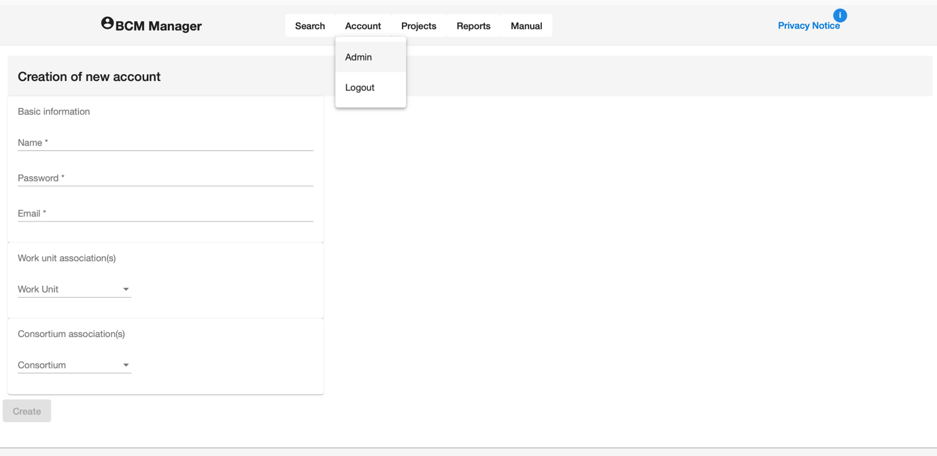

The ability to delete users or reset the password will be added in the future.

# Managed Gene Lists

A member of a consortium has access to the consortium gene list. There are separate lists for each consortium. The list can be used to record all genes of interest to the consortium, not just those entered into the production tracking system.

**For genes on the list in the production pipeline**

Every project associated with the gene is shown

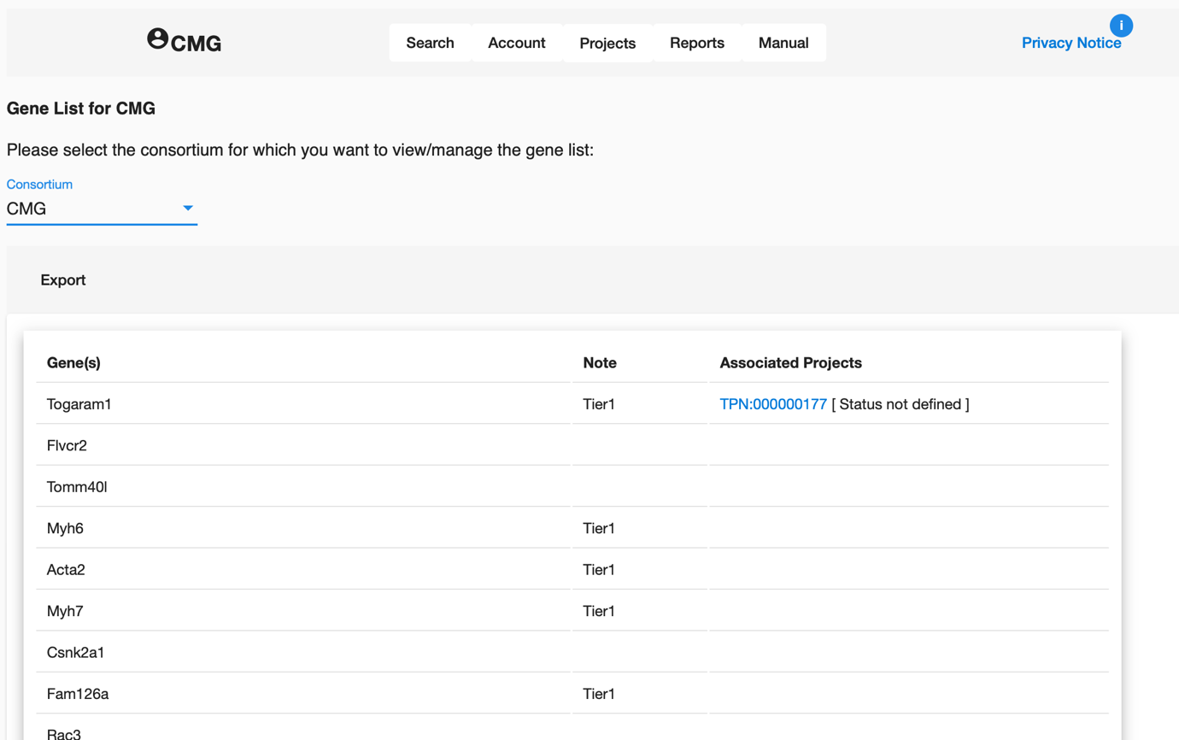

The gene lists can be maintained by members of the consortium who have been assigned the Manager role. When they open the gene list page, they have a different view that allows them to edit the list or import additional genes from a CSV file.

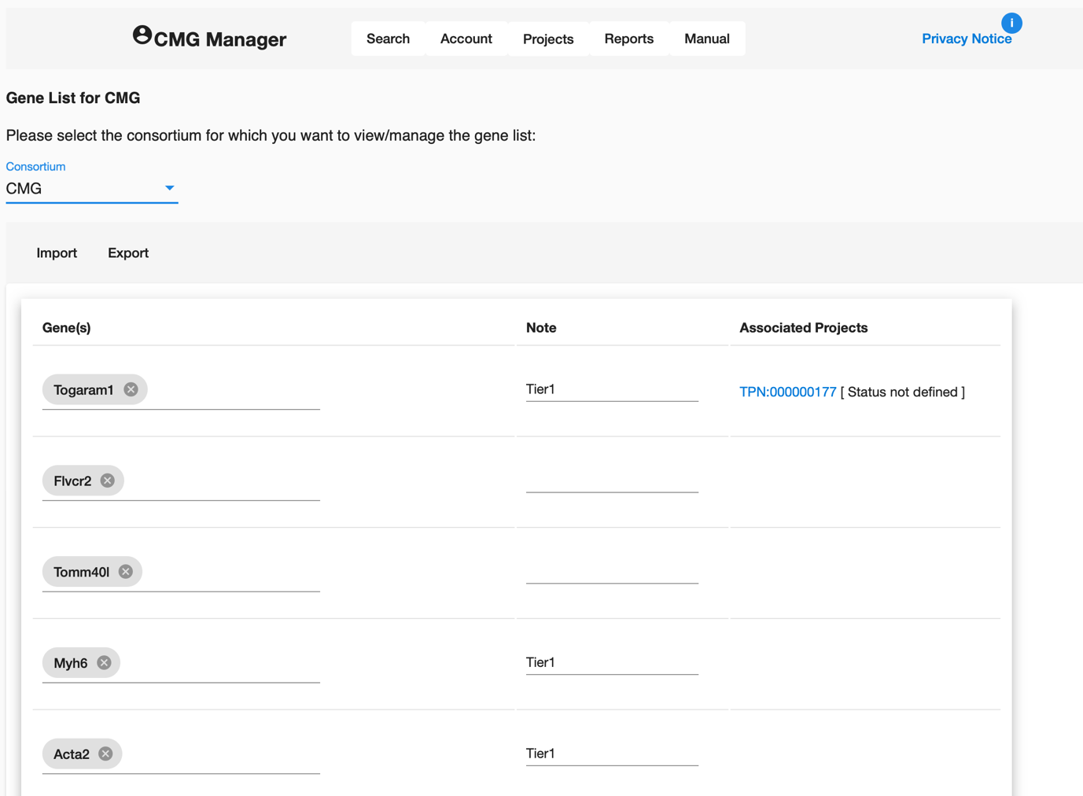

The format of a CSV file is:

< gene symbol >, <note>

However, this is something that could change in a future version of the application.

Members of a work unit who are not a member of the consortium cannot view the gene list.

Members of the consortium can see all the information about public plans, as well as protected and restricted plans that are associated with the consortium, however they do not have permission to edit the plans or projects.

