

Transcript Request and Tracking Proposal
SWE2106 Internet Technologies and Web Design
E-tivity 5
Submitted by Group A
Submitted to Dr. Robert Mugonza
10 November 2026

1. Problem and project overview
When transcript requests and updates are handled through separate channels, students can struggle to find out what stage a request has reached, and registrar staff can spend time answering repeat enquiries. Group A proposes a web application that gives each transcript request a unique reference, a current status, and a record of staff actions.
A student can submit a request and check it later. Registrar staff can review requests from one queue, record decisions, and add notes. Both users work from the same saved record.

Group A members
Name | Registration number
Byamugisha Alban | 2025/BSE/062/PS
Akisimire Timothy | 2025/BSE/031/PS
Odongo Emmanuel Bilal | 2025/BSE/142/PS
Mumbere Edwin | 2025/BSE/112/PS
Tibamanya Davis | 2025/BSE/172/PS
Asuma Kadde Kevin | 2025/BSE/045/PS
Ocero Brian | 2025/BSE/141/PS
Nsubuga Francis | 2025/BSE/243/PS
Arusio Simon Peter | 2025/BSE/041/PS

2. Users and objectives
Students need to submit a reason for requesting a transcript, keep the reference, and see the decision and any note. Registrar staff need to find pending requests, record decisions, and see who made earlier changes.
- Give students one place to submit and track their own requests.
- Give registrar staff a shared queue and a consistent process for recording decisions.
- Keep each request and its history in a persistent database.
- Enforce access and validation rules in the API and verify them with Postman.

3. Workflow and scope
Step | What the application does
Register and sign in | A new student can register with an @std.must.ac.ug address and sign in again later. Registrar staff use a separate staff account.
Submit | The student enters a reason. The API validates it, stores the request as Submitted, and returns a unique reference.
Review and decide | Staff move the request to Under review, then to Ready for collection or Rejected. Rejection requires a reason.
Notify and track | The student sees the new status and any saved note in the dashboard, including updates made while they were signed out. The request retains its history.
This release covers account access, transcript requests, review, status notifications, and tracking. Transcript generation, fee payments, and integration with university records are outside this release.

4. Technical solution
A browser interface built with HTML, CSS, and JavaScript sends requests to the Express API. SQLite stores users, sessions, transcript requests, and history. The server checks roles and ownership, and saves each status change and its history entry in one database transaction.
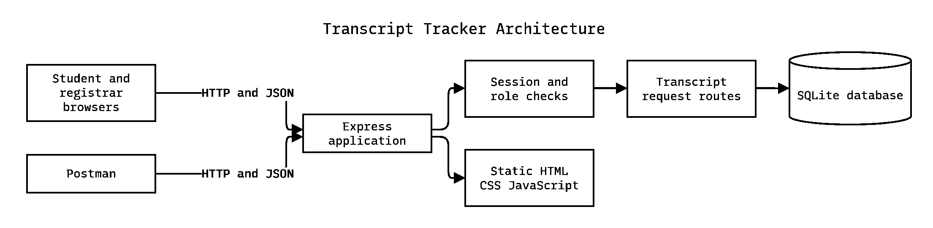
Figure 1. The browser and Postman use the same Express application and SQLite database.

5. Expected benefits
Students can check their status without repeatedly contacting the registrar. Staff can use a shared queue to identify requests that need action. The stored history gives both sides a reference when a decision needs clarification.

6. Testing and live demonstration
The current Express API has ten endpoints. The Postman collection uses local demo accounts and includes successful and invalid requests. Its latest verified run passed 22 checks across 18 requests. Browser testing also confirmed that a student can see a registrar note while signed in and after returning to the dashboard.
Demonstration | Expected result
Submit a valid request | 201 Created with a reference number.
Send a reason that is too short | 400 Bad Request.
Attempt a status update as a student | 403 Forbidden.
Attempt to skip review as registrar | 409 Conflict.
Complete review and show the student dashboard | The student sees the same reference, final status, and review note.

7. Delivery and team evidence
The proposal milestone is 10 November 2026. The Express setup, connected frontend and database, Postman collection, GitHub repository, and team presentation with a live demonstration support the 12 November 2026 milestone.
Each team member records their responsibility and submits their own GitHub pull request as contribution evidence. The open pull request for the Postman Desktop instructions gives the team an example.
Group A repository and deliverables
Postman Desktop instructions pull request

8. University deployment
The classroom implementation uses local demo accounts and a persistent SQLite database. A university rollout would require verified student sign-in, institution-managed staff access, secure hosting, and a backup and recovery plan. The registrar would confirm the review procedure and record retention requirements before a pilot with student records.

